OSPF v1.31 – Aaron Balchunas 1
- Open Shortest Path First -
OSPF (Open Shortest Path First)
OSPF is a standardized Link-State routing protocol, designed to scale
efficiently to support larger networks.
OSPF adheres to the following Link State characteristics:
•OSPF employs a hierarchical network design using Areas.
•OSPF will form neighbor relationships with adjacent routers in the
same Area.
•Instead of advertising the distance to connected networks, OSPF
advertises the status of directly connected links using Link-State
Advertisements (LSAs).
•OSPF sends updates (LSAs) when there is a change to one of its links,
and will only send the change in the update. LSAs are additionally
refreshed every 30 minutes.
•OSPF traffic is multicast either to address 224.0.0.5 (all OSPF
routers) or 224.0.0.6 (all Designated Routers).
•OSPF uses the Dijkstra Shortest Path First algorithm to determine
the shortest path.
•OSPF is a classless protocol, and thus supports VLSMs.
Other characteristics of OSPF include:
•OSPF supports only IP routing.
•OSPF routes have an administrative distance is 110.
•OSPF uses cost as its metric, which is computed based on the
bandwidth of the link. OSPF has no hop-count limit.
The OSPF process builds and maintains three separate tables: •A neighbor table – contains a list of all neighboring routers.
•A topology table – contains a list of all possible routes to all known
networks within an area.
•A routing table – contains the best route for each known network.
* * *
All original material copyright © 2007 by Aaron Balchunas (aaron@routeralley.com),
unless otherwise noted. All other material copyright © of their respective owners.
This material may be copied and used freely, but may not be altered or sold without the expressed written
consent of the owner of the above copyright. Updated material may be found at http://www.routeralley.com.

OSPF v1.31 – Aaron Balchunas 2
OSPF Neighbors
OSPF forms neighbor relationships, called adjacencies, with other routers in the same Area by exchanging Hello packets to multicast address 224.0.0.5.
Only after an adjacency is formed can routers share routing information.
Each OSPF router is identified by a unique Router ID. The Router ID can be determined in one of three ways:
•The Router ID can be manually specified.
•If not manually specified, the highest IP address configured on any Loopback interface on the router will become the Router ID.
•If no loopback interface exists, the highest IP address configured on any Physical interface will become the Router ID.
By default, Hello packets are sent out OSPF-enabled interfaces every 10 seconds for broadcast and point-to-point interfaces, and 30 seconds for non-broadcast and point-to-multipoint interfaces.
OSPF also has a Dead Interval, which indicates how long a router will wait without hearing any hellos before announcing a neighbor as “down.” Default for the Dead Interval is 40 seconds for broadcast and point-to-point
interfaces, and 120 seconds for non-broadcast and point-to-multipoint interfaces. Notice that, by default, the dead interval timer is four times the Hello interval.
These timers can be adjusted on a per interface basis:
Router(config-if)# ip ospf hello-interval 15
Router(config-if)# ip ospf dead-interval 60
* * *
All original material copyright © 2007 by Aaron Balchunas (aaron@routeralley.com), unless otherwise noted. All other material copyright © of their respective owners.
This material may be copied and used freely, but may not be altered or sold without the expressed written consent of the owner of the above copyright. Updated material may be found at http://www.routeralley.com.

OSPF v1.31 – Aaron Balchunas 3
OSPF Neighbors (continued)
OSPF routers will only become neighbors if the following parameters within
a Hello packet are identical on each router:
•Area ID
•Area Type (stub, NSSA, etc.)
•Prefix
•Subnet Mask
•Hello Interval
•Dead Interval
•Network Type (broadcast, point-to-point, etc.) •Authentication
The Hello packets also serve as keepalives to allow routers to quickly
discover if a neighbor is down. Hello packets also contain a neighbor field
that lists the Router IDs of all neighbors the router is connected to.
A neighbor table is constructed from the OSPF Hello packets, which
includes the following information:
•The Router ID of each neighboring router
•The current “state” of each neighboring router
•The interface directly connecting to each neighbor •The IP address of the remote interface of each neighbor
(Reference: http://www.cisco.com/warp/public/104/29.html)
* * *
All original material copyright © 2007 by Aaron Balchunas (aaron@routeralley.com),
unless otherwise noted. All other material copyright © of their respective owners.
This material may be copied and used freely, but may not be altered or sold without the expressed written
consent of the owner of the above copyright. Updated material may be found at http://www.routeralley.com.

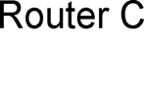
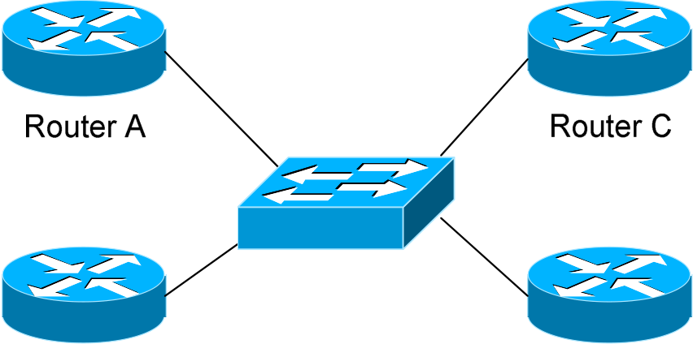
OSPF v1.31 – Aaron Balchunas 4
OSPF Designated Routers
In multi-access networks such as
Ethernet, there is the possibility of
many neighbor relationships on the same physical segment. In the above example, four routers are connected | 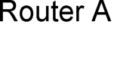
into the same multi-access segment.
Using the following formula (where
“n” is the number of routers): | 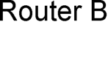 | 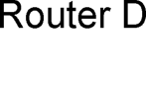
n(n-1)/2
…..it is apparent that 6 separate adjacencies are needed for a fully meshed network. Increase the number of routers to five, and 10 separate adjacencies would be required. This leads to a considerable amount of unnecessary Link State Advertisement (LSA) traffic.
If a link off of Router A were to fail, it would flood this information to all neighbors. Each neighbor, in turn, would then flood that same information to all other neighbors. This is a waste of bandwidth and processor load.
To prevent this, OSPF will elect a Designated Router (DR) for each multi-access networks, accessed via multicast address 224.0.0.6. For redundancy purposes, a Backup Designated Router (BDR) is also elected.
OSPF routers will form adjacencies with the DR and BDR. If a change occurs to a link, the update is forwarded only to the DR, which then forwards it to all other routers. This greatly reduces the flooding of LSAs.
DR and BDR elections are determined by a router’s OSPF priority, which is configured on a per-interface basis (a router can have interfaces in multiple multi-access networks). The router with the highest priority becomes the DR; second highest becomes the BDR. If there is a tie in priority, whichever router has the highest Router ID will become the DR.
To change the priority on an interface:
Router(config-if)# ip ospf priority 125
Default priority on Cisco routers is 1. A priority of 0 will prevent the router from being elected DR or BDR. Note: The DR election process is not preemptive. Thus, if a router with a higher priority is added to the network, it will not automatically supplant an existing DR. Thus, a router that should never become the DR should always have its priority set to 0.
* * *
All original material copyright © 2007 by Aaron Balchunas (aaron@routeralley.com), unless otherwise noted. All other material copyright © of their respective owners.
This material may be copied and used freely, but may not be altered or sold without the expressed written consent of the owner of the above copyright. Updated material may be found at http://www.routeralley.com.

OSPF v1.31 – Aaron Balchunas 5
OSPF Neighbor States
Neighbor adjacencies will progress through several states, including:
Down – indicates that no Hellos have been heard from the neighboring router.
Init – indicates a Hello packet has been heard from the neighbor, but two-way communication has not yet been initialized.
2-Way – indicates that bidirectional communication has been established. Recall that Hello packets contain a neighbor field. Thus, communication is considered 2-Way once a router sees its own Router ID in its neighbor’s Hello Packet. Designated and Backup DesignatedRouters are elected at this stage.
ExStart – indicates that the routers are preparing to share link state information. Master/slave relationships are formed between routers to determine who will begin the exchange.
Exchange – indicates that the routers are exchanging Database Descriptors (DBDs). DBDs contain a description of the router’s Topology Database. A router will examine a neighbor’s DBD to determine if it has information to share.
Loading – indicates the routers are finally exchanging Link State
Advertisements, containing information about all links connected to each router. Essentially, routers are sharing their topology tables with each other.
Full – indicates that the routers are fully synchronized. The topology table of all routers in the area should now be identical. Depending on the “role” of the neighbor, the state may appear as:
•Full/DR – indicating that the neighbor is a Designated Router (DR) •Full/BDR – indicating that the neighbor is a Backup Designated Router (BDR)
•Full/DROther – indicating that the neighbor is neither the DR or BDR
On a multi-access network, OSPF routers will only form Full adjacencies with DRs and BDRs. Non-DRs and non-BDRs will still form adjacencies, but will remain in a 2-Way State. This is normal OSPF behavior.
* * *
All original material copyright © 2007 by Aaron Balchunas (aaron@routeralley.com), unless otherwise noted. All other material copyright © of their respective owners.
This material may be copied and used freely, but may not be altered or sold without the expressed written consent of the owner of the above copyright. Updated material may be found at http://www.routeralley.com.

OSPF v1.31 – Aaron Balchunas 6
OSPF Network Types
OSPF’s functionality is different across several different network topology
types. OSPF’s interaction with Frame Relay will be explained in another
section
Broadcast Multi-Access – indicates a topology where broadcast occurs. •Examples include Ethernet, Token Ring, and ATM.
•OSPF will elect DRs and BDRs.
•Traffic to DRs and BDRs is multicast to 224.0.0.6. Traffic from
DRs and BDRs to other routers is multicast to 224.0.0.5. •Neighbors do not need to be manually specified.
Point-to-Point – indicates a topology where two routers are directly
connected.
•An example would be a point-to-point T1.
•OSPF will not elect DRs and BDRs.
•All OSPF traffic is multicast to 224.0.0.5.
•Neighbors do not need to be manually specified.
Point-to-Multipoint – indicates a topology where one interface can connect
to multiple destinations. Each connection between a source and destination
is treated as a point-to-point link.
•An example would be Point-to-Multipoint Frame Relay. •OSPF will not elect DRs and BDRs.
•All OSPF traffic is multicast to 224.0.0.5.
•Neighbors do not need to be manually specified.
Non-broadcast Multi-access Network (NBMA) – indicates a topology
where one interface can connect to multiple destinations; however,
broadcasts cannot be sent across a NBMA network.
•An example would be Frame Relay.
•OSPF will elect DRs and BDRs.
•OSPF neighbors must be manually defined, thus All OSPF traffic
is unicast instead of multicast.
Remember: on non-broadcast networks, neighbors must be manually
specified, as multicast Hello’s are not allowed.
* * *
All original material copyright © 2007 by Aaron Balchunas (aaron@routeralley.com),
unless otherwise noted. All other material copyright © of their respective owners.
This material may be copied and used freely, but may not be altered or sold without the expressed written
consent of the owner of the above copyright. Updated material may be found at http://www.routeralley.com.

OSPF v1.31 – Aaron Balchunas 7
Configuring OSPF Network Types
The default OSPF network type for basic Frame Relay is Non-broadcast Multi-access Network (NBMA). To configure manually:
Router(config)# interface s0
Router(config-if)# encapsulation frame-relay
Router(config-if)# frame-relay map ip 10.1.1.1 101 Router(config-if)# ip ospf network non-broadcast
Router(config)# router ospf 1
Router(config-router)# neighbor 10.1.1.1
Notice that the neighbor was manually specified, as multicasting is not allowed on an NBMA. However, the Frame-Relay network can be tricked into allowing broadcasts, eliminating the need to manually specify
neighbors:
Router(config)# interface s0
Router(config-if)# encapsulation frame-relay
Router(config-if)# frame-relay map ip 10.1.1.1 101 broadcast Router(config-if)# ip ospf network broadcast
Notice that the ospf network type has been changed to broadcast, and the broadcast parameter was added to the frame-relay map command. The neighbor no longer needs to be specified, as multicasts will be allowed out this map.
The default OSPF network type for Ethernet and Token Ring is Broadcast Multi-Access. To configure manually:
Router(config)# interface e0
Router(config-if)# ip ospf network broadcast
The default OSPF network type for T1’s (HDLC or PPP) and Point-to-Point Frame Relay is Point-to-Point. To configure manually:
Router(config)# interface s0
Router(config-if)# encapsulation frame-relay
Router(config)# interface s0.1 point-to-point
Router(config-if)# frame-relay map ip 10.1.1.1 101 broadcast Router(config-if)# ip ospf network point-to-point
* * *
All original material copyright © 2007 by Aaron Balchunas (aaron@routeralley.com), unless otherwise noted. All other material copyright © of their respective owners.
This material may be copied and used freely, but may not be altered or sold without the expressed written consent of the owner of the above copyright. Updated material may be found at http://www.routeralley.com.

OSPF v1.31 – Aaron Balchunas 8
Configuring OSPF Network Types (continued)
The default OSPF network type for Point-to-Multipoint Frame Relay is still Non-broadcast Multi-access Network (NBMA). However, OSPF supports an additional network type called Point-to-Multipoint, which will allow neighbor discovery to occur automatically. To configure:
Router(config)# interface s0
Router(config-if)# encapsulation frame-relay
Router(config)# interface s0.2 multipoint
Router(config-if)# frame-relay map ip 10.1.1.1 101 broadcast Router(config-if)# ip ospf network point-to-multipoint
Additionally, a non-broadcast parameter can be added to the ip ospf network command when specifying point-to-multipoint.
Router(config)# interface s0
Router(config-if)# encapsulation frame-relay
Router(config)# interface s0.2 multipoint
Router(config-if)# frame-relay map ip 10.1.1.1 101
Router(config-if)# ip ospf network point-to-multipoint non-broadcast
Router(config)# router ospf 1
Router(config-router)# neighbor 10.1.1.1
Notice the different in configuration. The frame-relay map command no longer has the broadcast parameter, as broadcasts and multicasts are not allowed on a non-broadcast network.
Thus, in the OSPF router configuration, neighbors must again be manually specified. Traffic to those neighbors will be unicast instead of multicast.
OSPF network types must be set identically on two “neighboring” routers, otherwise they will never form an adjacency.
* * *
All original material copyright © 2007 by Aaron Balchunas (aaron@routeralley.com), unless otherwise noted. All other material copyright © of their respective owners.
This material may be copied and used freely, but may not be altered or sold without the expressed written consent of the owner of the above copyright. Updated material may be found at http://www.routeralley.com.

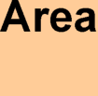
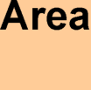
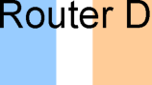
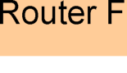
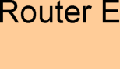
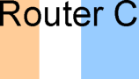
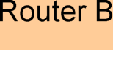
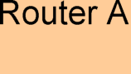
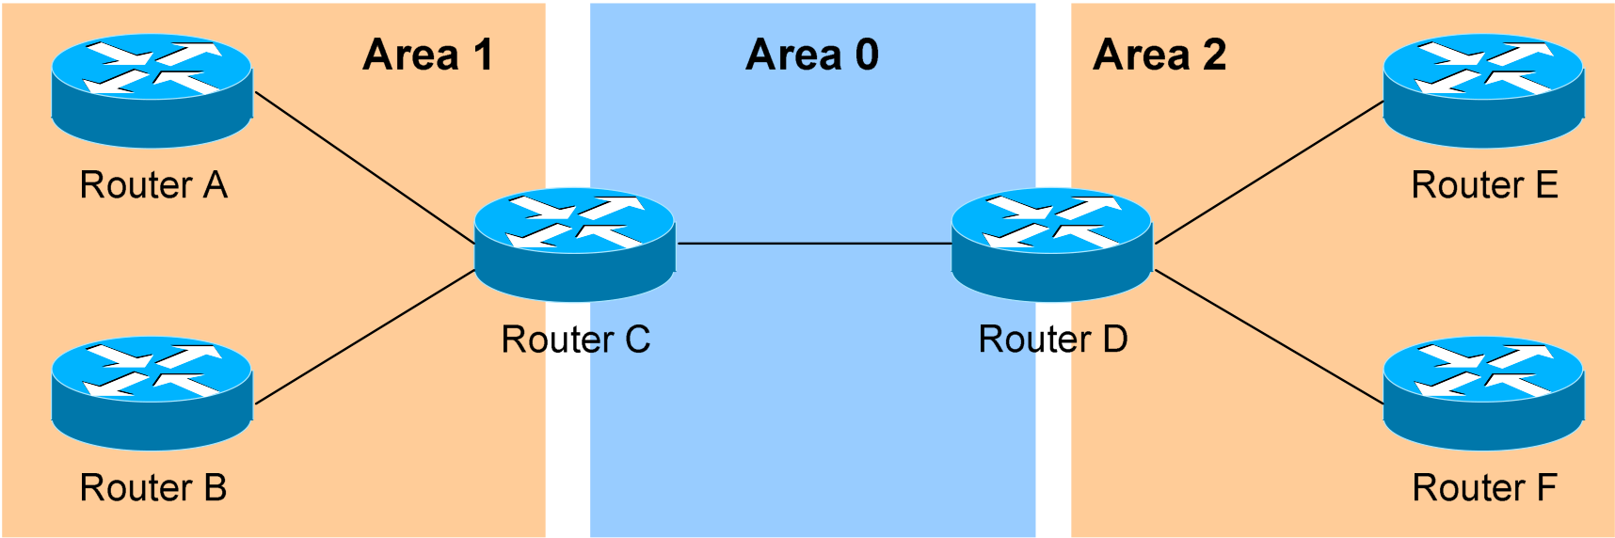
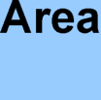
OSPF v1.31 – Aaron Balchunas 9
The OSPF Hierarchy
OSPF is a hierarchical system that separates an Autonomous System into individual areas. OSPF traffic can either be intra-area (within one area), inter-area (between separate areas), or external (from another AS).
OSPF routers build a Topology Database of all links within their area, and all routers within an area will have an identical topology database. Routing updates between these routers will only contain information about links local to their area. Limiting the topology database to include only the local area conserves bandwidth and reduces CPU loads.
Area 0 is required for OSPF to function, and is considered the “Backbone” area. As a rule, all other areas must have a connection into Area 0, though this rule can be bypassed using virtual links (explained shortly). Area 0 is often referred to as the transit area to connect all other areas.
OSPF routers can belong to multiple areas, and will thus contain separate Topology databases for each area. These routers are known as Area Border Routers (ABRs).
Consider the above example. Three areas exist: Area 0, Area 1, and Area 2. Area 0, again, is the backbone area for this Autonomous System. Both Area 1 and Area 2 must directly connect to Area 0.
Routers A and B belong fully to Area 1, while Routers E and F belong fully to Area 2. These are known as Internal Routers.
Router C belongs to both Area 0 and Area 1. Thus, it is an ABR. Because it has an interface in Area 0, it can also be considered a Backbone Router. The same can be said for Router D, as it belongs to both Area 0 and Area 2.
* * *
All original material copyright © 2007 by Aaron Balchunas (aaron@routeralley.com), unless otherwise noted. All other material copyright © of their respective owners.
This material may be copied and used freely, but may not be altered or sold without the expressed written consent of the owner of the above copyright. Updated material may be found at http://www.routeralley.com.

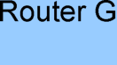
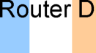
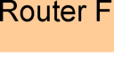
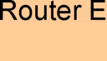
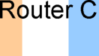
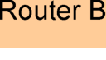
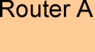
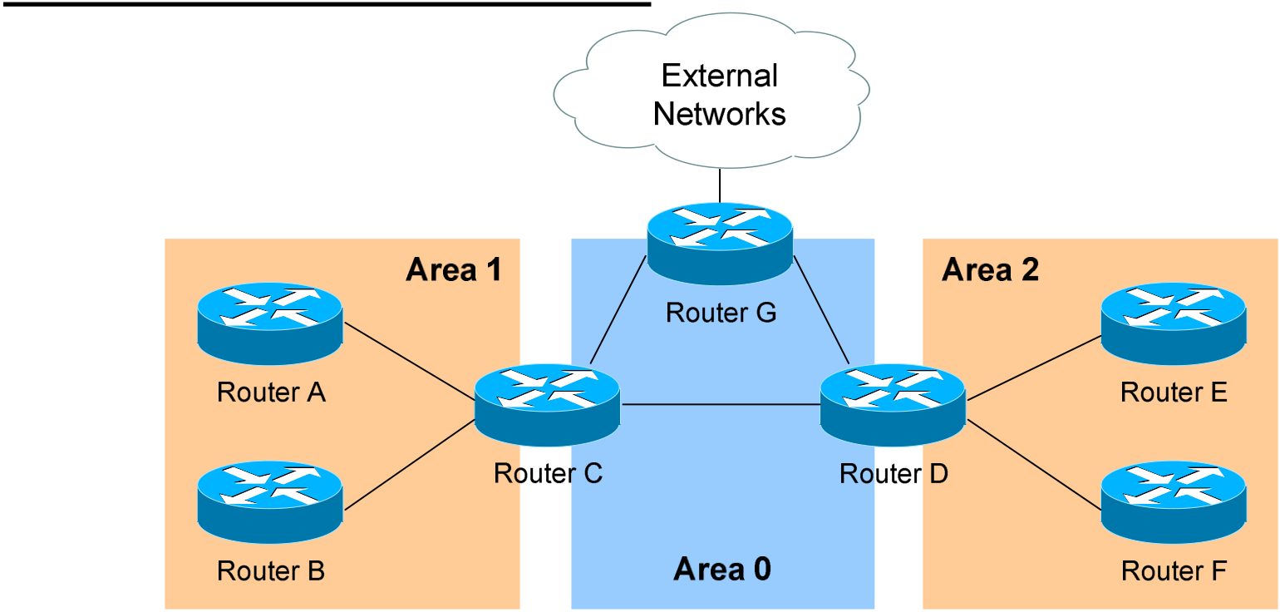
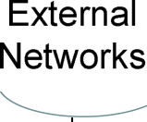
OSPF v1.31 – Aaron Balchunas 10
The OSPF Hierarchy (continued)
Now consider the above example. Router G has been added, which belongs to Area 0. However, Router G also has a connection to the Internet, which is outside this Autonomous System.
This makes Router G an Autonomous System Border Router (ASBR). A router can become an ASBR in one of two ways:
•By connecting to a separate Autonomous System, such as the Internet •By redistributing another routing protocol into the OSPF process.
ASBRs provide access to external networks. OSPF defines two “types” of external routes:
•Type 2 (E2) – Includes only the external cost to the destination network. External cost is the metric being advertised from outside the OSPF domain. This is the default type assigned to external routes. •Type 1 (E1) – Includes both the external cost, and the internal cost to reach the ASBR, to determine the total metric to reach the destination network. Type 1 routes are always preferred over Type 2 routes to the same destination.
Thus, the four separate OSPF router types are as follows:
•Internal Routers – all router interfaces belong to only one Area. •Area Border Routers (ABRs) – contains interfaces in at least two separate areas
•Backbone Routers – contain at least one interface in Area 0 •Autonomous System Border Routers (ASBRs) – contain a connection to a separate Autonomous System
* * *
All original material copyright © 2007 by Aaron Balchunas (aaron@routeralley.com), unless otherwise noted. All other material copyright © of their respective owners.
This material may be copied and used freely, but may not be altered or sold without the expressed written consent of the owner of the above copyright. Updated material may be found at http://www.routeralley.com.

OSPF v1.31 – Aaron Balchunas 11
LSAs and the OSPF Topology Database
OSPF, as a link-state routing protocol, does not rely on routing-by-rumor as RIP and IGRP do.
Instead, OSPF routers keep track of the status of links within their respective areas. A link is simply a router interface. From these lists of links and their respective statuses, the topology database is created. OSPF routers forward link-state advertisements (LSAs) to ensure the topology database is
consistent on each router within an area.
Several LSA types exist:
•Router LSA (Type 1) – Contains a list of all links local to the router, and the status and “cost” of those links. Type 1 LSAs are generated by all routers in OSPF, and are flooded to all other routers within the local area.
•Network LSA (Type 2) – Generated by all Designated Routers in OSPF, and contains a list of all routers attached to the Designated Router.
•Network Summary LSA (Type 3) – Generated by all ABRs in OSPF, and contains a list of all destination networks within an area. Type 3 LSAs are sent between areas to allow inter-area communication to occur.
•ASBR Summary LSA (Type 4) – Generated by ABRs in OSPF, and contains a route to any ASBRs in the OSPF system. Type 4 LSAs are sent from an ABR into its local area, so that Internal routers know how to exit the Autonomous System.
•External LSA (Type 5) – Generated by ASBRs in OSPF, and contain routes to destination networks outside the local Autonomous System. Type 5 LSAs can also take the form of a default route to all networks outside the local AS. Type 5 LSAs are flooded to all areas in the OSPF system.
Multicast OSPF (MOSPF) utilizes a Type 6 LSA, but that goes beyond the scope of this guide.
Later in this section, Type 7 NSSA External LSAs will be described in detail.
* * *
All original material copyright © 2007 by Aaron Balchunas (aaron@routeralley.com), unless otherwise noted. All other material copyright © of their respective owners.
This material may be copied and used freely, but may not be altered or sold without the expressed written consent of the owner of the above copyright. Updated material may be found at http://www.routeralley.com.

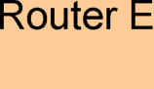
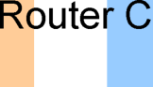
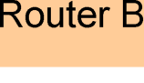
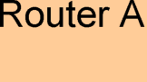
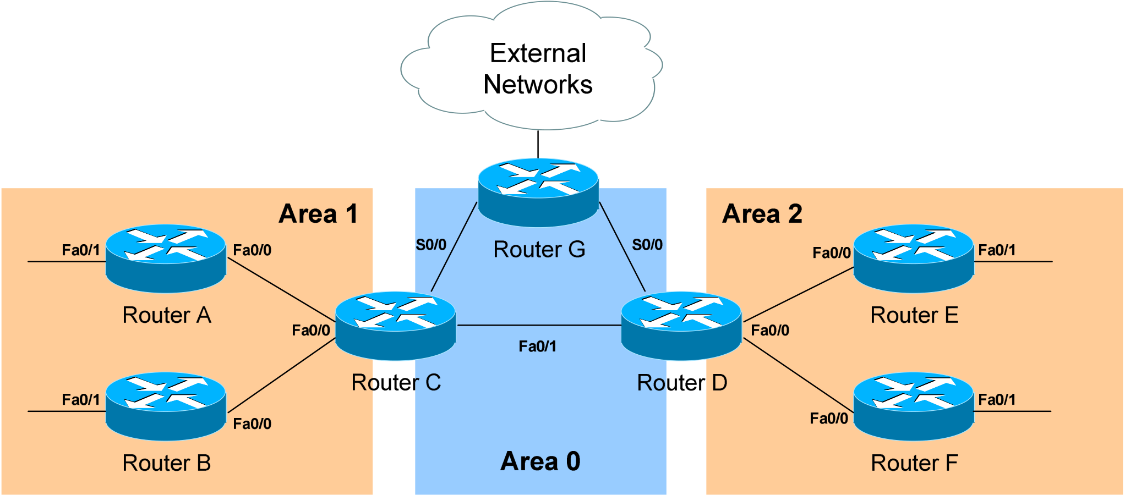
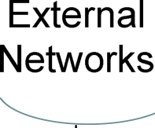
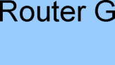
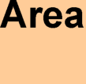
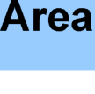
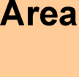
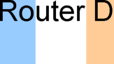
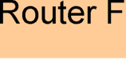
OSPF v1.31 – Aaron Balchunas 12
LSAs and the OSPF Topology Database (continued)
From the above example, the following can be determined: •Routers A, B, E, and F are Internal Routers.
•Routers C and D are ABRs.
•Router G is an ASBR.
All routers will generate Router (Type 1) LSAs. For example, Router A will generate a Type 1 LSA that contains the status of links FastEthernet 0/0 and FastEthernet 0/1. This LSA will be flooded to all other routers in Area 1.
Designated Routers will generate Network (Type 2) LSAs. For example, if Router C was elected the DR for the multi-access network in Area 1, it would generate a Type 2 LSA containing a list of all routers attached to it.
Area Border Routers (ABRs) will generate Network Summary (Type 3) LSAs. For example, Router C is an ABR between Area 0 and Area 1. It will thus send Type 3 LSAs into both areas. Type 3 LSAs sent into Area 0 will contain a list of networks within Area 1, including costs to reach those networks. Type 3 LSAs sent into Area 1 will contain a list of networks within Area 0, and all other areas connected to Area 0. This allows Area 1 to reach any other area, and all other areas to reach Area 1.
* * *
All original material copyright © 2007 by Aaron Balchunas (aaron@routeralley.com), unless otherwise noted. All other material copyright © of their respective owners.
This material may be copied and used freely, but may not be altered or sold without the expressed written consent of the owner of the above copyright. Updated material may be found at http://www.routeralley.com.













OSPF v1.31 – Aaron Balchunas 13
LSAs and the OSPF Topology Database (continued)
ABRs will also generate ASBR Summary (Type 4) LSAs. For example, Router C will send Type 4 LSAs into Area 1 containing a route to the ASBR, thus providing routers in Area 1 with the path out of the
Autonomous System.
ASBRs will generate External (Type 5) LSAs. For example, Router G will generate Type 5 LSAs that contain routes to network outside the AS. These Type 5 LSAs will be flooded to routers of all areas.
Each type of LSA is propagated under three circumstances: •When a new adjacency is formed.
•When a change occurs to the topology table.
•When an LSA reaches its maximum age (every 30 minutes, by default).
Thus, though OSPF is typically recognized to only send updates when a change occurs, LSA’s are still periodically refreshed every 30 minutes.
* * *
All original material copyright © 2007 by Aaron Balchunas (aaron@routeralley.com), unless otherwise noted. All other material copyright © of their respective owners.
This material may be copied and used freely, but may not be altered or sold without the expressed written consent of the owner of the above copyright. Updated material may be found at http://www.routeralley.com.

OSPF v1.31 – Aaron Balchunas 14
The OSPF Metric
OSPF determines the best (or shortest) path to a destination network using a
cost metric, which is based on the bandwidth of interfaces. The total cost of
a route is the sum of all outgoing interface costs. Lowest cost is preferred.
Cisco applies default costs to specific interface types:
Type Cost
Serial (56K) 1785
Serial (64K) 1562
T1 (1.544Mbps) 64
Token Ring (4Mbps) 25
Ethernet (10 Mbps) 10
Token Ring (16 Mbps) 6
Fast Ethernet 1
On Serial interfaces, OSPF will use the configured bandwidth (measured in
Kbps) to determine the cost:
Router(config)# interface s0
Router(config-if)# bandwidth 64
The default cost of an interface can be superseded:
Router(config)# interface e0
Router(config-if)# ip ospf cost 5
Changing the cost of an interface can alter which path OSPF deems the
“shortest,” and thus should be used with great care.
To alter how OSPF calculates its default metrics for interfaces:
Router(config)# router ospf 1
Router(config-router)# ospf auto-cost reference-bandwidth 100
The above ospf auto-cost command has a value of 100 configured, which is
actually the default. This indicates that a 100Mbps link will have a cost of 1
(because 100/100 is 1). All other costs are based off of this. For example, the
cost of 4 Mbps Token Ring is 25 because 100/4 = 25.
* * *
All original material copyright © 2007 by Aaron Balchunas (aaron@routeralley.com),
unless otherwise noted. All other material copyright © of their respective owners.
This material may be copied and used freely, but may not be altered or sold without the expressed written
consent of the owner of the above copyright. Updated material may be found at http://www.routeralley.com.

OSPF v1.31 – Aaron Balchunas 15
Configuring Basic OSPF
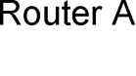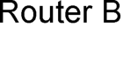
Routing protocol configuration occurs in Global Configuration mode. On Router A, to configure OSPF:
RouterA(config)# router ospf 1
RouterA(config-router)# router-id 1.1.1.1
RouterA(config-router)# network 172.16.0.0 0.0.255.255 area 1 RouterA(config-router)# network 172.17.0.0 0.0.255.255 area 0
The first command, router ospf 1, enables the OSPF process. The “1”indicates the OSPF process ID, and can be unique on each router. The process ID allows multiple OSPF processes to run on the same router. The router-id command assigns a unique OSPF ID of 1.1.1.1 for this router.
Note the use of a wildcard mask instead of a subnet mask in the network statement. With OSPF, we’re not telling the router what networks to advertise; we’re telling the router to place certain interfaces into specific areas, so those routers can form neighbor relationships. The wildcard mask 0.0.255.255 tells us that the last two octets can match any number.
The first network statement places interface E0 on Router A into Area 1. Likewise, the second network statement places interface S0 on Router A into Area 0. The network statement could have been written more specifically:
RouterA(config)# router ospf 1
RouterA(config-router)# network 172.16.1.2 0.0.0.0 area 1 RouterA(config-router)# network 172.17.1.1 0.0.0.0 area 0
In order for Router B to form a neighbor relationship with Router A, its connecting interface must be put in the same Area as Router A:
RouterB(config)# router ospf 1
RouterA(config-router)# router-id 2.2.2.2
RouterB(config-router)# network 172.17.1.2 0.0.0.0 area 0 RouterB(config-router)# network 172.18.1.1 0.0.0.0 area 2
If Router B’s S0 interface was placed in a different area than Router A’s S0 interface, the two routers would never form a neighbor relationship, and never share routing updates.
* * *
All original material copyright © 2007 by Aaron Balchunas (aaron@routeralley.com), unless otherwise noted. All other material copyright © of their respective owners.
This material may be copied and used freely, but may not be altered or sold without the expressed written consent of the owner of the above copyright. Updated material may be found at http://www.routeralley.com.

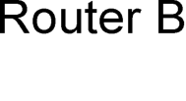
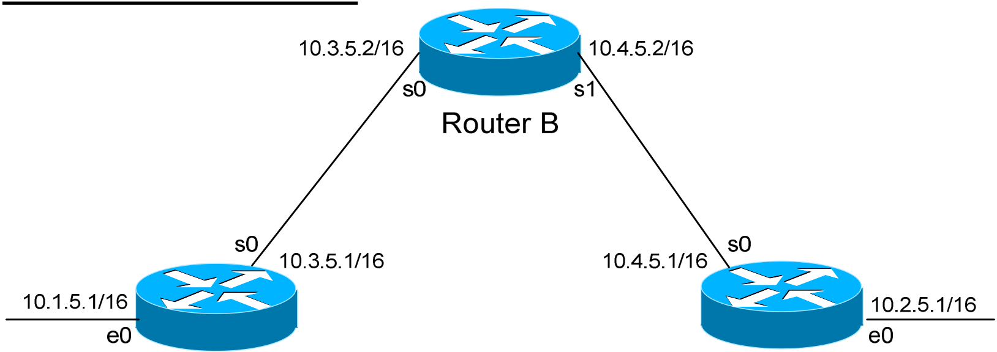
OSPF v1.31 – Aaron Balchunas 16
OSPF Passive-Interfaces
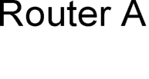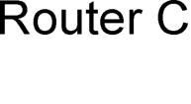
It is possible to control which router interfaces will participate in the OSPF process. Just as with EIGRP and RIP, we can use the passive-interface command.
However, please note that the passive-interface command works differently with OSPF than with RIP or IGRP. OSPF will no longer form neighbor relationships out of a “passive” interface, thus this command prevents updates from being sent or received out of this interface:
RouterC(config)# router ospf 1
RouterC(config-router)# network 10.4.0.0 0.0.255.255 area 0 RouterC(config-router)# network 10.2.0.0 0.0.255.255 area 0 RouterC(config-router)# passive-interface s0
Router C will not form a neighbor adjacency with Router B.
It is possible to configure all interfaces to be passive using the passive-interface default command, and then individually use the no passive-interface command on the interfaces that neighbors should be formed on:
RouterC(config)# router ospf 1
RouterC(config-router)# network 10.4.0.0 0.0.255.255 area 0 RouterC(config-router)# network 10.2.0.0 0.0.255.255 area 0 RouterC(config-router)# passive-interface default
RouterC(config-router)# nopassive-interface e0
Always remember, that the passive-interface command will prevent OSPF (and EIGRP) from forming neighbor relationships out of that interface. No routing updates are passed in either direction.
* * *
All original material copyright © 2007 by Aaron Balchunas (aaron@routeralley.com), unless otherwise noted. All other material copyright © of their respective owners.
This material may be copied and used freely, but may not be altered or sold without the expressed written consent of the owner of the above copyright. Updated material may be found at http://www.routeralley.com.

OSPF v1.31 – Aaron Balchunas 17
OSPF Authentication
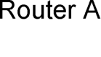
OSPF supports authentication to secure routing updates. However, OSPF authentication is configured differently than RIP or EIGRP authentication.
Two forms of OSPF authentication exist, using either clear-text or an MD5 hash. To configure clear-text authentication, the first step is to enable authentication for the area, under the OSPF routing process:
RouterA(config)# router ospf 1
RouterA(config-router)# network 172.17.0.0 0.0.255.255 area 0 RouterA(config-router)# area 0 authentication
Then, the authentication key must be configured on the interface:
RouterA(config)# interface s0
RouterA(config-if)# ip ospf authentication
RouterA(config-if)# ip ospf authentication-key MYKEY
To configure MD5-hashed authentication, the first step is also to enable authentication for the area under the OSPF process:
RouterA(config)# router ospf 1
RouterA(config-router)# network 172.17.0.0 0.0.255.255 area 0 RouterA(config-router)# area 0 authentication message-digest
Notice the additional parameter message-digest included with the area 0 authentication command. Next, the hashed authentication key must be configured on the interface:
RouterA(config)# interface s0
RouterA(config-router)# ip ospf message-digest-key 10 md5 MYKEY
Area authentication must be enabled on all routers in the area, and the form of authentication must be identical (clear-text or MD5). The authentication keys do not need to be the same on every router in the OSPF area, but must be the same on interfaces connecting two neighbors.
Please note: if authentication is enabled for Area 0, the same authentication must be configured on Virtual Links, as they are “extensions” of Area 0.
* * *
All original material copyright © 2007 by Aaron Balchunas (aaron@routeralley.com), unless otherwise noted. All other material copyright © of their respective owners.
This material may be copied and used freely, but may not be altered or sold without the expressed written consent of the owner of the above copyright. Updated material may be found at http://www.routeralley.com.

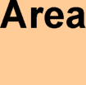
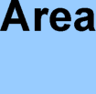
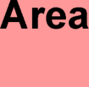
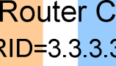
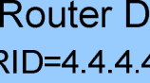
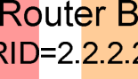
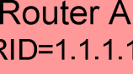
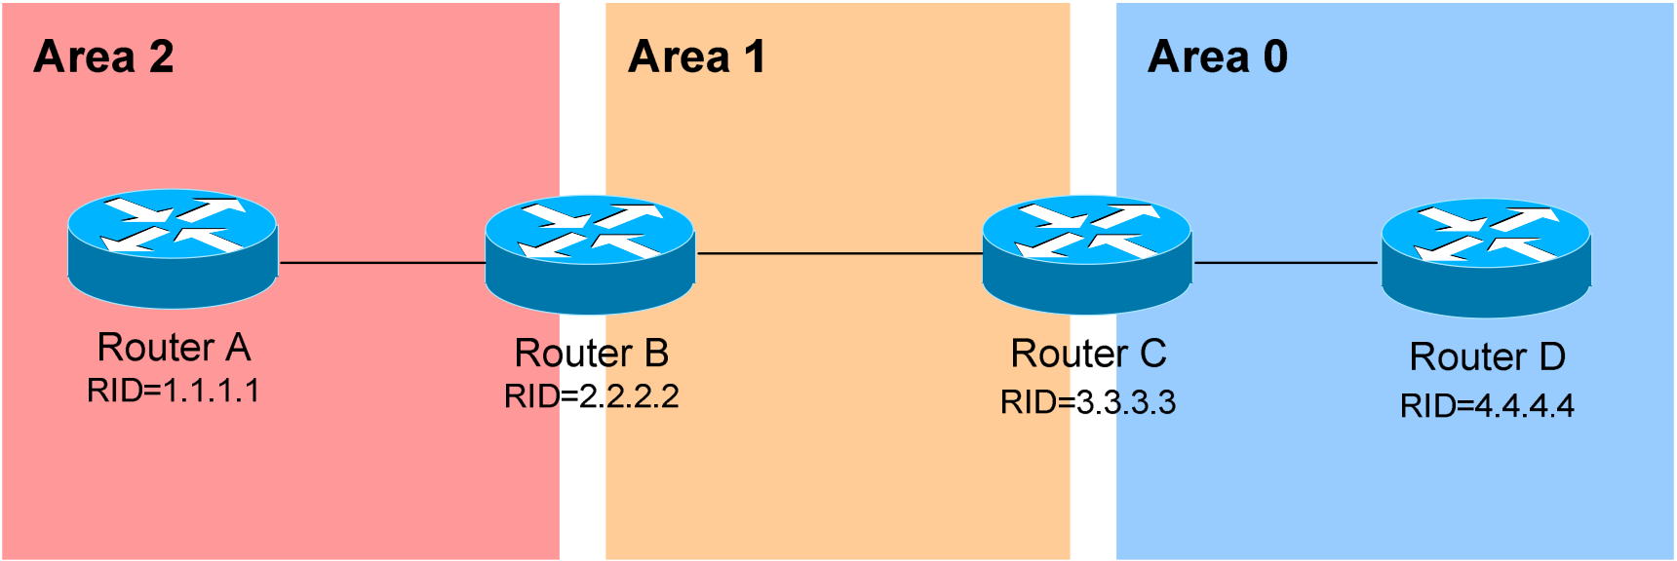
OSPF v1.31 – Aaron Balchunas 18
OSPF Virtual Links
Earlier in this guide, it was stated that all areas must directly connect into Area 0, as a rule. In the above example, Area 2 has no direct connection to Area 0, but must transit through Area 1 to reach the backbone area. In normal OSPF operation, this shouldn’t be possible.
There may be certain circumstances that may prevent an area from directly connecting into Area 0. Virtual links can be used as a workaround, to logically connect separated areas to Area 0. In the above example, a virtual link would essentially create a tunnel from Area 2 to Area 0, using Area 1 a transitarea. One end of the Virtual Link must be connected to Area 0.
Configuration occurs on the Area Border Routers (ABRs) connecting Area 1 to Area 2 (Router B), and Area 1 to Area 0 (Router C). Configuration on Router B would be as follows:
RouterB(config)# router ospf 1
RouterB(config-router)# router-id 2.2.2.2
RouterB(config-router)# area 1 virtual-link 3.3.3.3
The first command enables the ospf process. The second command manually sets the router-id for Router B to 2.2.2.2.
The third command actually creates the virtual-link. Notice that it specifies area 1, which is the transit area. Finally, the command points to the remote ABR’s Router ID of 3.3.3.3.
Configuration on Router C would be as follows:
RouterC(config)# router ospf 1
RouterC(config-router)# router-id 3.3.3.3
RouterC(config-router)# area 1 virtual-link 2.2.2.2
* * *
All original material copyright © 2007 by Aaron Balchunas (aaron@routeralley.com), unless otherwise noted. All other material copyright © of their respective owners.
This material may be copied and used freely, but may not be altered or sold without the expressed written consent of the owner of the above copyright. Updated material may be found at http://www.routeralley.com.

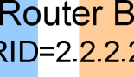
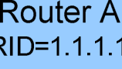
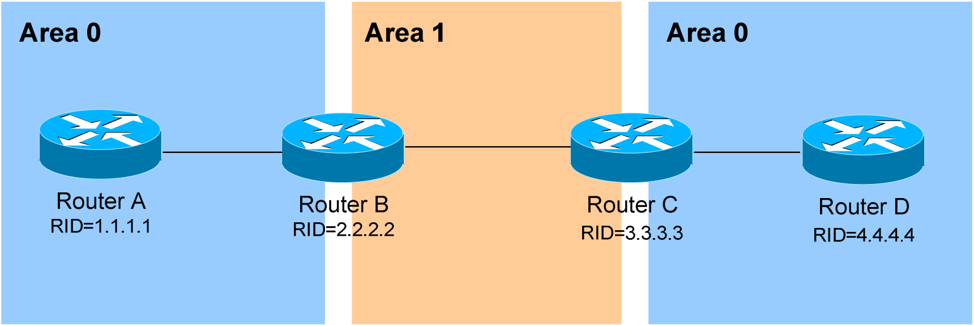





OSPF v1.31 – Aaron Balchunas 19
OSPF Virtual Links (continued)
It is also possible to have two separated (or discontiguous) Area 0’s. In order for OSPF to function properly, the two Area 0’s must be connected using a virtual link.
Again, configuration occurs on the transit area’s ABRs:
RouterB(config)# router ospf 1
RouterB(config-router)# router-id 2.2.2.2
RouterB(config-router)# area 1 virtual-link 3.3.3.3
RouterC(config)# router ospf 1
RouterC(config-router)# router-id 3.3.3.3
RouterC(config-router)# area 1 virtual-link 2.2.2.2
Always remember: the area specified in the virtual-link command is the transitarea. Additionally, the transit area cannotbe a stub area.
As stated earlier, if authentication is enabled for Area 0, the same
authentication must be configured on Virtual Links, as they are “extensions” of Area 0:
RouterB(config)# router ospf 1
RouterB(config-router)# area 1 virtual-link 3.3.3.3 message-digest-key 1 md5 MYKEY
RouterC(config)# router ospf 1
RouterC(config-router)# area 1 virtual-link 2.2.2.2 message-digest-key 1 md5 MYKEY
* * *
All original material copyright © 2007 by Aaron Balchunas (aaron@routeralley.com), unless otherwise noted. All other material copyright © of their respective owners.
This material may be copied and used freely, but may not be altered or sold without the expressed written consent of the owner of the above copyright. Updated material may be found at http://www.routeralley.com.

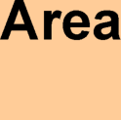
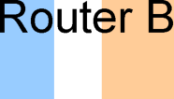
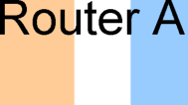
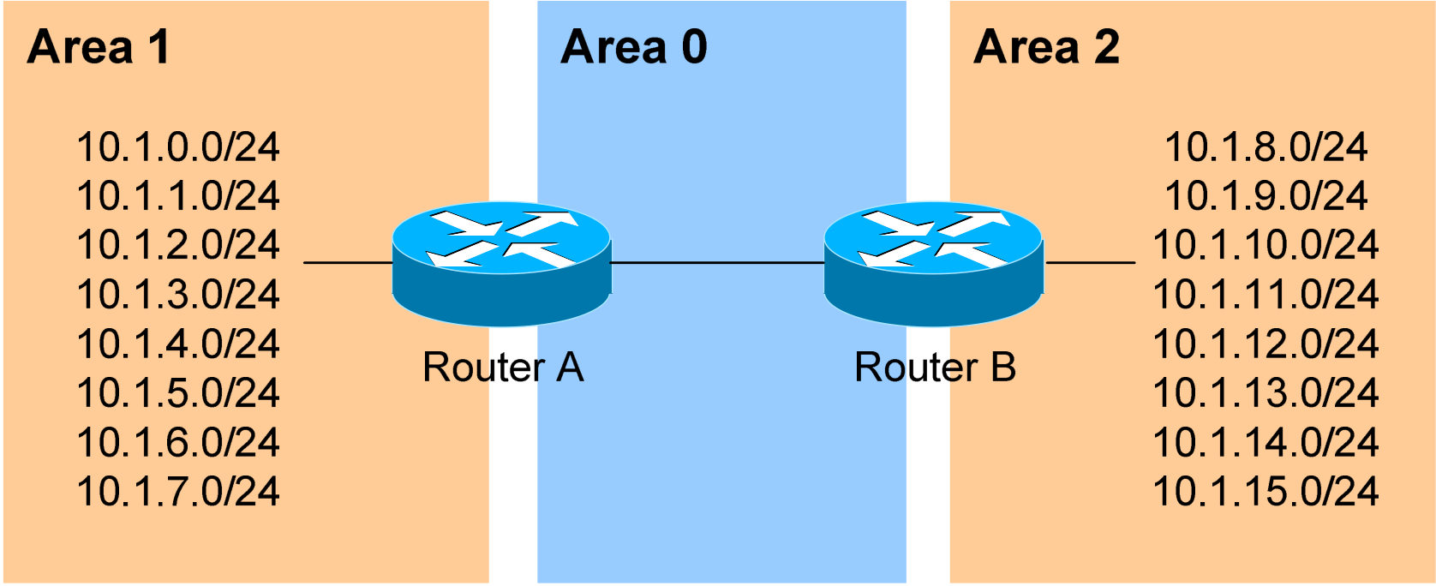
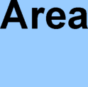
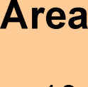
OSPF v1.31 – Aaron Balchunas 20
Inter-Area OSPF Summarization
Consider the above example. OSPF is a classless routing protocol, thus all of the listed networks would be advertised individually. This increases the size of the topology databases and routing tables on routers in the domain, and may be undesirable. Advertising only a summary route for inter-area
communication can reduce the load on router CPUs.
For example, all of the networks in Area 1 can be summarized as
10.1.0.0/21. Similarly, all of the networks in Area 2 can be summarized as 10.1.8.0/21.
Inter-area summarization is configured on Area Border Routers (ABRs). Configuration on Router A would be as follows:
RouterA(config)# router ospf 1
RouterA(config-router)# network 10.1.0.0 0.0.7.255 area 1 RouterA(config-router)# area 1 range 10.1.0.0 255.255.248.0
The network statement includes all of the 10.1.x.0 networks into Area 1. The area 1 range command creates a summary route for those networks, which is then advertised into Area 0, as opposed to each route individually.
Proper design dictates that a static route be created for the summarized network, pointing to the Null interface. This sends any traffic destined specifically to the summarized address to the bit-bucket in the sky, in order to prevent routing loops:
RouterA(config)# ip route 10.1.0.0 255.255.248.0 null0
In IOS versions 12.1(6) and later, this static route is created automatically.
* * *
All original material copyright © 2007 by Aaron Balchunas (aaron@routeralley.com), unless otherwise noted. All other material copyright © of their respective owners.
This material may be copied and used freely, but may not be altered or sold without the expressed written consent of the owner of the above copyright. Updated material may be found at http://www.routeralley.com.

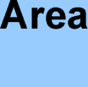
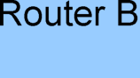
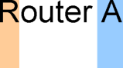

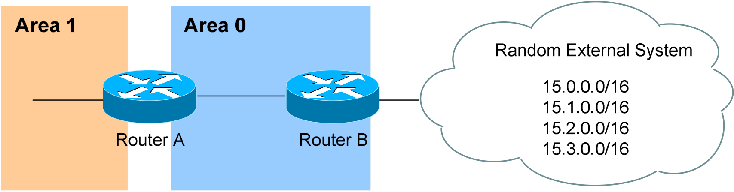
OSPF v1.31 – Aaron Balchunas 21
External OSPF Summarization
Consider the above example. Router B is an Autonomous System Border Router (ASBR). It is possible to redistribute the four “external” networks into the OSPF system. However, a separate route for each network will be advertised.
Again, this is wasteful. The four external networks can be summarized as 15.0.0.0/14.
External Summarization is configured on ASBRs, and will only
summarize external routes learned by route redistribution. Configuration on Router B would be as follows:
RouterB(config)# router ospf 1
RouterB(config-router)# summary-address 15.0.0.0 255.252.0.0
This summarized route is now propagated to all routers in every OSPF area.
Summarization can be used to filter certain routes (true route filtering is covered in a separate guide). To force OSPF to advertise the 15.0.0.0 and 15.1.0.0 networks as a summarized route, but not advertise the 15.2.0.0 and 15.3.0.0 prefixes:
RouterB(config)# router ospf 1
RouterB(config-router)# summary-address 15.0.0.0 255.254.0.0
RouterB(config-router)# summary-address 15.2.0.0 255.255.0.0 not-advertise RouterB(config-router)# summary-address 15.3.0.0 255.255.0.0 not-advertise
The first summary-address command summarizes the 15.0.0.0/16 and 15.1.0.0/16 networks to 15.0.0.0/15, and advertises the summary as normal in the OSPF domain. The next two summary-address commands specifically reference the 15.2.0.0/16 and 15.3.0.0/16 networks, with the not-advertise parameter. As implied, these networks will not be advertised in OSPF.
* * *
All original material copyright © 2007 by Aaron Balchunas (aaron@routeralley.com), unless otherwise noted. All other material copyright © of their respective owners.
This material may be copied and used freely, but may not be altered or sold without the expressed written consent of the owner of the above copyright. Updated material may be found at http://www.routeralley.com.

OSPF v1.31 – Aaron Balchunas 22
OSPF Area Types
In order to control the propagation of LSAs in the OSPF domain, several area types were developed.
Standard Area – A “normal” OSPF area.
•Routers within a standard area will share Router (Type 1) and Network (Type 2) LSAs to build their topology tables. Once fully synchronized, routers within an area will all have identical
topology tables.
•Standard areas will accept Network Summary (Type 3) LSAs, which contain the routes to reach networks in all other areas.
•Standard areas will accept ASBR Summary (Type 4) and External (Type 5) LSAs, which contain the route to the ASBR and routes to external networks, respectively.
Configuration of standard areas is straight forward:
Router(config)# router ospf 1
Router(config-router)# network 10.1.0.0 0.0.7.255 area 1
Stub Area – Prevents external routes from flooding into an area.
•Like Standard areas, Stub area routers will share Type 1 and Type 2 LSAs to build their topology tables.
•Stub areas will also accept Type 3 LSAs to reach other areas. •Stub areas will not acceptType 4 or Type 5 LSAs, detailing routes to external networks.
The purpose of Stub areas is to limit the number of LSAs flooded into the area, to conserve bandwidth and router CPUs. The Stub’s ABR will
automatically inject a default route into the Stub area, so that those routers can reach the external networks. The ABR will be the next-hop for the default route.
Configuration of stub areas is relatively simple:
Router(config)# router ospf 1
Router(config-router)# network 10.1.0.0 0.0.7.255 area 1 Router(config-router)# area 1 stub
The area 1 stub command must be configured on all routers in the Stub area. No ASBRs are allowed in a Stub area.
* * *
All original material copyright © 2007 by Aaron Balchunas (aaron@routeralley.com), unless otherwise noted. All other material copyright © of their respective owners.
This material may be copied and used freely, but may not be altered or sold without the expressed written consent of the owner of the above copyright. Updated material may be found at http://www.routeralley.com.

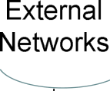
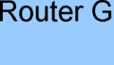
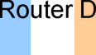
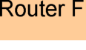
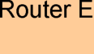
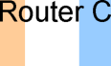
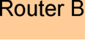
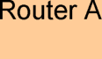
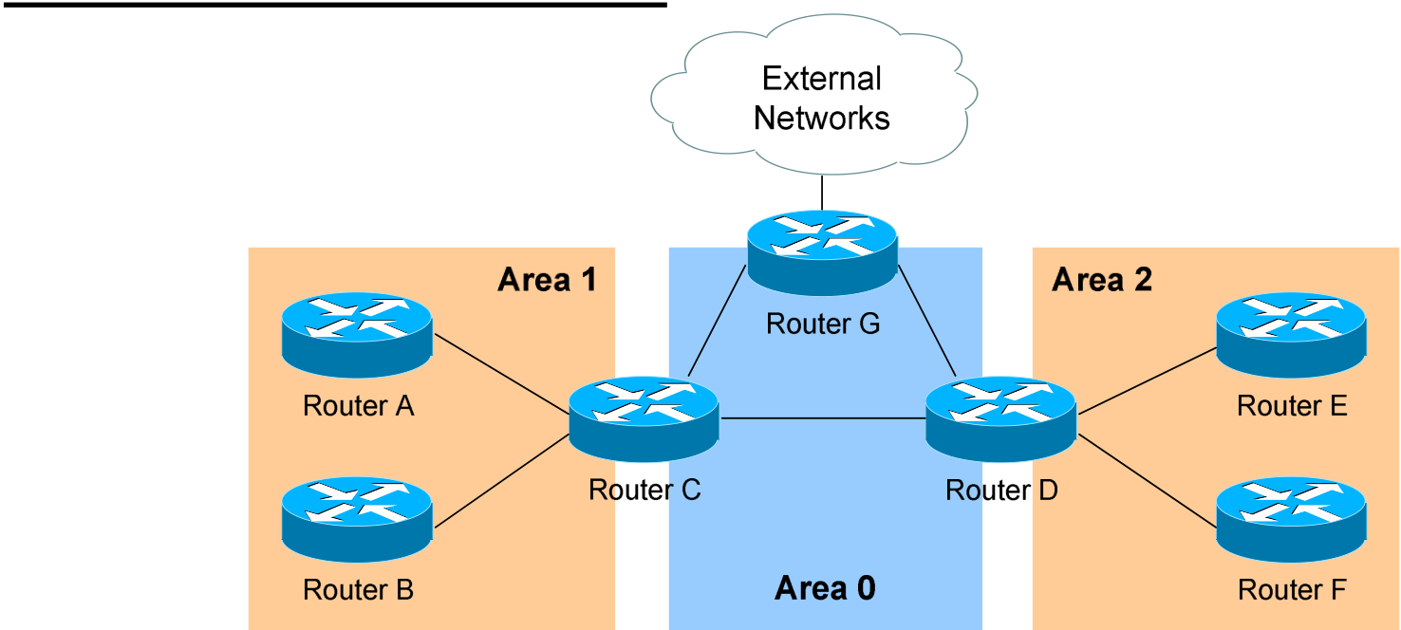
OSPF v1.31 – Aaron Balchunas 23
OSPF Area Types (continued)
Totally Stubby Area – Prevents both inter-area and external routes from flooding into an area.
•Like Standard and Stub areas, Totally Stubby area routers will share Type 1 and Type 2 LSAs to build their topology tables.
•Totally Stubby areas will not accept Type 3 LSAs to other areas. •Totally Stubby areas will also not acceptType 4 or Type 5 LSAs, detailing routes to external networks.
Again, the purpose of Totally Stubby areas is to limit the number of LSAs flooded into the area, to conserve bandwidth and router CPUs. The Stub’s ABR will instead automatically inject a default route into the Totally Stubby area, so that those routers can reach both inter-area networks and external networks. The ABR will be the next-hop for the default route.
Configuration of totally stubby areas is relatively simple:
Router(config)# router ospf 1
Router(config-router)# network 10.1.0.0 0.0.7.255 area 1 Router(config-router)# area 1 stub no-summary
The area 1 stub no-summary command is configured only on the ABR of the Totally Stubby area; other routers within the area are configured with the area 1 stub command. No ASBRs are allowed in a Totally Stubby area.
In the above example, if we were to configure Area 1 as a Totally Stubby area, it would not accept any external routes originating from the ASBR (Router G). It also would not accept any Type 3 LSAs containing route information about Area 0 and Area 2. Instead, Router C (the ABR) will inject a default route into Area 1, and all routers within Area 1 will use Router C as their gateway to all other networks.
* * *
All original material copyright © 2007 by Aaron Balchunas (aaron@routeralley.com), unless otherwise noted. All other material copyright © of their respective owners.
This material may be copied and used freely, but may not be altered or sold without the expressed written consent of the owner of the above copyright. Updated material may be found at http://www.routeralley.com.

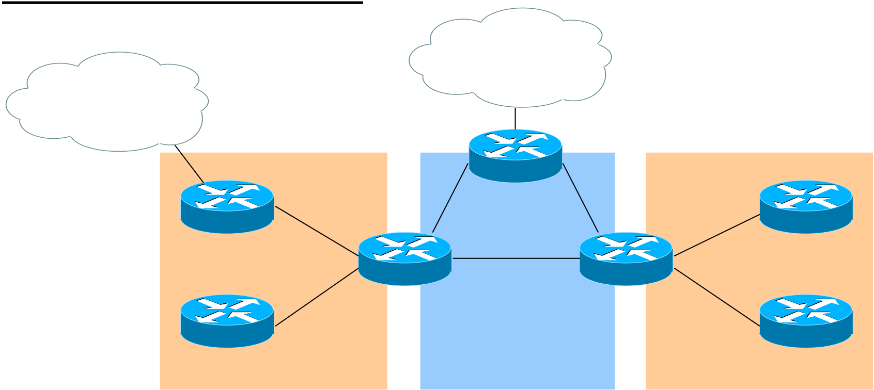
OSPF v1.31 – Aaron Balchunas 24
OSPF Area Types (continued)
External
More External | Networks
Networks
Area 1 Area 2
Router G
Router A | Router C | Area 0 | Router D | Router E
Router B |  |  |  | Router F
Not So Stubby Area (NSSA) – Similar to a Stub area; prevents external routes from flooding into an area, unless those external routes originated from an ASBR within the NSSA area.
•Like Standard and Stub areas, NSSA area routers will share Type 1 and Type 2 LSAs to build their topology tables.
•NSSA areas will also accept Network Summary (Type 3) LSAs, which contain the routes to reach networks in all other areas.
•NSSA areas will not acceptType 4 or Type 5 LSAs, detailing routes to external networks.
•If an ASBR exists within the NSSA area, that ASBR will generate Type 7 LSAs.
Again, NSSA areas are almost identical to Stub areas. If Area 1 was configured as an NSSA, it would not accept any external routes originating from Router G (an ASBR outside Area 1).
However, Area 1 also has an ASBR within the area (Router A). Those external routes will be flooded into Area 1 as Type 7 LSAs. These external routes will not be forwarded to other areas as Type 7 LSAs; instead, they will be converted into Type 5 LSAs by Area 1’s ABR (Router C).
Configuration of NSSA areas is relatively simple:
Router(config)# router ospf 1
Router(config-router)# network 10.1.0.0 0.0.7.255 area 1 Router(config-router)# area 1 nssa
The area 1 nssa command must be applied to all routers in the NSSA area.
* * *
All original material copyright © 2007 by Aaron Balchunas (aaron@routeralley.com), unless otherwise noted. All other material copyright © of their respective owners.
This material may be copied and used freely, but may not be altered or sold without the expressed written consent of the owner of the above copyright. Updated material may be found at http://www.routeralley.com.


OSPF v1.31 – Aaron Balchunas 25
OSPF Area Types (continued)
External
More External | Networks
Networks
Area 1 Area 2
Router G
Router A | Router C | Area 0 | Router D | Router E
Router B |  |  |  | Router F
Totally Not So Stubby Area (TNSSA) – Similar to a Totally Stubby area; prevents both inter-area and external routes from flooding into an area, unless those external routes originated from an ASBR within the NSSA area.
•Like Standard and Stub areas, TNSSA area routers will share Type 1 and Type 2 LSAs to build their topology tables.
•TNSSA areas will not accept Type 3 LSAs to other areas.
•TNSSA areas will not acceptType 4 or Type 5 LSAs, detailing routes to external networks.
•If an ASBR exists within the TNSSA area, that ASBR will generate Type 7 LSAs.
With the exception of not accepting inter-area routes, TNSSA areas are identical in function to NSSA areas.
Configuration of TNSSA areas is relatively simple:
Router(config)# router ospf 1
Router(config-router)# network 10.1.0.0 0.0.7.255 area 1 Router(config-router)# area 1 nssa no-summary
The area 1 nssa no-summary command is configured only on the ABR of the TNSSA area; other routers within the area are configured with the area 1 nssa command.
* * *
All original material copyright © 2007 by Aaron Balchunas (aaron@routeralley.com), unless otherwise noted. All other material copyright © of their respective owners.
This material may be copied and used freely, but may not be altered or sold without the expressed written consent of the owner of the above copyright. Updated material may be found at http://www.routeralley.com.

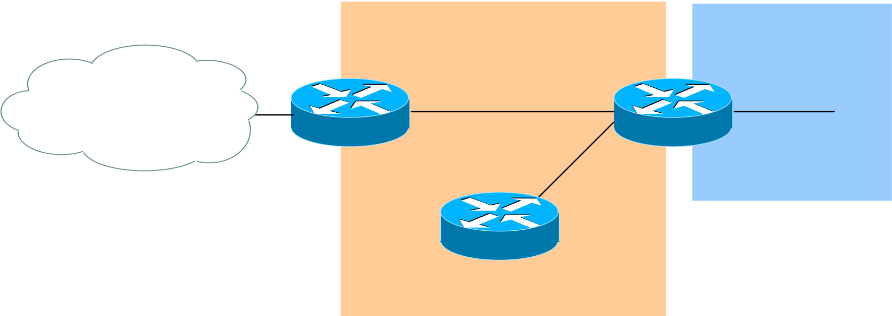
OSPF v1.31 – Aaron Balchunas 26
OSPF and Default Routes
We have learned about four types of OSPF areas:
•Standard areas •Totally Stubby areas
•Stub areas •Not So Stubby areas (NSSA)
The ABRs and ASBRs of Standard areasdo not automatically generate (or inject) default routes into the area. Consider the following example:
Area 1 Area 0
External
Networks
Router A Router C
Router B
Assume that Area 1 is configured as a Standard area. Router C will forward Type 3 LSAs from all other areas into Area 1, allowing Router A and Router B to reach inter-area networks.
Notice also that Router A is an ASBR, connecting to an external
Autonomous System. Thus, Router A will generate Type 5 LSAs, detailing the routes to these external networks.
To additionally force Router A to generate a default route (indicating itself as the next hop) for the external networks, and inject this into Area 1. This default route will be advertised as a Type 5 LSA to all other areas:
RouterA(config)# router ospf 1
RouterA(config-router)# default-information originate
Router A must have a default route in its routing table in order for the above command to function. Router A’s default route would point to some
upstream router in the external Autonomous System.
If a default route does not exist in its routing table, Router A can still be forced to advertise a default route using the always parameter:
RouterA(config)# router ospf 1
RouterA(config-router)# default-information originate always
* * *
All original material copyright © 2007 by Aaron Balchunas (aaron@routeralley.com), unless otherwise noted. All other material copyright © of their respective owners.
This material may be copied and used freely, but may not be altered or sold without the expressed written consent of the owner of the above copyright. Updated material may be found at http://www.routeralley.com.

OSPF v1.31 – Aaron Balchunas 27
OSPF and Default Routes (continued)
The ABRs of Stuband Totally Stubby areas automatically generate (and inject) a default route (0.0.0.0/0) into the area. Routers in Stub areas use this default route to reach external networks, while routers in Totally Stubby areas use the default route to reach both inter-area and external networks.
To control the “cost” metric of the default route in Stub or Totally Stubby areas (configured on the ABR):
Router(config)# router ospf 1
Router(config-router)# area 1 stub
Router(config-router)# area 1 default-cost 10
The ABRs of NSSA areas must be manually configured to generate (and inject) a default route into the area:
Router(config)# router ospf 1
Router(config-router)# area 1 nssa default-information-originate
Additionally, the ASBR of an NSSA area can generate and inject a default route. This default route will be advertised as a Type 7 LSA, as Type 5 LSA’s are not allowed in NSSAs. The command is no different than injecting a default route from an NSSA ABR:
Router(config)# router ospf 1
Router(config-router)# area 1 nssa default-information-originate
Reference: (http://www.cisco.com/en/US/tech/tk365/technologies_tech_note09186a0080094a74.shtml)
* * *
All original material copyright © 2007 by Aaron Balchunas (aaron@routeralley.com), unless otherwise noted. All other material copyright © of their respective owners.
This material may be copied and used freely, but may not be altered or sold without the expressed written consent of the owner of the above copyright. Updated material may be found at http://www.routeralley.com.

OSPF v1.31 – Aaron Balchunas 28
OSPF SPF Timers
To adjust the SPF timers in OSPF:
Router(config)# router ospf 1
Router(config-router)# timers spf 10 15
The timers spf command includes two parameters, measured in seconds. The first (10) indicates the SPF-Delay, or how long the OSPF should wait after receiving a topology change to recalculate the shortest path. The second (15) indicates the SPF-Holdtime, or how long OSPF should wait in between separate SPF calculations.
The timers spf command has actually become deprecated. It has been replaced with:
Router(config)# router ospf 1
Router(config-router)# timers throttle spf 5 10000 80000
The timers throttle spf command includes three parameters, measure in milliseconds. The first (5) indicates how long OSPF should wait after receiving a topology change to recalculate the shortest path. The second (10000) indicates the hold-down time, or how long OSPF should wait in between separate SPF calculations. If OSPF receives another topology change during the hold-time interval, it will continue to double the hold-time interval until it reaches the maximum hold-time (80000).
The purpose of the both SPF timer commands is to prevent OSPF from constantly converging, if the network links are “flapping.” The timers spf and timers throttle spf commands cannot be used together.
* * *
All original material copyright © 2007 by Aaron Balchunas (aaron@routeralley.com), unless otherwise noted. All other material copyright © of their respective owners.
This material may be copied and used freely, but may not be altered or sold without the expressed written consent of the owner of the above copyright. Updated material may be found at http://www.routeralley.com.

OSPF v1.31 – Aaron Balchunas 29
Advanced OSPF Configuration
To force the OSPF process to ignore OSPF Multicast (Type 6) LSAs:
Router(config)# router ospf 1
Router(config-router)# ignore lsa mospf
To force an interface to filter all outgoing OSPF LSA’s:
Router(config)# interface e0
Router(config-if)# ip ospf database-filter all out
Loopback interfaces are treated differently than other interfaces, when advertised in OSPF. OSPF will advertise a loopback interface as a specific “host” route (with a mask of /32 or 255.255.255.255). To force OSPF to advertise a loopback interface with its proper subnet mask:
Router(config)# interface loopback0
Router(config-if)# ip address 10.50.5.1 255.255.255.0 Router(config-if)# ip ospf network point-to-point
* * *
All original material copyright © 2007 by Aaron Balchunas (aaron@routeralley.com), unless otherwise noted. All other material copyright © of their respective owners.
This material may be copied and used freely, but may not be altered or sold without the expressed written consent of the owner of the above copyright. Updated material may be found at http://www.routeralley.com.

OSPF v1.31 – Aaron Balchunas 30
Troubleshooting OSPF
To view the OSPF Neighbor Table:
Router# show ip ospf neighbor
Neighbor ID Pri State Dead Time Address Interface
7.7.7.7 1 FULL/ - 00:00:36 150.50.17.2 Serial0
6.6.6.6 1 FULL/DR 00:00:11 150.50.18.1 Ethernet0
The Neighbor Table provides the following information about each
neighbor:
•The Router ID of the remote neighbor.
•The OSPF priority of the remote neighbor (used for DR/BDR
elections).
•The current neighbor state.
•The dead interval timer.
•The connecting IP addressof the remote neighbor.
•The local interface connecting to the remote neighbor.
To view the OSPF topology table:
Router# show ip ospf database
OSPF Router with ID (9.9.9.9) (Process ID 10)
Router Link States (Area 0)
Link ID | ADV Router Age Seq# | Checksum Link count
7.7.7.7 7.7.7.7 329 0x80000007 0x42A0 2
8.8.8.8 | 8.8.8.8 | 291 0x80000007 0x9FFC 1
Summary Net Link States (Area 0)
Link ID | ADV Router Age Seq# | Checksum
192.168.12.0 7.7.7.7 103 0x80000005 0x13E4
192.168.34.0 7.7.7.7 105 0x80000003 0x345A
The Topology Table provides the following information:
•The actual link (or route).
•The advertising Router ID.
•The link-state age timer.
•The sequence number and checksum for each entry.
(Reference: http://www.cisco.com/en/US/products/sw/iosswrel/ps5187/products_command_reference_chapter09186a008017d02e.html)
* * *
All original material copyright © 2007 by Aaron Balchunas (aaron@routeralley.com),
unless otherwise noted. All other material copyright © of their respective owners.
This material may be copied and used freely, but may not be altered or sold without the expressed written
consent of the owner of the above copyright. Updated material may be found at http://www.routeralley.com.

OSPF v1.31 – Aaron Balchunas 31
Troubleshooting OSPF (continued)
To view the specific information about an OSPF process:
Router# show ip ospf 1
Routing Process "ospf 1" with ID 9.9.9.9
Supports only single TOS(TOS0) routes
Supports opaque LSA
SPF schedule delay 5 secs, Hold time between two SPFs 10 secs Minimum LSA interval 5 secs. Minimum LSA arrival 1 secs Number of external LSA 0. Checksum Sum 0x0
Number of opaque AS LSA 0. Checksum Sum 0x0
Number of DCbitless external and opaque AS LSA 0
Number of DoNotAge external and opaque AS LSA 0
Number of areas in this router is 1. 1 normal 0 stub 0 nssa
External flood list length 0
Area BACKBONE(0)
Number of interfaces in this area is 1
Area has no authentication
SPF algorithm executed 3 times
Area ranges are
Number of LSA 2. Checksum Sum 0xDDEC
Number of opaque link LSA 0. Checksum Sum 0x0
Number of DCbitless LSA 0
Number of indication LSA 0
Number of DoNotAge LSA 0
Flood list length 0
The show ip ospf command provides the following information: •The local Router ID.
•SPF Scheduling information, and various SPF timers.
•The number of interfaces in specific areas, including the typeof area. •The link-state age timer.
•The sequence number and checksum for each entry.
* * *
All original material copyright © 2007 by Aaron Balchunas (aaron@routeralley.com), unless otherwise noted. All other material copyright © of their respective owners.
This material may be copied and used freely, but may not be altered or sold without the expressed written consent of the owner of the above copyright. Updated material may be found at http://www.routeralley.com.

OSPF v1.31 – Aaron Balchunas 32
Troubleshooting OSPF (continued)
To view OSPF-specific information on an interface:
Router# show ip ospf interface s0
Serial0 is up, line protocol is up
Internet Address 192.168.79.2/24, Area 0
Process ID 10, Router ID 9.9.9.9, Network Type POINT_TO_POINT, Cost: 64 Transmit Delay is 1 sec, State POINT_TO_POINT,
Timer intervals configured, Hello 10, Dead 40, Wait 40, Retransmit 5
Hello due in 00:00:04
Index 1/1, flood queue length 0
Next 0x0(0)/0x0(0)
Last flood scan length is 1, maximum is 1
Last flood scan time is 0 msec, maximum is 0 msec
Neighbor Count is 1, Adjacent neighbor count is 1
Adjacent with neighbor 7.7.7.7
Suppress hello for 0 neighbor(s)
The show ip ospfinterface command provides the following information: •The local Router ID.
•The interface network type.
•The OSPF cost for the interface.
•The interface Hello andDeadtimers.
•A list of neighbor adjacencies.
To view routing protocol specific information for OSPF:
Router# show ip protocols
Routing Protocol is “ospf 10"
Invalid after 0 seconds, hold down 0, flushed after 0 Outgoing update filter list for all interfaces is Incoming update filter list for all interfaces is Routing for Networks:
192.168.79.0 0.0.0.255 area 0
192.168.109.0 0.0.0.255 area 0
Routing Information Sources:
Gateway Distance Last Update
7.7.7.7 110 00:01:05
Distance: (default is 110)
The show ip protocols command provides the following information: •Locally originated networks that are being advertised.
•Neighboring sources for routing information
•The administrative distance of neighboring sources.
* * *
All original material copyright © 2007 by Aaron Balchunas (aaron@routeralley.com), unless otherwise noted. All other material copyright © of their respective owners.
This material may be copied and used freely, but may not be altered or sold without the expressed written consent of the owner of the above copyright. Updated material may be found at http://www.routeralley.com.

OSPF v1.31 – Aaron Balchunas 33
Troubleshooting OSPF (continued)
To reset an OSPF process, including neighbor adjacencies: Router# clear ip ospf process
To display information about OSPF virtual-links: Router# show ip ospf virtual-links
To display routes to both ABRs and ASBRs: Router# show ip ospf border-routers
To debug OSPF in realtime:
Router# debug ip ospf adj
Router# debug ip ospf events
Router# debug ip ospf hello
* * *
All original material copyright © 2007 by Aaron Balchunas (aaron@routeralley.com), unless otherwise noted. All other material copyright © of their respective owners.
This material may be copied and used freely, but may not be altered or sold without the expressed written consent of the owner of the above copyright. Updated material may be found at http://www.routeralley.com.

