Prashant Kumar
ENGR 0712
Prof. A Balazs

Random Walking (Non-Self-Avoiding and Self-Avoiding;

Hypothesis:
For a random walk, there exists an empirical correlation between the number of steps traveled and the distance from the origin.

Methodology:
To program the NSARW, all that was needed were two arrays to store the list of positions traveled and two primitive integers to store the current location of the NSARW. For the SARW, a much more involved algorithm was required. Two arrays to store the list of positions, a grid measuring N by N (where N is the number of steps going to be taken by the program) and a more advanced traveling algorithm were required. The backbone of the algorithm was taken from the NSARW, but to fulfill the requirements that the path not intersect itself, a backtrack method was implemented. If a SARW gets stuck, the backtrack method will bring the walker back some number of time steps (depending on its progress in the simulation) and resume the random walk. The functions are mutually recursive, ending only once the number of steps has been met. Both random walkers should have a plot function, and the main tester program has a linear regression function to analyze the goodness of fit to a line of the log-log plot of the distance vs. number of steps graph. The program rejects any fit with (r² < 0.95) and shows the first fit that has (r² > 0.95). The slope of the log-log plot is given in the terminal window.

Results:
After the first coding of the program, the generation of positions worked correctly for both the NSARW and the SARW. The program plotted the paths to the screen, though oriented upside-down (as that is how the computer stores the positions). The analysis method was implemented, but drawing the distance to time steps graph didn’t work correctly. It was determined that the program was processing the data incorrectly, giving erroneous values for the slope of the log-log plot. Various bugs were removed, and the tester code was revamped. Of the bugs fixed, one is the correct orientation of plot outputted to the screen, the correct sieving of distance-time points (every 10 rather then every 1), and fitting the data to a log-log plot (the program was unintentionally fitting the data to a linear plot). After correcting these bugs and making the second version, the program works as intended. Sample runs are attached.

Conclusion:
The program allows the nature of random walks (non-self-avoiding and self-avoiding) to be experimented with. The correlation of the distance vs. time steps graph was analyzed using a log-log plot. The values of the slope returned for the NSAWR and the SAWR were 0.63 and 0.69, both values roughly plus or minus 0.10. The implication of this finding is that those values are the exponents of the relationship between time steps and the average distance traveled.
NSAWR Plot

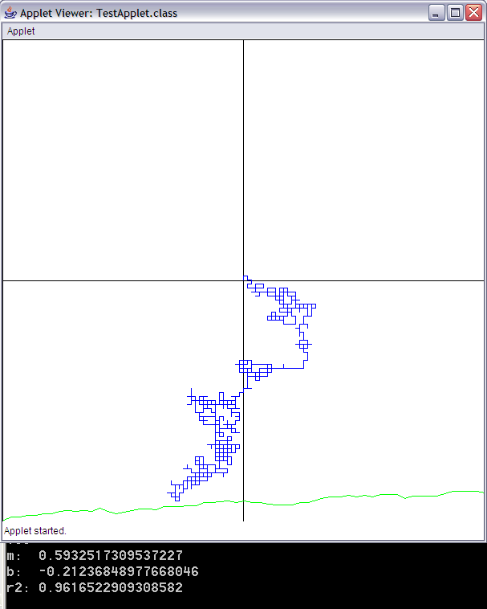
SAWR Plot

