Prashant Kumar
ENGR 0712
Prof. A Balazs

Cluster Counting and Site Percolation of a Lattice

Hypothesis:
Cluster counting, the method of assigning each cluster of percolated sites a group number, provides a visual representation of the percolation of a lattice and an intuitive way to check the percolation of the lattice (whether a path exists across it).

Methodology:
The algorithm implemented makes use of two grids to count the clusters. The first is an ordinary grid percolated with p fraction of the sites set to true. The second grid contains the cluster number of each site. Non-percolated sites have a cluster number of zero. All other sites are given cluster numbers of integers greater than zero. The cluster numbers in this algorithm increment down the columns, simply because of the order of the recursive calls. To determine the cluster number of each site, the grid is transversed until a percolated site is found. Then, a recursive function checks all the neighboring sites that are also percolated and assigns the current cluster number to each site before incrementing it for the next cluster. The sites are turned off on the first grid to ensure that the recursive calls don’t create an infinite loop.
After the first grid has been searched completely, the method for determining the percolation of the lattice merely consists of creating the a set (defined as the collection of items without repeat) of all the cluster numbers of the first row, and searching to see if any cluster numbers of the last row also belong to the set. For the visual interface, the information in the cluster number grid is outputted to the screen. For small lattices, the cluster numbers are outputted in a table in text format. For large lattices, each cluster is assigned a random color and outputted to the screen.

Results:
The program allows for the state of the grid, the number of clusters, and the existence of a path to be outputted. If a path exists, the first cluster number on which a path exists can be determined. Sample grids are attached. The number of clusters for a given p value has surprisingly low variance. By choosing different p values, it can be seen that the aggregation patterns change and suggest a critical threshold for the percolation of a lattice and the existence of a percolation threshold p_{c}.

Conclusion:
Cluster counting is a method that allows the percolation of lattices to be analyzed, suggesting visual schemes of presentation and providing intuitive methods to obtain desirable information, like whether a path exists or not.

Select visual (colored) cluster counting grids with different p values

0.525 | 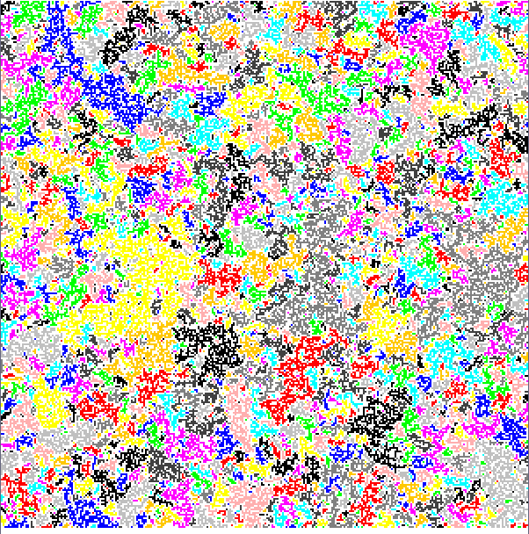  5057 clusters  No Path | 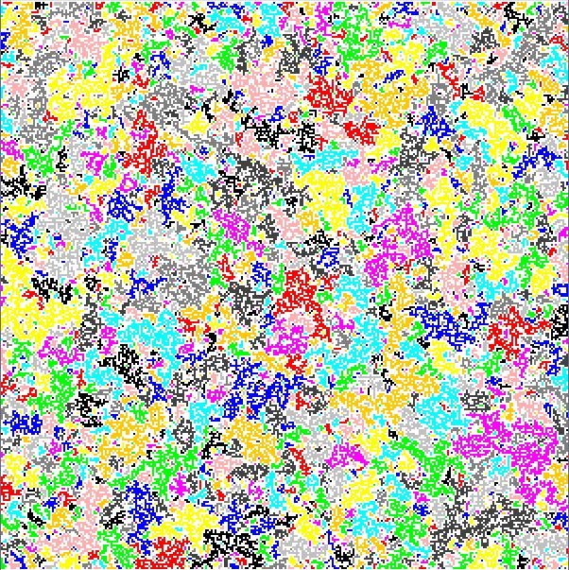  4887 clusters  No Path
0.550 | 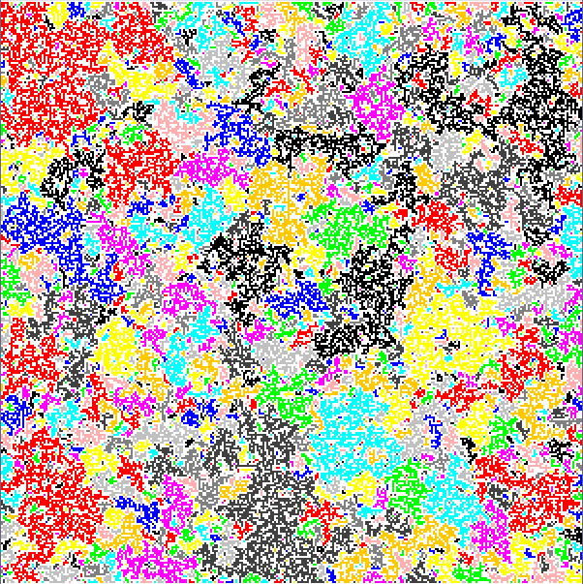  4069 clusters  No Path | 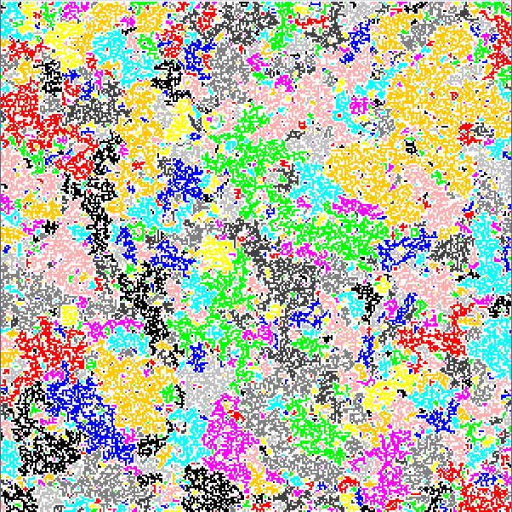  4088 clusters  No Path

Select visual (colored) cluster counting grids with different p values
(Continued)

0.575 | 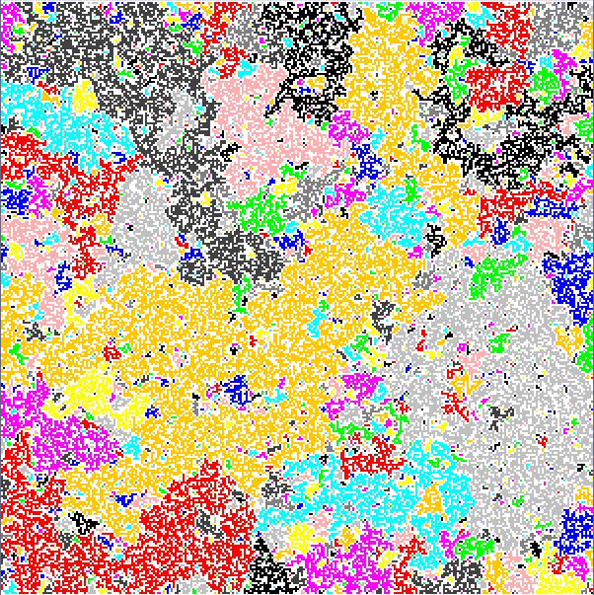  3051 clusters  No Path | 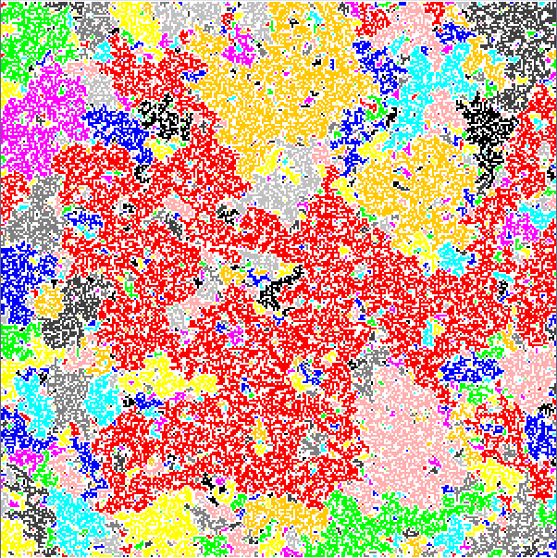  3117 clusters  No Path
0.600 | 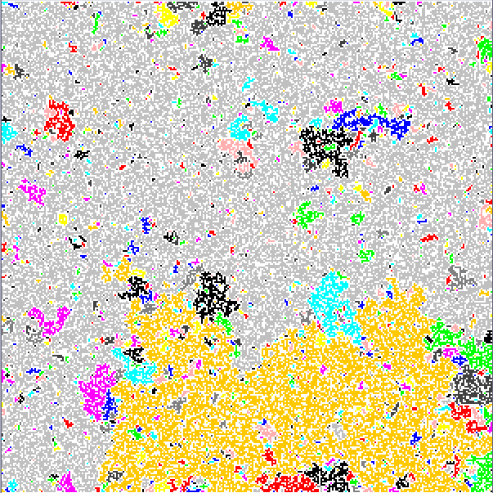  2383 clusters  Path on cluster 2 | 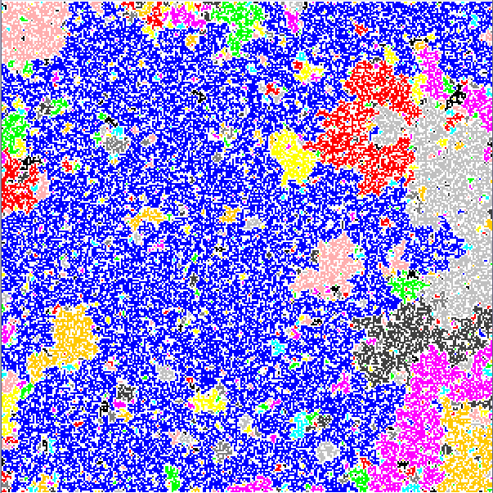  2312 clusters  Path on cluster 7

