Prashant Kumar
ENGR 0712
Prof. A Balazs

Metropolis Algorithm and Phase Separation

Hypothesis:
The Metropolis Algorithm (described in methodology) can be used to simulate phase separation. Temperature can be varied in simulations and the phenomena of simulated annealing can be observed.

Methodology:
The Metropolis Algorithm is an algorithm using random variables to simulate the interaction of particles moving to a more favorable thermodynamic state. It starts with a given initial state, which will be a random distribution of oil and water particles in these simulations. Grids are initialized to a random distribution of particles with ratio given by a parameter p. When the algorithm is called, it scans through the grid multiple times given by a parameter N. At each point, another point is selected at random. It is then calculated whether swapping the two particles would result in a more thermodynamically favored state and a decrease in the energy of the system. This is determined by looking at the neighbors of the particles. Like neighbors contribute to lower energy states and unlike neighbors contribute to higher energy states. Relative energies were assigned (+1 and −1) to each of the bonds.
If the swap results in a lower energy state, perform it. If not, there is some probability, calculated using the Boltzmann distribution, that the swap will still be performed. This is to account for temperature, and the possibility that a system will reach a higher energy state in order to reach a thermodynamically favored one. The form of Boltzmann’s distribution that was used was 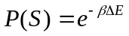, where 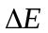 is the change in energy (energy of the final state minus the energy of the initial state) and 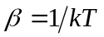 so that β is inversely proportional to the temperature T. This way, the parameter β can simply be changed to affect the temperature without needing to do excess work.
This version of the Metropolis Algorithm implements simulated annealing. In this design, temperature is decreased as time goes on (as time steps are counted in the simulation). The hope for this is for the grid to be amply mixed and make more changes initially so that the system does not get stuck in a state which is not completely phase separated. As time progresses, temperature is lowered, providing a less probability that an unfavorable change is made. The program allows dynamic viewing of the simulated annealing phenomena.

Results:
After experimenting with the parameters, an optimal grid size was found by letting the dimensions be 30 × 30. With this set up, the simulated annealing can be properly observed, and the simulation does not take too long. The tested trials were only done for an equal number of oil and water particles, though p could have easily been altered to result in a different distribution. Letting N = 1000, trials consistently phase separated. In fact, they had essentially separated around N = 500 (the 500th scan through the grid). The extra 500 time steps were to provide that all inconsistencies were removed. Any lone particles in the midst of the particles of the opposite type at the end of the simulation were simply due to chance. Refer to the attached trial run screenshots.

Conclusion:
Using computer simulations, phase separation was able to be modeled. Tenets were taken from chemistry and physics (namely, the Boltzmann distribution) to successfully model temperature. By varying temperature, simulated annealing was achieved and could be seen in the visual output to contribute to the complete phase separation of the oil and water particles.
Sample Run Pictures
Size = 30
N = 1000
Distribution: 50/50

Run | Before | After
1 | 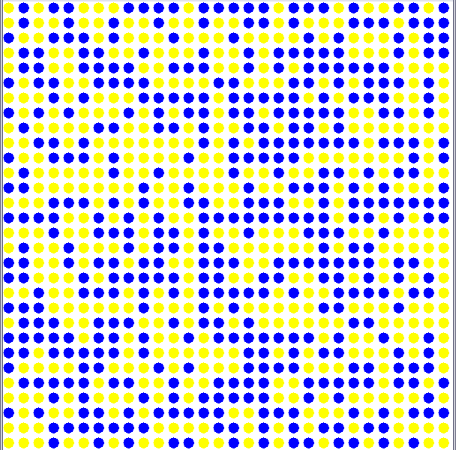 | 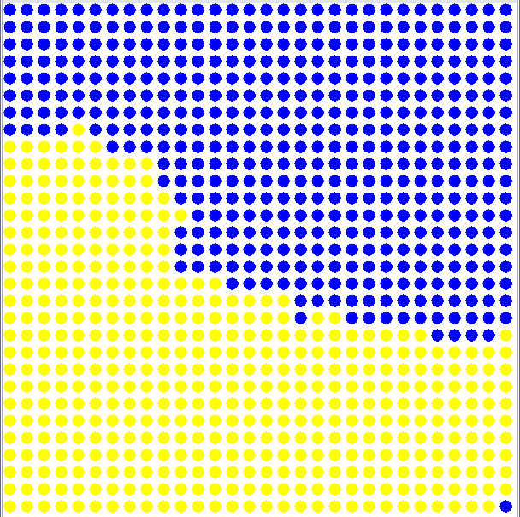
2 | 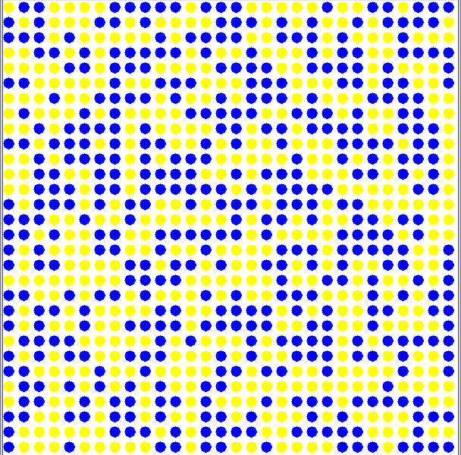 | 