Prashant Kumar
ENGR 0712
Prof. A Balazs

Diffusion Limited Aggregation

Hypothesis:
For the creation of a collection of particles by diffusion limited aggregation, the resulting arrangement is a fractal.

Methodology:
First, a lattice is created to hold all of the particles to be aggregated. A center particle is placed to initiate the aggregation. Then, particles are introduced at the edges of the grid and find their way to the center particle by means of a non-self-avoiding random walk. Once particles find the center particles or particles that have been attached to connecting particles, the walk of that particle ends and a new particles is introduced to make another random walk. Once that was coded, the extra feature of the existence of some probability p such that when a particle finds a branch, it will test whether or not it will stop or keep random walking, where p is the probability it stops and 1 − p is the probability that it keeps walking. After that was implemented, the option of having specific colored particles was introduced. With this playing rule, particles may only stop once they find a compatible neighbor, a neighbor that shares the same color as it.
The first version of the program was implemented with an array of Particles. The second version was implemented with a Hashtable of Positions mapping to Particles. Thus, memory requirements for the second implementation are independent of size and vary only with the number of particles requested. Additional features were added to the second version.

Results:
The results of the computer simulation show that the arrangement formed is some sort of self-repeating structure, suggesting that it is a fractal. As the probability p is reduced, the arrangement collapses toward the center, and the resulting structure has a lower average radius. When colored particles were introduced, the two colors grew along each other. When the red particles were added in greater number than the green, results suggest that it is not possible to enclose the green particle seed (failed to enclose the green seed at a ratio of 999:1). Consult the attached pictures.

Conclusion:
Through multiple runs, it became very clear that diffusion limited aggregation of particles led to the formation of a fractal. Different rules for different environments led to different formations, but each one was fundamentally fractal-like.

Acknowledgements:
Thanks to Duane for the optimization tip (not drawing the particle until in its final position).

First version DLA generator

Particle w/ p = 1.0 Particle w/ p = 0.10
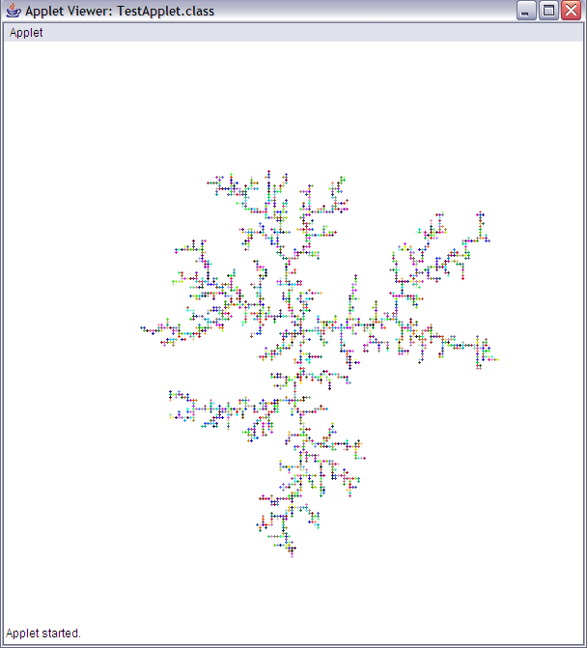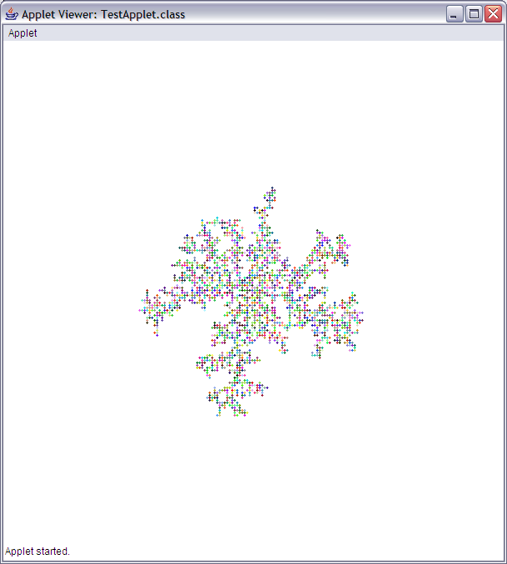

Colored Grid w/ p = 0.20 Colored Grid w/ p = 1.0
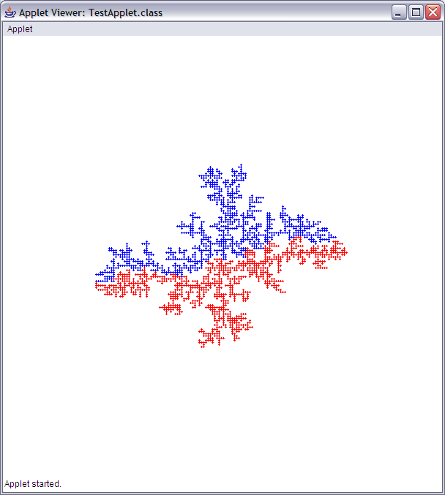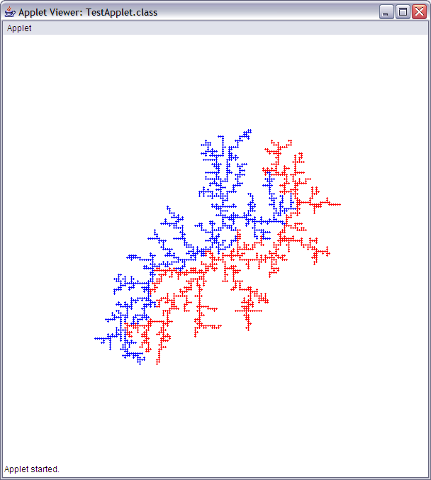

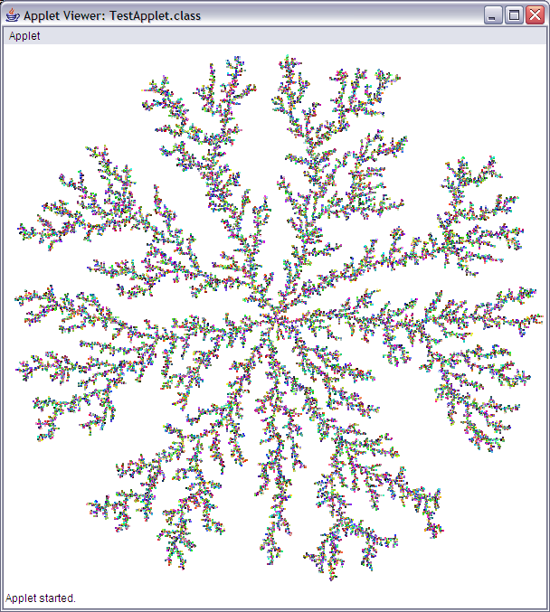
Detailed View
(Revised program)
Additional Pictures
(Revised)

