Prashant Kumar
ENGR 0712
Prof. A Balazs

Metropolis Algorithm and Phase Separation with Surfactant

Hypothesis:
The Metropolis Algorithm as implemented in the oil and water case can be modified to include a third surfactant particle in phase separation simulations. Temperature varies in simulations and the phenomena of simulated annealing can be observed.

Methodology:
Instead of two particles as in the last lab, there are three now: oil, soap, water. All of the same rules apply. When the algorithm is called, it scans through the grid, picking another point at random and checking whether swapping the two will result in a more favorable state. If so, the swap is performed. If not, a probability is generated using the Boltzmann distribution. Allowing 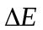 to be the change in energy and another parameter β to relate to the temperature such that 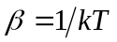, the formula to calculate the relative probability is 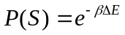. The β parameter increases with every time step, implying that temperature decreases. This is the implementation of simulated annealing. In terms of , relative energies are assigned to each of the neighbors. The oil next to water is very unfavorable (+2), but next to each other is favorable (-2). The soap tends to stick to other soap (-1). Instead of oil and water being neighbors, a more favored state is being next to soap (0). Program allows dynamic viewing of the grid.

Results:
The grid size dimensions were made 30 × 30. Letting N = 1000 in the two particle case, trials consistently phase separated, so that was what that parameter was set to be. Refer to the attached trial run screenshots for metropolis algorithm with surfactant. It was found that when the temperature was considerable low, there was still substantial movement by the particles, as opposed to the two particle case where the particles separated out and did nothing more. It implies that when soap is introduced, the equilibrium reached (in my simulations) was a dynamic neutral equilibrium, that multiple states had the lowest energies, and there were enough degrees of freedom for the grid to switch between the states. The soap tends to coat the surfaces of the oil and water droplets.

Conclusion:
Using computer simulations, phase separation was able to be modeled when accounting for a surfactant. By varying temperature, simulated annealing was achieved and could be seen in the visual output to contribute to the complete phase separation of the oil and water particles.
Sample Run Pictures
Size = 30
N = 1000

Distributions:
Trial 1 – 40/40/20
Trial 2 – 50/40/10

Run | Before | After
1 | 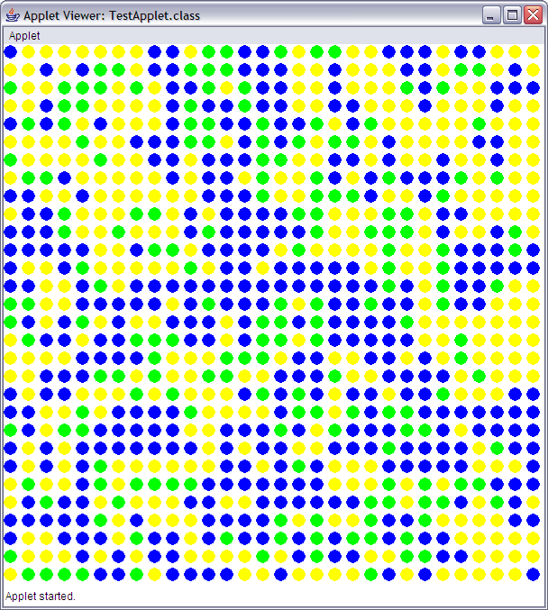 | 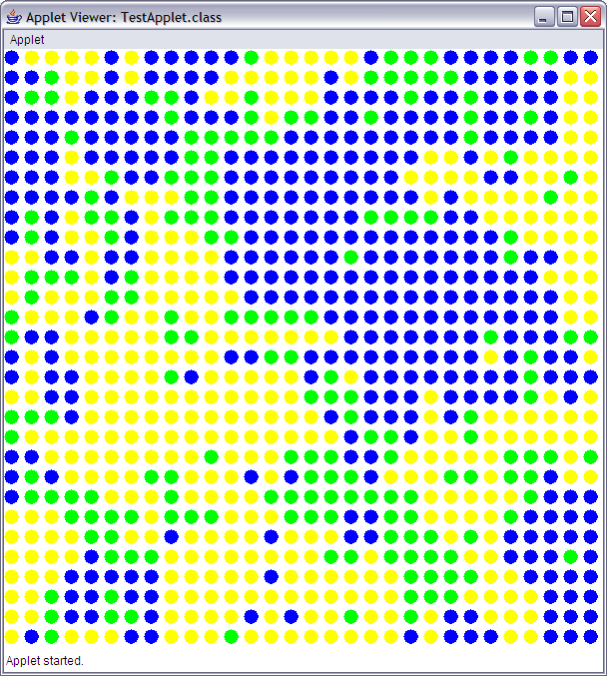
2 | 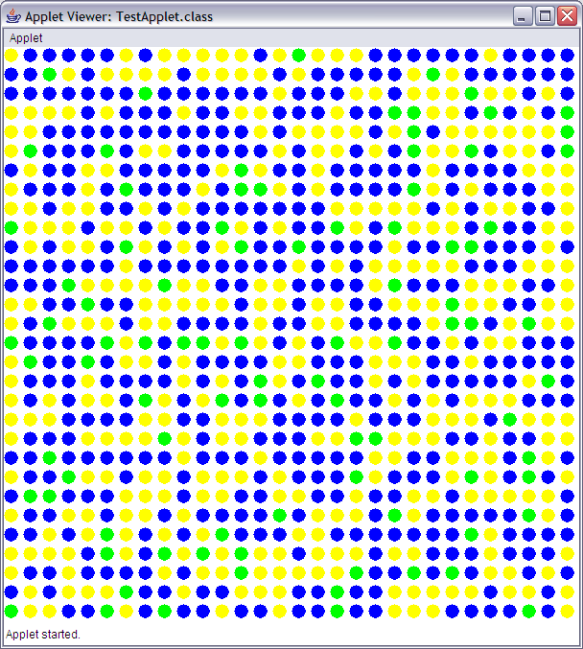 | 