CSE 201 Project High Level Design Document

## Team Member Names

1. Pranshu Kumar
2. Adam Joyner
3. Hancheng Dai

## Team Project Title

BuyerBoard

### Project Description

Craigslist, Olx.in, and Quikr and examples of sites that enable users to put up things they want to sell. Buyers can search for items and contact the seller directly if they would like to make a purchase.

With BuyerBoard we reverse this concept. Buyers put up things they would like to buy. Sellers can then contact buyers to continue the transaction. The Unique Value Proposition (UVP) for BuyerBoard is that people can customize what they want – 1 chair instead of a set of 6? Easy. Custom printed t-shirts at the lower cost than all the printing websites? Simple.

Once a user creates an account, they have both buying and selling privileges. A simple button in the navbar switches the 2 interfaces.

## Overall Design Description

To create BuyerBoard, we are using a model view controller development environment by implementing Laravel. We plan to create a very functional design so that that parts may be used and repeated over several aspects of the web app. The UI is going to be a clean and user-friendly design will simple, yet useful features, such as a search function that can be filtered by categories to make it easy fro users to find what they are looking for.

## UML Diagram 1

UML Diagram is showing how a user creates and modifies a buy post. 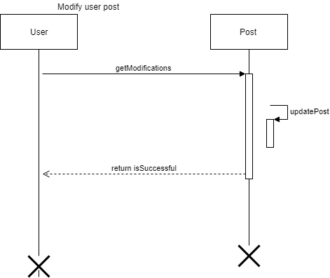

C:\Users\Adam\Downloads\Untitled Diagram (4).pngC:\Users\Adam\Downloads\Untitled Diagram (2).png

## UML Diagram 2

C:\Users\Adam\Downloads\Untitled Diagram (3).png

## 

## UML Diagram 3

C:\Users\Adam\Downloads\Untitled Diagram (6).png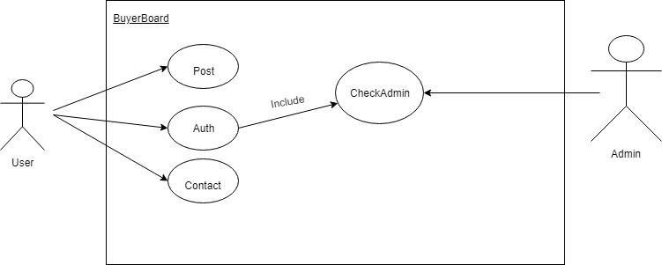

## UML Diagram 4

C:\Users\Adam\Downloads\Untitled Diagram (5).png

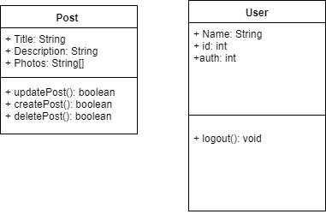

## UML Diagram 5

This diagram shows a seller following a category. Once the seller clicks the follow button, the category is added to an array (as a database entry) and a success message is returned

