**BuyerBoard**

**Software Requirements Specification**

**Version 1.0**

**Revision History**

|  |  |  |  |
| --- | --- | --- | --- |
| **Date** | **Version** | **Description** | **Author** |
|  |  |  |  |
|  |  |  |  |
|  |  |  |  |

**Table of Contents**

1. Introduction
   1. Purpose
   2. Scope
   3. Definitions, Acronyms and Abbreviations
   4. References
   5. Overview
2. Overall Description
   1. Use-Case Model Survey
   2. Assumptions and Dependencies
3. Specific Requirements
   1. Use-Case Reports
   2. Supplementary Requirements

1. Supporting Information

**Software Requirements Specification**

**1.**                  **Introduction**

BuyerBoard enables buyers to list items they would like to buy. Sellers can then directly contact buyers to continue the transaction.

**1.1**               **Purpose**

This document highlights the requirements of BuyerBoard’s website. The website itself is segmented by features, as highlighted in sections 2 and 3. This document details those features and what is needed to push them to production.

**1.2**               **Scope**

The entire BuyerBoard website

**1.5**               **Overview**

Section 2 describes the concept of BuyerBoard, its features and use-cases.

Section 3 addresses the specific software and technical requirements for BuyerBoard.

The sections contain sub-sections to maintain a logical flow when reading/glancing through.

**2.**                  **Overall Description**

**2.1**               **Use-Case Model Survey**

Buyer: Someone who wants to purchase an item/service

Seller: Someone who intends to sell a product/provide a service

Actions listed in the use-case diagram below: -

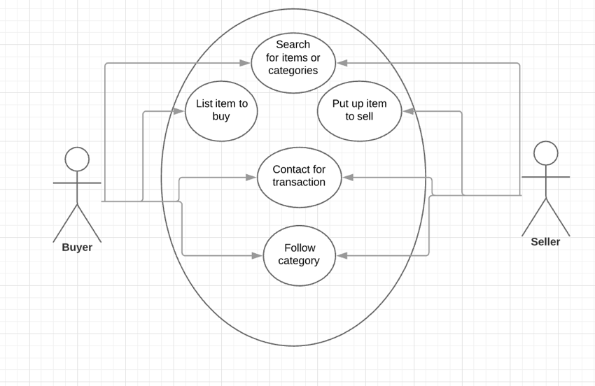

**2.2**               **Assumptions and Dependencies**

User-account related bundles in Laravel for faster completion of account creation, management and login pages.

**3.**                  **Specific Requirements**

**3.1**               **Use-Case Reports**

1. List item to buy: Buyer clicks the ‘buy’ button from the homepage/navbar, enters name and description of product, and clicks ‘post’
2. Put up item to sell: After clicking on a posting, seller clicks the ‘sell’ button (in the posting page), and obtains the contact info of the buyer
3. Contact for transaction: A way to dynamically display the contact info of the buyer. This confirms the seller and provides the contact info of the seller to the buyer too (ensures security of information by providing the buyer-contact info only after the seller clicks the ‘sell’ button)
4. Search for items in categories: The ability to search the BuyerBoard database for postings, from both the buyer and seller side. Display page contains a tiled layout with the posts
5. Follow category: Both buyers and sellers have the ability to follow categories that are pinned to the top of the search page, and also appear on their homepage (after login)

**3.2**               **Supplementary Requirements**

1. Account creation: Users must create an account before transacting on BuyerBoard. Can be done through the landing page and/or the navbar.
2. Account Management: The ability to set preferences, reset password etc. (features to be added on later)