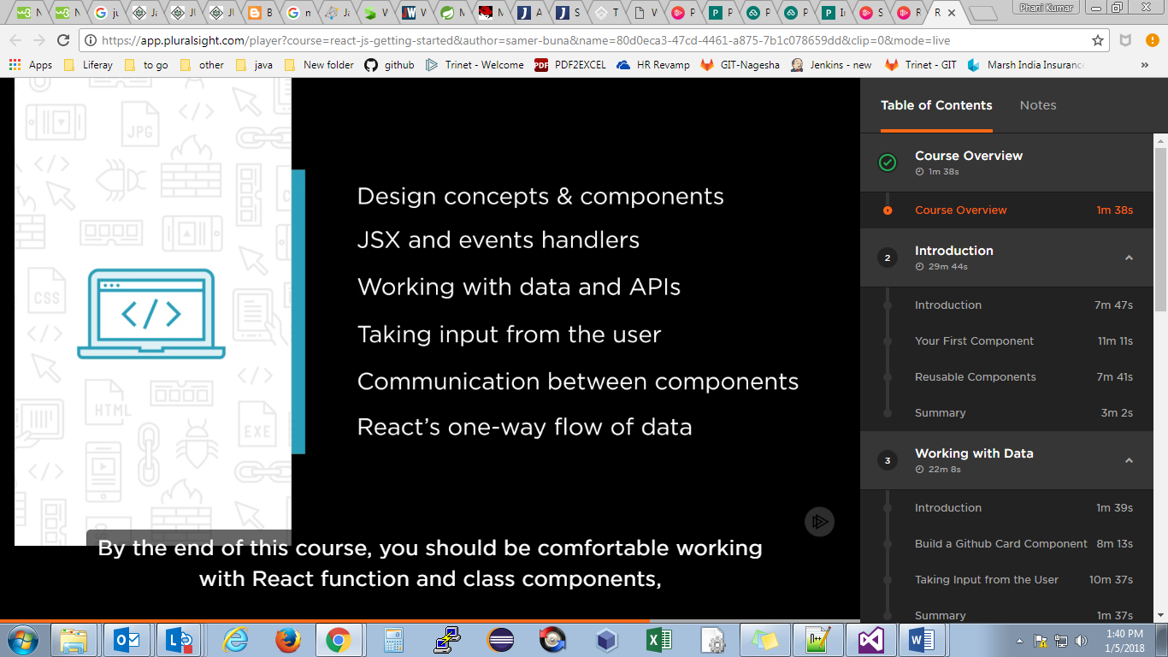

React has mainly 3 concepts.

1. Components
2. Reactive updates
3. Virtual views in memory

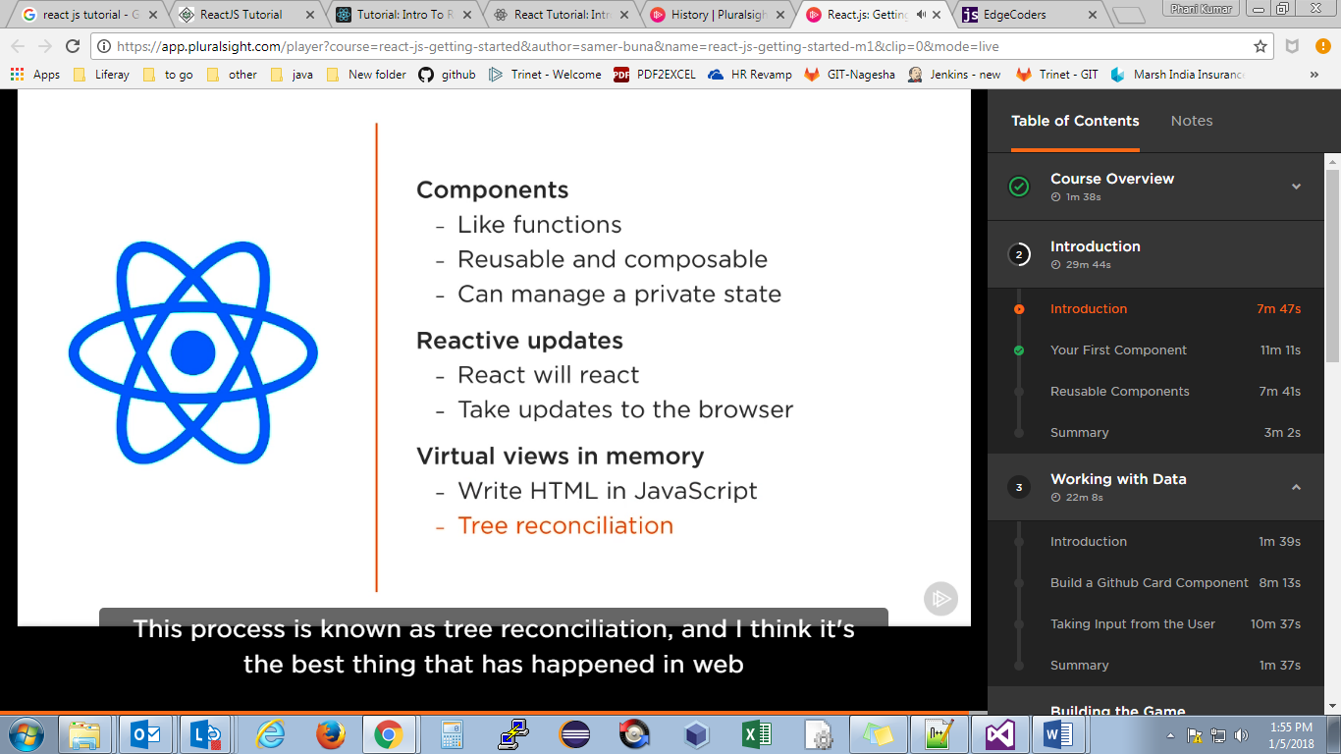

React has 2 types of components :

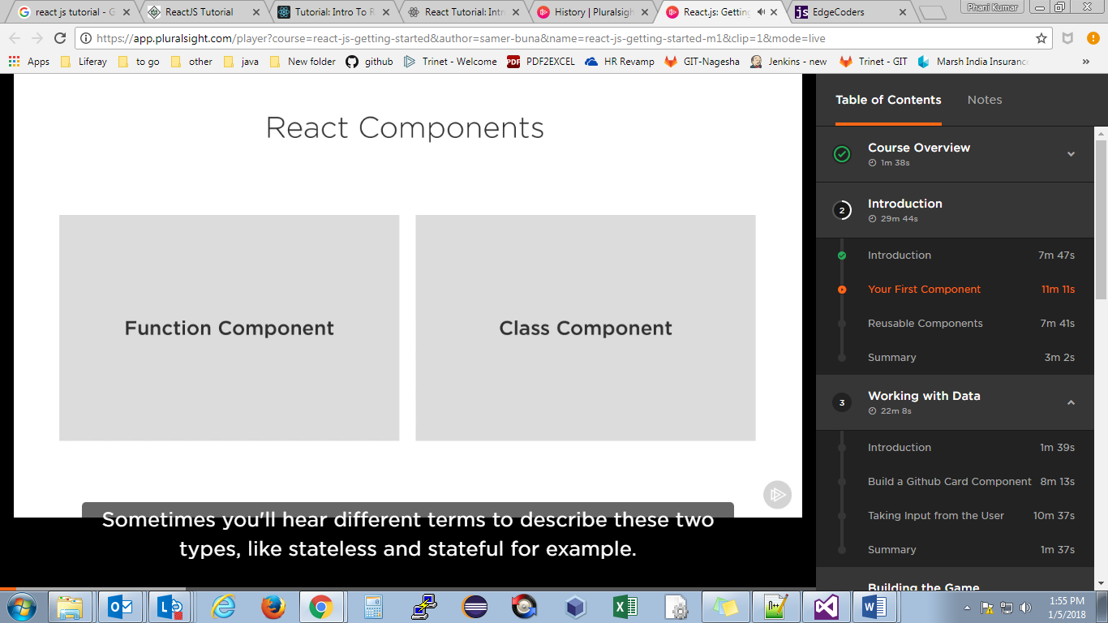

Function component: associated with presentation, this function receives a an obj of properties(props) and returns an obj like html which is really jsx

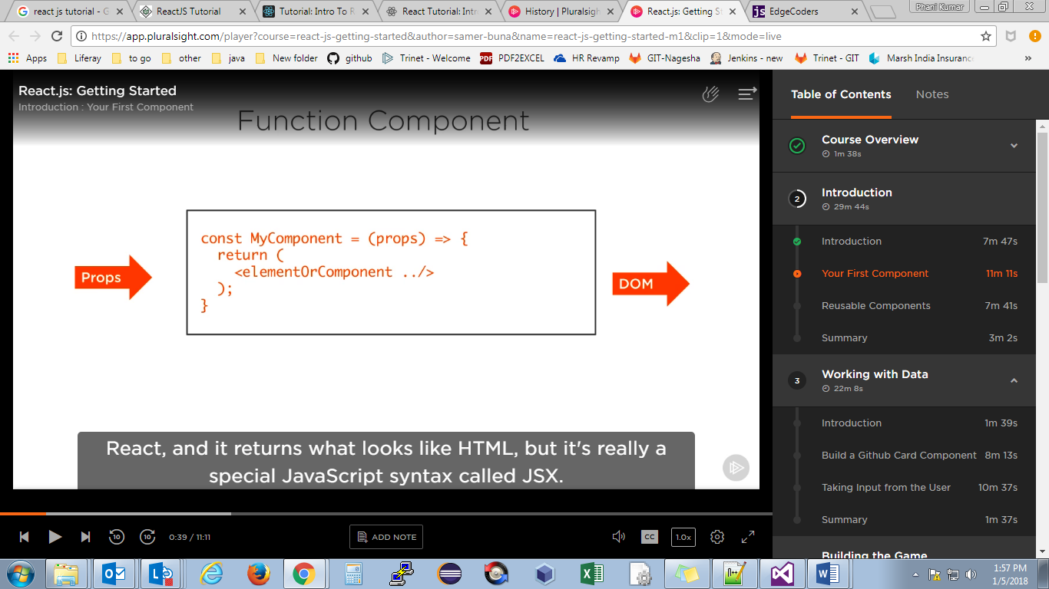

Class component: class component is a more featured way to define a react component

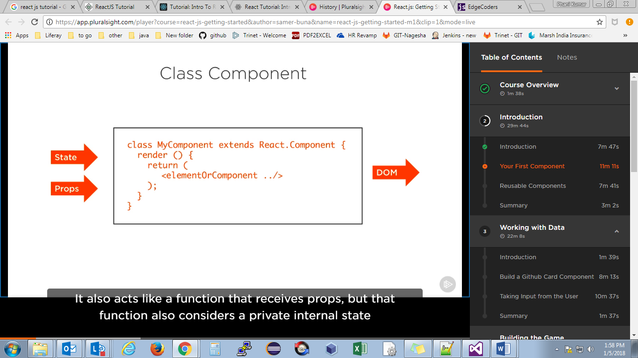

It is similar to functional component but the difference is it has a private internal state as additional input, that controls the returned jsx, this private internal state is what which gives the react a **reactive** nature, when the internal state of class component changes it automatically re-render the component

State and Props are 2 different inputs to the component, state can be changed, but props are fixed

Ex: JSX and React script

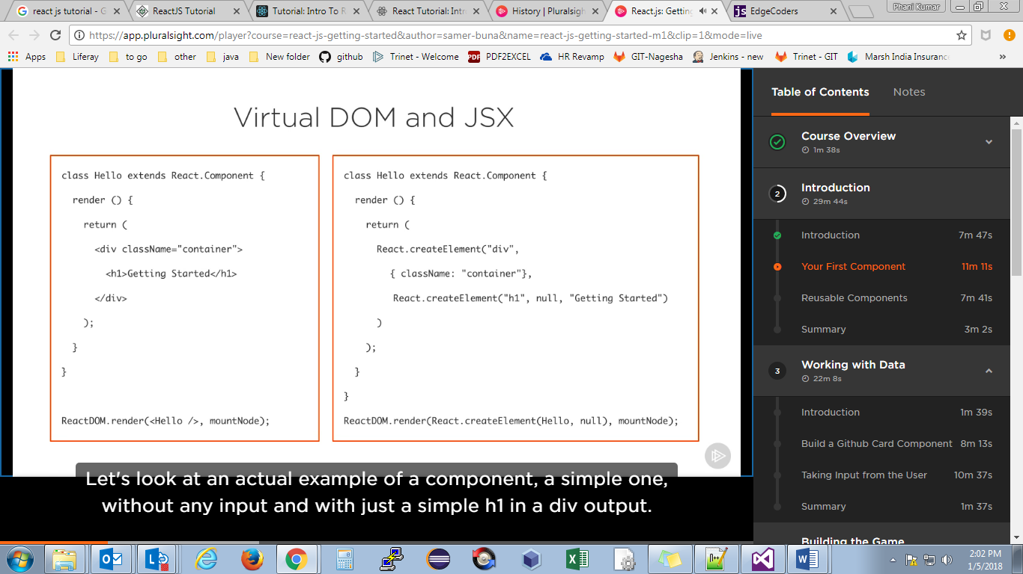

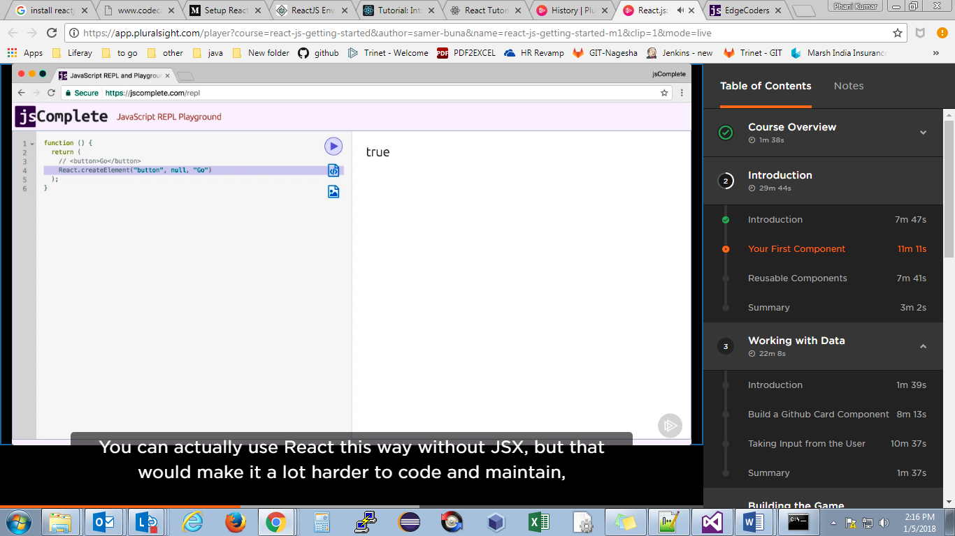

**Sample function component:**

const Name = function () { //constant variable should be with capital letter always

return(

<button>phani</button>

);

};

ReactDOM.render(<Name />, mountNode);

**Sample class component:**

class Name extends React.Component{

state={counter:0};

increment = () =>{

this.setState({

counter:this.state.counter+1

})

};

render(){

return(

<button onClick={this.increment}>phani - {this.state.counter}</button>

);

}

}

ReactDOM.render(<Name/>,mountNode);

