System for human identification based on finger vein pattern

Paweł Kupidura

1. Introduction
A reliable biometric system, which is essentially a pattern-recognition that recognizes a person based on physiological or behavioral characteristic, is an indispensable element in several areas, including e-commerce, various forms of access control security, and so on. Nowadays, security has been important for privacy protection and country in many situations, and the biometric technology is becoming the base approach to solve the increasing crime.

As the significant advances in computer processing, the automated authentication techniques using various biometric features have become available over the last few decades. Biometric characteristics include fingerprint, face, hand/finger geometry, iris, retina, signature, gait, voice, hand vein, odor or the DNA information.

Vein pattern is the network of blood vessels beneath person’s skin. Vein patterns are sufficiently different across individuals, and they are stable unaffected by aging and no significant changed in adults by observing. It is believed that the patterns of blood vein are unique to every individual, even among twins. Veins are internal, thus this characteristic makes the systems highly secure, and they are not been affected by the situation of the outer skin.

2. System outline

Final goal of this project is to provide full system for user identification – from capturing image, to result of identification.

First phase will be capturing image using IR camera and near infrared light source. Details of hardware part are described in section 3.
System flow
Image
capturing
module
Vein pattern
extraction module
Database
Matching
Identification result
registration
registered
pattern

Main part of the system is vein pattern extraction algorithm. In my approach I will use modified maximum curvature algorithm. Other algorithms and details of chosen one are described in section 4.

Last phase of the system will be template matching with ambigous regions, to check extracted pattern against already registered patterns. This part is described in section 5.

3. Vein image capturing
As veins are internal, their structure cannot be discerned in visible light. Until now, researchers used infrared imaging for personal identification.
Infrared is commonly divided into 3 spectral regions: near, mid and far-infrared light, but the boundaries between them are not agreed upon. There are two choices that focuses on imaging of vein patterns in hand by infrared light, the far-infrared (FIR) imaging and the near-infrared (NIR) imaging, which are suitable to capture human bodies images in a non-harmful way. [4]

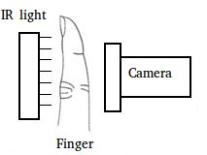
In my approach I will use NIR. Images of veins will be captured using board camera with CMOS sensor, with filter blocking wavelengths below 760nm.
With infrared light source behind finger, camera will be able to capture vein pattern as darker pixels on image.

4. Vein pattern extraction
Multiple methods for vein pattern extraction were proposed since veins have been considered as useful. Conventional methods such as the matched filter [3] method can extract patterns if the widths of veins are constant. However, these method cannot extract veins that are narrower/wider than the assumed widths, which degrades the accuracy of the personal identification.
Pattern extraction flowchart
Preprocessing
Curvatures
calculation
Detection of vein
centers and scoring
Image
Connection of
vein centers
The repeated line tracking method [2] can extract vein patterns from an unclear image, but it cannot sufficiently extract thin veins because the number of times that the tracking point moves on thin veins tends to be small statistically.

In my system I will use algorithm proposed by Miura [1] based on maximum curvatures of cross-sectional profiles of image. This approach allows to extract veins that are thin or bright on captured image.
However, my current research on this algorithm reveals possible problems with specific kind of veins

Algorithm for vein pattern extraction consist of four steps:
I. Image preprocessing
II. Extraction of center positions of veins
III. Connection of veins centers
IV. Binarization

I. Image preprocessing.
On captured grayscale image, histogram equalization and sharpening filter will be applied to improve contrast. Higher contrast allows to get deeper valleys on cross-sectional profile of veins, which is core part of algorithm.
Also, finger region will be detected to ignore background during pattern extraction.

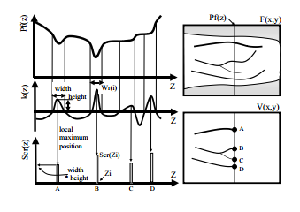Cross-sectional profile, curvatures and scores. [1]
II. Extraction of center positions of veins
To extract the centerline of veins with various widths and brightnesses, this method checks cross-sectional profiles of a finger-vein image. The cross-sectional profile of a vein looks like a dent because the vein is darker than the surrounding area. The center position of veins can be obtained by calculating local maximum curvatures in cross-sectional profiles. A score is assigned to each position, and it is larger when its dent is deeper or wider.

Calculation of the curvatures of profiles:
F is a finger image, and F(x, y) is the intensity of pixel (x, y). We define P_{f} (z) as a cross-sectional profile acquired from F(x, y) at any direction and position, where z is a position in a profile. To relate a position of P_{f} (z) to that of F(x, y), the mapping function T_{rs} is defined as F(x, y) = T_{rs}(P_{f} (z)).

The curvature, K(z), can be represented as

Detection of the centers of veins and assigning scores:
A profile is classified as concave or convex depending on whether K(z) is positive or negative. If K(z) is positive, the profile P_{f} (z) is concave. Local maximums of K(z) in each concave area are calculated, which results in discovering possible centers of veins. Those positions are defined as z_{i}', where i=0, 1, …, N – 1 (where N is the number of local maximum points in the profile).
Scores indicating the probability that found center positions are on veins are assigned to each center position. A score S_{cr}(z) is defined as follows:

Where W_{r} (i) is the width of the region where the curvature is positive and one of the z_{i} ' is located.
If W_{r} is large, the probability that it is a vein is also large. Moreover, the curvature at the center of a vein is large when it appears clearly. Therefore, the width and the curvature of regions are considerated in their scores. Scores are added to approprieate position on a plane V, which is a result of the emphasis of veins.

Calculations described above are done for cross-sectional profiles in four directions: vertical, horizontal and two diagonal. It allows to analyze all veins regardless of their direction – however original version of algorithm described in [1] does not always work properly with veins for which direction is neither vertical, horizontal or diagonal (angles between those discrete values). It is possible area for improvement.
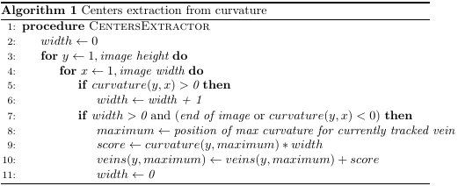Algorithm for processing one of four directions
III. Connection of vein centers.
To connect the centers of veins following operations are done. First, two neighboring pixels on the right side and two neighboring pixels on the left side of pixel (x, y) are checked.

If (x, y) and the pixels both sides have large values, a line is drawn horizontally. When (x, y) has a small value and the pixels on both sides have large values, a line is drawn with a gap at (x, y) . Therefore, the value of (x, y) should be increased to connect the line. When (x, y) has a large value and the pixels on both sides of (x, y) have small values, a dot of noise is at (x, y). Therefore, the value of (x, y) should be reduced to eliminate the noise.

This operation can be represented as follows:

Then, this calculation is made for the rest of directions, so C_{d2}, C_{d3} and C_{d4} are calculated.
Finally, final image G(x, y) is obtained by selecting maximum of C_{d1}, C_{d2}, C_{d3} and C_{d4} for each pixel. Result G(x, y) is extracted vein pattern.

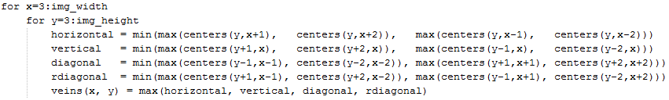
IV. Binarization
Finally, vein pattern G(x, y) is binarized with threshold. Median of values in G is used as threshold value.

5. Template matching
In the matching process, the pattern is converted into matching data, and these data are compared with recorded data.

Two methods are commonly used for matching lineshaped patterns: structural matching and template matching. Structural matching requires additional extraction of feature points such as line endings and bifurcations. Since a finger-vein pattern has few of these points, template matching based on comparison of pixel values is more appropriate for finger-vein pattern matching.

The conventional template-matching technique is not robust against pattern distortion. To solve this problem, the “ambiguous regions” around the veins are identified, and the slight misalignments between vein patterns in these regions are ignored. Robust template-matching is thereby achieved.

6. Conclusions
This brief outline will be base for future work on the system. Research and prototyping phase allowed to point out only possible flaws of chosen algorithms and approaches, but certainly there is space for improvement.

Tests of initial implementation have shown that algorithm proposed by [2] does not always work properly with veins rapidly changing angles.

References
1. Miura, N., A. Nagasaka and T. Miyatake, 2005. Extraction of Finger-Vein Pattern Using Maximum Curvature Points in Image Profiles.In IAPR conference on machine vision applications, 9: 347-350.
2. Miura, N., A. Nagasaka and T. Miyatake, 2004. Feature Extraction of finger-vein patterns based on repeated line tracking and its Application to Personal Identification. Machine Vision and Applications, 15: 194- 203.
3. A. Hoover, V. Kouznetsova, and M. Goldbaum, ”Locating Blood Vessels in Retinal Image by Piece-wise Threshold Probing of a Matched Filter Response,” IEEE Transactions on Medical Imaging, 2000.
4. Rongyang Xiao, Gongping Yang , Yilong Yin, and Lu Yang, 2013. A Novel Matching Strategy for Finger Vein Recognition IScIDE 2012, LNCS 7751, pp. 364–371.

