|  |  |  |
| --- | --- | --- |
| **acm.png** | **Call for Workshop Proposals**  Salvador, Brazil: August, 22-26, 2016  **http://conferences.sigcomm.org/sigcomm/2016** | **sig.png** |

SIGCOMM 2016 is soliciting proposals for new and recurring workshops. SIGCOMM 2016 will hold multiple one-day workshops in conjunction with the conference, to be held in Salvador, Brazil from August 22 to 26, 2016. Workshops will take place on Monday, August 22 and Friday, August 26.

We invite you to submit workshop proposals on any topic related to the broad set of research and application areas covered by the SIGCOMM conference. We welcome workshops on topics in network research, practice, and education. The workshop format itself should favor interaction among participants and community building. We welcome returning workshops.

A workshop proposal should contain at least the following information:

* 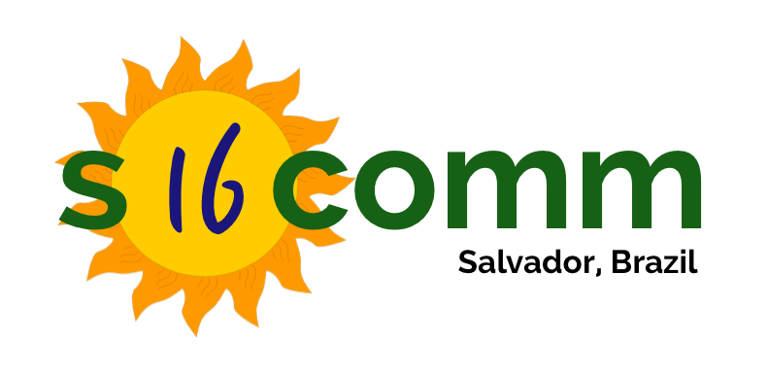Motivation and rationale for the workshop.
* A draft Call for Papers (CFP), as complete as possible.
* The workshop deadlines, both internal and external. See below for guidelines on important external guidelines.
* Names and affiliations of main organizers. If the workshop is not a teaching workshop, include a tentative composition of the committees (as complete as possible). Please indicate whether prospective TPC members have been contacted, and whether they have accepted the invitation.
* Workshop format, including expected number of presented papers, invited talks, panels, demonstrations, etc.
* Expected number of participants and the expected number of submissions (if appropriate).
* Prior history of this workshop, if any, including number of submissions, number of accepted papers, and attendee count. If the workshop was co-located with another conference please include details and a brief description why SIGCOMM is a more appropriate venue.
* A list of people whom you have solicited (or plan to solicit) to participate at the workshop. If the workshop is interdisciplinary, please provide details about your plans to advertise to other communities and how you intend to encourage participation at the workshop.
* If appropriate, a brief explanation of how the workshop relates to other workshops and conferences on similar topics.

If you have questions about your workshop proposal, please contact workshopchairs16@sigcomm.org. Also, email proposals in PDF to workshopchairs16@sigcomm.org by the deadline (see below).

## Important Workshop Dates (preliminary)

* Workshop Call for Papers due: November 23, 2015
* Notification of acceptance: December 4, 2015
* Workshop Call for Papers due: December 22, 2015

Note that there are only three weeks between the notification and the final CFP. Thus, we reiterate that you contact your workshop’s potential PC members before submitting the proposal.

## Additional Important Dates (preliminary)

* Paper submissions deadline: Before March 25, 2016
* Paper acceptance notification: Before end of April, 2016
* Camera ready due: Before end of May, 2016
* Program available online: Before mid-June, 2016
* List of organization details: Before mid-June, 2016

In order for the workshops to be synchronized with preparations for the main conference and with travel grants, the dates above must be followed strictly by all workshops. Please contact the SIGCOMM 2016 Workshop co-chairs (Jussara M. Almeida and Lars Eggert) at workshopchairs16@sigcomm.org with any questions.

## Organizing Committee

## General Chairs

## Marinho P Barcellos, UFRGS, Brazil

## Jon Crowcroft, U. of Cambridge, UK

## Program Committee Chairs

## Amin Vahdat, UCSD and Google, USA

## Sachin Katti, Stanford University, USA

## Local Arrangements Chairs

## Fabíola Greve, UFBA, Brazil

## Rosa M Leão, UFRJ, Brazil

## Workshop Chairs

## Jussara Almeida, UFMG, Brazil

## Lars Eggert, Netapp, Germany

## Poster Chairs

## Marco Canini, Université Catholique de Louvain, Belgium

## Daniel R Figueiredo, UFRJ, Brazil

## Demo Chairs

## Pan Hui, Hong Kong U. of Science and Technology, HK

## Christian E Rothenberg, UNICAMP, Brazil

## Tutorial Chair

## Raj Jain, Washington University in St. Louis, USA

## Publicity Chairs

## Ronaldo A Ferreira, UFMS, Brazil

## Hamed Haddadi, Queen Mary U. of London, UK

## Publication Chairs

## Aakanksha Chowdhery, Microsoft Research, USA

## Matteo Varvello, Telefonica, Spain

## Registration Chair

## Sharon Goldberg, Boston University, USA

## Travel Grant Chairs

## Phillipa Gill, Stony Brook University, USA

## Lisandro Z Granville, UFRGS, Brazil

## Sue Moon, KAIST, Korea

## Costin Raiciu, Univ. Politehnica of Bucharest, Romania

## Treasurer

## Christophe Diot, Technicolor, France

## Web Chairs

## Weverton Cordeiro, UFRGS, Brazil

## Anna-Kaisa Pietilainen, Inria, France

## Conference Coordinator

## Yashar Ganjali, U. of Toronto, Canada