# 为体育组织运营融资的五种方式

无论老板的目标是财富最大化还是获胜，以及体育组织是否为营利型，非营利型或政府机构，体育行业的经理都会使用以下 5 种方法为组织融资，见表{@fig:5methods}。这其中包括营利型公司常用的运营融资的三种方法：债务，股权和留存收益的再投资。在体育类公司，还常用到另外两种融资方式：政府资助和赠与。每个例子都将在本节中看到。这里给出了每种的简单介绍：

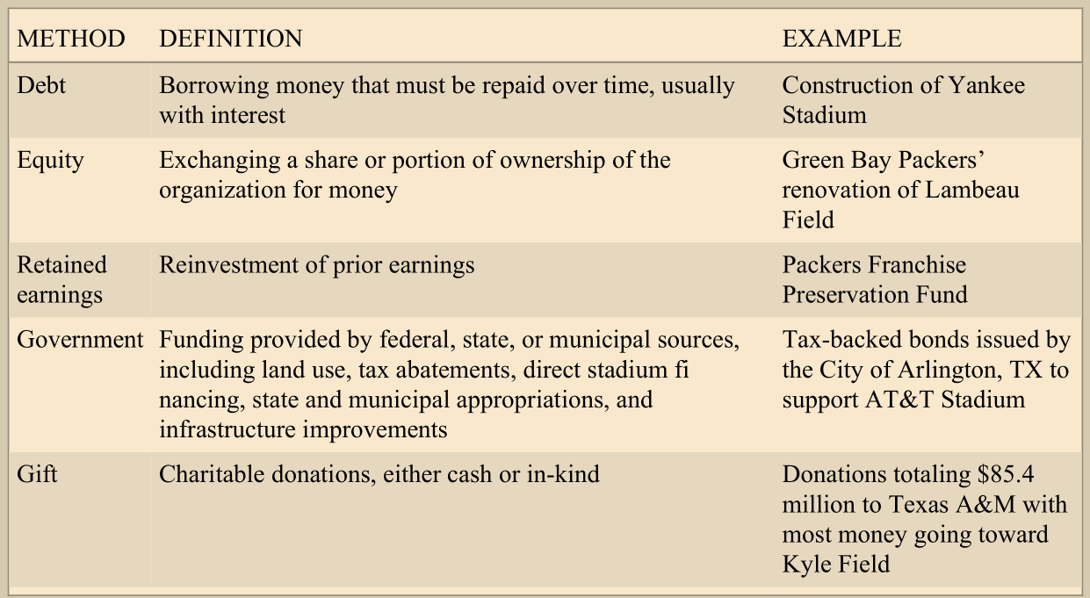 [表 1：体育组织运营常用的融资方法] | 方法 | 定义 | 实例 | | -------- | ------------------------------------------------------------------------------------------------------------ | ----------------------------------------------------------------------- | | 债务 | 借入资金必须随时间的推移而偿还，通常是有利息的 | 洋基体育场的建设 | | 股权 | 交换全部或部分的组织所有权以获得现金 | 绿湾包装工队对 Lambeau 球场的翻新 | | 留存收益 | 先前收益的再投资 | 包装工队的特许经营保存基金 | | 政府资助 | 由联邦（国家），州或市政府提供的资助，包括土地使用，税收减免，直接场馆融资，州或市政府的拨款以及基础设施改善 | 由德克萨斯州阿灵顿市发行的税收担保债券，用于支持 AT＆T 体育场 | | 赠与 | 慈善捐款，以现金或实物捐赠形式 | 向德克萨斯 A＆M 捐赠的总额为 8540 万美元，其中大部分资金用于 Kyle Field |

## Debt

When an organization borrows money that must be repaid over a period of time, usually with interest, debt financing is being used. Typically in sport, teams issue bonds or borrow from lending institutions (or in some instances their league) to finance operations through debt. The New York Yankees financed the new Yankee Stadium in this way. The team borrowed $105 million from a group of banks, including Goldman Sachs, to pay for cost overruns. The team also borrowed more than $1.2 billion through the tax-exempt and taxable bond markets (Kaplan, 2009). Debt financing may be either short-term or long-term; short-term debt obligations are those repaid in less than one year, and long-term obligations are those repaid in more than one year. A key point of financing operations with debt is that the lender does not gain an ownership interest in the organization. The sport organization's obligation is limited to the repayment of the debt.

## Equity

In contrast to debt financing, in equity financing, the owners exchange a share or portion of their ownership for money. The organization, therefore, obtains funds for operations without incurring debt and without having to repay a specific amount of money at a given time. A drawback is that ownership interest will be diluted and the original owners may lose control as additional investors are added. Stephen M. Ross used equity financing to raise capital after he purchased the Miami Dolphins in 2009. He sold minority interests in the team to several partners, including singers Marc Anthony and Gloria Estefan (Talalay, 2009). Few sport organizations issue stock, a common form of equity financing outside the sport industry. One of the few, the Green Bay Packers, used $143 million of stock proceeds to help finance the renovation of Lambeau Field ("History of Green Bay Packers," 2015).

Two reasons account for the fact that professional team sport organizations do not typically issue stock to raise equity capital. One reason is that little can remain hidden when a company is publicly traded. To comply with Securities and Exchange Commission (SEC) regulations, publicly traded organizations must file annualreports detailing the accounting activities of the organization. A team that claims financial hardship in seekingpublic funding for a new stadium may have difficulty convincing the municipality of the need if financialreports reveal significant positive cash flow. A second reason is that teams that issue stock must answer totheir shareholders. Stockholder demands for profitability might run counter to the goal of winning on the field(for example, the team might be unable to acquire a player at the trading deadline because of the near-termfinancial loss that would result from the acquisition). Concern over public ownership is so great that the NFLdoes not allow its teams to be publicly owned. The league instituted a ban on public ownership in 1960(Florio, 2011).

As noted above, the Green Bay Packers are an exception to the norm and the NFL rule. To keep thefranchise from leaving Green Bay, Wisconsin, the team went public in 1923, and today the Packers continueto be exempt from the NFL's prohibition on issuing shares. However, unlike those of a typical publicly tradedcompany, the Packers' shares do not appreciate in value and are not traded on a stock exchange. Despite sport organizations' reluctance to use equity financing, teams in leagues other than the NFL haveraised significant amounts of capital by doing so. The Cleveland Indians raised $60 million through the team'sinitial public offering (IPO) in 1998. The Florida Panthers, Boston Celtics, Vancouver Canucks, and ColoradoAvalanche all have used equity financing. Today, however, these teams are privately held (Kaplan, 1999).

## Retained Earnings

In addition to financing through debt and equity, organizations can finance operations or the acquisition of assets through the reinvestment of prior earnings. The portion of earnings that a firm saves in order to fund operations or acquire assets is termed retained earnings. The reinvestment of retained earnings is generally considered a type of equity financing, as this financing method is often used by publicly traded companies, when they choose to reinvest earnings rather than pay them to shareholders as dividends. However, in sport, financing through the reinvestment of retained earnings should be considered separately from equity financing, because organizations in the industry--with the exception of sporting goods manufacturers and retail stores--are typically privately held. Although earnings may be distributed to team owners, in sport they are often used to finance the acquisition of players, improve operations, or make other investments.

The Green Bay Packers reinvest retained earnings to maintain a competitive and successful football operation and to preserve the franchise and its traditions. However, because the franchise is owned by its shareholders and not a single, wealthy individual, the organization is at a disadvantage when reacting to business challenges. A wealthy owner is able to use personal funds to infuse cash into a sport organization.One method that the Packers use to overcome this disadvantage is the Packers Franchise Preservation Fund.By providing liquidity, the fund is intended to improve the sustain-ability of the corporation and franchise. In 2013, the fund totaled $127.5 million and is a part of the team's corporate reserve fund. At the end of the 2013 fiscal year, the corporate reserve fund totaled $254 million (Walker, 2013).

## Government Funding

In the sport industry, it is common for private organizations, such as professional sports teams, to receivefunding from governmental sources. In addition, public high schools and universities typically receive aportion of their financing through direct or indirect government funding, and this funding may support sportprograms at these schools. For all sport organizations, government financing may be provided by federal,state, or municipal sources and may include land use, tax abatements, direct stadium financing, state andmunicipal appropriations, and infrastructure improvements. During the 2012 season, 64 major-league teamsplayed in stadiums and arenas built with tax-free municipal debt (Kuriloff & Preston, 2012). Exhibit 1.2provides examples of direct stadium financing from government sources.

## Gifts

Gift financing includes charitable donations, either cash or in-kind, made to an organization. Gift financing isa primary source of operating and investing income for major collegiate sports programs. It is also asupplemental source for minor college programs and non-profit sport organizations. According to Wolvertonand Kambhampati (2015), colleges received $1.26 billion in athletic department donations during 2014. Ofthis total, the top 20 athletic departments received over $700 million, with Texas A&M collecting the most ofany department. See Exhibit 1.3 for athletic donations to the universities in the Southeastern Conference.

College athletic programs use revenue from gifts to offset the rising costs of collegiate sport, build or renovate facilities, and increase endowments; Duke University, for example, raises approximately $17 million each year for athletic scholarships. Other institutions use gift financing to offset losses in institutional (government) financing resulting from cuts in state government funds to colleges and universities. Most institutions are also seeking to increase their athletic department endowments (see Exhibit 1.4). Duke hopes to increase its endowment by $260 million to endow its scholarship costs fully. Stanford University's athletic endowment is worth between $450 million and $500 million and pays out at a 5.5% rate each year (Cohen, 2013).