目标：
1 了解体育行业的特殊性
Frick, B., & Wicker, P. (2016). The trickle-down effect: how elite sporting success affects amateur participation in German football. Applied Economics Letters, 23(4), 259-263.

2 哪些经济/管理理论适用于体育行业，这里有些推荐的文章。

结果不确定假设 Uncertainty of outcome (hypothesis):
Rottenberg, S. (1956). The baseball players’ labor market. Journal of Political Economy, 64,
242-258.

人力资本理论 Human capital theory:
Becker, G. S. (1962). Investment in human capital: A theoretical analysis. Journal of Political
Economy, 70, 9-49.

超级球星理论 Superstars:
Adler, M. (1985). Stardom and talent. American Economic Review, 75, 208-212.
Rosen, S. (1981). The economics of superstars. American Economic Review, 71, 845-858.

家庭经济理论 Economic household theory:
Becker, G. S. (1965). A theory of the allocation of time. The Economic Journal, 75(3), 493-
517.

消费资本理论 Consumption capital:
Stigler, G. J., & Becker, G. S. (1977) De gustibus non est disputandum, The American
Economic Review, 67(2), 76-90.

领导者继任 Leadership succession :
Soebbing, B. P., & Washington, M. (2011). Leadership succession and organizational performance: Football coaches and organizational issues. Journal of Sport Management, 25, 550-561.

3 体育行业又为经济提供了怎样的施展空间（实证分析角度）

Berri, D. J., & Bradbury, J. C. (2010). Working in the land of the metricians. Journal of
Sports Economics, 11(1), 29-47.
Humphreys, B. R., & Ruseski, J. E. (2010). Problems with data on the sport industry. Journal
of Sports Economics, 11(1), 60-76.
Kahn, L. M. (2000). The sports business as a labor market laboratory. Journal of Economic
Perspectives, 14(3), 75-94.

The economic theory of professional sports leagues

El-Hodiri and Quirk (1971) “An economic model of a professional sports league.” Journal of Political Economy Vol. 79 (6).
Rottenberg (1956). “The Baseball Players’ Labor Market.” Journal of Political Economy Vol. 64(3).
Vrooman (1995) “Theory of the perfect game: competitive balance in monopoly sports leagues.” Review of Industrial Organization

必读中文文献

Additional Readings in English

选读中文文献

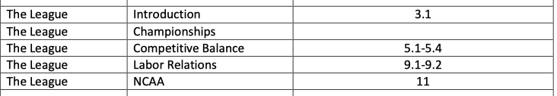
Demand and Supply Models
Producing Output and Production Functions
Market Structures: From Perfect Competition to Monopoly What is meant by the Economics of Sport?
How relevant is the economics discipline to the understanding of sport?
Externalities & Public Goods
Utility Functions and Indifference Curves
Regression Analysis

