MLB UPDATED SUPPLEMENT

to

The Report of the Independent

Members of the Commissioner’s

Blue Ribbon Panel on Baseball Economics

December 2001

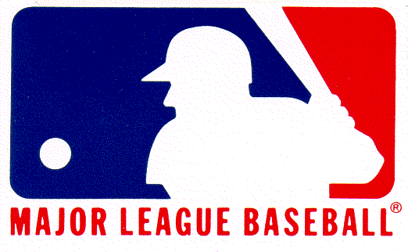
Table of Contents

I. Preface 1
II. The Blue Ribbon Panel on Baseball Economics 2
III. Blue Ribbon Panel’s Findings and Conclusions 3
IV. Overview of Updated Data 7
V. Updated Data and Analysis 11
- Average Payroll and Postseason Performance 11
Table 1 11
- Industry Revenues 12
Table 2 12
- Local Revenues 14
Table 3 14
Chart 2 15
Chart 3 16
- Central Fund Revenues 17
Table 6 17
- Club Payrolls 18
Table 7 18
- Club Competitiveness 19
Chart 12 19
- Club Profitability 20
Chart 1 20
Table 30 21
Chart 14 22
- Club (Industry) Debt 23
Chart 17 23
VI. Appendix A—Detailed Data 24
Table 27 24
Table 28 25
Table 29 26
VII. Appendix B—Definitions 27

I. Preface
The staff of Major League Baseball (MLB), at the direction of the Commissioner, has prepared this Supplement to update The Report of the Independent Members of the Commissioner’s Blue Ribbon Panel on Baseball Economics, which was released in July, 2000. The purpose of this document is to bring up to date the economic information that was examined by the Blue Ribbon Panel, which covered the 1995-1999 baseball seasons. Comparable data for the 2000 and 2001 seasons has been included in a number of updated tables and charts that now cover the period 1995-2001.
The organizational format for presenting data is the same used in The Report of the Independent Members. There are some small differences in data for the 1995-1999 seasons from those published in their July, 2000 Report, reflecting corrections made after further verification of data by the accounting firm Ernst and Young. None of the adjustments are of an order of magnitude that would reasonably alter the conclusions or recommendations of the Independent Members. Every effort has been made to ensure that the data in this Supplement are as complete, up-to-date and accurate as possible.
A number of the findings, observations and conclusions of the Blue Ribbon Panel have been excerpted from The Report of the Independent Members and recounted here verbatim—albeit in condensed, summary form—in order to provide context for the updated supporting data. This Supplement adheres closely to the analytical framework of The Report of the Independent Members, and where possible uses the precise language of the Independent Members to explain the data that have now been updated to cover the extended period since their Report was released.
It should be emphasized, however, that the new text labeled “Update” in the Overview of Updated Data and accompanying the updated tables and charts in the Updated Data and Analysis section has been provided by the MLB staff, not by the Independent Members who authored the July, 2000 Report. Any observations and opinions the individual Independent Members may have with respect to the updated data or explanatory text should properly come from them. MLB does not intend to imply that the Blue Ribbon Panel has met to update or revise The Report of the Independent Members released in July, 2000 or that the Independent Members in any way authored, endorsed or reviewed this Supplement.
At the direction of the Commissioner or the Independent Members, MLB may periodically expand this Supplement or publish additional updates of information in The Report of the Independent Members.
II. The Blue Ribbon Panel on Baseball Economics
The Commissioner’s Blue Ribbon Panel on Baseball Economics was formed to study whether revenue disparities among clubs are seriously damaging competitive balance, and, if so, to recommend structural reforms to ameliorate the problem.
Specifically, the Independent Members were charged with studying the economic condition of the game and producing a report addressing the relationship between MLB’s current economic structure and competitive balance, and the ramifications of the current economic system for the future growth, health, stability and competitive balance of Major League Baseball.
The Blue Ribbon Panel analyzed data provided by MLB for the years 1995-1999. Data included information about each club’s regular-season and post-season won-loss record, ticket and concession prices, local revenues, Central Fund revenues, player payrolls, revenue sharing payments/receipts, profits and losses, industry debt and franchise values. Data were verified by the accounting firm Ernst and Young through 1998.
The Independent Members of the panel were: Richard C. Levin, professor of economics and President of Yale University; former United States Senator George J. Mitchell; Paul Volcker, former Chairman of the Board of Governors of the Federal Reserve System; and George F. Will, political columnist and commentator who has written extensively about baseball. Representatives of 12 MLB clubs also participated on the Panel.
(Note: The Mission Statement of the Blue Ribbon Panel and a complete listing of the Independent Members and the Club Representatives can be found on pages 53-54 of The Report of the Independent Members. Biographies of the Independent Members can be found on pages 55-57. Definitions of Local Revenue, Central Fund Revenue, and Payroll, and the formulas used for calculating revenue sharing payments/receipts, can be found on page 59 of the Report.)

III. Blue Ribbon Panel’s Findings and Conclusions
After more than 18 months of considering voluminous data on the economic condition of the game, the Independent Members released a detailed, 87-page report in July, 2000. Their summary conclusions were as follows:
- Large and growing revenue disparities exist and are causing problems of chronic competitive imbalance.
- These problems have become substantially worse during the five complete seasons since the strike-shortened season of 1994, and seem likely to remain severe unless Major League Baseball undertakes remedial actions proportional to the problem.
- The limited revenue sharing and payroll tax that were approved as part of MLB’s 1996 Collective Bargaining Agreement with the Major League Baseball Players Association (MLBPA) have produced neither the intended moderating of payroll disparities nor improved competitive balance. Some low-revenue clubs, believing the amount of their proceeds from revenue sharing insufficient to enable them to become competitive, used those proceeds to become modestly profitable.
- In a majority of MLB markets, the cost to clubs of trying to be competitive is causing escalation of ticket and concession prices, jeopardizing MLB’s traditional position as the affordable family spectator sport.
The Independent Members reached other findings and conclusions, including, among others, these:
  - “Measured simply in terms of gross revenues, which almost doubled during the five complete seasons (1995-1999) since 1994, MLB is prospering. But that simple measurement is a highly inadequate gauge of MLB’s economic health. Because of anachronistic aspects of MLB’s economic structure, the prosperity of some clubs is having perverse effects that pose a threat to the game’s long-term vitality.”
  - “Widening revenue disparities have been accompanied by widening payroll disparities….Not surprisingly, there is a strong correlation between high player payrolls and success on the field. Although a high payroll is not always sufficient to produce a club capable of reaching postseason play—there are numerous instances of competitive failures by high-payroll clubs—a high payroll has become an increasingly necessary ingredient of on-field success.”
  - “In the context of baseball, proper competitive balance should be understood to exist when there are no clubs chronically weak because of MLB’s structural features. Proper competitive balance will not exist until every well-run club has a regularly recurring reasonable hope of reaching postseason play.”
  - “Granted, competitive balance as here defined has been an elusive goal, when it has been a goal at all, throughout MLB’s history. However, the fact that baseball’s structural flaws are historic is not an argument for continuing acceptance of them. This is particularly so when they are producing revenue disparities with unhealthy consequences for competitive balance.”
  - “What has made baseball’s recent seasons disturbing, and what makes its current economic structure untenable in the long run, is that, year after year, too many clubs know in spring training that they have no realistic prospect of reaching postseason play. Too many clubs in low-revenue markets can only expect to compete for postseason berths if ownership is willing to incur staggering operating losses to subsidize a competitive player payroll.”
  - “Furthermore, baseball fans are not, and should not be asked to be, as stoical about competitive imbalance as they have been in the past. Competition for the sports entertainment dollar, and for the sport fan’s attention, is increasingly intense. There was a time when baseball had the almost undivided attention of sports fans from April to October. Now, however, there are just six weeks between the last National Basketball Association (NBA) championship game and the first National Football League (NFL) preseason game. MLB must improve its competitive balance if it is to remain competitive with other sports attractions.”
  - “The NFL and NBA have thrived with structures that allow franchises in widely different kinds of markets (including small media markets such as Green Bay and San Antonio) to succeed. To ensure baseball’s broad and enduring popularity, and to guarantee its future growth, MLB needs a structure under which clubs in smaller markets can have regularly recurring chances to contend for championships.”
  - “MLB should vigorously develop new ways to increase revenues, but that alone will not solve the problem of competitive imbalance.”
  - “The heart of the problem is the large and growing disparity of what are called ‘local’ revenues. Although most of baseball’s revenues are these so-called ‘local revenues,’ none of the revenues really result exclusively from the sale of a local product. It takes two clubs to have a game and 30 clubs to have today’s division races. All clubs are selling—indeed, all are elements of—a single product, Major League Baseball.”
  - “Therefore, to reform baseball’s structure to produce reasonable competitive balance, substantially more of the industry’s revenues should be treated as just that—the industry’s revenues—and should be distributed in ways that cause all clubs to operate within a much narrower band of unequal economic resources. The band should be broad enough to allow baseball entrepreneurship to be rewarded, but narrow enough that intractable differences between local markets do not produce a baseball underclass of chronically uncompetitive clubs.”
  - “The fundamental objective of reform should be an industry in which each team’s success on the field, over time, will be determined by the skill of the players and the baseball acumen of the men and women who conduct the team’s business—scouting, player development, baseball management, marketing, etc.”
  - “Any reform of MLB should protect and balance the interests of players, clubs and fans. These three constituencies should cooperate to create an economic structure that promotes a reasonable rate of growth of player salaries, produces competitive balance and preserves baseball as affordable family entertainment.”
  - “In recent years there has been a rapidly accelerating disparity in revenues and, consequently, in payrolls between clubs in high- and low-revenue markets. There also has been a stronger correlation between club revenues/payrolls and on-field competitiveness in the years since the issue of competitive balance was studied by the Joint Economic Study Committee which issued its report in 1992.” (Note: That committee was established by the 1990 Basic Agreement and included representatives of MLB, the MLBPA and outside experts.) “The inescapable conclusion is that major structural problems exist in the economics of professional baseball. If these flaws are not addressed by MLB promptly, decisively, and ultimately in conjunction with the MLBPA, the future of the game as we have known it will be imperiled.”
  - “In short, it should be apparent that the time for tinkering with MLB’s existing, flawed economic structure has passed and that sweeping changes in the game’s economic landscape are necessary. What is required is a corrective course of action to: 1) implement reforms on matters that are not subject to collective bargaining and that can be imposed unilaterally by the Commissioner and the member clubs in the best interests of the game and its fans; and 2) engage the MLBPA in cooperative and collaborative discussions, as appropriate within the MLBPA’s collective bargaining rights, to develop and implement long-term structural changes, strategies and joint marketing initiatives to make the game more popular and prosperous, nationally and internationally.”
IV. Overview of Updated Data
Update—An update of the charts, tables and other data studied by the Commissioner’s Blue Ribbon Panel to include the 2000 and 2001 seasons suggests that the economic condition of the game has not improved significantly in the past two years, and in some ways—including industry profitability and debt levels—may have worsened.
In their July, 2000 report, the Independent Members wrote: “Our mission has been to consider the relevant economic data, indicators and variables. We have concluded that a majority of MLB clubs today are not reasonably competitive, that the problem of competitive balance is a product of MLB’s economic structure, and that this structure is adversely affecting the ability of most clubs to increase revenues and achieve operating stability.”
The more recent data, extending the Blue Ribbon Panel’s five-year view of club and industry performance to seven years, support the view that the structural flaws the Panel identified in MLB’s economic system remain, and the trends they foster relative to revenue and payroll disparities, competitive imbalance and operating losses have generally continued. The gap in both average local revenue and average payroll between clubs in Quartile I and Quartile IV continued to grow.
Three different teams from the bottom half of the payroll scale have reached postseason play in the past two seasons (including the Oakland Athletics, who have reached the playoffs both years), and they have won a combined total of five games. In the previous five years, only one team from the bottom half of the payroll scale reached postseason play (Houston in 1997) and did not win a playoff game. This could be interpreted as an improvement in competitive balance, but it is slight, and probably aberrational. None of the Quartile III and Quartile IV clubs advanced beyond the Division Series, and no team outside of the top payroll quartile has won a single World Series game in the past seven years.
The occasional low-payroll teams that do contend for and achieve postseason berths appear to have little realistic opportunity to retain their best players long enough, or to acquire suitable reinforcements, to become regular contenders. The game’s current economic system makes it problematic for many clubs to compete for premium free agents—including players they have developed into stars and would like to retain—or to sign the best available amateur or foreign players. Only a few clubs have the resources to sign the top veteran and entry-level players (including foreign free agents).
The harsh reality facing the majority of MLB clubs under the current economic system is that they must make a choice between being competitive on the field or operating on a break-even or modestly profitable basis. Only two of the 30 MLB clubs (the New York Yankees and Cleveland Indians) have shown an operating profit over the seven-year period, and despite generally robust revenue growth, MLB’s industry-wide operating losses and long-term debt have reached historic levels.
Over the period 1995-2001, MLB clubs had an average operating loss of $46 million, and the total industry operating loss for the period was $1.4 billion. Industry indebtedness, excluding guaranteed player contracts for future seasons and deferred compensation, has grown from $593 million in 1993 to $3.1 billion in 2001. Industry debt is now more than three times the level it was in 1997.
As is usually the case with businesses that routinely lose money, the mounting operating losses and debt levels have put several MLB clubs at serious risk. The inflationary pressures of trying to field a competitive team have continued to cause a corresponding spiral in ticket and concession prices that is alarming to heretofore loyal fans and could “price out” or reduce the frequency of attendance by families that traditionally have been baseball’s core audience. Meanwhile, failure to implement an economic system that fosters a more desirable degree of competitive balance could jeopardize the popularity and future growth of MLB, including sustained revenue growth, as the Blue Ribbon Panel’s Report warned.
Many of the specific observations, findings and conclusions in the Report of the Independent Members bear repeating as the data on which they were based are updated to include the two seasons since the Report was issued.
1. The Blue Ribbon Panel’s Report stated: “Despite impressive industry-wide revenue growth over the past five years, MLB has an outdated economic structure that has created an unacceptable level of revenue disparity and competitive imbalance over the same period. The growing gap between the ‘have’ and the ‘have not’ clubs—which is to say the minority that have a realistic chance of succeeding in postseason play and the majority of clubs that have poor prospects of reaching the postseason—is a serious and imminent threat to the popularity, health, stability and growth of the game. Players appear to share this view. In a survey of MLB players published in the May 2, 2000 edition of Baseball Weekly, lack of competitive balance was cited as the biggest problem facing the game today. A vast majority of players surveyed responded that it was ‘very important’ that small market teams have the same chance of reaching the World Series as large market teams.”
Update—The positive industry revenue growth continued in 2000, increasing 20.4 percent, which was largely attributable to a new MLB network television contract with Fox and national cable contract with ESPN, and the opening of new ballparks in San Francisco, Houston and Detroit. (Seattle, which opened its new ballpark at midseason in 1999, also had the first full year of revenues from Safeco Field.) Revenue growth slowed to 6.7 percent in 2001, when new ballparks opened in Milwaukee and Pittsburgh. Overall, industry revenue has risen from $1.38 billion in 1995 to $3.55 billion in 2001, with increases of 28.2 percent in 1996, 16.5 percent in 1997, 19.9 percent in 1998, 11.4 percent in 1999, and, as noted, 20.4 percent and 6.7 percent in 2000 and 2001, respectively. Growing disparities in revenue and payroll between “have” and “have not” clubs characterize the seven-year period (1995-2001) as they did the five-year period (1995-99) examined by the Blue Ribbon Panel.
2. The Blue Ribbon Panel’s Report stated: “The introduction of limited revenue sharing and a ‘luxury tax’ on payrolls for a trial period under the 1996 Collective Bargaining Agreement (known as the ‘Basic Agreement’) apparently did not create any significant ‘drag’ on player salaries and has not significantly enhanced competitive balance. In fact, a number of low-revenue clubs, realizing that they had no realistic chance to compete for the postseason, opted instead for marginal profitability from revenue sharing proceeds and did not increase their player payrolls to levels that would make them competitive. This grim fact of modern baseball life has frustrated fans in low-revenue markets.”
Update—The average payroll in payroll Quartile III has increased from $41 million in 1999 to $49.7 million in 2001, and in payroll Quartile IV from $20.2 million in 1999 to $35.5 million in 2001, which indicates that some low-revenue clubs have increased their payrolls in an effort to become more competitive. Average club payroll increased industry-wide by 17 percent in 2000 and by 13.1 percent in 2001. Moreover, the increase in payrolls in payroll Quartile I and Quartile II has continued to be greater than that in payroll Quartile III and Quartile IV. In payroll Quartile I, the average payroll increased from $78.8 million in 1999 to $99.9 million in 2001, and in payroll Quartile II, the average payroll increased from $55.7 million in 1999 to $75.1 million in 2001. The limited revenue sharing and luxury tax introduced in 1996 still does not appear to have created any significant “drag” on player salaries and does not appear to have significantly enhanced competitive balance.
3. The Blue Ribbon Panel’s Report stated: “A reasonably level playing field, on which clubs representing markets that are quite diverse geographically, demographically and economically can compete with at least periodic opportunities for success, is fundamental to MLB’s continued growth and popular appeal. Yet, from 1995 through 1999, a total of 158 MLB postseason games were played. During this period, no club whose payroll fell in the lower half of the industry won even a single postseason game. Only one has even qualified for the postseason.”
Update—That was what George F. Will, one of the Independent Members of the Blue Ribbon Panel, in a Newsweek column dubbed “the 158-game winning streak.” The streak was broken in 2000. The updated numbers: From 1995 through 2001, a total of 224 MLB postseason games were played. During this period, five clubs whose payrolls fell in the lower half of the industry qualified for the postseason, and they won a total of five games. None advanced past the first round of the playoffs. No team outside the top payroll quartile has won a World Series game during the period, and only one has reached the World Series. (The 1998 San Diego Padres, then in payroll Quartile II, won the National League pennant but were swept in the World Series in four straight games by the New York Yankees.) The seven-year postseason record for 1995-2001 is 219-5 (a .978 winning percentage) in favor of the top two payroll quartiles.
4. The Blue Ribbon Panel’s Report stated: “MLB is now essentially divided into three groups of unequal size: 1) clubs that expect to reach and perform well in the postseason; 2) clubs that hope for an occasional ‘dream season’ to reach the postseason; and 3) clubs that know going to spring training that they will not make the playoffs.”
Update—Although some clubs have moved into higher revenue quartiles, largely because of increased local revenues from new ballparks, and some have increased payroll in an effort to become more competitive, other clubs have cut payroll because of what their ownership considers intolerable operating losses and have fallen to lower payroll quartiles. The “caste system” of clubs stratified by revenue and payroll disparities remains essentially as described in the July, 2000 Report.

V. Updated Data and Analysis

A. Average Payroll and Postseason Performance
Table 1: Division Series (“DS”), League Championship Series (“LCS”), and World Series (“WS”) Games Won by Payroll Quartile, 1995-2001
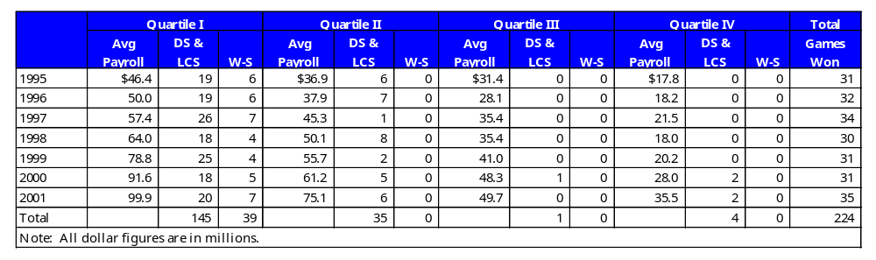

The Blue Ribbon Panel’s Report stated: “From 1995 through 1999, a total of 158 postseason games were played. For analytical purposes, it is useful to divide the clubs into ‘quartiles’ by ranking them (based on payroll) from high to low and separating the clubs into four equal size groups. For example in 1995, the seven clubs with the highest payrolls would constitute ‘Quartile I.’ (Footnote: Prior to the expansion in 1998, each quartile consisted of seven clubs. After the 1998 expansion, Quartile I and Quartile III have eight clubs, and Quartile II and Quartile IV have seven clubs.) During this five year period, no club from payroll Quartile III or Quartile IV won a Division Series or League Championship Series game, and no club from payroll Quartile II, Quartile III or Quartile IV won a World Series game.”

Update—The average payroll in payroll Quartile I has grown from $46.4 million in 1995 to $99.9 million in 2001. In payroll Quartile II, the average has grown from $36.9 million to $75.1 million. In payroll Quartile III, the average has grown from $31.4 million to $49.7 million. In payroll Quartile IV, the average has grown from $17.8 million to $35.5 million over the seven years.

The Blue Ribbon Panel suggested that one indicator of a system that could achieve a durable competitive balance in baseball would be a ratio of approximately 2:1 between the average payroll of the payroll Quartile I clubs to the average payroll of the payroll Quartile IV clubs. In 2001, the ratio was closer to 3:1. In 1999, the last season examined by the Blue Ribbon Panel, the actual gap in average payroll between payroll Quartile I clubs ($78.8 million) and payroll Quartile IV clubs ($20.2 million) was $58.6 million. By 2001, the actual gap had grown to $64.4 million.

As previously noted, from 1995 through 2001, a total of 224 postseason games were played. During this seven-year period, no club from payroll Quartile II, Quartile III or Quartile IV won a World Series game, only one club from outside payroll Quartile I reached the World Series, and five clubs in payroll Quartile III and Quartile IV won a total of only five games, never advancing to the League Championship Series.

B. Industry Revenues

Table 2: Industry Revenues, 1995-2001

The Blue Ribbon Panel’s Report stated: “The years following the 1994-1995 players’ strike have seen substantially increased revenue to the industry. The average revenue of clubs in 1999 approached $100 million. Industry revenues have doubled during the past five years . . .

“Revenue to clubs comes primarily from three sources: 1) so-called local revenues include ticket sales, local television, radio and cable rights, ballpark concessions, parking, and team sponsorships; 2) Central Fund revenues are generated by industry-wide contracts, such as national television contracts and licensing arrangements, and historically have been distributed evenly to all clubs; and 3) revenue sharing, introduced in 1996, which transfers locally generated money from high-revenue clubs to low-revenue clubs.
“Revenues, in all likelihood, will continue to grow during the next decade as new ballparks are opened. New ballparks have opened this season [2000] in San Francisco, Houston and Detroit, and others are expected to open in 2001 in Milwaukee and Pittsburgh, and soon in San Diego and Cincinnati. Plans are moving forward for new ballparks in other communities in the future.
“The new generation of ballparks that began with the 1992 opening of Oriole Park at Camden Yards in Baltimore includes design and programming features and modern amenities that have proved to be enormously popular with the public. These ballparks have dramatically increased the attendance and revenues of the clubs that play in them. In addition to Baltimore, the franchises with new ballparks that opened in the 1990s include Arizona, Atlanta, Chicago White Sox, Cleveland, Colorado, Seattle and Texas. St. Louis and Anaheim undertook major renovations that transformed dual-purpose stadiums (football and baseball) into baseball-oriented facilities. New ballpark construction and renovation has made a substantial contribution to revenue growth in the second half of the past decade.
“In fact, the construction or renovation of facilities to add modern amenities has been effective in increasing the revenue–and therefore the player payroll and competitiveness–of some clubs. In many cases, the ballparks themselves have become attractions, dramatically increasing attendance and revenues and providing the club the financial resources to field teams with payrolls high enough to have a chance to be competitive.
“It is reasonable to expect that new ballparks will continue to fuel industry revenue growth for the foreseeable future, and this is a positive trend for the industry. However, revenue growth alone does not provide a long-term solution for the structural flaws in MLB’s economic system. Eventually, most clubs will have attractive, baseball-oriented facilities with modern amenities, and then the revenue/payroll disparities that breed competitive imbalance will be magnified because the clubs in large media markets have revenue opportunities from new ballparks that are greater than those of their counterparts in smaller markets. They can command more for naming rights, ballpark signage, team sponsorships, etc. They can charge more for tickets, sell more suites and club seats than their small market competitors, as well as receive substantially more for local television and radio rights. The level of public investment in new ballparks also varies dramatically from community to community, which means that some clubs need to devote much more of their newly generated revenue to private financing and debt service than others.
“New ballparks are vitally important for expanding the game’s prosperity. Baseball is best enjoyed in intimate, charming venues that become attractions in themselves and enhance the entertainment experience, regardless of whether the home team is winning or losing. However, they are not in and of themselves the answer to solving the competitive balance and economic problems that plague MLB.”
Update—As previously noted, industry revenue growth slowed dramatically in 2001 from the robust levels of the previous six years, increasing 6.7 percent from the prior year, compared to increases of 28.2 percent in 1996, 16.5 percent in 1997, 19.9 percent in 1998, 11.4. percent in 1999, and 20.4 percent in 2001. Without new ballparks that opened in Milwaukee and Pittsburgh, 2001 growth was only 5.5 percent. Moreover, the projected outlook for revenue growth in 2002 has been revised downward because no new ballparks will open and the continuing national economic slowdown, exacerbated by the events of September 11, 2001, has caused a downturn in corporate spending. As noted in the Blue Ribbon Panel’s Report, new ballparks that enhance the entertainment experience of baseball, with modern amenities and premium seating, are important to the industry and to future revenue growth, but they should not be viewed as a panacea for MLB’s economic and competitive balance problems.

C. Local Revenues
Table 3: Local Revenue Growth, 1995-2001

The Blue Ribbon Panel’s Report stated: “Local revenue grew 87 percent from 1995 to 1999, adding some one billion dollars (or roughly $200 million each year) to the industry’s total revenues. From 1996 through 1999, local revenue constituted approximately 79 percent of total industry revenue. (Footnote: In 1995, during a strike-shortened season, local revenues comprised approximately 84 percent of industry revenues.)”
Update—Local revenue grew 141 percent from 1995 to 2001, adding some $1.6 billion (or roughly $275 million each year) to the industry’s total revenues. From 1996 through 2001, local revenue constituted approximately 78 percent of total industry revenue.
The Blue Ribbon Panel’s Report stated: “In 1999, the range of local revenues was enormous, from $12 million for Montreal to $176 million for the New York Yankees. This begs the obvious question: How can a club like Montreal expect to compete with the New York Mets, whose local revenues are ten times greater? The inescapable answer is: They cannot, even with a productive scouting and player development system and sound baseball management. Several low-revenue clubs in the 1990s have tried to remain competitive on the field with a strategy of devoting their modest resources to scouting and player development and fielding teams of young, talented players who likely would have had more minor-league seasoning with higher-revenue, higher-payroll clubs. The theory under which these lower-revenue clubs have operated is that their fans would appreciate seeing young, aggressive, ‘hungry and hustling’ teams and that they would be able to retain a nucleus of these young stars long enough to contend periodically for the postseason. Unfortunately, doing so has become increasingly problematic, and fans in those markets have become progressively frustrated, disillusioned and resigned to also-ran status as a seemingly endless succession of home-grown talent has moved on, via free agency or financially motivated trades, to help high-revenue, high-payroll clubs to championships.”
Update—In 2001, the range of local revenues was even more enormous, from $9.8 million for Montreal to $217.8 million for the Yankees, which meant that many clubs could not realistically compete with league and division rivals whose local revenues (and payrolls) are multiples more. An outstanding recent example of a low-revenue club remaining competitive through sound baseball management, including scouting and development, is the Oakland Athletics, who are in revenue Quartile IV and payroll Quartile IV, but have made it to the playoffs the past two seasons, winning two games each time in the best-of-five Division Series before falling to the Yankees.
Chart 2: Average Local Revenue by Club, 1995-2001
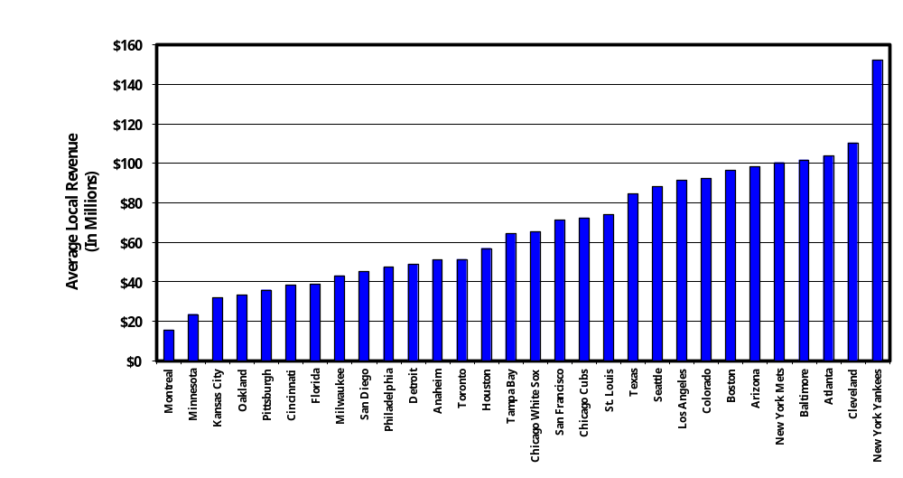
The Blue Ribbon Panel’s Report stated, referring to the comparable chart for the period 1995-1999: “The graphic depiction of the problem illustrates just how steep a mountain the low-revenue clubs have to climb.”
Update—The mountain is still steep for the low revenue clubs. The average local revenue for the clubs at the high end of the graph has grown at a faster rate than the average local revenues of the clubs at the low end of the graph.
The Blue Ribbon Panel’s Report stated: “Local revenues generally are the largest component of most clubs’ annual revenue. Unlike other professional sports, in which a much larger portion of television rights fees are pooled and distributed equally among all teams, most MLB television and radio rights are negotiated and sold locally, in each individual market. Only the rights to network television and radio (essentially rights to postseason games) and a national cable package are sold by MLB, with the revenue going to the Central Fund. Because local markets vary greatly in size, the local TV and radio revenues flowing to each club vary in size by large amounts. The local radio and TV rights received by some clubs exceed the total revenues of other clubs.
“Media market rank also affects other local revenues available to clubs, including the amount they can charge for ballpark naming rights, signage, sponsorships, etc. No matter how well-managed a club might be, it cannot change its media market rank – a factor in the revenue disparity that translates to payroll disparity and competitive imbalance.”
Update—This has not changed.
Chart 3: Average Local Revenue by Revenue Quartile, 1995-2001
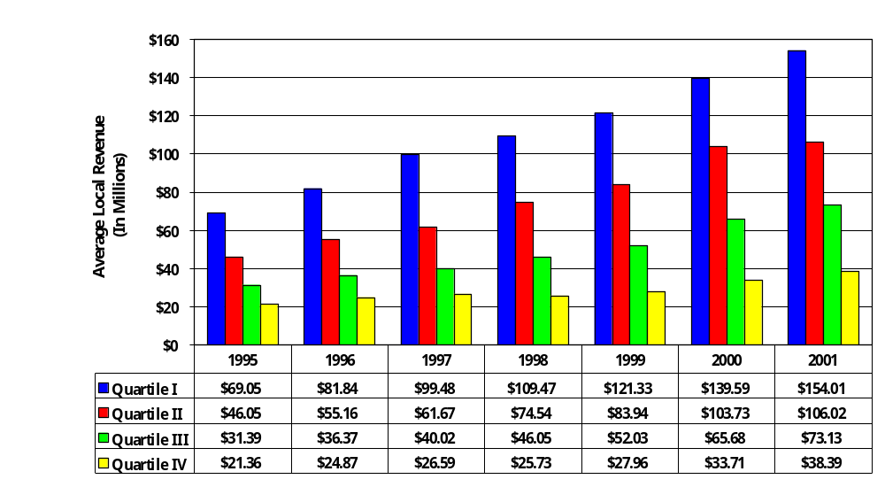

The Blue Ribbon Panel’s Report stated: “The disparity in local revenues also can be examined by considering all clubs in their respective revenue quartiles, where Quartile I contains the highest revenue clubs and Quartile IV contains the lowest revenue clubs.
“Over the period 1995 to 1999, average local revenue (i.e., ticket sales, concessions, local and television and radio, sponsorships, etc.) has increased by $53.5 million for revenue Quartile I clubs, but has increased only an average of $7.9 million for revenue Quartile IV clubs. Revenue Quartile I, Quartile II and Quartile III all had regular increases during the five-year period, as shown below. The average for revenue Quartile IV has not shown a consistent increase. (The average declined from 1997 to 1998.) The seemingly unbridgeable—and ultimately unacceptable—chasm between the ‘haves’ and the ‘have- nots’ has grown wider.”
Update—Over the period 1995 to 2001, average local revenue has increased by $84.96 million for revenue Quartile I clubs, but has increased only by $17.03 million for revenue Quartile IV clubs. The chasm between the “haves” and the “have nots” continues to grow wider.

D. Central Fund Revenues
Table 6: Average Annual Net Central Fund Distribution, 1995-2001
The Blue Ribbon Panel’s Report stated: “Central Fund revenue historically has been distributed equally to all clubs. The table [above] shows the amount of the annual allocation. (Footnote: Net Central Fund distributions may vary slightly—less than 5 percent—from the table to reflect certain financial arrangements, including those for new franchises entering MLB; however, in 1998 and 1999, Arizona and Tampa Bay, as new franchises, received approximately 42 percent and 53 percent of the Central Fund Distribution made to the other 28 clubs.)
“Central Fund distributions have risen each year, but not as fast as the local revenues of some of the highest revenue clubs. The lowest revenue clubs, however, find that their Central Fund distribution is now larger than their local revenues.
“In addition to the central revenues that are shared equally by the clubs through the Central Fund, MLB has, since 1996, redistributed local revenues centrally through the mechanism contained in Article XXV of the Basic Agreement. Over this four-year period through the 2001 season, the higher revenue clubs have redistributed a total of $312 million to lower revenue clubs. Accordingly, in addition to the Central Fund payments a club receives, each club’s total revenue figures reflect the club’s revenue sharing (payments) or receipts.”
Update—The average annual net Central Fund distribution had its largest increase in the seven-year period in 2000, from $13,419,062 in 1999 to $18,186,432. This was in part because of a new network television contract with Fox and a new national cable television package with ESPN. For the first time in the seven-year period, the average annual net Central Fund distribution declined in 2001 from the previous year, to $17,856,000.

E. Club Payrolls
Table 7: Average Club Payroll, 1995-2001
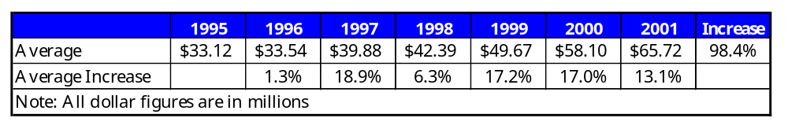
The Blue Ribbon Panel’s Report stated: “Quite simply, the higher revenue clubs have the financial resources to: 1) sign high-salaried free agents from other clubs; 2) retain their own high-salaried players; and 3) sign top prospects from the Rule 4 draft, where signing bonuses for highly sought-after players have risen dramatically in recent years, and players from foreign countries, where players are exempt from the draft and can be signed as free agents. The rich clubs become richer in talent, stockpiling expensive players, while poor teams cannot afford to bid on premium players either at the entry level or on the veteran free agent market.”
Update—The average club payroll has continued to rise, increasing 17 percent in 2000 and 13.1 percent in 2001. The average club payroll increased by 50 percent for the five-year period, 1995-1999. That increase was 98.4 percent for the seven-year period, 1995-2001.

F. Club Competitiveness
Chart 12: Postseason Games Won by Payroll Quartile, 1995-2001
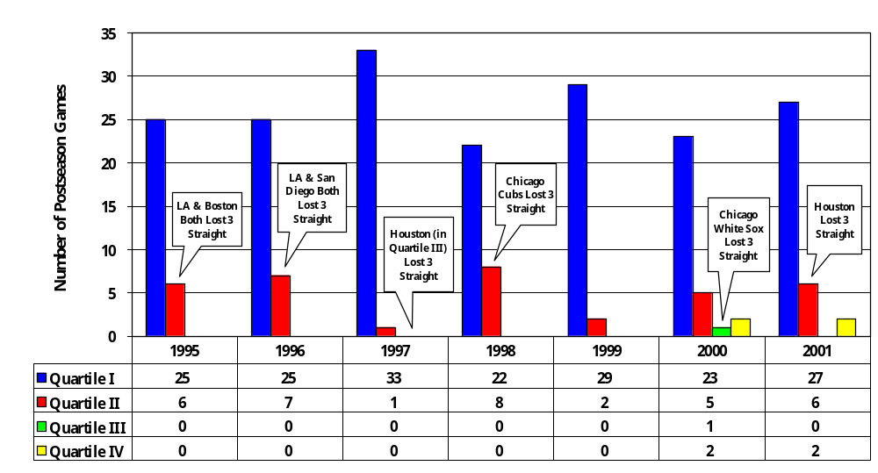
The Blue Ribbon Panel’s Report stated: “The stratification of clubs in different payroll quartiles into consistent contenders, occasional contenders and hopeless pretenders is also reflected when the results of postseason games are analyzed.
“From 1995 through 1999, a total of 158 postseason games were played. During this five-year period, no club from payroll Quartile III or Quartile IV won a postseason game. Further, only one club from payroll Quartile III appeared in the postseason during this period.”
Update—Teams from payroll Quartile III and Quartile IV have reached the postseason four times in 2000 and 2001, and once in 1995-1999, winning a total of five games. None has advanced beyond the Division Series. For the seven-year period 1995-2001, teams from payroll Quartile III and Quartile IV have won only 2.2 percent of all postseason games (five of 224).

G. Club Profitability
Chart 1: Average Annual Operating Income for All Clubs, 1995-2001
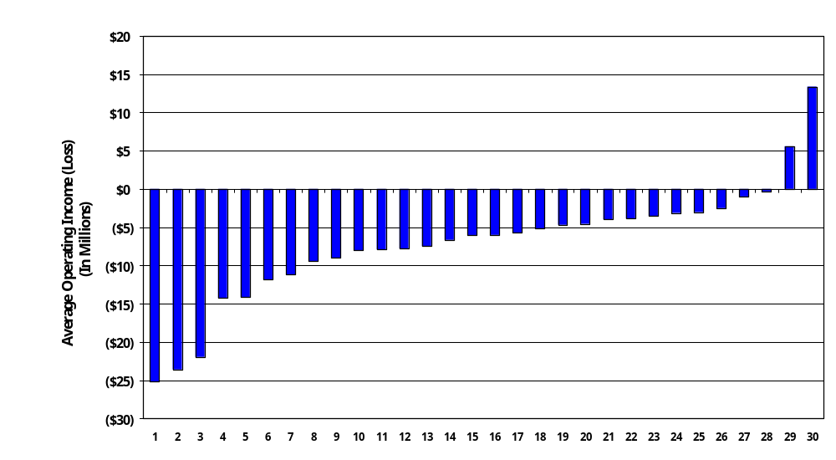

Table 30: Total Operating Income (Loss) by Club, 1995-2001

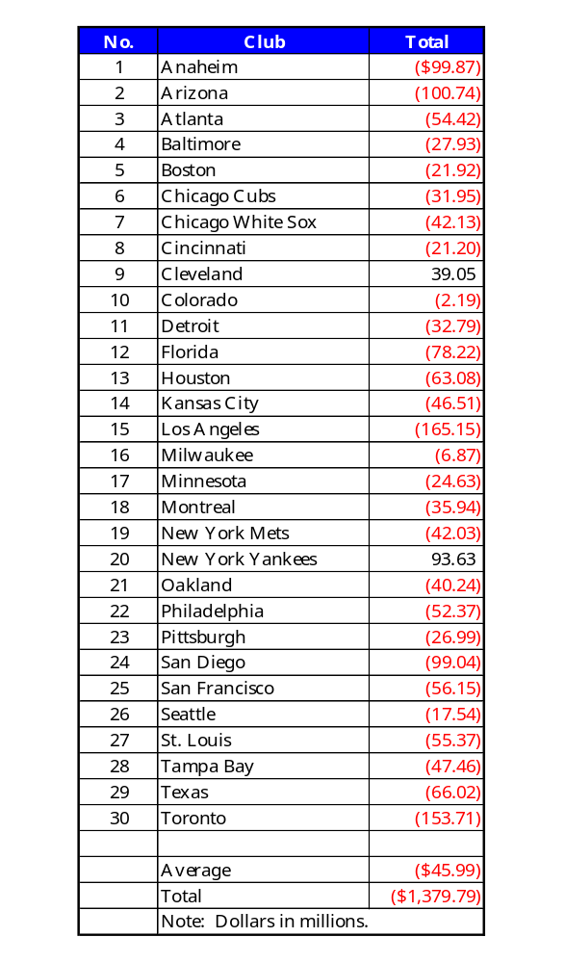
The Blue Ribbon Panel’s Report stated: “From 1995 through 1999, only three clubs achieved profitability: Cleveland, Colorado and the New York Yankees.”
Update—For the seven-year period from 1995 through 2001, only two clubs achieved profitability: Cleveland and the New York Yankees.
Chart 14: MLB Total Revenue and Operating Loss, 1995-2001
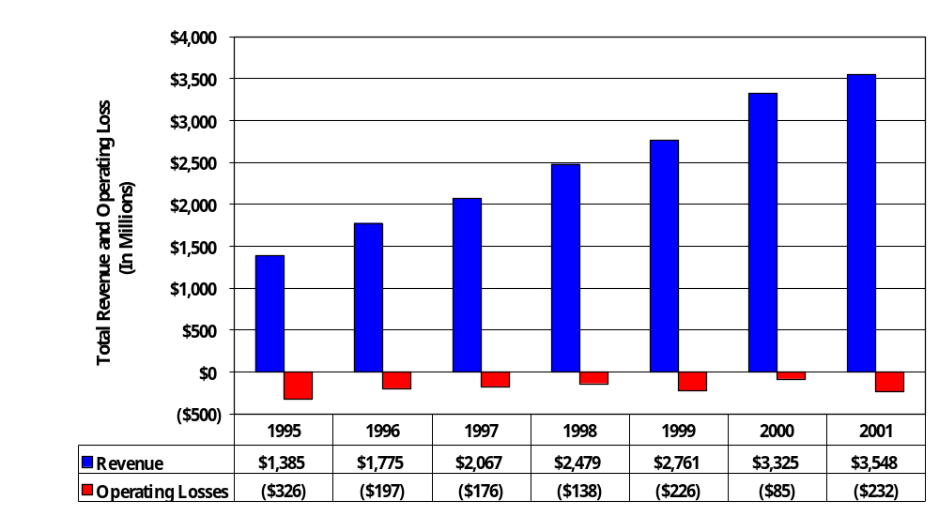
The Blue Ribbon Panel’s Report stated: “Industry revenue has grown impressively in the past five years. Operating income, however, has been another story. While revenue growth has been steady, operating losses improved only slightly from those sustained in 1995, and remain large. The total MLB losses for the past five years exceed $1 billion.”
Update—Industry revenue continued to grow in 2000 and 2001 – as previously noted, by 20.4 percent in 2000 and 6.7 percent in 2001. Operating income continues to be a different story. Total MLB operating losses in 2000, when new network and national cable TV contracts went into effect, new ballparks opened in three cities (San Francisco, Houston, Detroit) and Seattle played its first full season in its new ballpark, were $85 million, the lowest in the seven-year period. Operating losses in 2001 are $232 million, the most since 1995. Total MLB operating losses for the past seven years exceed $1.38 billion.

H. Club (Industry) Debt
Chart 17: Industry Debt, 1993-2001
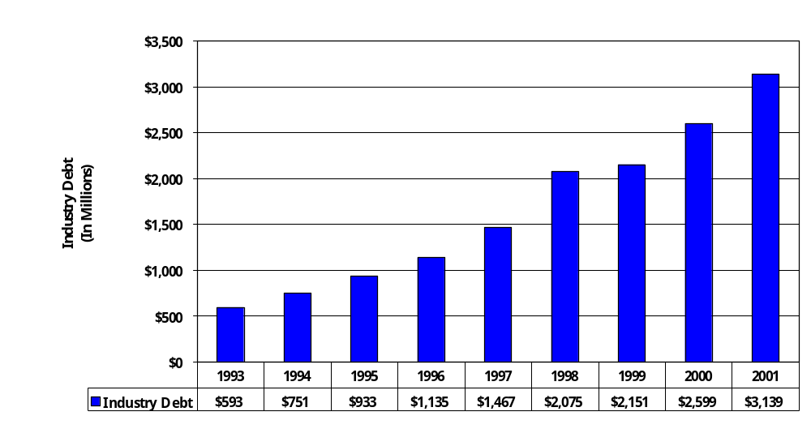
The Blue Ribbon Panel’s Report stated: “Total industry debt (which includes long-term debt, notes payable and revolving credit) has risen 243 percent from 1993 through 1999, the last year for which information was available. The average club debt in 1999 was approximately $69 million, and undoubtedly will continue to rise. Corporate debt has to be serviced, and will exert pressure on club economics. Many clubs have reached dangerous levels of debt.”
Update—Total industry debt has risen from $593 million in 1993 to 3.14 billion in 2001 (429 percent). The average club debt in 2001 is approximately $105 million. (This excludes deferred compensation. Deferred compensation commitments in 2001 total an additional $1.11 billion, with eight clubs that have commitments exceeding $60 million. Deferred compensation has increased by more than 300 percent since 1995.)
VI. Appendix A

Detailed Data on Local Revenue, Total Revenue and Payroll by Club, 1995-2001

Appendix III to the Blue Ribbon Panel’s Report included detailed information on local revenue, total revenue, and payroll by club for the period 1995-1999. This information has been updated to include 2000 and 2001 in the following tables.

Table 27: Local Revenues by Club, 1995-2001

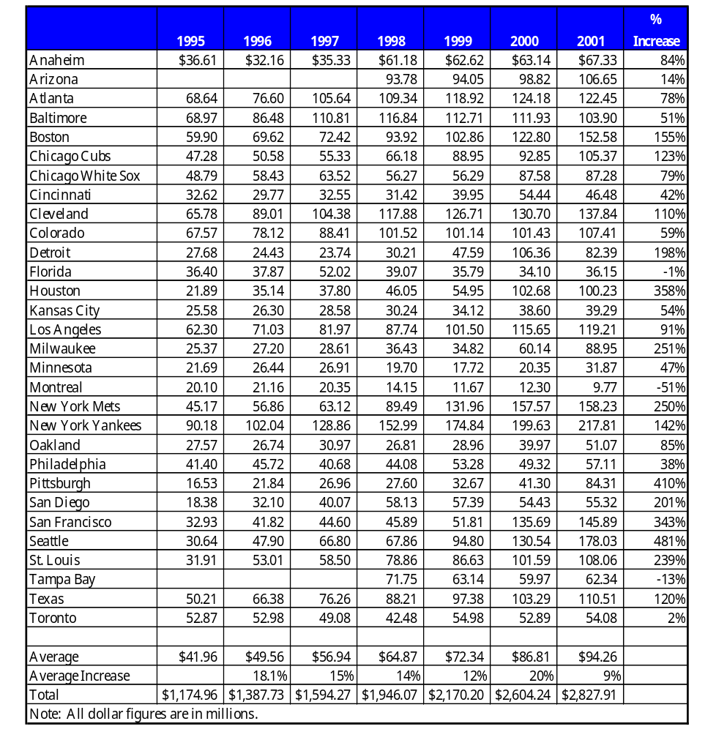

Table 28: Total Revenue by Club, After Revenue Sharing, 1995-2001

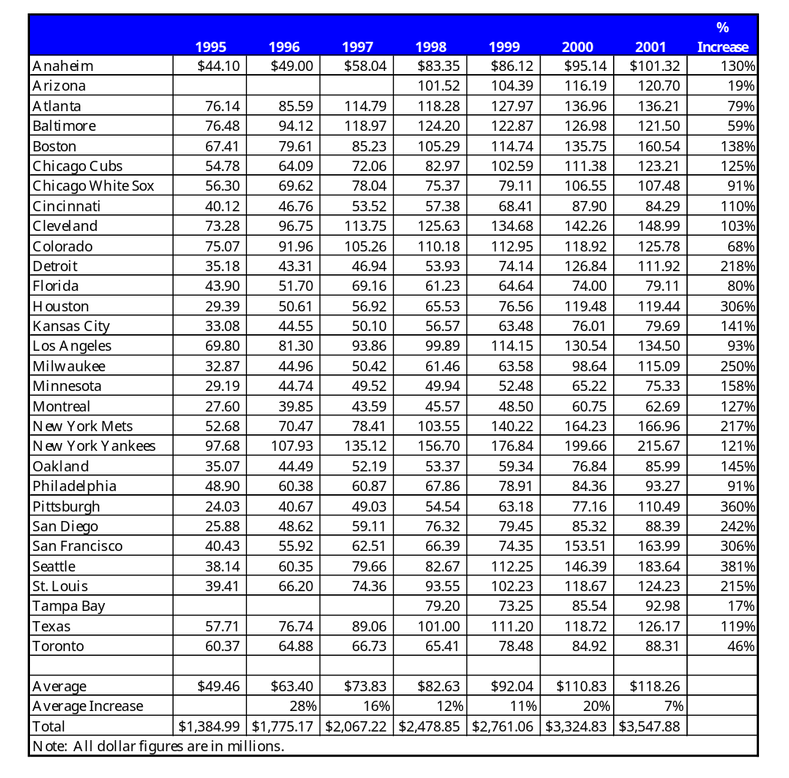

Table 29: Payroll by Club (25-Man Roster), 1995-2001

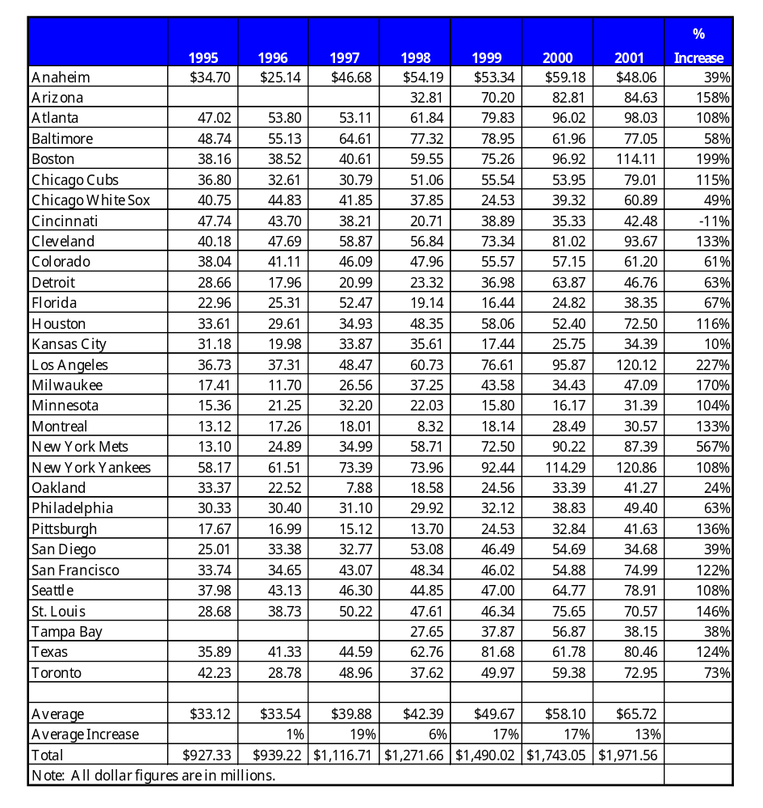
VII. Appendix B

Definitions

- Revenue
  - Local revenue consists of gate receipts, local television, radio and cable rights fees, ballpark concessions, local advertising, sponsorship and publications, parking, suite rentals and postseason and spring training revenues. Local revenues are the largest single component of most clubs’ total annual revenues.
  - Central Fund revenue is the money distributed to clubs from national licensing fees and television/radio contracts.
  - Revenue sharing receipts/payments, introduced in 1996, are local revenues transferred by formula from high-revenue clubs to low-revenue clubs.

- Payroll
  - Payroll is calculated from the active 25-man roster (including players on the disabled lists) as of August 31 each year and termination pay where applicable.
  - The MLB Labor Relations Department defines the 25-man roster payrolls to include guaranteed base salary, earned incentives and a pro-rated allocation of signing bonuses.

- Revenue and Payroll Quartiles
  - For the purposes of the Blue Ribbon Panel Report, and this update, clubs were divided into four quartiles based on revenue and payroll. Revenue Quartile I clubs had the greatest revenue, while Quartile IV clubs had the lowest. Similarly, payroll Quartile I clubs were those with the largest player payrolls, while Quartile IV clubs were those with the smallest payrolls.
  - Prior to expansion in 1998, each quartile consisted of seven clubs. After the 1998 expansion, Quartile I and Quartile III have eight clubs and Quartile II and Quartile IV have seven clubs.

