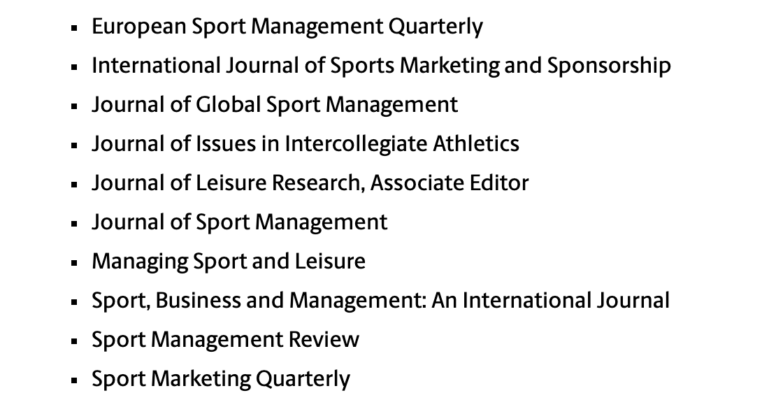

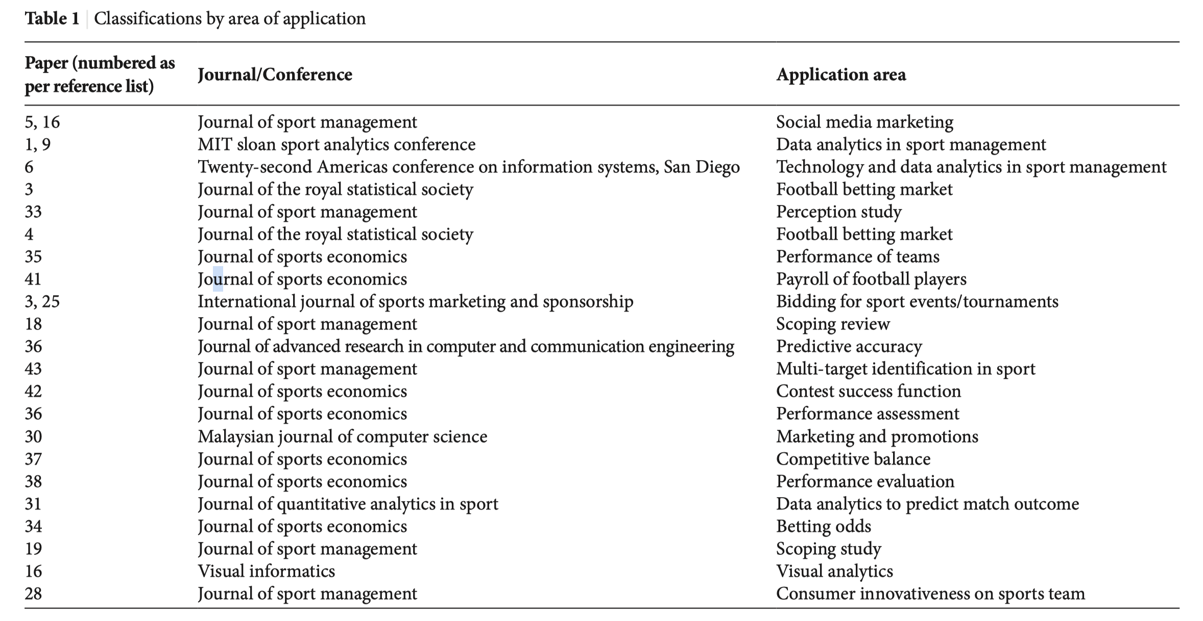

Aug. 25 Article #1 Jianakoplos, N.A. & Shields, M. (2012) Practice or Profits: Does the NFL Preseason Matter? Journal of Sports Economics, (13:4) 451-465. Oct. 6 Article #2 Garcia, J. & Rodriguez, P. (2002) The Determinants of Football Match Attendance Revisited: Empirical Evidence from the Spanish Football League. Journal of Sports Economics, 18-38. Oct. 20 Article #3 Leeds, Michael A. (2007) Do Good Olympics Make Good Neighbors? Contemporary Economics Policy, 460-467. Oct. 27 Article #4 Coates, D. & Humphreys, B.R. (2005) Novelty Effects of New Facilities on Attendance at Professional Sporting Events. Contemporary Economic Policy, 436-455. Nov.3 Article #5 Hakes, J. K., & Sauer, R. D. (2006) An Economic Explanation of the "Moneyball" Hypothesis. Journal of Economic Perspectives , 173-185. Nov. 10 Article #6 Schmidt, M.B. & Berri, D.J. (2004) The Impact of Labor Strikes on Consumer Demand: An Application to Professional Sports. American Economic Review, 344-357.

