**Assumptions**

1. User can load card with provided balance details at the start ( 5, 10, 15, 20, 30, 50)
2. Valid trip will start with either Tube or Bus number.
3. All bus fares are same irrespective of any zone, which is £ 1.80.
4. For Bus trip user is charged with maximum fare of £ 1.80.
5. Valid bus number is less than 1000 and greater than 0.
6. Any two zones including zone 1 🡪 it includes zone 1 to 2 or 2 to 1 but can’t include zone 1 to 3 as it will include 1, 2 & 3 which equals any three zones.
7. Any station cannot be in more than 2 zones.
8. If user does not swap out in that case to station is empty

For example: “Tube Holborn to “ 🡪 for this type of input it will be considered that, user has not swipe out for this journey, so it will be charged maximum fare (which is £3.20 ).

**StationDetails.java file contains Fare details as per below assumption**

**zoneFares is a map with “from,to” as key and fare as value of map as shown below**

zoneFares.put ("1,1",2.5); 🡪 Anywhere in zone 1

zoneFares.put ("2,2",2.0); 🡪 Any one zone outside zone 1

zoneFares.put ("3,3",2.0); 🡪 Any one zone outside zone 1

zoneFares.put ("1,2",3.0); 🡪 Any two zones including zone 1

zoneFares.put ("2,1",3.0); 🡪 Any two zones including zone 1

zoneFares.put ("2,3",2.25); 🡪 Any two zones excluding zone 1

zoneFares.put ("3,2",2.25); 🡪 Any two zones excluding zone 1

zoneFares.put ("1,3",3.2); 🡪 Any three zones (from 1 to 3)

zoneFares.put ("3,1",3.2); 🡪 Any three zones (from 3 to 1)

zoneFares.put ("bus",1.80); 🡪 Any bus journey

**Class Diagram**

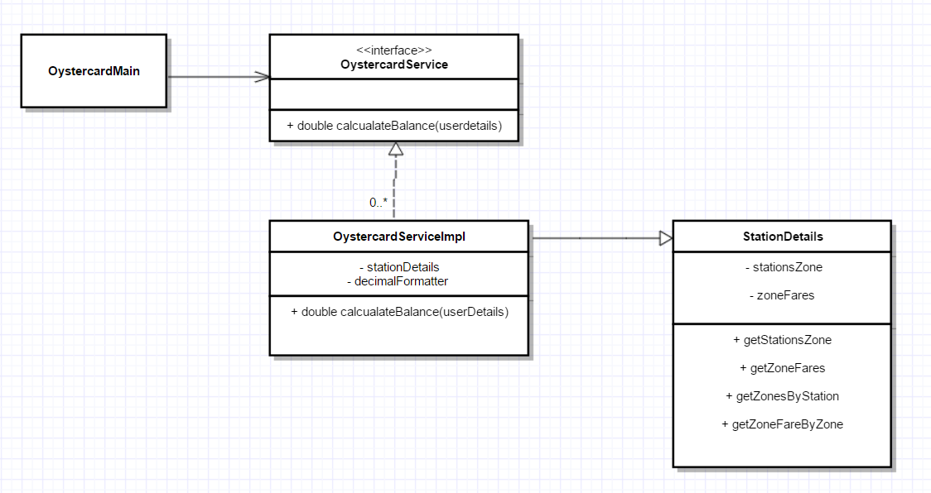

**Prerequisite:**

1. JDK1.8
2. Maven 3.3.9
3. IntelliJ Idea (or any Java IDE like Eclipse)

**How to run program**

1. Load pom.xml from projects root directory.
2. Run Test Cases to Test the program 🡪 OystercardServiceImplTest has all the test case to test different the program with different inputs.
3. Alternatively you can also run Main program to test 🡪 Execute 🡪 OystercardMain.java

Sample Input / Output after executing **OystercardMain.java**

***************** Oyster Card System ********************

Choose amount to load card with initial balance

1. £10

2. £20

3. £30

4. £40

5. £50

3

Please enter number of trips user has taken

10

Enter user's trip details

Enter Trip#1: Tube Wimbledon to Earl's Court

Enter Trip#2: Tube Earl's court to Holborn

Enter Trip#3: Tube Earl's court to Hammersmith

Enter Trip#4: 328 bus from Earl's Court to

Enter Trip#5: Tube Holborn to

Enter Trip#6: 328 bus from Earl's Court to Chelsea

Enter Trip#7: Tube Earl's court to Holborn

Enter Trip#8: Tube Wimbledon to Holborn

Enter Trip#9: Tube Wimbledon to Wimbledon

Enter Trip#10: Tube Holborn to Holborn

Output🡪

User's journey details -->

Fare for trip -> Tube Wimbledon to Earl's Court = 2.25

Fare for trip -> Tube Earl's court to Holborn = 2.5

Fare for trip -> Tube Earl's court to Hammersmith = 2.0

Fare for trip -> 328 bus from Earl's Court to = 1.8

Fare for trip -> Tube Holborn to = 3.2

Fare for trip -> 328 bus from Earl's Court to Chelsea = 1.8

Fare for trip -> Tube Earl's court to Holborn = 2.5

Fare for trip -> Tube Wimbledon to Holborn = 3.2

Fare for trip -> Tube Wimbledon to Wimbledon = 2.0

Fare for trip -> Tube Holborn to Holborn = 2.5

**Users remaining balance is: 6.25**