**CSC 391 Project 1**

**3.2.1 Spatial filter**

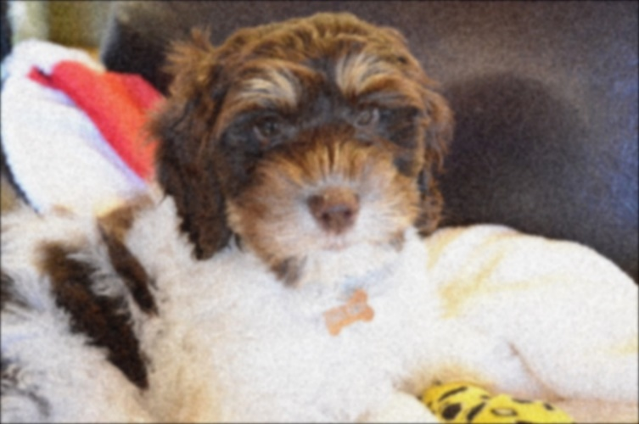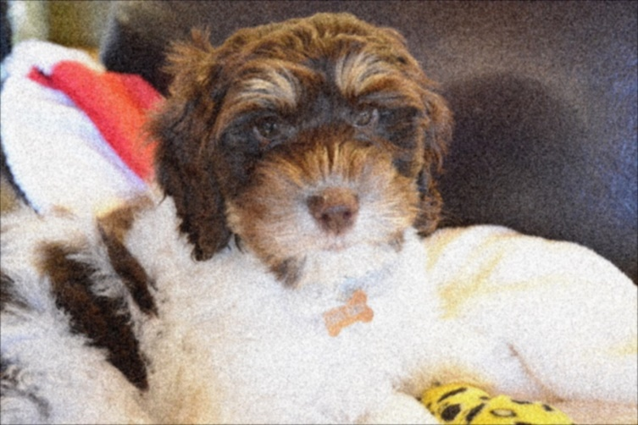Gaussian 5x5 Gaussian 11x11

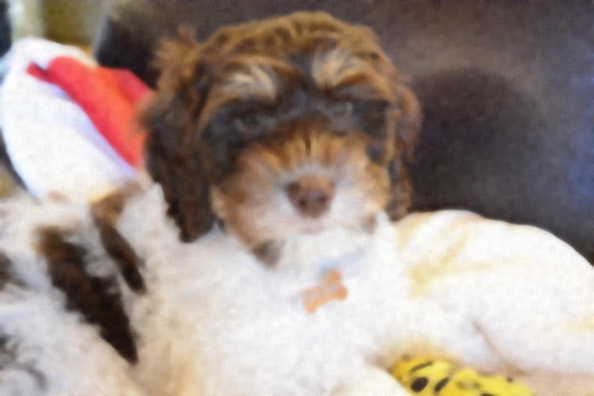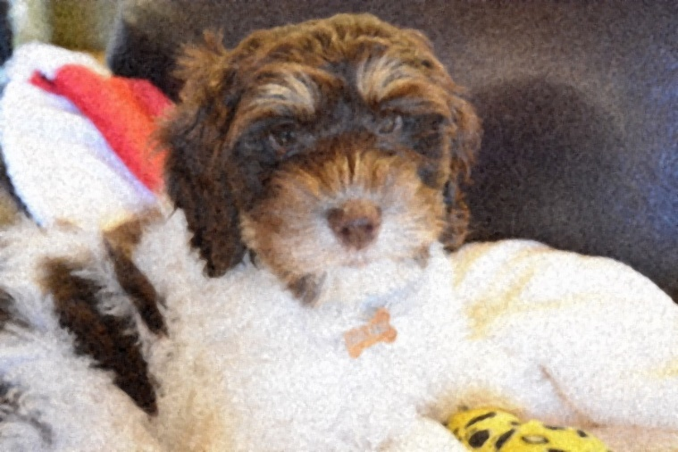Median 5x5 Median 11x11

In both filters, with better denoising performance, the resolution gets lower. This is probably because with a filter of larger size, the filter will use more neighbors to impute the pixel. This leads to a better denoising result while also blurring edges.

**3.2.2 Canny edge detection**

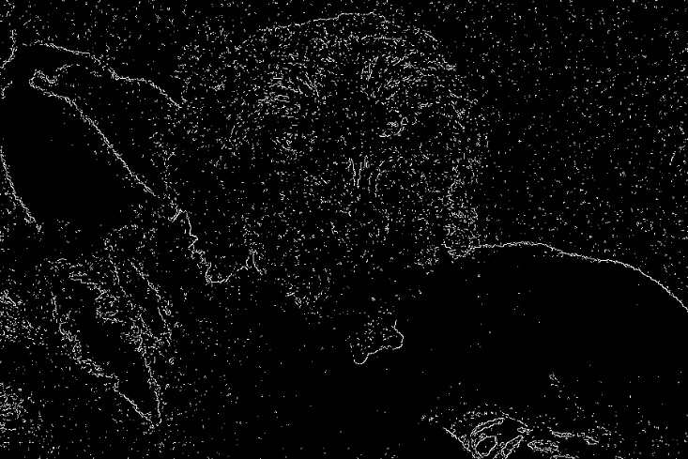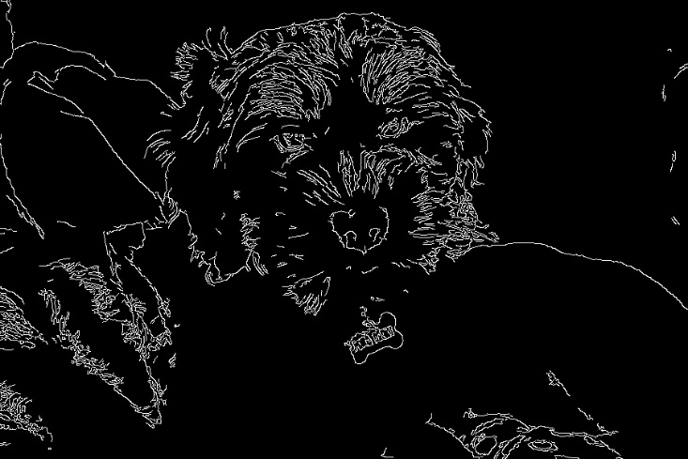Original Noisy

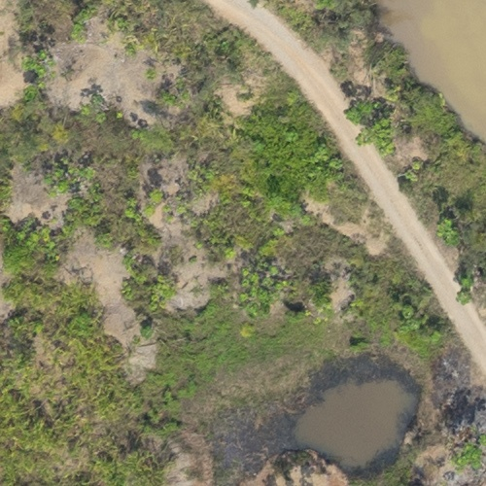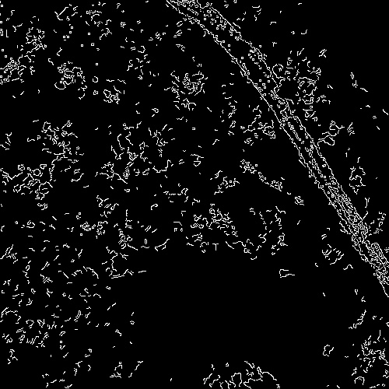Field image

In order to better extract edges from the noisy image, I first apply Gaussian filter to the noisy image and then try the edge detection.

**4.1 2-D DFT**

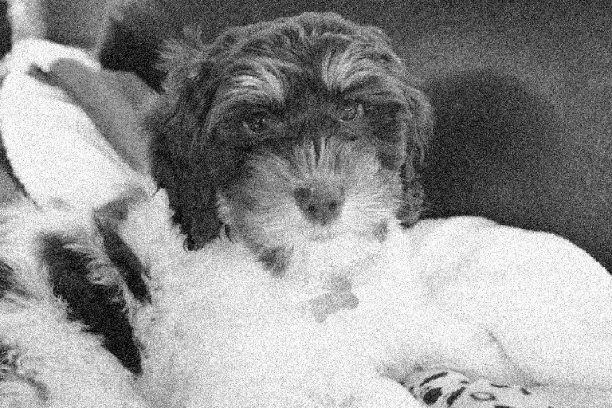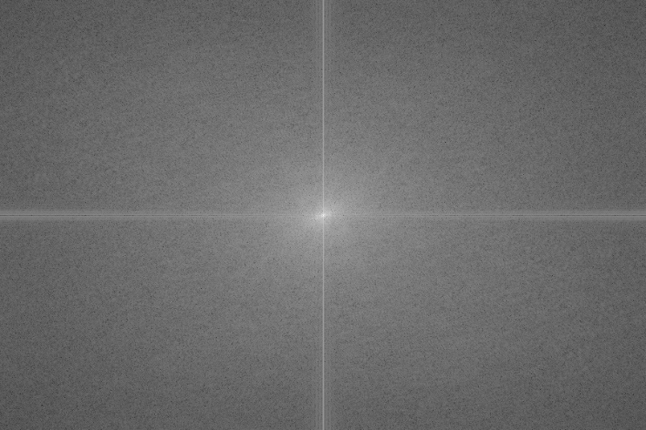Log(Magnitude+1) of DFT Original gray image

Magnitude

**4.2 Frequency analysis**

1. When the image is smoother (less artificial content), the coefficient decays faster, because smoother images tend to have less high-frequency “ingredients”
2. The noisy one gives the Fourier coefficients of higher frequency a greater magnitude compared to the original image.

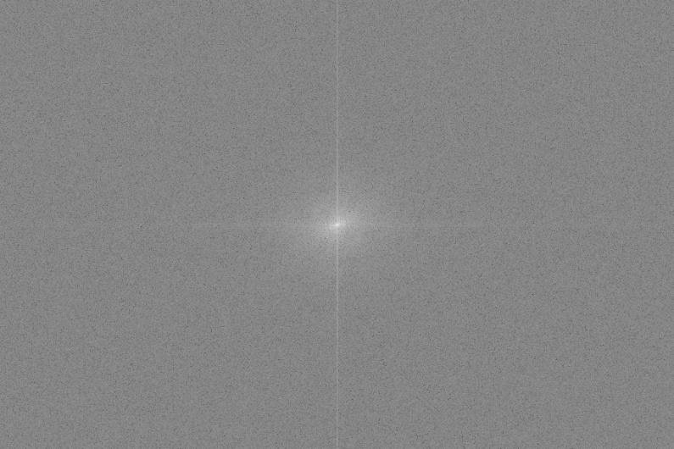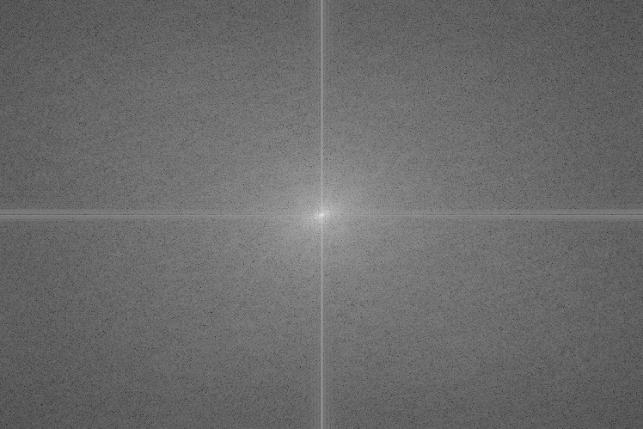 DFT of original puppy image DFT of 0.5-noisy puppy image

1. Because the image has strong edges along that direction, which is, in this case, along the axis.
2. Removing coefficient far away from the center will make the image blurred. (Like an ideal low pass filter)

Removing coefficients near the center only leaves high frequencies, which is some specific edges. (Like an ideal high pass filter)

When smoothing an image, we can use low pass filter, and when we want edge detection, we can apply the high pass filter.

**5.1 Butterworth low pass filter**

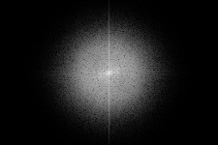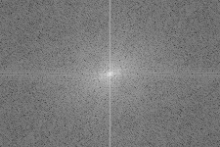Original LogMagnitude Butterworth low pass LogMagnitude

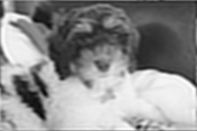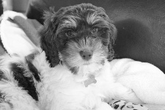

**5.2 Compare ideal and Butterworth filter**

Ideal low pass Butter low pass



Ideal high pass Butter high pass

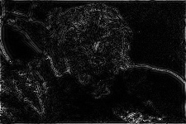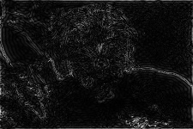

By my observation, the ideal filters have more noise in the image than Butterworth filters do.

This is because Butterworth low/high pass filter removes frequencies out of the threshold in a smoother way, while the ideal low/high pass filter obtains a very sharp decay around the cutoff frequency.