Procedure

1. Create Employee Table
CREATE TABLE employee (
id INT PRIMARY KEY,
name VARCHAR(50),
salary INT
);

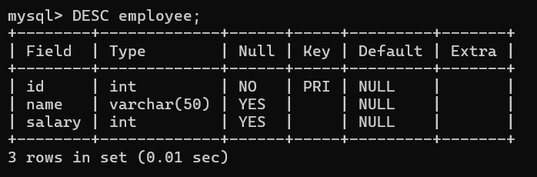

2. Insert Sample Data (for testing)
INSERT INTO employee VALUES
(101, 'Prajwal', 30000),
(102, 'Prafull', 35000),
(103, 'Pratap', 40000);
SELECT * FROM employee;
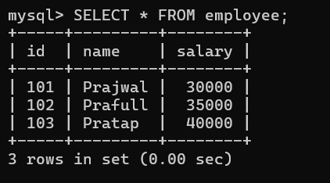

Program 1. insert employee

DELIMITER //
CREATE PROCEDURE addEmployee(
IN eid INT,
IN ename VARCHAR(50),
IN esalary INT
)
BEGIN
INSERT INTO employee(id, name, salary)
VALUES(eid, ename, esalary);
END //
DELIMITER ;

▶ Call
CALL addEmployee(101, 'Prajwal', 40000);
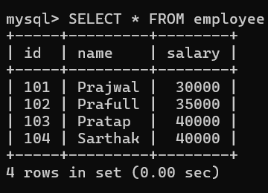

Program 2. search record
DELIMITER //
CREATE PROCEDURE getEmployeeById(
IN emp_id INT
)
BEGIN
SELECT * FROM employee
WHERE id = emp_id;
END //
DELIMITER ;

▶ Call
CALL getEmployeeById(101);

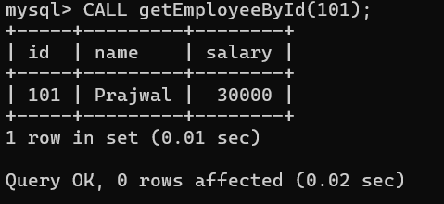
- Update
DELIMITER //
CREATE PROCEDURE updateEmployeeSalary(
IN emp_id INT,
IN new_salary INT
)
BEGIN
UPDATE employee
SET salary = new_salary
WHERE id = emp_id;
END //
DELIMITER ;

Call
CALL updateEmployeeSalary(101, 50000);

Select * from employee;
