Function
DELIMITER //
CREATE FUNCTION CalculateBonus(salary INT)
RETURNS INT
DETERMINISTIC
BEGIN
DECLARE bonus INT;
SET bonus = salary * 0.15;
RETURN bonus;
END //
DELIMITER ;
SELECT CalculateBonus(50000) AS bonus;
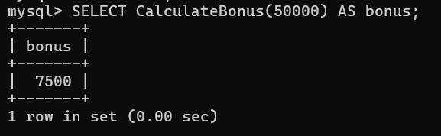
SELECT name, salary, CalculateBonus(salary) AS bonus
FROM employees;
