A.CREATE TABLE
CREATE TABLE main (
id INT PRIMARY KEY,
salary INT
);
B.Insert data into table
INSERT INTO main (id, salary)
VALUES
(1, 50000),
(2, 60000),
(3, 45000),
(4, 70000),
(5, 55000);
SELECT * FROM main;
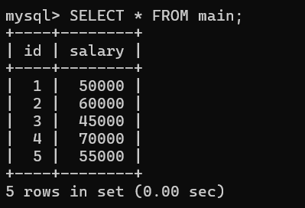

1.Before insert Triggers
DELIMITER //

CREATE TRIGGER t_before_insert
BEFORE INSERT ON main
FOR EACH ROW
BEGIN
IF NEW.salary < 0 THEN
SET NEW.salary = 0;
END IF;
END //

DELIMITER ;

INSERT INTO main VALUES (8, -5000);

SELECT * FROM main;
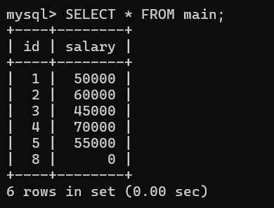

2.After insert

DELIMITER //

CREATE TRIGGER t_after_insert
AFTER INSERT ON main
FOR EACH ROW
BEGIN
INSERT INTO backup(id, salary)
VALUES (NEW.id, NEW.salary);
END //

DELIMITER ;

INSERT INTO main VALUES (11, 5000);
INSERT INTO main VALUES (12, 10000);
SELECT*FROM main;
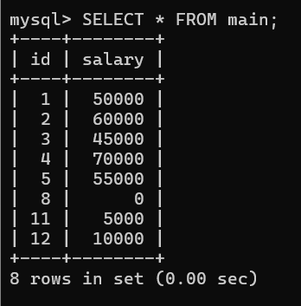
SELECT * FROM backup;
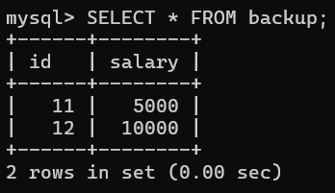

3.Before update

DELIMITER //

CREATE TRIGGER before_update_salary
BEFORE UPDATE ON employees
FOR EACH ROW
BEGIN
IF NEW.salary < 5000 THEN
SIGNAL SQLSTATE '45000'
SET MESSAGE_TEXT = 'Salary cannot be less than 5000';
END IF;
END;
//
DELIMITER ;

Check output:
Valid: UPDATE employees SET salary = 8000 WHERE id = 1;
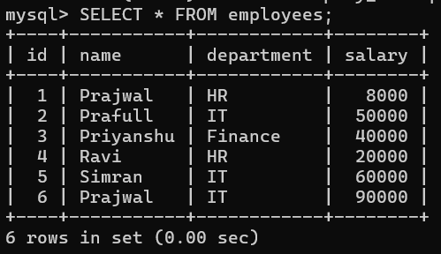

Invalid: UPDATE employees SET salary = 3000 WHERE id = 1;

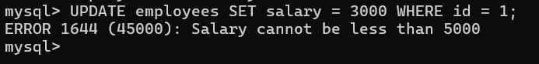

- After update
DELIMITER //
create trigger after_u
after update on main
for each row
begin
insert into backup(id,salary)
values(OLD.id, OLD.salary);
insert into update_log(id, old_salary, new_salary) values (OLD.id, OLD.salary, NEW.salary);
end;
//
DELIMITER ;

SELECT*FROM main;
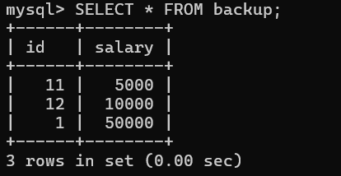
SELECT * FROM update_log;
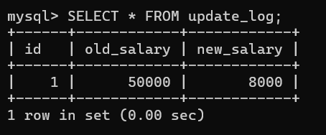

- Before delete
DELIMITER //
create trigger before_delet_main
before delete on main
for each row
begin
insert into backup(id,salary) values (old.id,old.salary);
end;
//
DELETE FROM main WHERE id = 1;
SELECT * FROM backup;
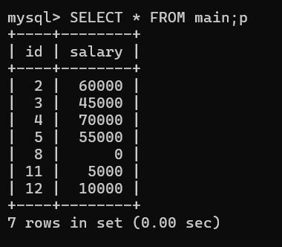

- after delete
DELIMITER //

CREATE TRIGGER after_delete_main
AFTER DELETE ON main
FOR EACH ROW
BEGIN
INSERT INTO backup(id, salary)
VALUES (OLD.id, OLD.salary);
END //

DELIMITER ;

INSERT INTO main VALUES (1, 5000);
DELETE FROM main WHERE id = 1;
SELECT * FROM backup;
