Updated August 2025

Main Manuscript for
Effective Network Profiles of the Human Cingulate Gyrus
Phillip Demarest^{1,2,3}; Patrick Luckett^{1,3}; Gansheng Tan^{1,2,3}; Xiaoxuan Liu^{1,2,3}; Siddharth S. Sivakumar^{1,2,3}; Tao Xie^{1,3}; Hohyun Cho^{1,3}; James R. Swift^{1,3}; Markus Adamek^{1,3}; William Engelhardt^{1,3}; Simon Haroutounian^{4,5}; Lawrence N. Eisenman⁶; Adam S. Greenblatt⁶; *Jon T. Willie⁷; *Peter Brunner^{1,3}; *Eric C. Leuthardt^{1,2,3}

- Division of Neurotechnology, Department of Neurosurgery,
Washington University in St. Louis School of Medicine, St Louis, MO, 63110, USA.
- Department of Biomedical Engineering, McKelvey School of Engineering,
Washington University in St. Louis, St Louis, MO, 63130, USA.
- Department of Neurosurgery, Washington University in St. Louis School of Medicine, St Louis, MO, 63110, USA.
- Division of Clinical and Translational Research, Department of Anesthesiology,
Washington University in St. Louis School of Medicine, St Louis, MO, 63110, USA.
- Washington University Pain Center, Washington University in St. Louis School of
Medicine, St Louis, MO, 63110, USA.
- Department of Neurology, Washington University in St. Louis School of Medicine, St Louis, MO, 63110, USA.
- Department of Neurosurgery, The University of Texas at Austin, Dell Medical School, Austin, Texas, 78712, USA.

*Corresponding Author Eric C. Leuthardt
Email: leuthardte@wustl.edu
PNAS requires the corresponding author to provide an ORCID identifier at submission and strongly encourages all authors to use an ORCID ID. Do not include ORCIDs in the manuscript file; individual authors must link their ORCID account to their PNAS profile at www.pnascentral.org. For proper authentication, authors are not permitted to add ORCIDs on proofs. Learn more or register for ORCID.
Author Contributions:
Conceptualization: PD, JTW, PB, ECL
Methodology: PD, PL, GT, XL, TX, HC, JS, WE, SH, MA, LNE, ASG, JTW, PB, ECL
Investigation: PD, PL, JTW, PB, ECL
Visualization: PD, PL, GT, SSS, JTW, PB, ECL
Supervision: JTW, PB, ECL
Writing—original draft: PD, ECL
Writing—review & editing: PD, PL, GT, XL, SSS, TX, HC, JS, WE, SH, MA, LNE, ASG, JTW, PB, ECL

Competing Interest Statement: The Authors declare that they have no competing interests.
Classification: Biological Sciences: Neuroscience
Keywords: Cingulate Cortex, Cortico-cortical evoked potentials, effective connectivity

This PDF file includes:
Main Text
Figures 1 to 5

Abstract
The human cingulate gyrus supports diverse functions, yet its effective networks lack standardized, network-level models. We mapped the effective networks of the anterior, mid, and posterior cingulate in 15 resection-free patients using single-pulse electrical stimulation and multimodal analysis of cortico-cortical evoked potentials (CCEPs). A morphology-based CCEP coherence measure complemented conventional amplitude-based measures, revealing connections undetected by amplitude alone. Across cingulate effective networks, we identified cortical hub regions with shared connectivity across all cingulate subregions, an anterior-posterior connectivity gradient consistent with known cingulum white-matter organization, and evaluated the morphological heterogeneity of CCEPs across the cortex for each effective network. Finally, a random forest classification model trained on CCEP features distinguished cingulate subregion networks with 75% accuracy and revealed that conventional assumption-based features had the lowest predictive strength. These results motivate multimodal, data-driven approaches to modeling effective connectivity and provide detailed, network-level models of the human cingulate.
Significance Statement
Invasive electrical stimulation is one of the few ways to map causal interactions in the living human brain. We compare effective networks across anterior, mid, and posterior cingulate subregions, identify core regions that show shared connectivity across subregions, and reveal a clear anterior-posterior gradient in network organization. Our quantitative framework supports network-level comparisons beyond conventional methods, improving how stimulation-evoked networks are defined and compared. Furthermore, understanding cingulate connectivity has direct clinical and scientific relevance as cingulate subregions are often targeted for neuropsychiatric disorders such as depression, anxiety, and pain, and due to their functional role in cognition and behavior.

Main Text

Introduction

In humans, the cingulate gyrus (Cg) is widely recognized as a central locus involved in a broad range of processes. Forming an arch-shaped convolution directly dorsal to the corpus callosum, the Cg has historically been defined by its functional, anatomical, connective, and cytoarchitecturally distinct subdivisions (1–9). The most formal model of the Cg groups these subdivisions into four regions: the anterior cingulate cortex (ACC), midcingulate cortex (MCC), posterior cingulate cortex (PCC), and retrosplenial cortex (3, 6).
The ACC is one of the most widely studied cortical regions and is implicated in cognitive control, autonomic control, social cognition, decision-making, prediction error, pain, and emotion (10–16). The ACC’s diverse functional profile affords an equally intricate repertoire of functional and structural connections. The most well-documented connections are with limbic, frontal, orbitofrontal, parietal, thalamic, cingulate, and midbrain structures (2, 4, 8, 17). The MCC has two functionally and connectively distinct divisions consisting of its anterior and posterior sections. The anterior section has been reported to have functional overlap with the ACC, especially in cognitive and sensory-related functions. Uniquely, the MCC, especially its posterior section, plays a primary role in reflexive orientation and response selection. The MCC is anatomically adjacent and strongly connected to somatomotor regions, and thus, plays a role in sensory and motor-related behaviors (4, 18). The PCC and retrosplenial cortex, while functionally distinct, are often grouped anatomically. These are key regions in the human default mode network, and have well-established functional roles in memory, introspection, self-referential cognition, visual processing, and attention. These regions have documented functional and structural connections to limbic, frontal, orbitofrontal, visual, cingulate, and parietal areas (4, 10, 19–21).
The human Cg is studied in the field of human connectivity most often due to its complexity, relevance to cognition and behavior, and role in various disease states (22). Connectivity is often studied through a functional or structural lens. Functional connectivity represents connections between regions based on the shared statistical content of the physiology recorded within brain regions, typically under behavioral paradigms. Unlike structural connectivity, functional connectivity draws connections between regions regardless of direct structural links (23, 24). In contrast, structural connectivity infers the presence and direction of white matter fibers between regions (25). While these metrics are both useful and accessible through modern imaging techniques, they do not resolve the cause-and-effect relationships between structures, or the nuanced physiology indicative of one neuronal population’s influence over another.
Effective connectivity refers to the influence one neuronal population has over another (23). While this measure can be inferred statistically, interventional methods such as direct electrical stimulation of brain regions provide causal models of effective connectivity. Specifically, stereotactic electroencephalography (SEEG)-mediated direct single-pulse electrical stimulation (SPES) of brain regions produces cortico-cortical evoked potentials (CCEPs) in effectively connected regions. Subsequently, the analysis of CCEP quality and characteristics elucidates the mechanisms of how the stimulated region influences effectively connected areas (26). For example, CCEP magnitude indicates the strength of directional connectivity, CCEP latency reflects aspects of fiber pathways such as distance from the site of stimulation, and CCEP morphological features can provide insight into the neurophysiological processes that influence effective pathways (e.g., connection directness, pathway signatures, directionality of connections) (27–31).
While CCEP analysis has the potential to reveal invaluable information on the dynamics and function of neural systems, the lack of a formally established methodology and analysis standards limits the utility and interpretability of effective connectivity characterization (29, 32). This is especially true for evaluating the effective networks of the Cg, as its functional complexity and highly integrated nature likely follow intricate effective connections throughout the brain. Current studies of effective connectivity, even those evaluating the networks of the Cg, use highly variable stimulation parameters, drastically affecting CCEP characteristics, or include data from patients with major cortical resections, which alters tractography and cortical physiology (27, 33, 34). Analytical methods also have an effect on the statistical content and interpretability of CCEPs. Therefore, the choice of analytical method directly determines how the effective connections between regions are characterized and defined. For example, studies of effective connectivity often use CCEP magnitude or rely on pre-defined assumptions about CCEP shape, thus limiting the utility and depth of network-wide characterization (28, 29). Further, due to the high dimensionality of data required to profile entire effective networks, studies of effective connectivity utilizing more rigorous analytical approaches often focus on subsets of networks, especially in work investigating hypothesis-preselected circuits. While these methods are critical for providing deep insight into the neural mechanisms of the connections comprising networks, this level of detail makes it difficult to profile entire effective networks and compare them (29, 32, 35). Furthermore, understanding effective networks, especially those of the human Cg, has direct clinical relevance as subregions are targeted for interventions to treat a diverse set of neuropsychiatric disorders, including depression, anxiety, and pain (36–38).
The present study presents a comparison between the divergent profiles of the human ACC, MCC, and PCC (including retrosplenial cortex) effective networks acquired through direct SPES. Data were acquired using constant SPES parameters from patients without any resections. Cg subregion profiles were modeled across a breadth of features extracted from CCEPs, including magnitude, morphology, morphological diversity, inter-regional similarity, spatial patterning, temporal dynamics, broadband gamma content, assumption-free waveform features, and assumption-based waveform features. Our study provides a network-level profile of the characteristics, similarities, and differences between the Cg effective networks modeled across several metrics. Further, through a machine-learning approach, we provide direct, quantitative evidence on the utility of effective connectivity metrics used to model effective networks, specifically by characterizing their predictive strength in classifying Cg networks. In aggregate, this work provides a comprehensive foundation for classifying the complex interactions that the Cg has with the rest of the brain.

Results

Patient Demographics, SEEG Coverage, and Stimulation Locations
Our models of Cg effective connectivity were derived from invasive electrophysiological data obtained from 15 patients with intractable epilepsy undergoing invasive SEEG monitoring (Age: mean ±SD, 33.3 ±11.85). Details, including patient duration of invasive monitoring, and clinical details, can be found in Supplemental Table 1. Experimental design is shown in Figure 1a.
The number of channels within each major brain region across patients in our study population is shown in Figure 1b. There was a median of 156 contacts ± 64.5 MAD across major brain regions, with the temporal lobe containing 1060 channels, the frontal lobe containing 484 channels, and the orbitofrontal cortex containing 223 channels. The number of contacts within the cingulate cortex (167), somato-motor cortices (198), hippocampus (145), amygdala (94), and insula (212) were within the MAD across all regions. The operculum (88), parietal lobe (80), and thalamus (16) were the least sampled regions.
Figure 1c shows a breakdown of the stimulation locations within the Cg. Within our study population, 40% of stimulations were delivered to the left Cg, with 18.4% of stimulations occurring at the left ACC, 14.8% at the left MCC, and 6.4% at the left PCC, and 60% were delivered to the right Cg, with 26.4% of stimulations occurring at the right ACC, 24.9% at the right MCC, and 8.8% at the right PCC.
Figure 1d shows a set of exemplar CCEPs recorded from different brain regions in response to stimulation of the ACC, MCC, or PCC. The morphological characteristics of the CCEPs vary depending on where the response was recorded and which subregion was stimulated.
CEP Coherence as a Measure of Effective Connectivity
While CCEP magnitude (CCEP_{mag}) is useful for detecting regions effectively connected to the site of stimulation, it does not reveal CCEP morphological information, which is necessary for insight into the dynamics and functional properties of inter-regional connectivity (29). To this end, we implemented a CCEP coherence (CCEP_{coh}) measure, in addition to CCEP_{mag} (measured as response RMS), to quantify the effective connectivity of the Cg subregions to other cortical areas. Since CCEPs resulting from SPES are characterized by detectible statistical changes in the local-field potential (LFP) morphology of regions effectively connected to stimulated tissue, the metric of CCEP_{coh} complements measures of CCEP_{mag} by providing measures of morphological consistency and diversity. Figure 2a demonstrates how CCEP_{coh} is calculated. For each contact, a set of unique pairwise correlations between stimulation events was calculated for the pre-stimulation window (baseline window) and the post-stimulation window (CCEP window). A Cohen’s d between these two distributions represents the overall morphological consistency of the CCEPs recorded at each contact, relative to a distribution of baseline LFP (Figure 2b). We defined any contacts with a significant difference between these distributions as effectively connected to the stimulated region (Wilcoxon rank sum, α = 0.0001, Benjamini-Hochberg FDR < 0.0001). Cortical surfaces showing the percentage of significant contacts within each brain region are shown in Supplemental Figure 1. Overall, this approach is used to represent statistical changes in the behavior of the LFP at regions effectively connected to each Cg subregion, where a greater Cohen’s d represents a consistently evoked CCEP morphology, and a smaller Cohen’s d represents a more diverse set of waveforms. A set of exemplar CCEP_{coh} distributions indicative of consistent morphology obtained from recordings in the orbitofrontal cortex is shown in Figure 2c.
We next determined the relationship between CCEP_{coh} (Cohen’s d) and CCEP_{mag} (RMS). Supplemental Figure 2a shows a highly correlated relationship between these two metrics (Spearman’s rho = 0.73, p < 0.0001). Using receiver operating characteristic analysis, we evaluated which metric had greater performance in classifying significantly effectively connected contacts. Both metrics demonstrated large areas under the curve (0.99 for Cohen’s d, 0.95 for RMS), showing high reliability in differentiating between significant and non-significant for both measures. For this study, we primarily report effective connectivity as CCEP_{coh} due to its greater area under the curve, its high correlation with CCEP_{mag}, and the utility of this measure for interpreting the morphological attributes of CCEPs across regions.
Effective Connectivity Networks of Cg Subregions.
First, we evaluated the global effective connectivity of the Cg subregions by comparing the CCEP_{coh} across all significant contacts within each stimulation condition (n = 1030 for ACC, n = 1430 for MCC, n = 566 for PCC). Figure 2d shows a comparison of CCEP_{coh} (mean ±SD, 0.61 ±0.58 for ACC, 0.69 ±0.61 for MCC, 0.74 ±0.64 for PCC) and variance of the CCEP_{coh} distributions relative to baseline (mean ±SD, 0.0012 ±0.033 for ACC, 0.0026 ±0.0.042 for MCC, 0.0062 ±0.051 for PCC) across stimulation conditions. We observed a significant difference in CCEP_{coh} between ACC and PCC stimulation conditions (Wilcoxon rank sum, α = 0.001, p = 0.004 for ACC vs MCC, p = 5.077E-8 for ACC vs PCC, p = 0.003 for MCC vs PCC), which may indicate a proximity effect of CCEP morphological profiles (i.e. ACC having a statistically different CCEP_{coh} profile from the PCC, but neither the ACC or PCC having a statistically different profile from the MCC). Further, there was a hemispheric difference in the CCEP_{coh} distributions (mean ±SD, 0.61 ±0.57 for left ACC, 0.61 ±0.59 for right ACC, 0.62 ±0.52 for left MCC, 0.73 ±0.67 for right MCC, 0.63 ±0.63 for left PCC, 0.79 ±0.64 for right PCC) when comparing CCEPs resulting from stimulation of the left PCC and right PCC (Wilcoxon rank sum, α = 0.001, p = 0.35 for ACC, p = 0.13 for MCC, p = 1.14E-5 for PCC). There were no statistically significant differences in relative variance between CCEP_{coh} distributions (mean ±SD, -0.005 ±0.03 for left ACC, 0.006 ±0.03 for right ACC, -0.007 ±0.03 for left MCC, 0.009 ±0.05 for right MCC, -0.002 ±0.03 for left PCC, -0.002 ±0.03 for right PCC) within the three stimulation conditions; however, there were hemispheric differences in the ACC and MCC stimulation conditions (Wilcoxon rank sum, α = 0.001, p = 1.47E-13 for ACC, p = 8.45E-15 for MCC, p = 0.02 for PCC).
Figure 2e shows the entirety of the divergent Cg effective connectivity network. This visualizes the effective connectivity of each Cg subregion to each cortical region available from our study data. Additionally, we evaluated the inter-Cg subregion effective connectivity (Supplemental Figure 2b) to determine whether there was a proximity effect of connectivity between subregions. We found no significant differences in the CCEP_{coh} between connections from the ACC to the MCC and the ACC to the PCC, nor the PCC to the MCC and the PCC to the ACC. Instead, there was a significant difference in connectivity between the MCC to the ACC and MCC to the PCC (Wilcoxon rank sum, α = 0.001, p = 7.84E-6, mean ±95% CI, 0.40 ±0.10 MCC to ACC, 1.56 ±0.38 MCC to PCC).
Relative Connectivity of Cortical Regions to Each Cg Subregion
To determine the connectivity profile of each cortical region to each of the Cg subregions, we implemented a relative connectivity analysis. The results of this analysis are visualized in Figure 2f. For each region, we calculated a geometric mean effective connectivity value for each of the Cg subregions. This enabled the identification of cortical areas with preferential and non-preferential effective connectivity to each Cg subregion. We found a highly heterogeneous relative connectivity profile across cortical regions. Notably, frontal regions showed higher connectivity to the ACC and MCC, and parietal regions showed higher connectivity to the MCC and PCC. The insula cortex, specifically the short insular gyrus and the superior insula, showed dominant effective connectivity to the ACC and MCC. The long insular gyrus had substantially higher effective connectivity to the MCC and PCC than to the ACC. There were also several regions with near-complete effective connectivity dominance to single Cg subregions. Examples include subregions of the hippocampus, which were predominantly connected to the PCC, the motor cortices, which were only effectively connected to the MCC, and the superior temporal gyrus, which was only effectively connected to the ACC.
This analysis enabled us to identify regions that had highly similar effective connectivity to each of the Cg subregions (within 5% of the centroid of the triangular connectivity plane; for details, see “Relative Cingulate Cortex Connectivity” in Methods). When using CCEP_{coh} to model effective connectivity, these regions included the middle-frontal gyrus, the triangular part of the inferior frontal gyrus, gyrus rectus, the anterior segment of the circular sulcus of the insula, the middle temporal gyrus, and the temporal pole. Extended cortical surface models showing the effective connectivity of each region to each Cg subregion using CCEP are shown in Supplemental Figure 2c.
The relative Cg subregion effective connectivity modeled using CCEP_{mag} is shown in Supplemental Figure 3a. While the relative connectivity profile across cortical regions was similar to what was found using CCEP_{coh}, there were notable differences. Namely, several regions of the hippocampus showing significant CCEP_{coh} were not significant when using CCEP_{mag} as the metric for effective connectivity across stimulation conditions (Supplemental Figure 3b). We found that the middle-frontal gyrus, the triangular part of the inferior frontal gyrus, gyrus rectus, inferior segment of the circular sulcus of the insula, and lateral nucleus of the amygdala had highly similar effective connectivity to each Cg subregion.
Spatial Distributions of Effective Connectivity Across Cg Subregion Effective Connectivity Networks
We next characterized the spatial profile of Cg subregion connectivity across the cortex. We found that across all three spatial axes (anterior-posterior, superior-inferior, and left-right), the distributions of significantly effectively connected contacts in each stimulation condition showed significant spatial clustering (Figure 3a, Moran’s I statistic, 1,000 permutation significance test, α = 0.01, p < 0.001 for all conditions). We next evaluated whether the spatial clustering, specifically the centroid of these spatial distributions, was significantly different between stimulation conditions across each spatial axis. We found that there was only a significant difference in centroid positions along the anterior-posterior axis, specifically between the ACC and MCC centroids (permutation-based pairwise comparison of centroid differences, α = 0.05, p = 0.008) and ACC and PCC (p = 0.002) centroids. The expanded spatial distributions and permutation distributions are shown in Supplemental Figure 4. These results reflect a clear anterior-posterior effective connectivity gradient, with the centroid of the ACC distribution being most anterior and the PCC distribution centroid being the most posterior.
We next aimed to characterize the hemispheric differences in effective connectivity across major brain region groups, contralateral and ipsilateral to the stimulated Cg subregion (Figure 3b). For regions contralateral to the stimulated subregion, we found significantly higher effective connectivity from the ACC to the right orbitofrontal cortex (Wilcoxon rank sum, α = 0.05, p < 0.05) and from the MCC to the left frontal cortex (p < 0.001). There were insufficient contralateral contacts in the operculum, temporal lobe, hippocampus, amygdala, parietal lobe, and thalamus for statistical comparisons due to limitations in the clinical coverage of this patient population. We found no significant differences between hemispheres for the somato-motor cortices or the insular cortices in this contralateral comparison. For comparison of major region groups ipsilateral to the stimulated Cg subregion, we found significantly higher effective connectivity (i.e., hemispheric dominance) from the MCC to the right orbitofrontal cortex (p < 0.001), significantly higher effective connectivity from the ACC and MCC to the left frontal cortex (ACC p < 0.05, MCC p < 0.001), significantly higher effective connectivity from the PCC to the right operculum (p < 0.05), significantly higher effective connectivity from the ACC, MCC, and PCC to the right temporal lobe (ACC p < 0.001, MCC p < 0.001, PCC p < 0.05), significantly higher effective connectivity from the PCC to the right hippocampus (p < 0.05), and significantly higher connectivity from the MCC and PCC to the right insula (MCC p < 0.05, PCC p < 0.001). A cortical surface visualization showing the average hemispheric difference of contacts within each region across stimulation conditions is shown in Supplemental Figure 5. Notably, only frontal regions demonstrated a left hemisphere dominance in effective connectivity for ACC and MCC conditions, with most other regions having right hemisphere dominance across stimulation conditions.
Morphology-based Hierarchical Clustering Models of Cg Subregion Effective Connectivity Networks
Beyond a divergent model of Cg effective connectivity and characterizing CCEP morphological consistency across regions using CCEP_{coh}, we also aimed to evaluate the morphological similarity of CCEPs among cortical regions. To this end, we implemented an inter-region cross-correlation analysis to evaluate the morphological similarity of CCEPs between cortical regions for each Cg subregion’s effective connectivity network. We then used hierarchical clustering to group regions by the morphological similarity of CCEPs for each stimulation condition (Supplemental Figure 6). The results of this analysis are shown in Figure 4, revealing three highly differentiable inter-regional correlation matrices across stimulation conditions. Our analysis revealed eight clusters for the ACC (Figure 4a_{i} and a_{ii}), six clusters for the MCC (Figure 4b_{i} and b_{ii}), and seven clusters for the PCC (Figure 4c_{i} and c_{ii}). A full list of regions within each cluster for each stimulation condition is described in Supplemental Results. Notably, the MCC contained the largest single cluster, accounting for 30 of the 45 regions included in the hierarchical clusters. It also appeared that there was no major spatial organization of clusters across stimulation conditions, indicating that the morphological signature of CCEPs is not clustered in space.
We next compared the average pairwise morphological similarity of regions within each correlation matrix between stimulation conditions. The MCC network had the highest mean pairwise correlation values across regions (mean ±95% CI, 0.37 ±0.04) and was significantly different from both the ACC network (ACC 0.32 ±0.04, Wilcoxon rank sum, α = 0.05, p = 0.018) and PCC network (PCC 0.29 ±0.03, p = 2.42E-4). There was no significant difference between the ACC network and the PCC network (p = 0.129).
We next evaluated the diversity of inter-regional CCEP morphology across Cg subregion effective connectivity networks. To do this, we performed a comparison of the cophenetic distance distributions of each network’s dendrogram. The PCC network dendrogram contained the highest average cophenetic distance (mean ±SD, 0.69 ±0.20) and lowest cophenetic entropy (0.326). The ACC and MCC network dendrograms were highly similar (ACC cophenetic distance 0.57 ±.22, cophenetic entropy 0.390; MCC cophenetic distance 0.54 ±0.24, cophenetic entropy 0.395). Pairwise comparisons of these distributions revealed a significant difference between all three stimulation conditions (Wilcoxon rank sum, α = 0.05, p < 0.001 for comparisons).
Feature Importance in Classifying the Effective Connectivity Networks of Cg Subregions
Finally, we evaluated the importance of features used to profile the Cg effective connectivity networks. To do this, we determined the predictive strength of features in classifying the stimulated Cg subregion in a random forest model. Features were characterized into 6 main groups (for details, see Assessing Feature Importance for Classifying Cg Effective Connectivity Networks in Methods): effective connectivity, spatial, waveform (assumption-free), evoked gamma, temporal, and waveform (assumption-based). Additional results describing the temporal dynamics of CCEPs and Cg stimulation-evoked gamma responses across the cortex can be found in Supplemental Results and Supplemental Figures 7-10. Figure 5a shows the confusion matrix outlining the performance of our model in predicting which Cg subregion was stimulated at each contact. The overall accuracy of the model was 75.5%. The classification accuracy was 78.9% for ACC contacts, 73.1% for MCC contacts, and 72% for PCC contacts. Figure 5b shows the predictor strength of features ranked from highest to lowest. CCEP_{mag} (RMS) was the highest predictor, followed by each of the three spatial coordinates of the contacts. Measures of effective connectivity were all ranked in the top 50% of features for predictor strength. Notably, assumption-based waveform features, which are commonly used to characterize effective connectivity, had the lowest predictor strength. Figure 5c shows the average contact classification accuracy across cortical regions. Most regions had high classification accuracy. The only regions with chance or less than chance accuracy were in the hippocampus and amygdala. Correctly classified contacts showed significantly higher RMS and Cohen’s d than incorrectly classified (Figure 5d; mean ±SD, correct RMS 0.49 ±0.72, incorrect RMS 0.32 ±0.31, Wilcoxon rank sum, α = 0.05, p < 0.0001; correct Cohen’s d 0.21 ±0.45, incorrect Cohen’s d 0.11 ±0.27, p < 0.0001). Correctly classified contacts were also shown proportionately greater significance than incorrectly classified contacts for both RMS and Cohen’s d (Figure 5e; correct RMS 18.0%, incorrect RMS 9.27%; correct Cohen’s d 26.0%, incorrect Cohen’s d 18.5%). While this trend demonstrates that statistical significance may play a role in representing effective connectivity, the overall classification accuracy across contacts was substantially higher than the proportion of significant contacts across conditions (15.8% of contacts significant for RMS, 24.4% of contacts significant for Cohen’s d).

Discussion

Our study presents a multi-modal effective connectivity profile of the human Cg modeled using invasive SPES of 15 resection-free human patients with refractory epilepsy. The present study provides direct evidence of the differential topographical organization of the ACC, MCC, and PCC effective networks. We demonstrate a clear spatial organization of these networks, specifically along an anterior-posterior axis, which mirrors anatomical organization. We also revealed the differential hierarchical organization of effective networks, as defined by CCEP morphology. Further, by extracting and comparing several statistical features of CCEPs, we confirm that effective connectivity is measurement-dependent and that conventional methods, such as response magnitude, are not sufficient in fully characterizing effective networks or detecting connections to stimulated regions.
We quantified effective connectivity with two complementary metrics: CCEP magnitude, which captures the strength of connection (and is widely used in the literature), and CCEP coherence, which measures the consistency of the evoked waveform to stimulation. While CCEP magnitude is a suitable measure for identifying responses based on the strength of connection, CCEP coherence serves as a measure of response waveform morphological consistency or heterogeneity. This measure is an alternative to isolating the most common components of evoked waveforms, which is critical to understanding highly specific interactions between regions, especially in hypothesis-preselected CCEP studies supported by basis profiling and canonical response parameterization (29, 32). We instead leverage this metric of coherence to represent the diversity of observed waveform morphology at sites effectively connected to the stimulated target, which better serves comparisons of whole-network profiles. If effective connectivity can be defined as the influence that one neuronal population exerts over another (23), then the morphological changes in LFP following SPES provide insight into the function and physiological mechanisms related to how the stimulation site communicates with downstream regions. Thus, this measure represents the diversity of accessible signaling or communication between effectively connected regions.
By implementing CCEP coherence as a measure of effective connectivity, we were able to detect changes not only in the magnitude of the LFP, but also in how uniformly that response’s morphology is reproduced across stimulation events. This measure’s utility was evident when defining effective connections from the Cg subregions to the hippocampus. We found that several hippocampal subregions showed significant effective connectivity when using CCEP coherence, but not when using CCEP magnitude. This result may reflect highly variable hippocampal activity (e.g., sharp-wave ripples), which prevent detectible quantitative changes in LFP magnitude after stimulation, or unique stimulation-induced changes in LFP morphology due to the geometric relationship between recording electrodes and the hippocampus’s curved anatomical structure (39, 40). This indicates that while the magnitude of the LFP after stimulation was not statistically different from pre-stimulation, changes in CCEP morphological characteristics were detectable through our CCEP coherence metric.
Our models of Cg effective connectivity showed widespread connections with prominent responses in areas coinciding with previous literature. The ACC showed predominant connections to orbito-frontal, frontal, mesial temporal, temporal, and insular structures, reproducing previous stimulation studies and supporting functional and anatomical literature (4, 41). Interestingly, of all three stimulation conditions, the ACC was the only subregion to show significant connections to the superior temporal gyrus, possibly reflecting the ACC’s top-down attentional and conflict-monitoring modulation of auditory and language processing (42, 43). While functional and anatomical links between these two regions have been noted (4, 44, 45), to our knowledge, the physiology and role of this effective connection have yet to be studied. The MCC’s predominant connections to frontal, somato-motor, insular, and mesial temporal structures, and the PCC’s connections to frontal, parietal, insular, and mesial temporal structures also support previous findings (4, 41).
We were able to profile the relative connectivity of each cortical region to each of the Cg subregions. Through this analysis, we found that the middle-frontal gyrus, the triangular part of the inferior frontal gyrus, and the gyrus rectus exhibited near-equivalent effective connectivity with all three CC subregions. This was true for both of our effective connectivity measures, meaning that the observed CCEPs in these regions had near-equal magnitude (directional connectivity) and coherence (morphological diversity) (28). This finding reveals the existence of Cg “hubs,” or regions with effective overlap between all three Cg subregions. Specifically, the highly similar nature of connective input from each cingulate subregion to these regions (in both magnitude and morphological diversity) suggests these regions may play a similar computational or functional role in all three Cg effective networks.
While current evidence cannot provide a concrete mechanistic explanation for why these regions share common effective connectivity with all three cingulate subregions, existing literature points towards potential explanations and future directions. For example, the middle frontal gyrus (nomenclature used in the anatomical parcellation for this study, commonly referred to as the dlPFC) is functionally coupled with the ACC in cognitive control tasks as part of the executive control circuit (46), implicated in MCC function such as task anticipation and feedback mediated decision making (18), and co-activates with the PCC and precuneus as part of frontoparietal default mode regions (47). However, it is unknown as to whether this overlap is due to region-specific domain-general computations that are inherently required by all three Cg networks (48), or whether there is a coordination role of the dlPFC that mediates dynamic interactions between these networks, potentially through top-down neurophysiological and cognitive processes (49). Future work incorporating relevant behavioral paradigms during effective connectivity mapping or direct high-frequency stimulation of these Cg hub regions will be essential to resolve their mechanistic function across each Cg network. Further, convergent models evaluating the CCEP characteristics at each Cg subregion in response to stimulation of these hub regions will provide insight into the directionality and characteristics of these connections.
Beyond direct connectivity measures, we analyzed spatial patterns of effective connectivity to provide insight into high-level spatial trends of the Cg networks. Since CCEPs represent synaptic input into regions connected to the site of stimulation, we would expect that the spatial profiles of our Cg effective networks would follow similar trends to known Cg tractography and white-matter anatomy (50). As such, we hypothesized that the effective connectivity distribution of the human Cg would follow a corresponding anterior-posterior gradient, specifically that distributions of connectivity would be most anteriorly weighted for the ACC stimulation condition, and most posteriorly weighted for the PCC stimulation condition. Indeed, our results support this hypothesis, demonstrating a statistically significant relationship between the anterior-posterior spatial distribution of connectivity for each Cg network and the anatomical positions of the human Cg (2). This finding not only demonstrates the utility of emergent profiling of effective connectivity networks but also its potential in bridging measures of connectivity.
Following similar evidence profiling hemispheric differences in white matter tractography and cingulate network functional asymmetry, we evaluated the differences in Cg effective connectivity between hemispheres (51). Of significant comparisons between hemispheres with adequate coverage, Cg networks showed ipsilateral right-hemisphere dominance across most major regions, except for the frontal cortex, which had significantly higher left-hemisphere connectivity in the ACC and MCC networks. Frontal asymmetries related to ACC and MCC network functions have been documented in functional imaging and electrophysiological studies, with left hemisphere frontal dominance being associated with gray matter volume (52), emotion (53), pain perception (54, 55), and cognition (56). Our observations of significant ipsilateral right-hemisphere dominance coincide with previous evaluations of hemispheric asymmetries in the DMN (52). In contrast, another study characterizing the asymmetries of cingulum bundle connections revealed left-hemisphere dominance across most cortical regions; however, their stimulation targets, stimulation parameters, and measures of connectivity differed from ours (57). While our results reinforce the utility of effective modeling in understanding the overlap between functional and anatomical connectivity and further elucidate the spatial dimension of Cg effective connectivity, future work with higher spatial sampling and symmetrical coverage will be necessary to better understand hemispheric asymmetries of Cg networks.
Studies of effective connectivity resulting from the analysis of CCEPs are often constrained to a subset of approaches that specifically evaluate the interactions between sites of stimulation and recording (26, 32). Since the morphological content of CCEPs is critical to modeling effective networks, we implemented an inter-regional model of morphological similarity and used a threshold-optimized hierarchical clustering approach to identify prevalent waveforms across Cg subregion networks. This also allowed us to cluster regions by CCEP morphology, further contributing to the utility of our comprehensive effective connectivity profiles of the Cg. Specifically, while divergent models of connectivity are often complicated due to the number of data (32), this inter-regional model allowed us to reduce the dimensionality of our divergent model to identify groups of regions with shared CCEP morphology. Thus, this analysis has tremendous utility in identifying regions of interest for hypothesis pre-selected studies, or for characterizing network-wide and region-specific changes in CCEP morphological content.
The intuition behind this analysis is that the inter-regional landscape of morphological similarity can reveal additional information about the diversity of CCEPs within networks, which presents insights into the neural interactions and functions underlying effective networks. We found that the MCC network contained the highest morphological similarity between regions and the largest cluster of regions of the three Cg networks. While all three Cg subregions perform highly diverse and complex functions (4), the MCC’s role in behaviors requiring rapid response selection (for example, response to pain, and orienting the body to stimuli) may support the notion that it requires sets of stereotyped neural interactions with other regions to produce rapid, stereotyped behaviors (18). Interestingly, temporal analysis revealed that CCEPs in the MCC condition were low-latency and homogenous, which further supports this idea. Thus, it is possible that out of the three Cg subregions, the MCC network has the most stereotyped set of communication characteristics and thus requires less diversity in how it communicates with other regions when compared to the ACC or PCC. This, of course, is preliminary and speculative, and does not account for the battery of complex cognitive functions of the MCC, which likely require diverse communication protocols between regions. However, such studies evaluating the relationship between network function and diversity of inter-regional neural interactions can be supported through this analysis.
This inter-regional analysis also presents CCEP clusters organized by morphological similarity between regions. We found that the morphology of some clusters followed the N1/N2 shape often described in contemporary analyses of CCEPs (26, 28, 58, 59), especially clusters with the highest inter-regional morphological similarity. However, other clusters expressed CCEP morphologies beyond the commonly assumed N1/N2 shape. Others have noted CCEP morphologies that do not rely on pre-defined assumptions about shape, the limitations of such assumptions on characterizing effective networks, and the utility of assumption-free approaches for formalizing CCEP analysis (29, 35, 60). This aligns with our findings; however, to our knowledge, no other study has directly supported this notion with quantitative evidence. To this end, we used a random forest model to assess the predictive strength across a panel of CCEP features for classifying which cingulate subregion was stimulated. This approach revealed the CCEP features with the highest predictive strength for characterizing Cg effective networks. We found that assumption-based waveform features consisting of qualities of N1 and N2 peaks had the lowest predictor strength for classifying the stimulated Cg subregion. This result indicates that the quantitative content represented by these assumption-based features is inferior to other measures (such as coherence or magnitude) in differentiating Cg networks. This further supports previous assertions that formalized, assumption-free methods of analyzing CCEPs will be essential to characterize and compare effective networks (29).
When evaluating the classification accuracy of our model across cortical regions, we hypothesized that Cg “hub” regions, i.e., regions with near identical primary measures of effective connectivity, would have the lowest classification accuracy, especially due to the similarity of how connected these regions are to each Cg subregion. We did not observe this in our results, indicating that the statistical content of features beyond primary measures of effective connectivity is useful for distinguishing CC subregion networks. Instead, hippocampal and amygdala structures had the lowest classification accuracy, demonstrating low distinguishability between the statistical content extracted from CCEPs in this region. Interestingly, when comparing the frequency of statistical significance between correctly and incorrectly classified CCEPs, we found that while statistical significance was more prevalent in correctly classified responses, only 18-26% of these responses showed statistical significance. This finding may challenge the notion that traditional statistics are sufficient to fully describe effective networks, and instead, multi-modal approaches consisting of a breadth of features will be necessary in characterizing them.
Limitations and Future Directions
Our study included patients with medically refractory epilepsy requiring invasive monitoring via SEEG. It is possible that excessive epileptiform activity could have an impact on the physiology underlying models of effective networks. Regardless, invasively monitored patients with epilepsy have remained a strong model of normal human physiology (26).
Our study provides a comprehensive profile of the Cg effective connectivity networks. These profiles were constructed using a divergent model of effective connectivity, meaning that the characteristics of the features we extracted reflect the connections from the Cg subregion to regions of the cortex. Since effective networks consist of complex, often multidirectional neural interactions, our results do not reflect a complete model of the human Cg effective networks. To form a complete model of the human cingulate cortex’s effective connectivity, future convergent models following similar frameworks will be necessary to characterize all directional patterns of neural interactions (32).
Further, “one-to-all” (divergent) and “all-to-one” (convergent) studies produce data that are often high-dimensional, making interpretation of specific connections difficult. While our present work provides a profile of Cg effective connectivity indexing across all available regions, we do not present detailed qualities of single connections. We believe that future work, centered on single or a few effective pathways, will be essential to approaching a comprehensive understanding of the Cg’s effective networks. However, our work provides a comprehensive, methodologically sound profile that we believe will be useful to any future work evaluating Cg connectivity or function.
Another limitation of this study is contact coverage. Invasive studies of human effective connectivity are limited by several factors, including biases in contact placement due to clinical needs. While our study addresses other confounding factors, the resolution of our Cg networks is limited by the placement and density of contacts. The subregions of the Cg consist of parcellations more granular than the level of resolution presented in this study. However, as the formalization of CCEP analysis and effective network modeling improves within the field, we will be able to produce effective connectivity models with higher resolution and investigate the profile of the Cg in greater detail.

Materials and Methods

Participants and data collection: This study includes 15 patients with intractable epilepsy undergoing invasive SEEG monitoring at the Barnes-Jewish Hospital epilepsy monitoring unit (Saint Louis, MO). Patients underwent intracranial SPES as part of their clinical mapping procedure and were provided with informed consent. Patient electrophysiology was recorded using a 256-channel clinical system at a sampling rate of 2 kHz. Data collection and event logging were managed using BCI2000 (61). SEEG electrodes were composed of 4-18 contacts with 1.5-mm insulation between them. Patients included in this study had at least one electrode in the PCC, MCC, or ACC. Patients with major lesions or prior resections were not included in this study. Patients unable to provide informed consent or who refused to give informed consent were not recruited for this study.
Electrode localization and patient brain segmentation: Patient-specific brain models were generated using pre-operative T1-weighted structural MRI, computer tomography scans, FreeSurfer, and the VERA colocalization software (62). The Destrieus Atlas (2009), which includes a cytoarchitectonic and functional parcellation of the cingulate sulci and gyri, was used for cortical parcellation (63). Electrode localization was performed using VERA, which performs an automated cluster-based detection of electrodes using post-operative CT scans, with manual post-detection alignments and adjustments (62). For the standardization of anatomy and electrode locations, brain models and electrodes were projected to MNI space. Electrodes were labeled based on the anatomical label of parcellation nearest to the electrode coordinate center. Electrodes localized in Cg subregions were selected a priori for SPES. Electrode pairs for SPES were then defined as any pair comprising at least one electrode in a Cg subregion.
Intracranial SPES: To evoke cortical responses to stimulation of the Cg subregions across the cortex, bipolar SPES was delivered to each Cg subregion. The current work defines three stimulation conditions: stimulation of the ACC, MCC, or PCC. SPES was delivered at 6 mA at 0.5 Hz, using a 0.2-ms biphasic square pulse. These parameters have previously been validated in both clinical mapping procedures and studies of effective connectivity in humans (26, 27, 64). Stimulation was delivered using a Nihon Kohden MS-120B-K-EEG cortical stimulator in conjunction with Nihon Kohden PE-210AK software (Nihon Kohden, Japan). Single pulses were delivered across each preselected electrode pair (dipole) localized within the Cg for each patient. SPES was delivered for approximately two minutes for 60 stimulation events (trials). Stimulation events were logged using g.TRIGBOX (g.tec medical engineering, Austria) connected via a 3.5 mm tip-sleeve cable connected to the cortical stimulator.
Data Preprocessing: Processing of electrophysiological data and statistical analysis was conducted in MATLAB environment (Mathworks, Nattick, MA, USA). SEEG data were preprocessed by first removing the stimulation artifact across all trials. The onset of stimulation was determined using the logged stimulation events recorded through the g.TRIGBOX. Stimulation artifacts were removed from the SEEG recordings using two-way interpolation. Channels containing excessive epileptogenic activity were excluded from analysis. For each channel and stimulation event, we replaced the signal within a 15-sample window around stimulation onset with an interpolated signal derived from time-reversed pre- and post-stimulation segments, weighted by complementary ramp functions (65). Next, a 5th-order Butterworth high-pass filter with a 0.5 Hz cutoff frequency was applied to remove slow drift. A 60 Hz line noise and its harmonics at 120 Hz and 180 Hz were removed using a 2nd-order infinite impulse response notch filter.
To improve the spatial specificity of recordings, a small Laplacian re-referencing method was used. The signal at each contact was re-referenced by subtracting the average signal recorded from all contacts within a 5-mm radius. The data were then epoched into 1900-ms trials centered about each stimulation event. Finally, the data were normalized by z-scoring to a 900-ms pre-stimulation window taken from the start of the trial to 50-ms before the stimulation event (to avoid any potential contamination from stimulation events).
For downstream analysis of CCEP temporal dynamics and evoked gamma responses, we extracted spectral features from the re-referenced data, creating spectral time series that were then epoched as described above. For temporal dynamics analysis, we isolated the predominant broadband spectral content of the CCEPs (broadband CCEP) by applying a 3rd-order Butterworth bandpass filter with cutoff frequencies of 5-40 Hz. For evoked gamma responses, we extracted broadband gamma activity using a 4th-order Butterworth bandpass filter with cutoff frequencies of 70-170. Both filtering operations used transfer functions to second-order sections (SOS, via the tf2sos MATLAB function) to improve the numerical stability and reduce quantization errors inherent in higher-order digital filters. Data were then filtered using zero-phase filtering (using the filtfilt MATLAB function), which applies the filter in both forward and reverse directions to minimize phase distortion while effectively doubling the filter order.
Data Processing and Statistical Analysis: For statistical analysis, we used non-parametric tests. To account for multiple comparisons for significance tests conducted on data at the level of individual contacts, we used the Benjamini-Hochberg false discovery rate (FDR) procedure to calculate an Alpha value such that the FDR was < 0.0001.
Measures of Effective Connectivity: We defined two measures of effective connectivity: response coherence and response magnitude. Response coherence was used as a metric to quantify SPES-evoked changes in LFP morphology at each contact relative to pre-stimulation (Figure 2a-2b). This was done by comparing the distributions of inter-trial pairwise Spearman Correlations between pre- and post-stimulation time windows. The pre-stimulation (henceforth referred to as baseline) window was defined by an 850-ms window from the start of each trial, and the post-stimulation (henceforth referred to as CCEP) window was defined as a 700-ms window following stimulation onset. The Cohen’s d between these distributions defined the effect size of effective connectivity as measured by response coherence. A Wilcoxon rank sum test was used to determine which contacts were significantly effectively connected to the stimulated region between these distributions.
Response magnitude was calculated by taking the root mean square (RMS) of the CCEP window for each trial. The response magnitude at each contact was defined as the average RMS across trials. A Wilcoxon signed-rank test was used to compare the trial distributions of CCEP RMS and baseline RMS at each contact and determine which contacts had significant changes in LFP magnitude in response to SPES. For each Cg subregion stimulation condition, effective connectivity to a given brain region (measured by both coherence and magnitude) was computed as the mean value across all contacts in that region that showed a statistical significance (FDR < 0.0001). The effective connectivity of each brain region to the Cg subregions was then calculated for both coherence and magnitude by taking the average of all significant contacts within each region.
Relative Cingulate Cortex Connectivity: To characterize the relative connectivity of brain regions to the three Cg subregions, we implemented a triangular geometric mean mapping approach. The connectivity values at each region to each of the three subregions were normalized to create barycentric coordinates, which were then mapped onto an equilateral triangle with vertices representing exclusive connectivity to each subregion. Brain regions were included in this relative connectivity analysis if they had valid connectivity values for all three subregion stimulation conditions. For any region-subregion pairing in which no contacts were significant, we assigned a connectivity value of zero for this analysis. For visualization, RGB color values were derived using trilinear interpolation across the triangular space, thus assigning each region a color corresponding to its relative connectivity to each of the cingulate cortex subregions. When assigning relative connectivity coordinates to cingulate subregions themselves, self-connectivity was set to zero to visualize the relative connectivity to the other two subregions. Any regions with barycentric coordinates within a central circle whose area was 5% of the equilateral triangle’s total area were classified as equally connected to all three subregions.
Spatial Organization of Cg Connectivity: To characterize the spatial organization of effective connectivity across the three Cg subregions, we performed a spatial distribution analysis along three orthogonal anatomical axes: anterior-posterior, superior-inferior, and left-right. For each axis, the respective coordinates from significantly responsive contacts were divided into 50 equally spaced bins. The coherence effect sizes were min-max normalized to compare across stimulation conditions. Mean normalized effect sizes were computed for each bin, creating a spatial profile of connectivity strength along each anatomical axis. To capture smoothed spatial variation in connectivity strength while reducing noise from sparse electrode coverage, a 4th-order polynomial trend line was fitted to the binned mean effect sizes for each condition. The spatial centroid of each connectivity distribution was calculated as the weighted center of mass using the following equation:
$$c=\frac{\sum_{i=1}^{n}{\left(x_{i}⋅w_{i}\right)}}{\sum_{i=1}^{n}{w_{i}}}$$
Equation 1. Calculation for centroids of connectivity spatial distributions.
Where c is the centroid’s position, x_{i} is the position along the spatial axis, and w_{i} is the mean effect size at each bin.
To assess whether the spatial distribution of connectivity effects exhibited spatial clustering, we performed Moran’s I spatial autocorrelation analysis on the polynomial-fitted connectivity profiles (66). A spatial weight matrix was constructed with an epsilon of 1_{E}-5 to define spatial adjacency relationships between bins based on their proximity along each anatomical axis. For each stimulation condition and anatomical axis, we computed the observed Moran’s I statistic and compared it to a distribution of Moran’s I statistics generated from 1,000 random spatial permutations to calculate a p-value for each spatial distribution. A p-value < 0.01 was considered significant for this analysis.
Statistical comparisons of spatial centroids between stimulation conditions were performed using a permutation-based pairwise comparison of observed centroid differences between conditions. For each pairwise comparison between stimulation conditions, we computed the observed difference in spatial centroids and compared this to a null distribution generated by 1,000 random permutations of condition labels. A p-value < 0.01 was considered significant for this analysis.
To examine hemispheric differences in effective connectivity, contacts were grouped into major class regions and tested for significant hemispheric asymmetries in connectivity using a Wilcoxon rank sum test. This was done for major regions, both contralateral and ipsilateral to the stimulation sites within each stimulation condition.
Hierarchical Clustering of Cg Effective Connectivity Networks: To characterize the morphological relationships of CCEPs across the cortex, and organize these regions into clustered Cg subnetworks, we performed a maximum correlation-aligned inter-channel pairwise coherence analysis, followed by a hierarchical clustering analysis. To reduce computational load, we downsampled each average CCEP waveform by a factor of 3.
To compute inter/intra-regional coherence for each stimulation condition, we performed pairwise lag-corrected Spearman’s correlations of trial-averaged CCEP waveforms between all significantly coherent contacts both within and between all regions. To account for differences in onset latency of CCEPs between regions or contacts, and better isolate the morphological similarity between CCEPs, we performed a Spearman’s cross-correlation between each time series for both baseline and CCEP windows (note that window indices were also adjusted for the downsampled time series). The maximum Spearman’s Rho for each pairwise correlation was used to generate distributions of CCEP morphological coherence between brain regions for both baseline and CCEP windows. A Wilcoxon rank sum test between these distributions was used to determine which regions had significant CCEP morphological similarities.
The resulting data structure from this analysis was a correlation matrix for each stimulation condition, representing the average lag-corrected Spearman’s correlation between regions. We next applied a mask to this matrix to remove any non-significant indices or indices where we did not have sufficient data to make inter-regional comparisons. To compare the overall morphological similarity of CCEPs between stimulation conditions, we performed a Wilcoxon rank sum test between the correlation values of each correlation matrix.
We then applied agglomerative hierarchical clustering to these matrices to identify subnetworks with shared CCEP morphology for each stimulation condition. For this analysis, we calculated the distance matrix of each correlation matrix by subtracting each index from one. We then computed a linkage matrix encoding relationships between regions as a dendrogram, which was used for defining clusters of regions.
To select a distance threshold to cluster regions, we implemented an automated selection algorithm (see Automated Dendrogram Distance Threshold Selection in Supplemental Methods). To characterize the overall differences in dendrogram diversity, we calculated distributions of cophenetic distance (i.e., pairwise differences in branch length across the entire tree) for each stimulation condition and compared these distributions using a Wilcoxon rank sum test. The dendrogram diversity was evaluated by calculating the cophenetic entropy of these distributions.
Assessing Feature Importance for Classifying Cg Effective Connectivity Networks: To assess the importance of the effective connectivity metrics extracted in this study to classify which Cg subregion was stimulated, we used Random Forest Models (69). The model inputs included features aggregated across subjects at each contact, and the model was trained to classify contacts into three groups, specifically corresponding to which Cg subregion was stimulated (ACC, MCC, PCC). The input features for each contact (see Supplemental Methods for description and methods for all features not outlined above) included response coherence, baseline coherence, Cohen’s d of response coherence, response coherence variance, response magnitude, contact position (X, Y, and Z- each a separate feature), response latency, response duration, peak response magnitude, peak response latency, response offset, peak broadband gamma magnitude, evoked gamma response, gamma response latency, gamma response duration, response onset angle, response offset angle, each of the (up to) three dominant CCEP angles (each a separate feature), onset of each of the three dominant CCEP angles (each a separate feature), N1 peak amplitude, N1 peak prominence, N1 peak width, N2 peak amplitude, N2 peak prominence, N2 peak width, N2 Peak latency. The details for the methodology used to extract temporal features, gamma features, response angles, and N1/N2 features are described in Supplemental Methods.
All models were trained with a 5/10-fold nested cross-validation in aggregate across all subjects (5-fold for inner folds, 10-fold for outer folds). Within each fold, models were optimized using 200 iterations of Bayesian optimization, and weighted classification was employed during training to address class imbalance (i.e., differences in sample number for each condition). Permutation feature importance was used to identify the strongest predictive features of the output based on the trained models (70). Permutation feature importance assesses the contribution of each feature by measuring the impact on model performance when the values of that feature are randomly permuted. First, baseline model performance was established using the unaltered dataset. Then, one feature is permuted at a time, and the resulting decrease in model accuracy is recorded. This process is repeated for each feature, with greater drops in performance indicating more important features. For this analysis, permutation importance was calculated across all models trained during cross-validation, and the feature weights for each model were averaged. This process was repeated 1,000 times per model, and the results were averaged to yield a single importance weight for each feature.

Acknowledgments

We thank the diligent team members of the Barnes-Jewish Hospital epilepsy monitoring unit and the clinical teams that have made this research possible. We thank all of the amazing patients who contributed their time and effort to advance our understanding of the human brain, even when facing their own clinical challenges. We would also like to thank research team members for their feedback and support throughout the development of this manuscript, especially to Ki Yun (Kay) Park and Kara Donovan. We would also like to thank Shuran (Rayna) Tang, Maple, and Sooty for being an especially supportive presence throughout the actualization of this work.

References

1. K. Brodmann, Vergleichende Lokalisationslehre der Grosshirnrinde in ihren Prinzipien dargestellt auf Grund des Zellenbaues (Barth, 1909).
2. F. Jin, P. Zheng, H. Liu, H. Guo, Z. Sun, Functional and anatomical connectivity‐based parcellation of human cingulate cortex. Brain Behav 8, e01070 (2018).
3. B. A. Vogt, E. A. Nimchinsky, L. J. Vogt, P. R. Hof, Human cingulate cortex: surface features, flat maps, and cytoarchitecture. J Comp Neurol 359, 490–506 (1995).
4. I. Oane, A. Barborica, I. R. Mindruta, Cingulate Cortex: Anatomy, Structural and Functional Connectivity. Journal of Clinical Neurophysiology 10.1097/WNP.0000000000000970 (2022). https://doi.org/10.1097/WNP.0000000000000970.
5. Y. Shen, et al., Functional connectivity gradients of the cingulate cortex. Commun Biol 6, 1–9 (2023).
6. N. Palomero-Gallagher, B. A. Vogt, A. Schleicher, H. S. Mayberg, K. Zilles, Receptor architecture of human cingulate cortex: evaluation of the four-region neurobiological model. Hum Brain Mapp 30, 2336–2355 (2009).
7. C. Yu, et al., Functional segregation of the human cingulate cortex is confirmed by functional connectivity based neuroanatomical parcellation. Neuroimage 54, 2571–2581 (2011).
8. M. Beckmann, H. Johansen-Berg, M. F. S. Rushworth, Connectivity-based parcellation of human cingulate cortex and its relation to functional specialization. J Neurosci 29, 1175–1190 (2009).
9. N. L. Jorstad, et al., Transcriptomic cytoarchitecture reveals principles of human neocortex organization. Science 382, eadf6812 (2023).
10. B. A. Vogt, Pain and emotion interactions in subregions of the cingulate gyrus. Nat Rev Neurosci 6, 533–544 (2005).
11. H. L. Gallagher, C. D. Frith, Functional imaging of “theory of mind.” Trends Cogn Sci 7, 77–83 (2003).
12. H. D. Critchley, et al., Human cingulate cortex and autonomic control: converging neuroimaging and clinical evidence. Brain 126, 2139–2152 (2003).
13. A. J. Shackman, et al., The integration of negative affect, pain and cognitive control in the cingulate cortex. Nat Rev Neurosci 12, 154–167 (2011).
14. B. Y. Hayden, S. R. Heilbronner, J. M. Pearson, M. L. Platt, Surprise Signals in Anterior Cingulate Cortex: Neuronal Encoding of Unsigned Reward Prediction Errors Driving Adjustment in Behavior. J Neurosci 31, 4178–4187 (2011).
15. G. Lettieri, et al., Dissecting abstract, modality-specific and experience-dependent coding of affect in the human brain. Sci. Adv. 10, eadk6840 (2024).
16. D. Edmonds, et al., The human social cognitive network contains multiple regions within the amygdala. Sci. Adv. 10, eadp0453 (2024).
17. I. Cifre, et al., Disrupted functional connectivity of the pain network in fibromyalgia. Psychosom Med 74, 55–62 (2012).
18. B. A. Vogt, Midcingulate cortex: Structure, connections, homologies, functions and diseases. Journal of Chemical Neuroanatomy 74, 28–46 (2016).
19. R. Leech, D. J. Sharp, The role of the posterior cingulate cortex in cognition and disease. Brain 137, 12–32 (2014).
20. N. Kaboodvand, L. Bäckman, L. Nyberg, A. Salami, The retrosplenial cortex: A memory gateway between the cortical default mode network and the medial temporal lobe. Hum Brain Mapp 39, 2020–2034 (2018).
21. E. H. Willbrand, et al., Uncovering a tripartite landmark in posterior cingulate cortex. Sci. Adv. 8, eabn9516 (2022).
22. B. A. Vogt, The cingulate cortex in neurologic diseases: History, Structure, Overview. Handb Clin Neurol 166, 3–21 (2019).
23. K. J. Friston, Functional and effective connectivity: a review. Brain Connect 1, 13–36 (2011).
24. S. Krohn, et al., A spatiotemporal complexity architecture of human brain activity. Sci. Adv. 9, eabq3851 (2023).
25. A. Griffa, P. S. Baumann, J.-P. Thiran, P. Hagmann, Structural connectomics in brain diseases. Neuroimage 80, 515–526 (2013).
26. C. J. Keller, et al., Mapping human brain networks with cortico-cortical evoked potentials. Philos Trans R Soc Lond B Biol Sci 369, 20130528 (2014).
27. M. A. Hays, et al., Effects of stimulation intensity on intracranial cortico-cortical evoked potentials: A titration study. Clinical Neurophysiology 132, 2766–2777 (2021).
28. L. H. Levinson, et al., Data processing techniques impact quantification of cortico-cortical evoked potentials. Journal of Neuroscience Methods 408, 110130 (2024).
29. K. J. Miller, et al., Canonical Response Parameterization: Quantifying the structure of responses to single-pulse intracranial electrical brain stimulation. PLoS Comput Biol 19, e1011105 (2023).
30. D. Prime, M. Woolfe, S. O’Keefe, D. Rowlands, S. Dionisio, Quantifying volume conducted potential using stimulation artefact in cortico-cortical evoked potentials. Journal of Neuroscience Methods 337, 108639 (2020).
31. Y. Huang, C. Keller, “How Can I Investigate Causal Brain Networks with iEEG?” in Intracranial EEG: A Guide for Cognitive Neuroscientists, Studies in Neuroscience, Psychology and Behavioral Economics., N. Axmacher, Ed. (Springer International Publishing, 2023), pp. 639–655.
32. K. J. Miller, K.-R. Müller, D. Hermes, Basis profile curve identification to understand electrical stimulation effects in human brain networks. PLOS Computational Biology 17, e1008710 (2021).
33. S. Parmigiani, et al., Simultaneous stereo-EEG and high-density scalp EEG recordings to study the effects of intracerebral stimulation parameters. Brain Stimulation 15, 664–675 (2022).
34. R. Matsumoto, et al., Functional connectivity in the human language system: a cortico-cortical evoked potential study. Brain 127, 2316–2330 (2004).
35. G. Ojeda Valencia, et al., Signatures of Electrical Stimulation Driven Network Interactions in the Human Limbic System. J. Neurosci. 43, 6697–6711 (2023).
36. H. S. Mayberg, et al., Deep brain stimulation for treatment-resistant depression. Neuron 45, 651–660 (2005).
37. K. R. Bijanki, et al., Cingulum stimulation enhances positive affect and anxiolysis to facilitate awake craniotomy. J Clin Invest 129, 1152–1166.
38. S. G. J. Boccard, E. A. C. Pereira, T. Z. Aziz, Deep brain stimulation for chronic pain. Journal of Clinical Neuroscience 22, 1537–1543 (2015).
39. A. A. Liu, et al., A consensus statement on detection of hippocampal sharp wave ripples and differentiation from other fast oscillations. Nat Commun 13, 6000 (2022).
40. V. Kokkinos, Interpretation of the Intracranial Electroencephalogram of the Human Hippocampus. Neurosurg Clin N Am 35, 73–82 (2024).
41. I. Oane, et al., Cingulate cortex function and multi-modal connectivity mapped using intracranial stimulation. NeuroImage 220, 117059 (2020).
42. V. van Veen, J. D. Cohen, M. M. Botvinick, V. A. Stenger, C. S. Carter, Anterior cingulate cortex, conflict monitoring, and levels of processing. Neuroimage 14, 1302–1308 (2001).
43. K. L. Anbuhl, M. Diez Castro, N. A. Lee, V. S. Lee, D. H. Sanes, Cingulate cortex facilitates auditory perception under challenging listening conditions. bioRxiv 2023.11.10.566668 (2023). https://doi.org/10.1101/2023.11.10.566668.
44. K. Harada, et al., Altered Connectivity of the Anterior Cingulate and the Posterior Superior Temporal Gyrus in a Longitudinal Study of Later-life Depression. Front Aging Neurosci 10, 31 (2018).
45. V. J. Schmithorst, S. K. Holland, E. Plante, Diffusion tensor imaging reveals white matter microstructure correlations with auditory processing ability. Ear Hear 32, 156–167 (2011).
46. K. P. Schulz, A.-C. V. Bédard, R. Czarnecki, J. Fan, Preparatory Activity and Connectivity in Dorsal Anterior Cingulate Cortex for Cognitive Control. Neuroimage 57, 242–250 (2011).
47. R. N. Spreng, W. D. Stevens, J. P. Chamberlain, A. W. Gilmore, D. L. Schacter, Default network activity, coupled with the frontoparietal control network, supports goal-directed cognition. Neuroimage 53, 303–317 (2010).
48. M. Assem, M. F. Glasser, D. C. Van Essen, J. Duncan, A Domain-General Cognitive Core Defined in Multimodally Parcellated Human Cortex. Cereb Cortex 30, 4361–4380 (2020).
49. M. A. Salehinejad, E. Ghanavati, M. H. A. Rashid, M. A. Nitsche, Hot and cold executive functions in the brain: A prefrontal-cingular network. Brain Neurosci Adv 5, 23982128211007769 (2021).
50. B. H. Silverstein, et al., Dynamic tractography: Integrating cortico-cortical evoked potentials and diffusion imaging. Neuroimage 215, 116763 (2020).
51. A. Honnedevasthana Arun, A. Connelly, R. E. Smith, F. Calamante, Characterisation of white matter asymmetries in the healthy human brain using diffusion MRI fixel-based analysis. NeuroImage 225, 117505 (2021).
52. V. M. Saenger, F. A. Barrios, M. L. Martínez-Gudiño, S. Alcauter, Hemispheric asymmetries of functional connectivity and grey matter volume in the default mode network. Neuropsychologia 50, 1308–1315 (2012).
53. M. Palmiero, L. Piccardi, Frontal EEG Asymmetry of Mood: A Mini-Review. Front Behav Neurosci 11, 224 (2017).
54. P. Demarest, et al., A novel theta-controlled vibrotactile brain-computer interface to treat chronic pain: A pilot study. (2023).
55. N. Rustamov, et al., Spatial and Frequency-specific Electrophysiological Signatures of Tonic Pain Recovery in Humans. Neuroscience 465, 23–37 (2021).
56. E. E. Smith, S. J. Reznik, J. L. Stewart, J. J. B. Allen, Assessing and Conceptualizing Frontal EEG Asymmetry: An Updated Primer on Recording, Processing, Analyzing, and Interpreting Frontal Alpha Asymmetry. Int J Psychophysiol 111, 98–114 (2017).
57. I. A. Danstrom, et al., Asymmetric Cingulum Bundle Connectivity Is Modulated by Paracingulate Sulcus Morphology. Hum Brain Mapp 46, e70230 (2025).
58. Y. Kubota, et al., In vivo human hippocampal cingulate connectivity: A corticocortical evoked potentials (CCEPs) study. Clinical Neurophysiology 124, 1547–1556 (2013).
59. J.-D. Lemaréchal, et al., A brain atlas of axonal and synaptic delays based on modelling of cortico-cortical evoked potentials. Brain 145, 1653–1667 (2022).
60. Y. Huang, et al., Theta-burst direct electrical stimulation remodels human brain networks. Nat Commun 15, 6982 (2024).
61. G. Schalk, D. J. McFarland, T. Hinterberger, N. Birbaumer, J. R. Wolpaw, BCI2000: a general-purpose brain-computer interface (BCI) system. IEEE Transactions on Biomedical Engineering 51, 1034–1043 (2004).
62. M. Adamek, R. Swift, James, P. Brunner, VERA - a versatile electrode localization framework. (2022). https://doi.org/10.5281/zenodo.7486842. Deposited December 2022.
63. C. DESTRIEUX, B. FISCHL, A. DALE, E. HALGREN, Automatic parcellation of human cortical gyri and sulci using standard anatomical nomenclature. Neuroimage 53, 1–15 (2010).
64. R. Matsumoto, T. Kunieda, D. Nair, Single pulse electrical stimulation to probe functional and pathological connectivity in epilepsy. Seizure 44, 27–36 (2017).
65. L. J. Crowther, et al., A quantitative method for evaluating cortical responses to electrical stimulation. Journal of Neuroscience Methods 311, 67–75 (2019).
66. Y. Chen, New Approaches for Calculating Moran’s Index of Spatial Autocorrelation. PLoS One 8, e68336 (2013).
67. R. Killick, P. Fearnhead, I. A. Eckley, Optimal detection of changepoints with a linear computational cost. Journal of the American Statistical Association 107, 1590–1598 (2012).
68. E. E. Cureton, Rank-biserial correlation. Psychometrika 21, 287–290 (1956).
69. L. Breiman, Random Forests. Machine Learning 45, 5–32 (2001).
70. A. Fisher, C. Rudin, F. Dominici, All Models are Wrong, but Many are Useful: Learning a Variable’s Importance by Studying an Entire Class of Prediction Models Simultaneously. J Mach Learn Res 20, 177 (2019).

Figures and Tables

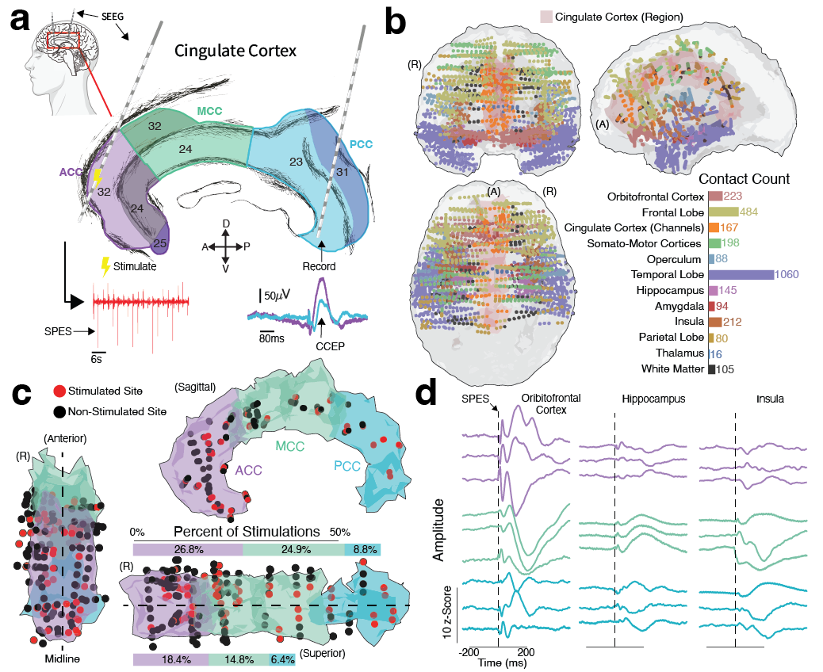

Figure 1. Experimental overview and anatomical coverage of SEEG recordings and stimulation. (a) Schematic of the experimental design. Patients with intractable epilepsy undergoing invasive SEEG monitoring received single-pulse electrical stimulation (6 mA, 0.2-ms biphasic square pulse, 0.5 Hz, 1-2 minutes) to the cingulate cortex (Cg) subregion(s). Cortico-cortical evoked potentials (CCEPs) were recorded from contacts distributed across various brain regions. (b) Anatomical coverage of SEEG contacts pooled from 15 patients, projected onto an MNI-space cortical model generated from volumetric averaging across all patients. The area of the Cg is shown in light red. Colors of contacts represent the major brain regions where contacts were located. (c) Position of contacts within the subregions of the Cg across patients, projected onto a volumetrically averaged MNI-space model, highlighting stimulated (red) and non-stimulated (black) contacts. Bar plots adjacent to the superior cortical view illustrate the distribution of stimulations across Cg subregions and hemispheres. (d) Exemplar CCEP waveforms across representative cortical regions, reflecting distinct morphological qualities elicited by stimulation of different Cg subregions.

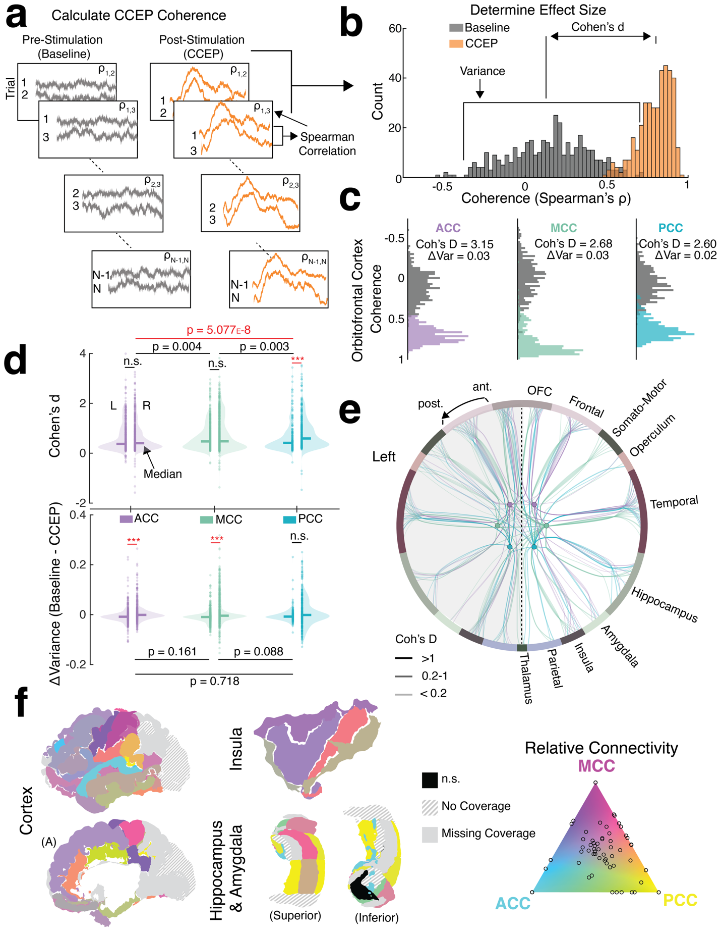
Figure 2. Cingulate cortex effective connectivity modeled using cortico-cortical evoked potential (CCEP) coherence. (a & b) Methodological overview of CCEP coherence calculation. (a) The inter-trial pairwise Spearman’s correlations were calculated for the baseline and task CCEP windows, resulting in (b) the baseline and CCEP distributions of local field potential coherence for each contact. The effect size of connectivity between the stimulated cingulate cortex (Cg) subregion and the contact was defined as the Cohen’s d between these distributions, representing the degree of separation between the single-pulse electrical stimulation (SPES) induced changes in the local field potential (LFP) morphology and the expected morphological similarity of pre-SPES LFP behavior. The variance of the CCEP distribution was subtracted from the variance of the baseline distribution to represent the variation in the inter-trial CCEP morphology corrected by the expected variation of inter-trial LFP morphology before SPES. (c) Exemplar baseline and CCEP coherence distributions recorded from representative contacts located in the orbitofrontal cortex after stimulation of each Cg subregion. (d) Global statistical comparison of Cohen’s d (top) and ΔVariance (bottom) across all cortical contacts for each Cg stimulation condition: (L) or right (R) anterior, mid, or posterior cingulate (ACC, MCC, or PCC, respectively). Statistical differences were assessed using Wilcoxon rank sum tests (α = 0.001). (e) Visualization of the divergent Cg effective connectivity network. Each circle in the middle represents a stimulation condition: either the left or right ACC (purple), MCC (green), or PCC (blue). The outer circle contains nodes representing each cortical region grouped into major anatomical areas, distinguished by unique colors. Cortical regions within each major anatomical area are ordered from anterior to posterior. Connectivity strength from stimulated Cg subregions to these cortical regions is represented by lines, whose thickness and opacity indicate the median Cohen’s d across contacts within each region. (f) Cortical surface models visualize the relative effective connectivity of each Cg subregion to each cortical region. For each stimulation condition, the mean connectivity across all significant contacts within each region was calculated. The geometric mean of these three values was then plotted on a triangle, where the vertices of the triangle represent full connectivity to a Cg subregion. A color was assigned to each region based on an interpolated colormap across this triangle. Regions with similar connectivity to all three Cg subregions appear at the center of the triangle (greyish color). Regions with biased or preferential connectivity to one or more Cg subregions will appear closer to the triangle’s edges, towards the vertices representing the subregions with greater connectivity.

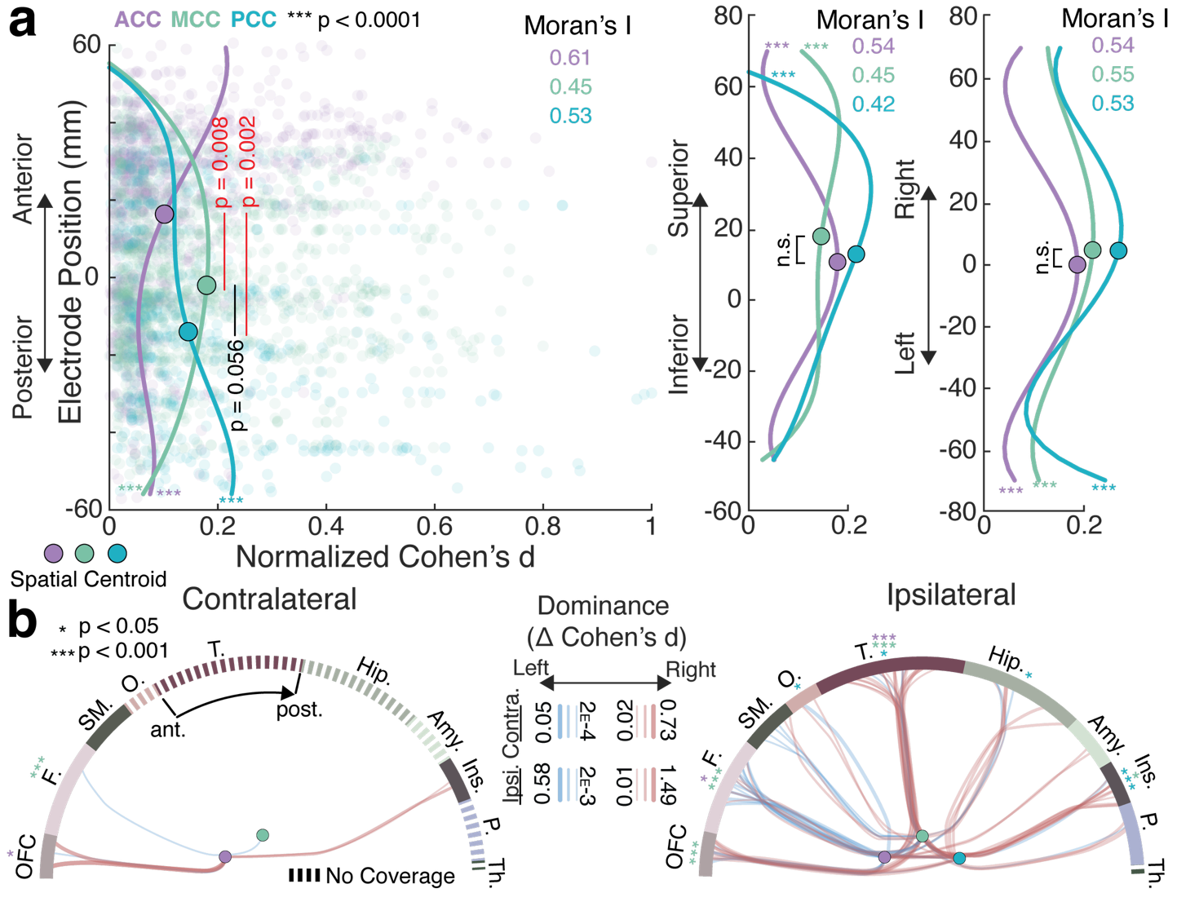
Figure 3. Spatial Distribution of Effective Connectivity Across the Cortex. (a) Distributions of normalized effective connectivity (Cohen’s d) across the anterior-posterior, inferior-superior, and left-right axes. Lines show a 4th-order polynomial trend line fitted to the mean Cohen’s d of 50 evenly spaced bins for each spatial dimension. The circles along the lines represent the centroids of each effective connectivity distribution. Moran’s I was calculated to quantify biases in connectivity across each spatial dimension for each condition. Permutation-based pairwise comparisons of observed centroid differences were calculated to compare centroids of distributions for each stimulation condition (α = 0.05). (b) Network wiring diagrams showing hemispheric differences in connectivity for regions contralateral (left) or ipsilateral (right) to the site of stimulation for each condition. Blue lines represent greater connectivity in the left hemisphere, and red lines represent greater connectivity in the right hemisphere. The thickness of lines represents the magnitude of the difference between the average connectivity strength of significant contacts within the right and left regions. Statistical tests between left and right hemisphere regions were conducted on contacts within major region groups: orbitofrontal cortex (OFC), frontal cortex (F), somato-motor cortices (SM), operculum (O), temporal lobe (T), hippocampus (Hip), amygdala (amy), insula (Ins), parietal lobe (P), thalamus (Th) (α = 0.05, * p < 0.05, *** p < 0.001). Dashed lines on the outer network semicircle represent major region groups without substantial contacts for statistical comparisons.

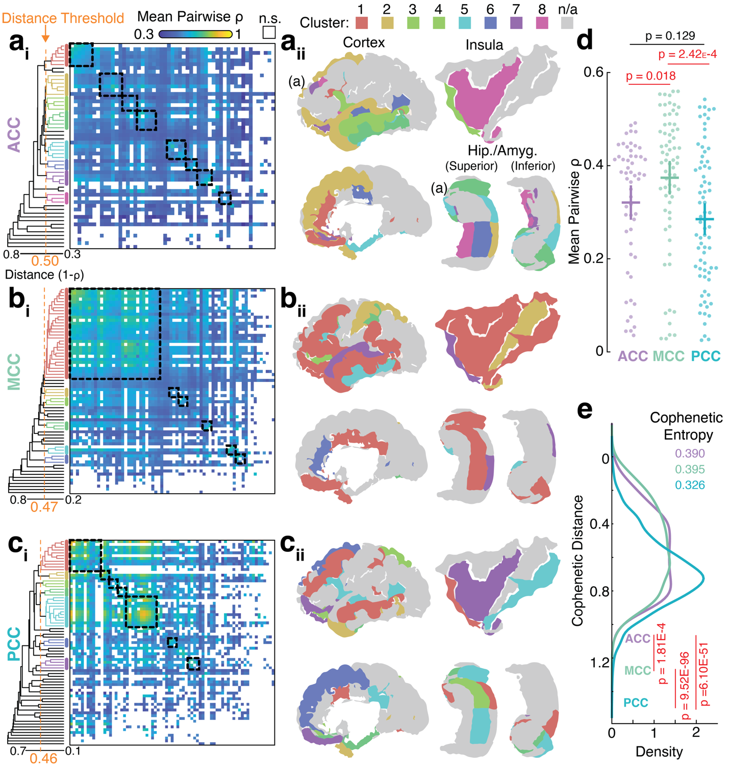
Figure 4. Hierarchical Clustering of Cingulate Cortex Effective Connectivity Networks. (a-c) Cingulate cortex (Cg) subnetworks are defined and organized through hierarchical clustering of cortico-cortical evoked potential (CCEP) morphology. (a) Subnetworks of the anterior cingulate cortex (ACC). (a_{i}) Correlation matrix showing the mean inter-regional similarity of CCEP morphology, organized from highest to lowest similarity. Dotted boxes show clusters. White entries in the correlation matrix represent regions without statistically significant CCEPs (Wilcoxon rank sum test, α = 0.0001). The adjacent dendrogram shows the hierarchical structure of the correlation matrix. Clusters of regions on the dendrogram are colored by cluster number, from highest to lowest intra-cluster similarity. The optimal distance threshold to resolve clusters is shown by the dashed orange line. (a_{ii}) Anatomical location of clusters. (b) Mid-cingulate cortex (MCC) subnetworks. (c) Posterior cingulate cortex (PCC) subnetworks. (d) Comparison of inter-regional CCEP morphological similarity across stimulation conditions (Wilcoxon rank sum, α = 0.05). (e) Comparison of dendrogram tree diversity as a distribution of cophenetic distance across stimulation conditions (Wilcoxon rank sum, α = 0.05).

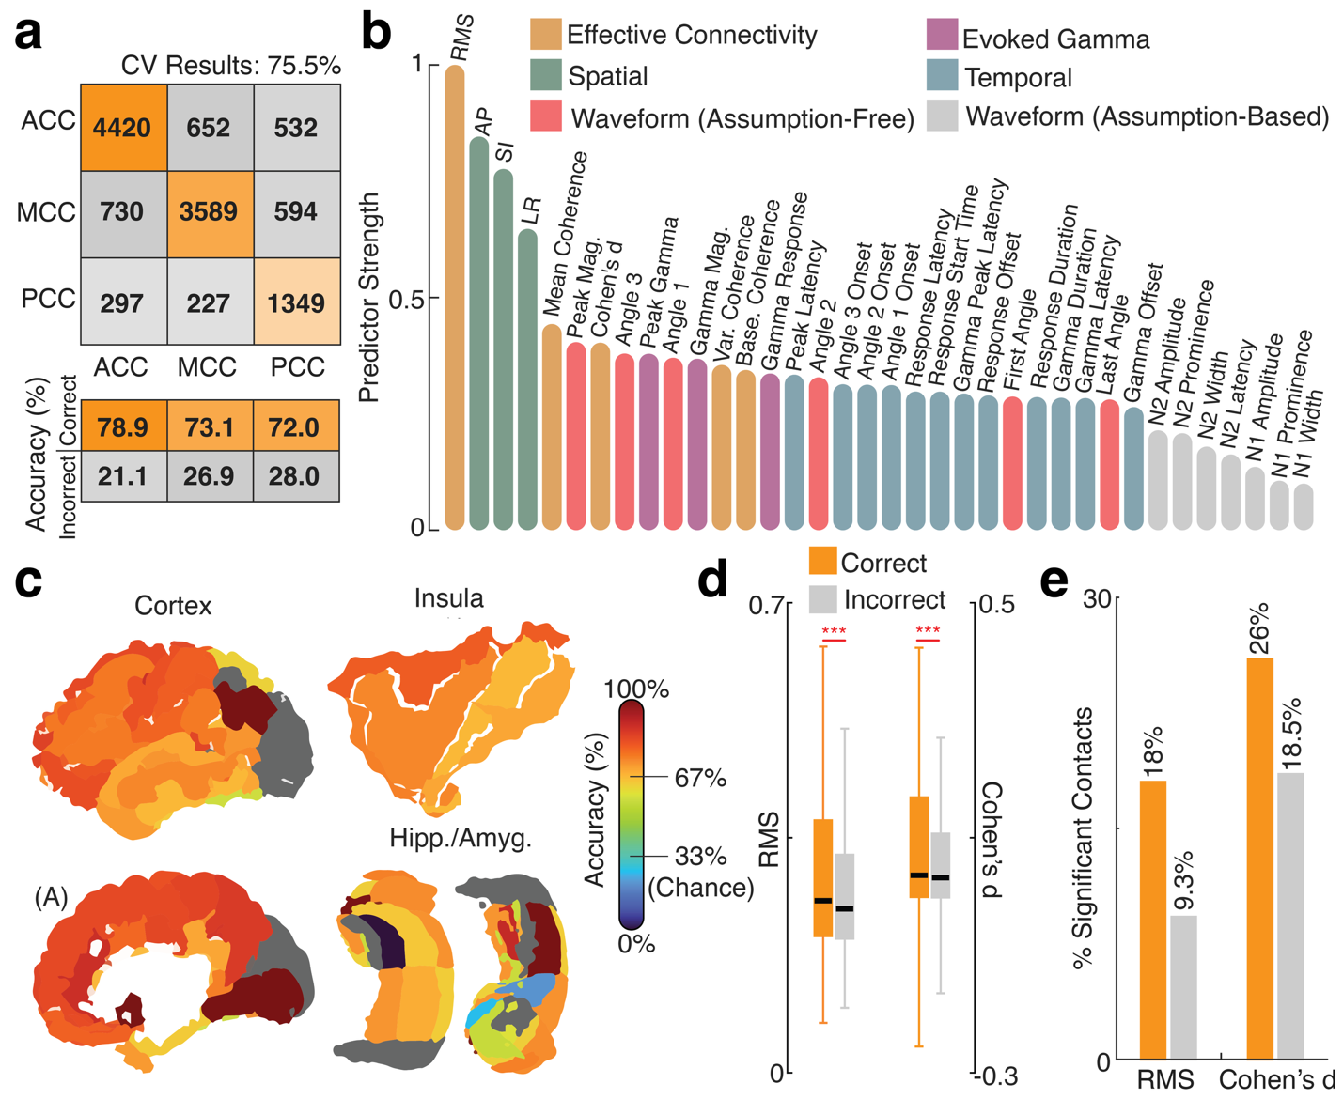
Figure 5. Assessing Feature Importance for Classifying Effective Connectivity to Cingulate Cortex Subregions. (a) Confusion matrix evaluating the classification performance of a Random Forest Model trained to classify contacts by which cingulate cortex subregion was stimulated. (b) Predictive strength of input features in classifying which cingulate subregion was stimulated, indicating the impact of each feature on the classification model after random permutation. Features were divided into six feature classes: effective connectivity features, spatial features, assumption-free waveform features, evoked gamma features, temporal features, and assumption-based waveform features. Features (in descending order of predictor strength) included CCEP amplitude as root-mean-squared (RMS), anterior-posterior contact position (AP), superior-inferior contact position (SI), left-right contact position (LR), mean CCEP coherence (Mean Coherence), peak broadband CCEP magnitude (Peak Mag.), CCEP coherence as Cohen’s d (Cohen’s d), third angle of the broadband CCEP waveform (Angle 3), peak broadband gamma response magnitude (Peak Gamma), first angle of the broadband CCEP morphology (Angle 1), average magnitude of the broadband gamma response (Gamma Mag.), difference between the variance of the baseline and CCEP coherence distributions (Var. Coherence), average coherence of the baseline coherence distribution (Base. Coherence), gamma response as Spearman’s rho (Gamma Response), latency of the peak broadband CCEP magnitude (Peak Latency), second angle of the broadband CCEP waveform (Angle 2), latency of the third angle of the CCEP waveform (Angle 3 Onset), latency of the second angle of the CCEP waveform (Angle 2 Onset), latency of the first angle of the CCEP waveform (Angle 1 Onset), latency of the broadband CCEP waveform onset detected using the first derivative of the broadband magnitude (Response Latency), latency of the broadband CCEP waveform onset detected using the broadband magnitude (Response Start Time), latency of the peak evoked gamma response (Gamma Peak Latency), latency of the broadband CCEP waveform offset (Response Offset), angle of the CCEP waveform response onset (First Angle), duration of CCEP calculated from the magnitude of the broadband CCEP waveform (Response Duration), duration of evoked gamma response (Gamma Duration), latency of the evoked gamma response onset (Gamma Latency), angle of the CCEP waveform response offset (Last Angle), evoked gamma response offset (Gamma Offset), N2 peak amplitude (N2 Amplitude), N2 peak prominence (N2 Prominence), N2 peak width (N2 Width), N1 peak amplitude (N1 Amplitude), N1peak prominence (N1 Prominence), N1 peak width (N1 Width). (c) Classification accuracy expressed as a percentage of contacts correctly classified for each brain region, across brain regions. (d) Comparison of primary effective connectivity measures, RMS, and Cohen’s d between correctly and incorrectly classified contacts (Wilcoxon rank sum test, α = 0.05, *** p < 0.001). (e) Differences in the percentage of significant contacts for correctly and incorrectly classified contacts across primary effective connectivity measures.

