Exercise 1-3

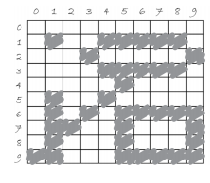

1. point(1, 1);
2. ellipse(6, 2, 7, 3);
3. line(1, 5, 1, 9);
4. line(0, 9, 5, 4);
5. rect(5, 6, 9, 9);