Exercise 1-4

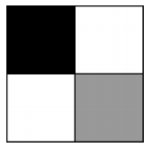

1. Background(255);
2. fill(0);
3. rectMode(CORNERS);
4. rect(0, 0, width/x, height/2);
5. fill(220);
6. rect(width, height, width/x, height/2);