Exercise 9-4

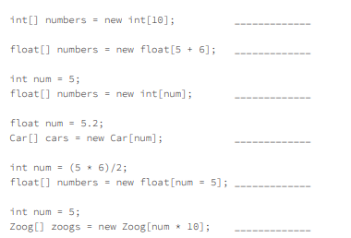

1. Valid
2. Valid
3. Invalid
   1. Creates int’s for a float array
4. Invalid
   1. Argument must be int
5. Valid
6. Valid