Github

# Overview *(last week)*

<https://github.com/pl218/PIUC/pulse>

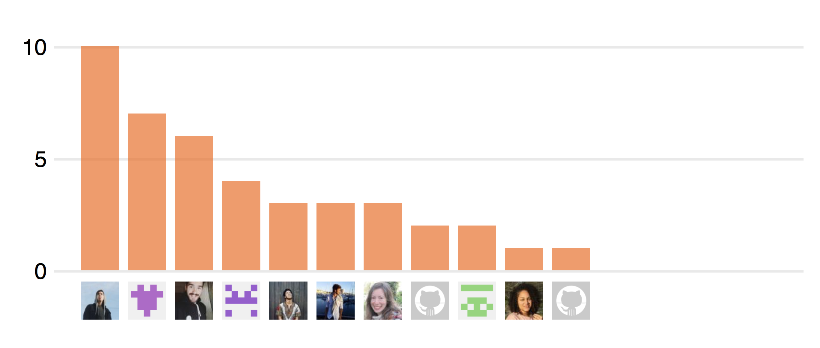

Excluding merges, 11 authors have pushed 7 commits to master and 42 commits to all branches. On master, 4 files have changed and there have been 0 additions and 0 deletions.

# Contributors(since 17/09)

<https://github.com/pl218/PIUC/graphs/contributors>

Contributions to master, excluding merge commits

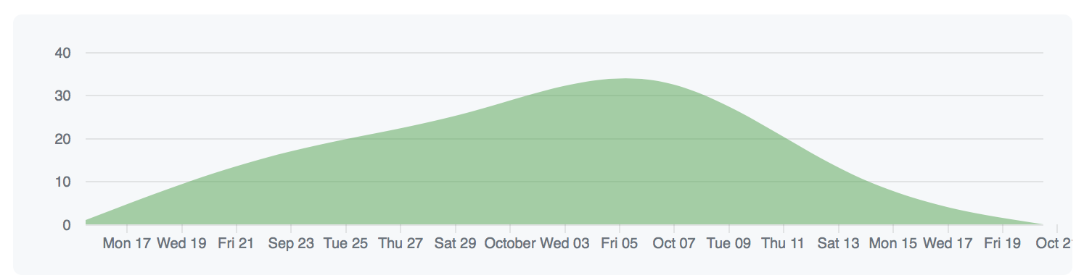

# 

# Traffic *(since 17/09)*

As of today the team have 36 contributors and made 108 commits in total and counting.

**Git clones** (since 08/10)

The graph above shows the quantity of times the repository was cloned (green line) and how many people cloned it (blue line).

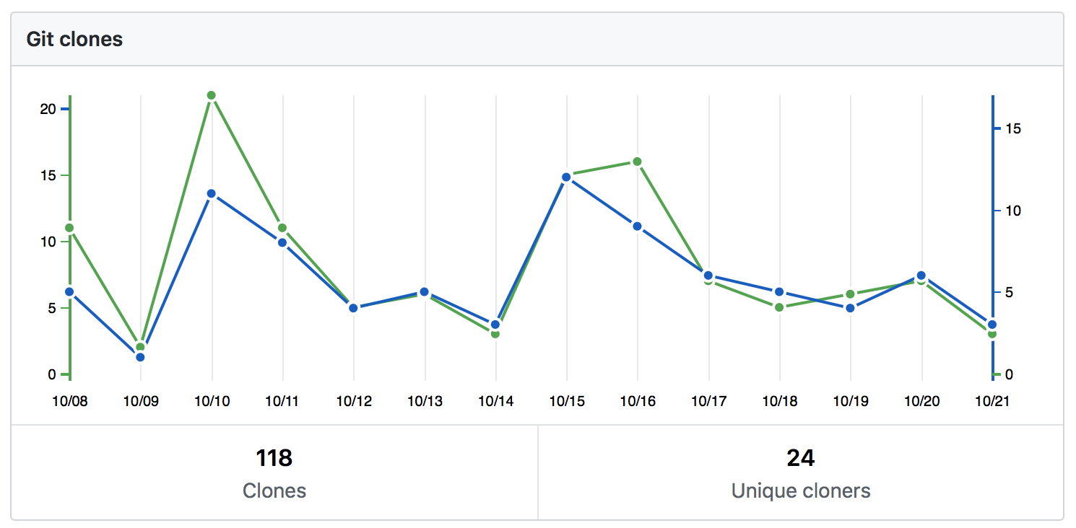

**Visitors** (since 08/10)

This graph represents the people who visited the repository.

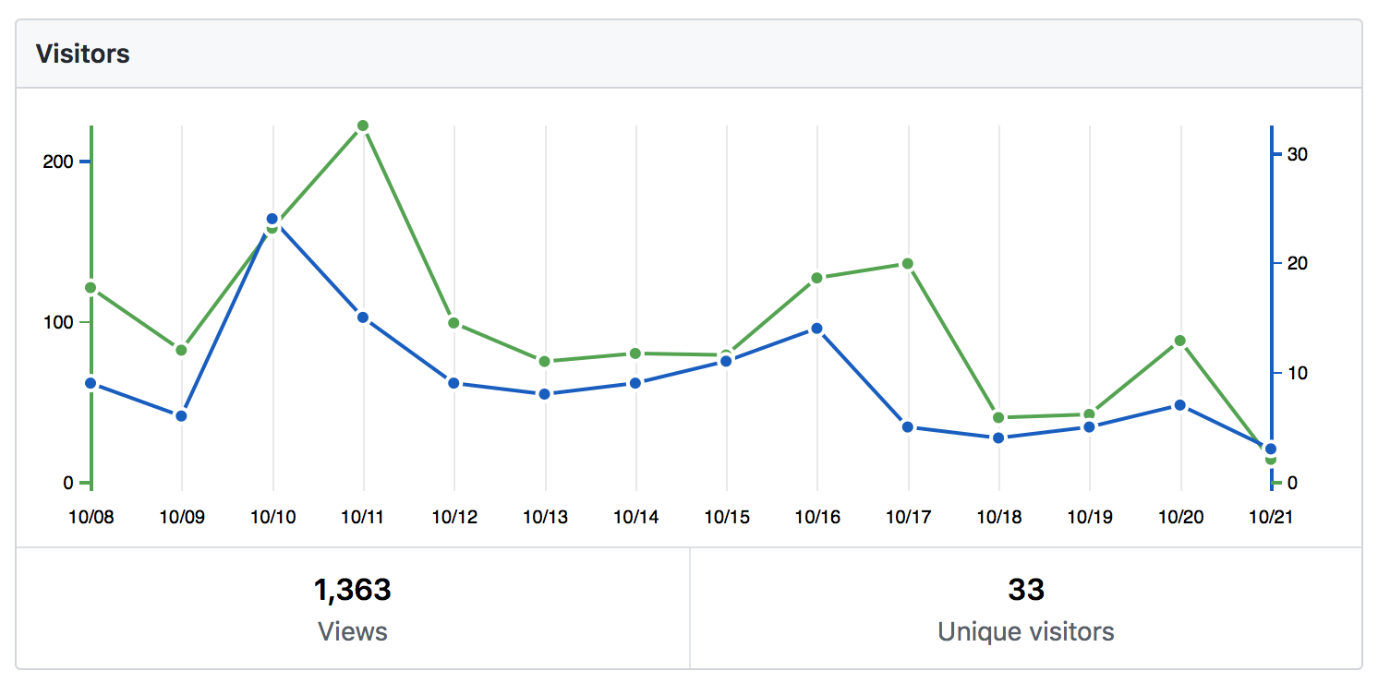

# Commits

<https://github.com/pl218/PIUC/graphs/commit-activity>

**Commits per week**

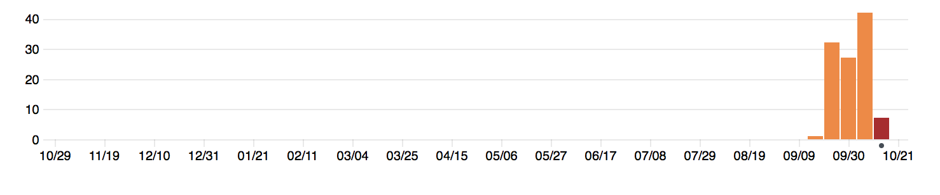

Week of Oct 7: 42 commits

Week of Oct 14: 14 commits

**Commits per day of week**

