GitHub

At a high level, GitHub is a website and cloud-based service that helps developers store and manage their code, as well as track and control changes to their code. Github is he number one web platform used by developers to store their repositories.
As of today the team have 22 contributors and made 72 commits in total and counting.

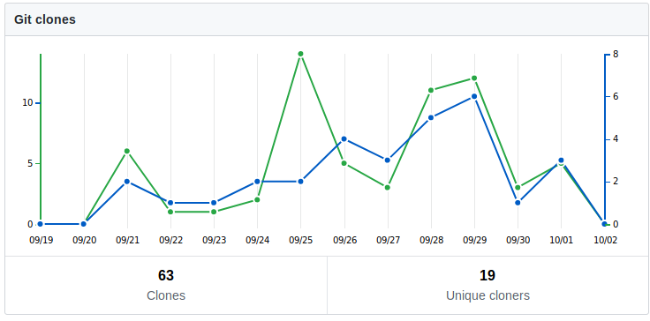

The graph above shows the quantity of times the repository was cloned (green line) and how many people cloned it (blue line). We can observe that only about 60% of the team cloned the repository however with 3 contributors deciding only contributing through Github website itself.
Since Github can be quite tricky and confusing to learn this numbers are quite normal for a team who have little to no experience with git. These values should go down as people get familiarized wit git.

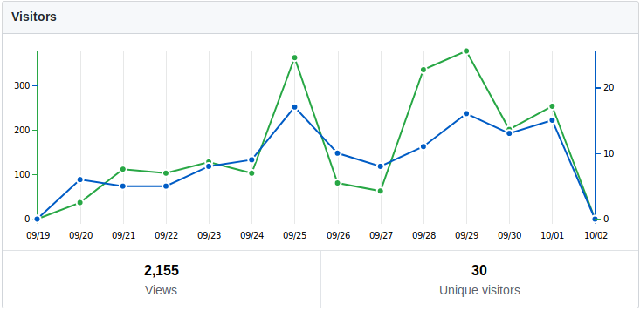

This graph represents the people who visited the repository. From this we can see that the whole team visited the repository. Besides that we can determine the days that our team is more active on GitHub which would be in the weekends and had a spike on 25/9 from a mini-workshop on git that was lectured by the environment team.
With the fact that every member of the team is a student this values are also quite normal and expected.

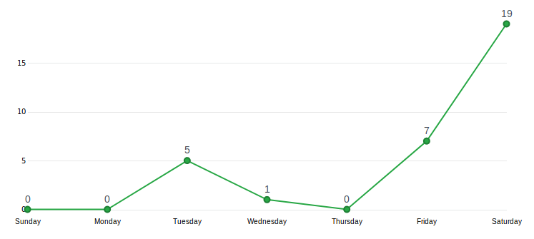

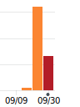

The chart on the left represents the number of commits made in which week. On the right, we have a closer look ate the secound week of the sprint. We can see that people started using more actively GitHub on the second week of the sprint with a growth of 3200% in number of commits in comparison with the first week.
The third week, that just started two days ago has almost half of the commits made during the whole week of the second week.
With this in mind we can conclude that the team is more active on GitHub even with the quite steep learning curve of git.

In conclusion, since little people knew how to work with git, this are actually pretty good values however with big gaps to fill like the number of contributors, quality of commits and the very little usage of issues, branches, merge requests etc.
The team is very well headed but has to improve and learn some important notions about git and GitHub.

