**Colinear Convolution on Cifar Dataset**

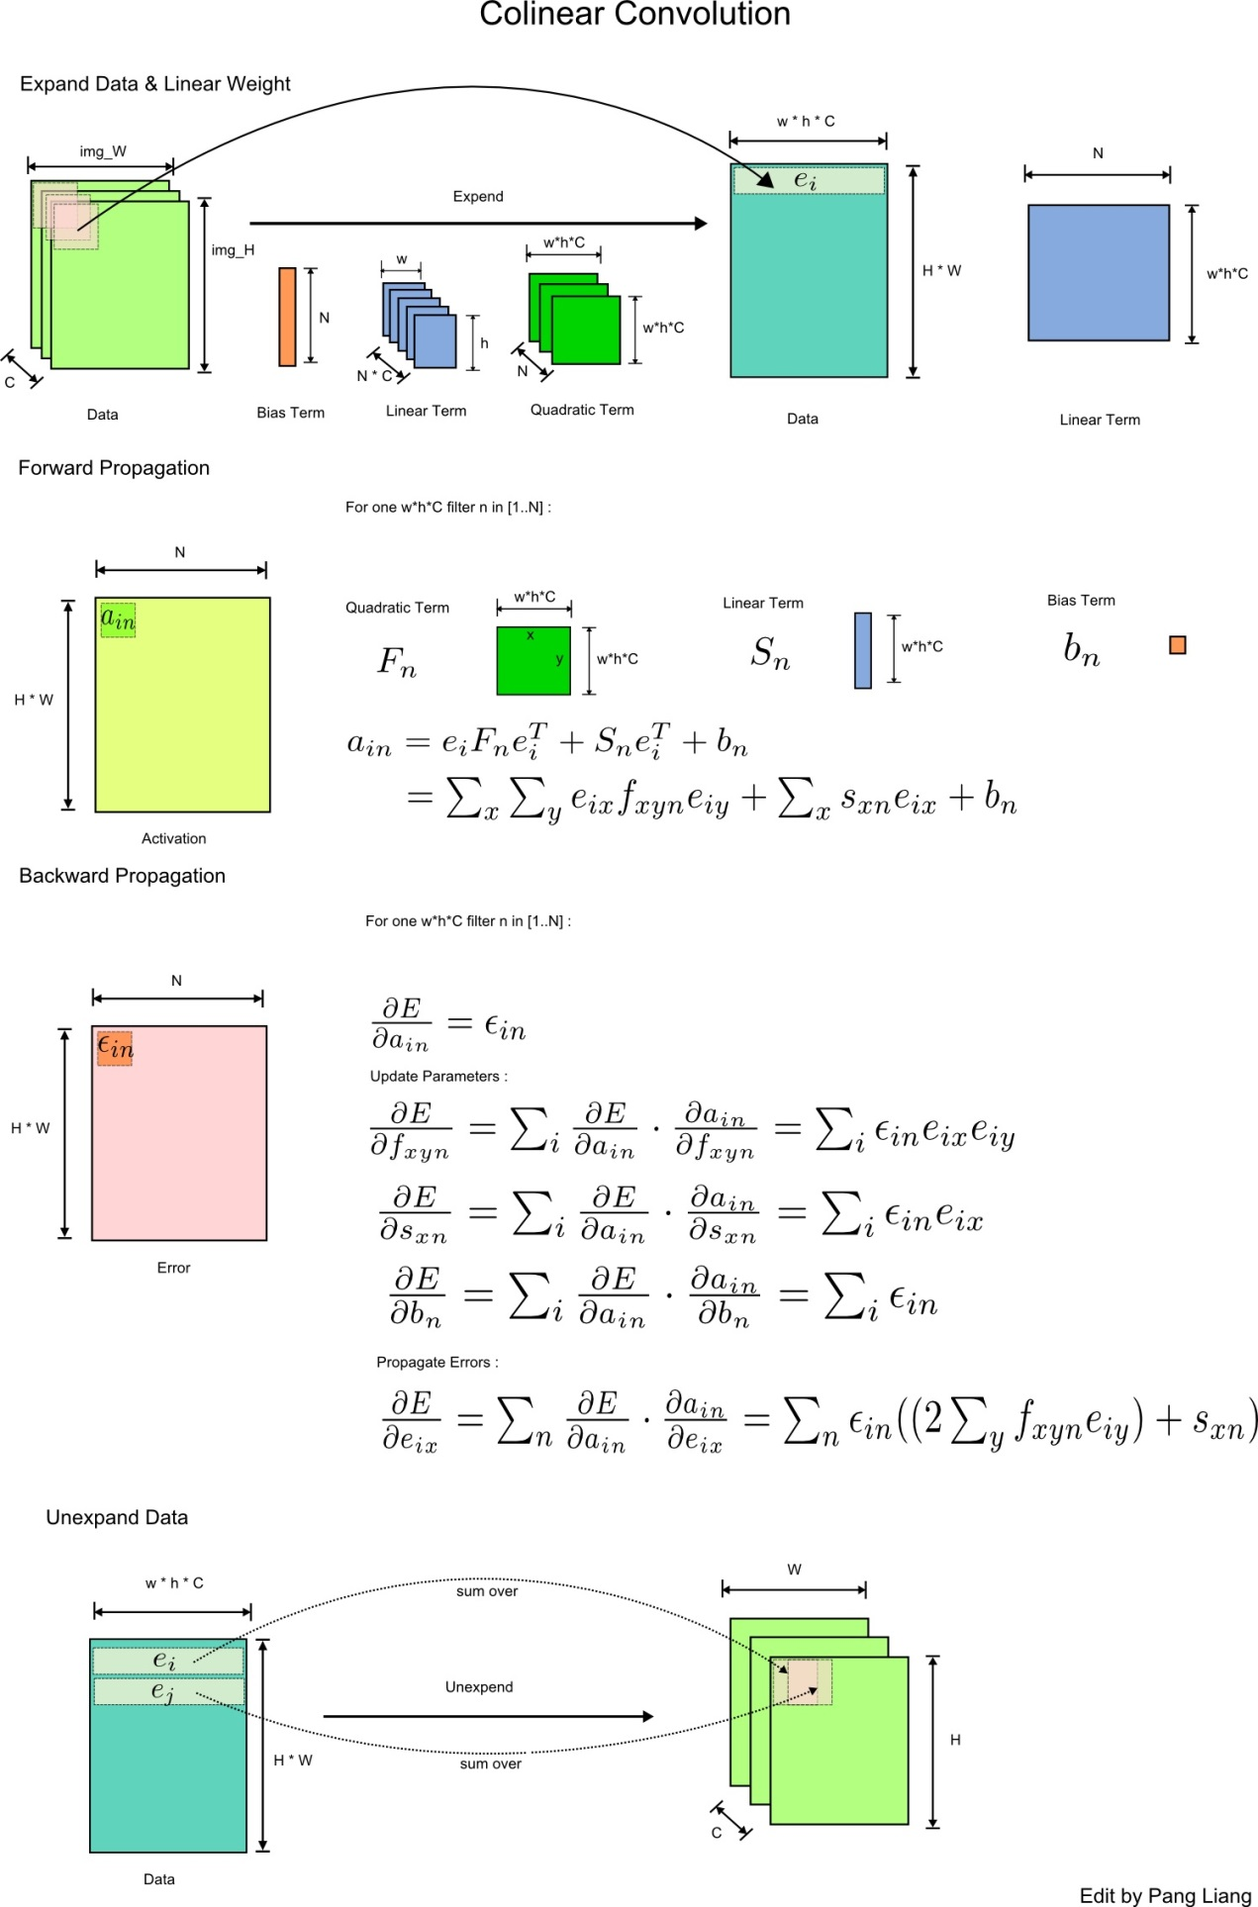

**Cifar Net Structure**

