SE LAB GROUP ASSIGNMENT 1 REPORT TEMPLATE
Software Engineering | Smart Ticketing System (Ticket Vendor Machine) | Sem 1_2627 | Template for the file [YourID]_[YourStudentName].docx
Marking of this report
No. | Task | Marks | Section in this report
1 | Clarification Q&A (Excel) | 5 | 2.1
2 | Requirements Specification | 15 | 2.2
3 | Use Case Modeling | 10 | 3.1
4 | Activity Diagrams | 10 | 3.2
5 | Detailed System Modeling: "Buy a Ticket" | 15 | 3.3
6 | UI/UX Design | 5 | 4.1
7 | Architectural Design | 10 | 4.2, 4.3
8 | Visual Studio Engineering (Model-to-Code) | 10 | 5.1
9 | GitHub & AI Tooling (Copilot) | 10 | 5.2
10 | Demo Application (C# and MSSQL) | 10 | 5.3
Total |  | 100 | Weight: 20% of QT2 (plus 1 bonus point towards the Final Project for exceptional work)

How to use this template
- Keep all titles and numbering. Replace every blue [bracketed placeholder] with your own content, and delete all grey "Guidance" paragraphs, unused figure frames and this instruction page before you submit.
- Keep the headings as real Word headings (the navigation pane must work). Update the table of contents before submitting (right-click, Update Field).
- Group of 3 to 5 students. Section 7 must list the % contribution of each member (total 100%) and must match your readme.txt.
- Submit [YourID]_[YourStudentName].docx, readme.txt (GitHub link and other links such as Figma and database script instructions) and the % contribution of each member. All final artifacts are also uploaded to the shared GitHub repository.
- The report must also address the content of "LabGroupAssignment1.pdf". Use the checklist in section 6 to show where each item is covered.
- Keep your diagrams consistent with each other: the rubric rewards diagrams that are syntactically correct, logically sound and aligned. Use the consistency table in section 3.4.
- The workbook A1_Team_Workbook (Q&A, requirements, prompt log, commit log, progress log) is your working record and the source for several tables here.

Smart Ticketing System
Ticket Vendor Machine (TVM)
Software Engineering Lab Group Assignment 1 – Sem 1_2627
Group [XX]
1. [StudentID1] : [Student Name 1]
2. [StudentID2] : [Student Name 2]
3. [StudentID3] : [Student Name 3]
4. [StudentID4] : [Student Name 4] (delete if not in your group)
5. [StudentID5] : [Student Name 5] (delete if not in your group)

GitHub repository | Figma / other link | Date submitted
[link] | [link] | [date]

Table of Contents
Table of Contents 4
1. Introduction 6
1.1 Purpose and Scope 6
1.2 Problem Statement in Our Own Words 6
1.3 Team and Roles 6
2. Phase 1: Requirements Engineering (20 marks) 7
2.1 Clarification Q&A (5 marks) 7
2.2 Requirements Specification (15 marks) 7
2.2.1 Functional Requirements 7
2.2.2 Non-Functional Requirements 7
2.2.3 Domain Requirements 8
3. Phase 2: UML Modeling & System Design (35 marks) 9
3.1 Use Case Modeling (10 marks) 9
3.1.1 Use Case Diagram 9
3.1.2 Actors and Use Case List 9
3.1.3 Use Case Descriptions 9
3.2 Activity Diagrams (10 marks) 10
3.2.1 Passenger Buys a Ticket at the TVM 10
3.2.2 Communication with External Payment Gateways 10
3.3 Detailed System Modeling: Main Use Case "Buy a Ticket" (15 marks) 10
3.3.1 Sequence Diagram 10
3.3.2 State Chart Diagram 10
3.3.3 Class Diagram (Domain Model) 10
3.4 Model Consistency Check 10
4. Phase 3: UI/UX & Architecture (15 marks) 12
4.1 UI/UX Design (5 marks) 12
4.2 Architectural Design (10 marks) 12
4.2.1 Architecture Diagram 12
4.2.2 Deployment Diagram 12
5. Phase 4: Implementation, Tooling & Demo (30 marks) 13
5.1 Visual Studio Engineering: Model-to-Code (10 marks) 13
5.1.1 Forward Engineering (Model to Code) 13
5.1.2 Backward Engineering (Code to Model) 13
5.1.3 Code Map 13
5.2 GitHub & AI Tooling (10 marks) 13
5.2.1 Source Control 13
5.2.2 AI Assistance: Copilot Prompt Documentation 14
5.2.3 Reflection on AI Use 14
5.3 Demo Application (10 marks) 14
6. Checklist for "LabGroupAssignment1.pdf" 16
7. Contribution of Each Member 16
8. Conclusion and Lessons Learnt 16
References 16
Appendix 17
Appendix A: readme.txt 17
Appendix B: Full-size Diagrams 17

1. Introduction

1.1 Purpose and Scope
Guidance (delete before submitting): Two or three sentences: what the report covers, which system (the Ticket Vendor Machine within the Smart Ticketing System) and what is in and out of scope.
[Purpose and scope]

1.2 Problem Statement in Our Own Words
Guidance (delete before submitting): Summarize the business context: ticket types, payment modes (Credit Card, QR Code linked to a banking system, Digital Wallet), the passenger interaction, and the ambiguities you found. Do not copy the assignment text.
[Problem statement]

1.3 Team and Roles
No. | Name | Student ID | Main responsibilities
1 | [ ] | [ ] | [ ]
2 | [ ] | [ ] | [ ]
3 | [ ] | [ ] | [ ]
4 | [ ] | [ ] | [ ]
5 | [ ] | [ ] | [ ]

2. Phase 1: Requirements Engineering (20 marks)

2.1 Clarification Q&A (5 marks)
Guidance (delete before submitting): Identify the ambiguities in the problem statement. List the clarifying questions you would ask the stakeholders and give logical, assumed answers to base your design on. Put the full list in the Excel workbook (sheet "Clarification Q&A") and show the most important ones here. Look for hidden complexity: payment timeouts, card or QR failure, refunds, cancellation, ticket types and fares, printer or paper out, offline operation, multiple machines, security.
ID | Question to the stakeholder | Assumed answer | Why it matters | Requirement ID
01 | Which transport services and ticket types will the TVM support? | Initially, Bus and MRT tickets; one ticket per transaction. | Defines the initial scope and prevents unsupported ticket types from being assumed. | FR2, FR3, DR1
Q02 | How does a passenger select a destination? | Passenger presses Start, chooses a transport service and destination, then confirms the selection. | Defines the main user flow and interface screens. | FR1, FR2, FR3
Q03 | How is the fare determined? | The TVM retrieves the current fare from the authorized transport operator based on service and destination. | Incorrect fare calculation could lead to incorrect charges or invalid tickets. | FR4, DR1, DR2
Q04 | Which payment methods are supported? | Credit/debit card where supported, banking-linked QR payment, and approved digital wallets. | Each method requires a different payment interaction and integration. | FR5, FR6, FR7, DR3
Q05 | How do QR payment and digital-wallet payment work? | The TVM displays a transaction-specific QR code; the passenger scans it using a compatible banking or wallet app. | Clarifies which device displays the QR code and how the payment begins. | FR7, DR3
Q06 | How does the TVM verify that payment succeeded? | A trusted payment provider response is verified by the TVM; a passenger's phone screen alone is not sufficient. | Prevents issuing tickets based on unverified payment claims. | FR8, NFR3, DR4
Q07 | How long should the TVM wait for payment confirmation? | Wait up to 60 seconds for initial confirmation, then show a pending/timeout message and reconcile the transaction status before retrying. | Prevents indefinite waiting and accidental duplicate charges. | FR9, FR13, NFR4
Q08 | What happens if a payment is declined or fails? | Display a clear failure message and let the passenger retry or cancel; do not issue a paid ticket. | Defines a safe failure path. | FR9, FR13
Q09 | What information must the ticket contain? | A unique ticket identifier, barcode, transport/ticket details, fare or ticket type, and required validity information. | Supports ticket validation and transport-operator rules. | FR10, FR11, DR5
Q10 | What happens if payment succeeds but the printer fails or runs out of paper? | Record the payment and print failure, prevent a second charge for the same purchase, and follow a defined recovery/refund process. | Payment and ticket delivery can fail independently. | FR12, FR14, NFR2
Hidden complexities we uncovered
[Three to five points where the Q&A changed the requirements]

2.2 Requirements Specification (15 marks)
Guidance (delete before submitting): A formal set of Functional, Non-Functional and Domain requirements for the TVM. Every requirement has an ID and is testable. The workbook sheet "Requirements" is the working copy.

2.2.1 Functional Requirements
ID | Requirement ("The system shall…") | Priority | Use case | Source (Q&A)
FR1 | The system shall display an idle/start screen when the TVM is ready for a new passenger. | Must | UC01 | Q02
FR2 | When the passenger presses Start, the system shall display the supported transport services and destinations. | Must | UC01 | Q01, Q02
FR3 | The system shall allow the passenger to select and confirm a destination. | Must | UC01 | Q02
FR4 | The system shall retrieve and display the fare for the selected transport service and destination before payment. | Must | UC01 | Q03
FR5 | The system shall allow the passenger to choose a supported payment method: card, banking-linked QR, or digital wallet. | Must | UC02 | Q04
FR6 | For card payment, the system shall initiate a transaction through the approved card terminal/payment gateway. | Must | UC02 | Q04
FR7 | For QR or digital-wallet payment, the system shall generate and display a unique QR code linked to the current transaction. | Must | UC02 | Q05
FR8 | The system shall verify payment using an authenticated response from the trusted payment provider before issuing a paid ticket. | Must | UC02, UC03 | Q06, Q13
FR9 | The system shall display the payment status as successful, failed, pending, or timed out, as applicable. | Must | UC02 | Q07, Q08
FR10 | After verified payment, the system shall generate a unique ticket identifier and corresponding barcode. | Must | UC03 | Q09
FR11 | The system shall print the ticket with the barcode and required ticket information. | Must | UC03 | Q09
FR12 | The system shall record the transaction identifier, fare, payment status, ticket status, and timestamp. | Must | UC03, UC04 | Q10, Q18
FR13 | If payment fails, the system shall not issue a paid ticket and shall allow the passenger to retry or cancel. | Must | UC02 | Q07, Q08
FR14 | If payment succeeds but printing fails, the system shall record the failure and support recovery/refund without charging again for the same purchase. | Must | UC04 | Q10
FR15 | The system shall allow the passenger to cancel before payment completion and shall check transaction status if payment may already have been submitted. | Must | UC01, UC02 | Q11
FR16 | After a completed or cancelled transaction, the system shall return to the idle/start screen. | Must | UC04 | Q12
FR17 | The system shall expire a pre-payment session after 60 seconds of inactivity and clear temporary session data. | Should | UC01 | Q12
FR18 | The system shall prevent duplicate ticket issuance for the same successfully paid transaction. | Must | UC03, UC04 | Q07, Q10, Q11
FR19 | If a required service is unavailable, the system shall display a service-unavailable message and prevent unsafe ticket issuance. | Must | UC04 | Q13
FR20 | The system shall provide multiple languages interface options. | Should | UC01 | Q15

2.2.2 Non-Functional Requirements
Guidance (delete before submitting): Critical focus: reliability and response time. Write exact, measurable expectations (a number, a unit, a condition and how you will measure it). "Fast response" is not acceptable. Example of the format: "The system shall display the destination menu within 1 second of pressing Start in 95% of cases, measured over 1,000 transactions." Add other categories where they matter (security, availability, usability, capacity, maintainability).
ID | Category | Measurable requirement | Measurement method | Related FR
NFR1 | Reliability / Availability | The TVM shall achieve at least 99.5% operational availability per calendar month, excluding approved scheduled maintenance. | Measure scheduled service time and unplanned downtime monthly. Availability = (scheduled service time − unplanned downtime) / scheduled service time × 100%. | FR1–FR19
NFR2 | Reliability / Recovery | For recoverable software or communication incidents, the TVM shall restore service within 5 minutes in at least 95% of incidents, provided hardware and external services are available. | Test at least 100 simulated recoverable incidents; record incident-to-service-restored time. | FR12, FR14, FR19
NFR3 | Reliability / Transaction integrity | The TVM shall issue no paid ticket without verified payment and shall prevent duplicate charging or ticket issuance for the same transaction. | Run tests with declined, duplicated, delayed, and repeated payment notifications; verify transaction and ticket records. | FR8, FR10, FR12, FR18
NFR4 | Response time | The TVM shall display the destination menu within 2 seconds after Start in at least 95% of requests when destination data is available and the system is under the agreed normal test load. | Measure 1,000 Start-to-menu-display requests; at least 950 must be ≤2 seconds. | FR2
NFR5 | Response time | Local user actions (for example, selecting a destination or payment method) shall receive a visible response within 1 second in at least 95% of requests under the agreed normal test load. | Measure 1,000 local interaction events; at least 950 must be ≤1 second. | FR3, FR5
NFR6 | Response time / Timeout | The TVM shall wait no longer than 60 seconds for initial payment confirmation before showing a pending/timeout message, and shall reconcile transaction status before permitting a retry that could create another charge. | Run payment simulations with success, failure, delayed response, and no response; verify timeout and reconciliation logs. | FR7–FR9, FR13, FR18
NFR7 | Security | The TVM shall use encrypted communication with payment services and shall not store full card numbers or card verification codes in local logs. | Inspect configuration, network traffic, and logs during security testing. | FR6–FR8, FR12
NFR8 | Usability | The TVM shall provide Vietnamese and English instructions and clear error messages for payment failure, timeout, and printer failure. | Verify all required screens in both languages and test each listed error scenario. | FR9, FR13, FR14, FR20
NFR9 | Maintainability / Logging | The TVM shall record timestamped diagnostic events for payment failures, printer failures, service outages, and recovery actions without logging sensitive card data. | Trigger each failure scenario and inspect the resulting logs. | FR12, FR14, FR19

2.2.3 Domain Requirements
Guidance (delete before submitting): Rules that come from the transport and payment domain rather than from the user: for example fare rules, payment standards and bank or wallet rules, ticket and barcode format, data retention, regulatory or accessibility rules.
ID | Domain requirement | Domain / source | Related FR / NFR
DR1 | Ticket fares shall follow the current fare rules published by the authorized transport operator. | Transport operator fare policy | FR4
DR2 | The TVM shall use the authorized transport operator's destination list and fare data. | Transport operator data source | FR2, FR4
DR3 | QR and wallet transactions shall follow the selected provider's QR format, transaction-expiry rules, and confirmation protocol. | Bank / QR / digital-wallet provider | FR5, FR7–FR9
DR4 | A ticket shall be treated as paid and eligible for use only after successful payment has been verified. | Transport and payment business rules | FR8, FR10, FR11
DR5 | Each issued ticket shall have a unique identifier and barcode readable by the designated ticket-validation system, and shall include required ticket/validity details. | Transport operator ticketing specification | FR10, FR11
DR6 | Card transactions shall follow applicable payment-provider requirements and payment-card security standards, including PCI DSS where applicable. | Payment provider / applicable card-security standards | FR6, NFR7
DR7 | Transaction and operational records shall be retained for the period required by applicable Vietnamese law and the transport operator's policies. | Applicable Vietnamese law / operator policy | FR12, NFR9
DR8 | Refunds and payment reversals shall follow the applicable transport operator and payment-provider procedures. | Transport operator / payment provider | FR14, FR15
DR9 | The TVM shall comply with applicable Vietnamese requirements concerning electronic payments, personal data protection, and public transportation ticketing. | Applicable Vietnamese laws and regulations | FR6–FR12, NFR7

3. Phase 2: UML Modeling & System Design (35 marks)

3.1 Use Case Modeling (10 marks)

3.1.1 Use Case Diagram
Guidance (delete before submitting): Actors (passenger, payment gateways, maintenance staff, etc.), the system boundary, and include or extend relationships where they make sense.
[ Use case diagram ] 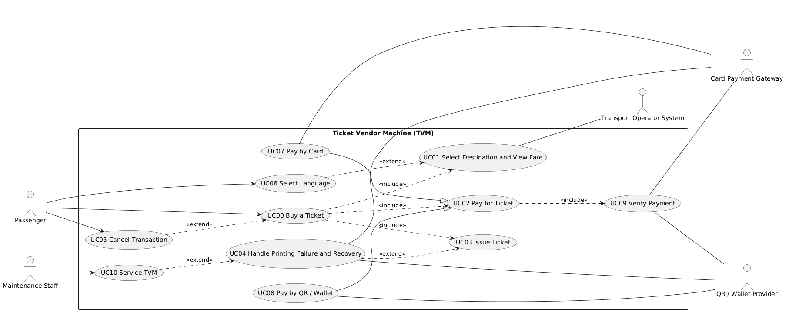

3.1.2 Actors and Use Case List
ID | Use case | Primary actor | Short description
UC00 | Buy a Ticket | Passenger | Passenger selects a destination, pays, and receives a printed ticket.
UC01 | Select Destination and View Fare | Passenger | Passenger chooses a service and destination and confirms the fare shown.
UC02 | Pay for Ticket | Passenger | Passenger chooses a payment method and the TVM tracks the payment result.
UC03 | Issue Ticket | Passenger | After verified payment, the TVM generates the ticket ID and barcode and prints the ticket.
UC04 | Handle Printing Failure and Recovery | Passenger | If printing fails after payment, the TVM logs it, avoids a second charge, and starts a refund or recovery.
UC05 | Cancel Transaction | Passenger | Passenger cancels, or the 60 s idle limit expires, and the session is cleared.
UC06 | Select Language | Passenger | Passenger switches the interface between Vietnamese and English.
UC07 | Pay by Card | Passenger | Passenger inserts or taps a card and the TVM sends the authorization to the card gateway.
UC08 | Pay by QR / Wallet | Passenger | TVM shows a transaction QR code and the passenger confirms payment in a banking or wallet app.
UC09 | Verify Payment | Payment Gateway / QR Wallet Provider | TVM checks the signed confirmation, transaction ID, amount and duplicates before marking payment verified.
UC10 | Service TVM | Maintenance Staff | Staff clear a fault, refill paper, run a health check, and return the TVM to service.

3.1.3 Use Case Descriptions
UC00: Buy a Ticket
Item | Content
Use case ID and name | UC00 Buy a Ticket
Primary actor / secondary actors | Passenger / Transport Operator System, Payment Gateway, QR / Wallet Provider
Related requirements | FR1 to FR19; NFR1, NFR3, NFR4, NFR5, NFR6; DR1 to DR5
Pre-conditions | TVM is in service and showing the idle screen.
Trigger | Passenger presses Start.
Main flow | 1. Passenger presses Start.  2. TVM displays destinations.  3. Passenger selects a destination.  4. TVM retrieves and displays the fare (UC01).  5. Passenger confirms the destination.  6. Passenger selects a payment method.  7. TVM creates the transaction and prompts for card or QR (UC02, UC07/UC08).  8. Payment Gateway processes the payment.  9. TVM receives and verifies the result (UC09).  10. TVM generates the ticket ID and barcode and prints the ticket (UC03).  11. TVM dispenses the ticket, marks the transaction COMPLETED, and returns to idle.
Alternate flows | 5a. Passenger cancels or is idle for 60 s: UC05.  6a. Passenger changes language: UC06.
Exception flows | 4a. Fare data unavailable: TVM shows “Service unavailable” and returns to idle.  9a. Payment failed or timed out: see UC02.  10a. Printer error or paper out: see UC04
Post-conditions | A ticket is printed and the transaction is COMPLETED, or the transaction is CANCELLED or FAILED with no paid ticket left without a refund process.

UC01: Select Destination and View Fare

Item | Content
Use case ID and name | UC01 Select Destination and View Fare
Primary actor / secondary actors | Passenger / Transport Operator System
Related requirements | FR1 to FR4, FR17, FR19, FR20; NFR4, NFR5; DR1, DR2
Pre-conditions | TVM is idle and in service.
Trigger | Passenger presses Start.
Main flow | 1. Passenger presses Start.  2. TVM displays services and destinations within 2 s.  3. Passenger selects a destination.  4. TVM retrieves and displays the fare.  5. Passenger confirms the selection.
Alternate flows | 2a. Passenger changes language: UC06.  3a. Passenger changes the destination before confirming: return to step 2.
Exception flows | 4a. Fare data unavailable: TVM shows “Service unavailable” and returns to idle.  5a. Passenger idle for 60 s: session expires (UC05).
Post-conditions | A destination and fare are confirmed for the transaction.

UC02: Pay for Ticket
Item | Content
Use case ID and name | UC02 Pay for Ticket
Primary actor / secondary actors | Passenger / Payment Gateway, QR / Wallet Provider
Related requirements | FR5 to FR9, FR13, FR15, FR18; NFR3, NFR6; DR3, DR4, DR8
Pre-conditions | A fare is confirmed.
Trigger | Passenger confirms the destination and fare.
Main flow | 1. TVM displays the payment methods (Card, Banking QR, Wallet).  2. Passenger chooses a method.  3. TVM creates the transaction and a payment request.  4. Passenger pays (UC07 or UC08).  5. TVM verifies the result (UC09).  6. TVM displays the payment status as successful.
Alternate flows | 4a. Passenger cancels before paying: UC05.
Exception flows | 5a. Payment declined: TVM shows “Payment failed”; passenger retries or cancels.  5b. No response within 60 s: TVM shows “Pending”, reconciles the status, and allows a retry only if the status is confirmed failed.  5c. Verification fails: TVM rejects the result and keeps the payment unverified.
Post-conditions | Payment is VERIFIED, FAILED, or PENDING. No ticket is issued unless it is VERIFIED.

UC03: Issue Ticket
Item | Content
Use case ID and name | UC03 Issue Ticket
Primary actor / secondary actors | Passenger / none
Related requirements | FR10 to FR12, FR16, FR18; NFR3; DR4, DR5, DR7
Pre-conditions | Payment is VERIFIED.
Trigger | TVM marks the payment VERIFIED.
Main flow | 1. TVM generates a unique ticket ID and barcode.  2. TVM prints the ticket.  3. TVM records the transaction ID, fare, payment status, ticket status, and timestamp.  4. TVM dispenses the ticket and returns to idle.
Alternate flows | None
Exception flows | 2a. Printer error or paper out: UC04.
Post-conditions | One ticket is printed and recorded; no duplicate ticket exists for the transaction.

UC04: Handle Printing Failure and Recovery
Item | Content
Use case ID and name | UC04 Handle Printing Failure and Recovery
Primary actor / secondary actors | Passenger / Payment Gateway, QR / Wallet Provider
Related requirements | FR12, FR14, FR16, FR19; NFR2, NFR8, NFR9; DR8
Pre-conditions | Payment is VERIFIED and printing has failed.
Trigger | Printer reports an error or paper out.
Main flow
  1. TVM detects the printer error.
  2. TVM records PRINT_FAILED and logs the failure.
  3. TVM shows the error and a reference number.
  4. TVM starts the refund or recovery process.
  5. TVM returns to idle.
Alternate flows | 4a. Printer recovers: TVM reprints the same ticket without charging again.
Exception flows | 4b. Refund request fails: TVM flags the transaction for manual follow-up.  5a. Printer unusable: TVM goes out of service (UC10).
Post-conditions | The failure is logged, the passenger is not charged again for the same purchase, and a refund or reprint is started.
UC05: Cancel Transaction
Item | Content
Use case ID and name | UC05 Cancel Transaction
Primary actor / secondary actors | Passenger / none
Related requirements | FR15, FR16, FR17; NFR6; DR8
Pre-conditions | A transaction is in progress.
Trigger | Passenger presses Cancel, or 60 s of inactivity before payment.
Main flow | 1. Passenger presses Cancel.  2. TVM clears session data.  3. TVM records the transaction as CANCELLED.  4. TVM returns to idle.
Alternate flows | 1a. 60 s idle before payment: TVM expires the session and continues from step 2.
Exception flows | 1b. Payment may already be submitted: TVM checks the status first; if payment is confirmed, it continues to ticket issuance or refund.
Post-conditions | The transaction is CANCELLED and session data is cleared.
UC06: Select Language
Item | Content
Use case ID and name | UC06 Select Language
Primary actor / secondary actors | Passenger / none
Related requirements | FR20; NFR8
Pre-conditions | TVM is showing any passenger screen.
Trigger | Passenger presses the language button.
Main flow | 1. Passenger selects Vietnamese or English.  2. TVM redisplays all screens and messages in that language.
Alternate flows | None
Exception flows | None
Post-conditions | The interface uses the chosen language until the session ends.

UC07: Pay by Card
Item | Content
Use case ID and name | UC07 Pay by Card
Primary actor / secondary actors | Passenger / Card Payment Gateway
Related requirements | FR6; NFR7; DR6, DR9
Pre-conditions | Passenger chose Card as the payment method.
Trigger | TVM prompts for the card.
Main flow | 1. TVM prompts “Insert or tap card”.  2. Passenger inserts or taps the card.  3. TVM sends the authorization request to the gateway.  4. Gateway returns the result.
Alternate flows | 2a. Passenger cancels: UC05.
Exception flows | 2b. Card unreadable: TVM asks the passenger to try again or choose another method.  4a. Card declined: UC02 failure path.
Post-conditions | The gateway has returned an authorization result for the transaction. Full card numbers and CVV are not stored.
UC08: Pay by QR / Wallet
Item | Content
Use case ID and name | UC08 Pay by QR / Wallet
Primary actor / secondary actors | Passenger / QR / Wallet Provider
Related requirements | FR7, FR9; DR3
Pre-conditions | Passenger chose Banking QR or Wallet.
Trigger | TVM requests a payment from the provider.
Main flow | 1. TVM generates a unique QR code for the transaction.  2. TVM displays the QR code.  3. Passenger scans it with a banking or wallet app and confirms.  4. Provider sends the payment result.
Alternate flows | 3a. Passenger cancels: UC05.
Exception flows | 3b. QR expires or no confirmation within 60 s: UC02 timeout path.  4a. Payment declined by the bank or wallet: UC02 failure path.
Post-conditions | The provider has returned a payment result for the transaction.

UC09: Verify Payment
Item | Content
Use case ID and name | UC09 Verify Payment
Primary actor / secondary actors | Payment Gateway, QR / Wallet Provider / none
Related requirements | FR8, FR18; NFR3; DR3, DR4
Pre-conditions | A payment request has been sent to the provider.
Trigger | TVM receives a payment confirmation.
Main flow | 1. TVM receives the signed confirmation.  2. TVM verifies the signature.  3. TVM checks the transaction ID, amount, and currency.  4. TVM checks that it is not a duplicate notification.  5. TVM marks the payment VERIFIED.
Alternate flows | None
Exception flows | 2a. Signature invalid or data mismatch: TVM rejects the notification and keeps the payment unverified.  4a. Duplicate notification: TVM ignores it and issues no second ticket.
Post-conditions | The payment is VERIFIED, or it stays unverified and no ticket can be issued.
UC10: Service TVM
Item | Content
Use case ID and name | UC10 Service TVM
Primary actor / secondary actors | Maintenance Staff / none
Related requirements | FR19; NFR1, NFR2, NFR9
Pre-conditions | TVM is OUT_OF_SERVICE, or a printer failure has been logged.
Trigger | Staff attend the TVM after a fault.
Main flow | 1. Staff open the TVM and read the logged fault.  2. Staff refill paper or fix the fault.  3. Staff run a health check.  4. TVM logs the recovery action and returns to idle.
Alternate flows | None
Exception flows | 3a. Health check fails: TVM stays out of service and the fault stays logged.
Post-conditions | The fault is cleared, the recovery is logged, and the TVM is back in service.

3.2 Activity Diagrams (10 marks)

3.2.1 Passenger Buys a Ticket at the TVM
[ Activity diagram: buy a ticket ] 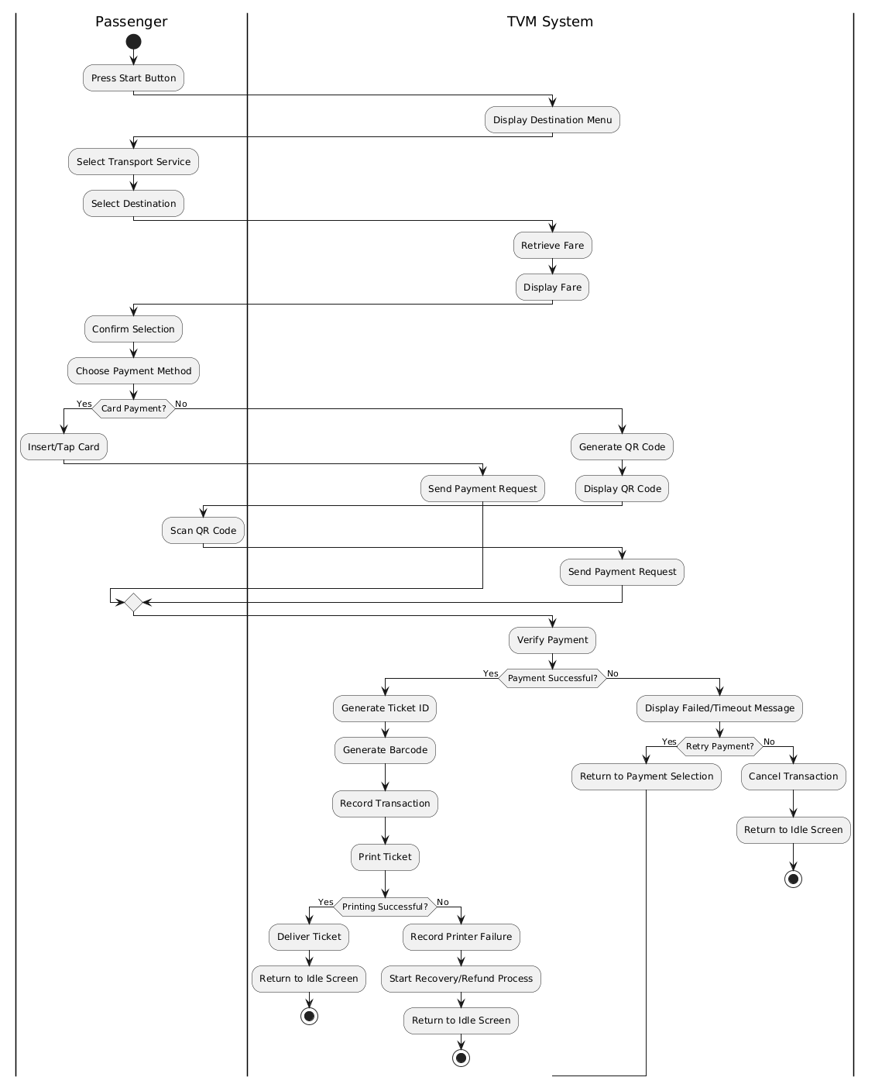

3.2.2 Communication with External Payment Gateways
[ Activity diagram: payment gateway integration ] 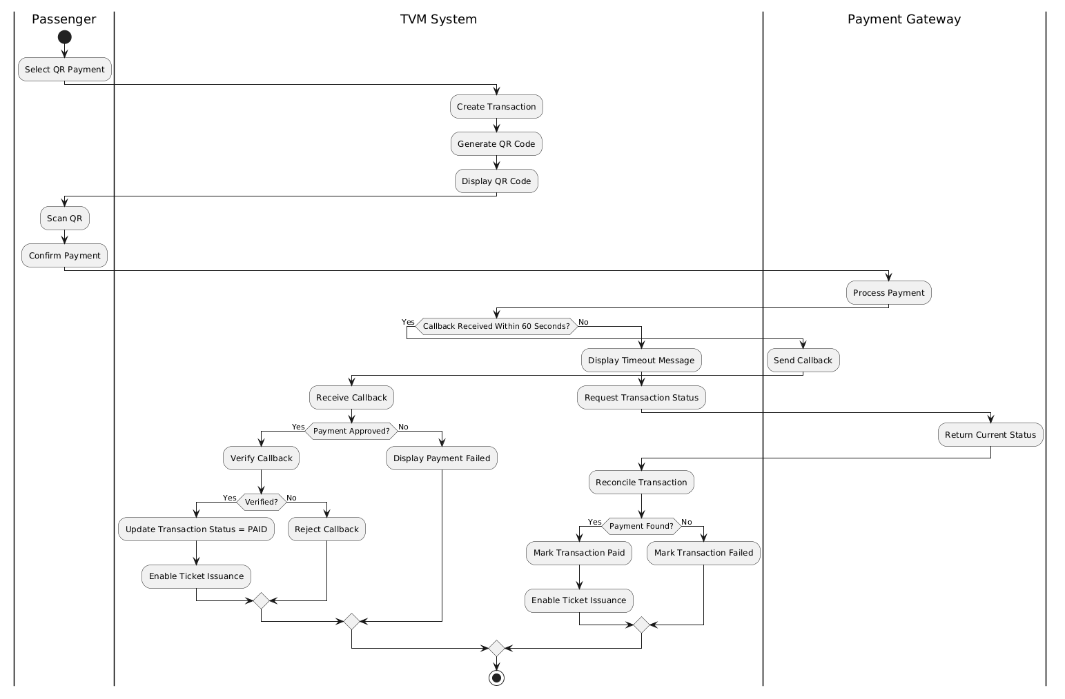

3.3 Detailed System Modeling: Main Use Case "Buy a Ticket" (15 marks)

3.3.1 Sequence Diagram
[ Sequence diagram: Buy a Ticket ] 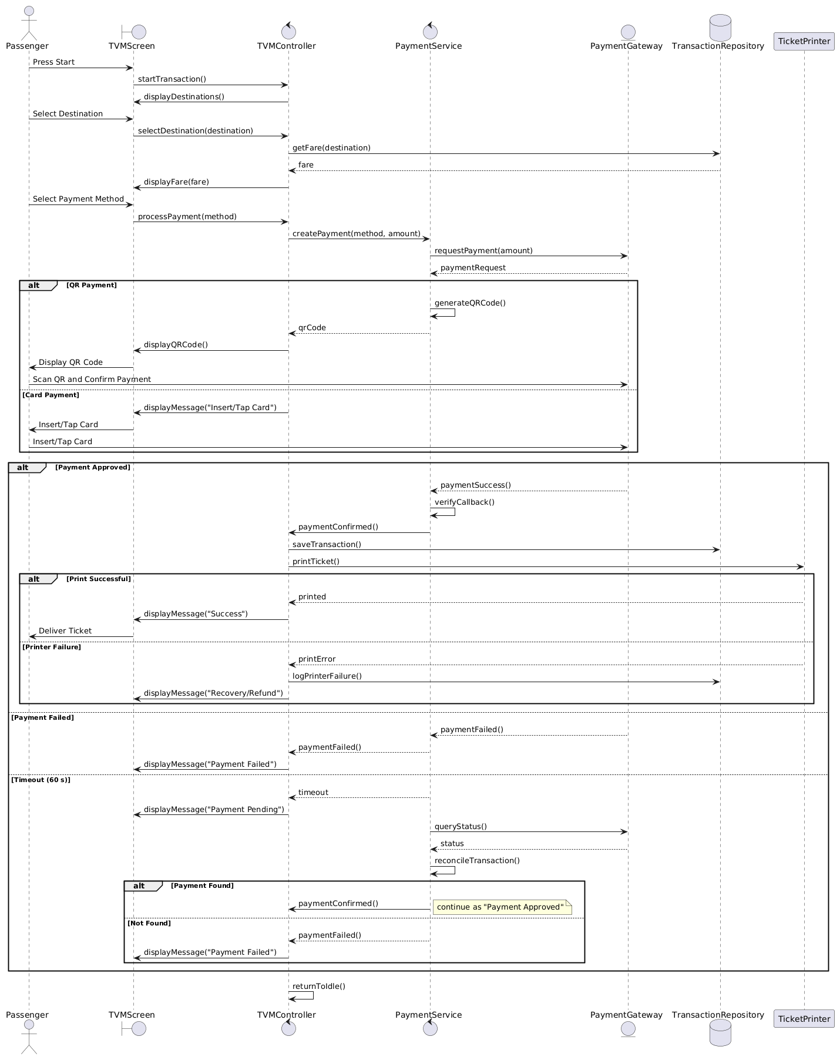

3.3.2 State Chart Diagram
[ State chart diagram ] 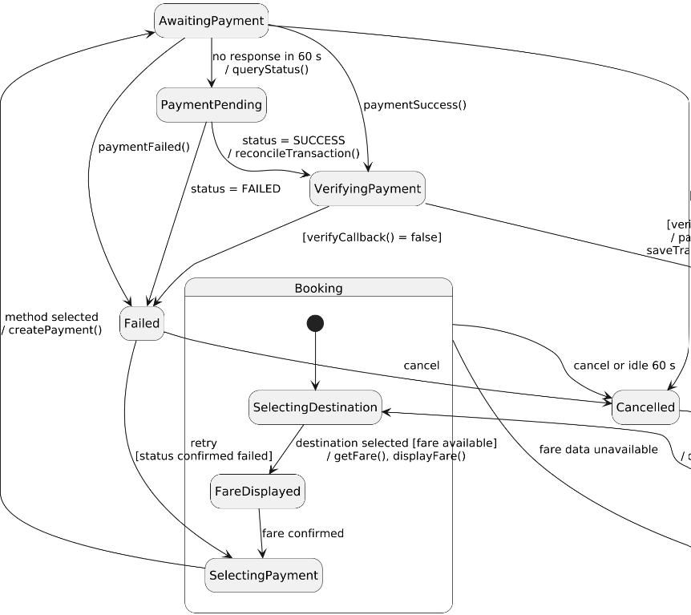
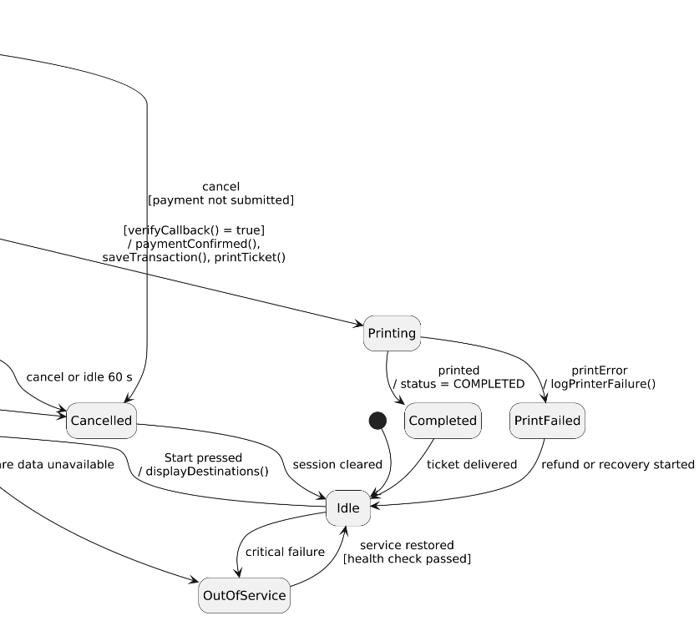

3.3.3 Class Diagram (Domain Model)
[ Class diagram ] 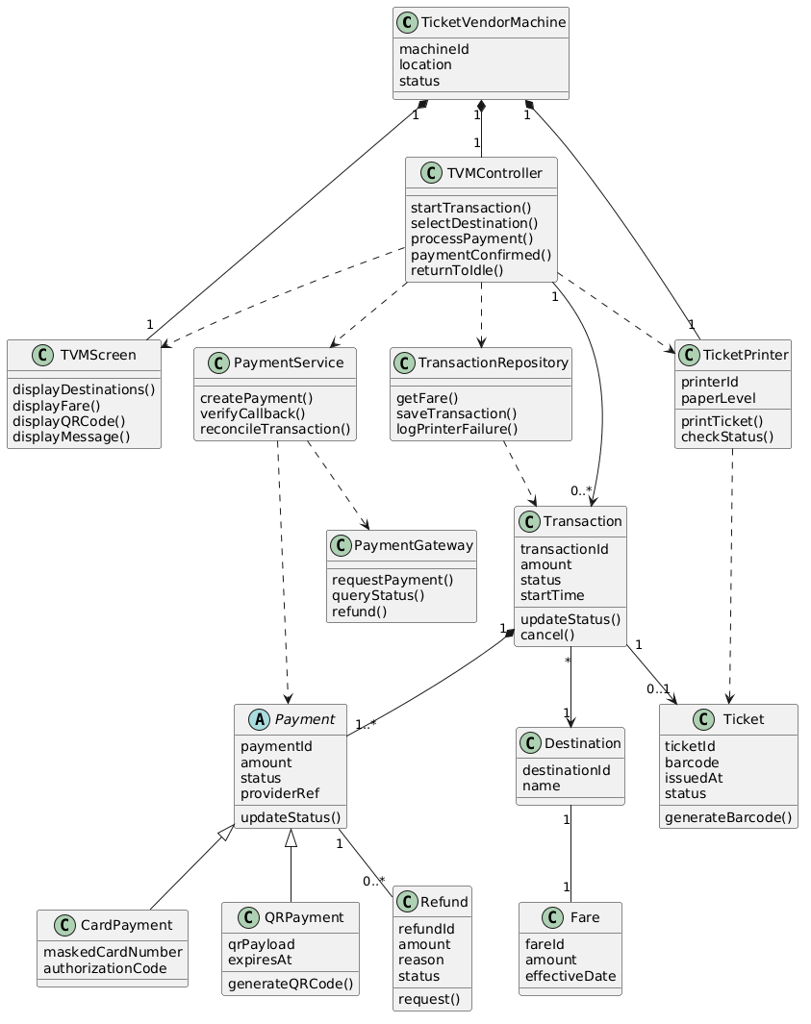
Class | Key attributes | Key methods | Relationships
TicketVendorMachine | machineId, location, status | startTransaction(), displayDestinations(), returnToIdle() | Processes 0..* Transaction; composed of 1 TicketPrinter
Destination | destinationId, name | getFare() | Has 1 Fare; chosen by many Transactions
Fare | fareId, amount, effectiveDate | none | Belongs to 1 Destination
Transaction | transactionId, amount, status, startTime | updateStatus(), cancel() | Handled by 1 TicketVendorMachine; travels to 1 Destination; composed of 1..* Payment; results in 0..1 Ticket
Payment (abstract) | paymentId, amount, status, providerRef | initiate(), verifyResult(), queryStatus() | Part of 1 Transaction; uses PaymentGateway; has 0..* Refund; generalizes CardPayment and QRPayment
CardPayment | maskedCardNumber, authorizationCode | authorize() | Subclass of Payment
QRPayment | qrPayload, expiresAt | generateQR() | Subclass of Payment (covers banking QR and digital wallet)
PaymentGateway | none | requestPayment(), queryStatus(), verifyCallback(), refund() | Used by Payment; represents external providers (VNPay, MoMo, ZaloPay, card acquirer)
Ticket | ticketId, barcode, issuedAt, status | generateBarcode() | Result of 1 Transaction; printed by TicketPrinter
TicketPrinter | printerId, paperLevel | printTicket(), checkStatus() | Part of 1 TicketVendorMachine; prints Ticket
Refund | refundId, amount, reason, status | request() | Belongs to 1 Payment

3.4 Model Consistency Check

Consistency check | Diagrams involved | Done
Every use case in the diagram has a description, and every description is in the diagram | Use case diagram / descriptions | ✓
Every step of the main flow appears in the activity diagram | Descriptions / activity | ✓
Objects and messages in the sequence diagram exist as classes and methods in the class diagram | Sequence / class | ✓
State names and transitions match the events in the sequence diagram | State chart / sequence | ✓
Payment gateway steps match between the two activity diagrams and the sequence diagram | Activity / sequence | ✓
Requirement IDs are cited in the use cases | Requirements / use cases | ✓
The class diagram matches the C# code generated in 5.1 | Class / code | ✓

4. Phase 3: UI/UX & Architecture (15 marks)

4.1 UI/UX Design (5 marks)
Guidance (delete before submitting): Wireframes or mockups of the TVM screens, designed with Balsamiq, Figma or a similar tool. Make them modern and intuitive for a touchscreen kiosk (large buttons, clear language, accessibility). Link each screen to a step of the main use case.
Screen | Name / purpose | Linked use case step | Tool and link
S01 | Home / Start: idle screen with Start button and English/Vietnamese toggle | UC00 step 1; alternate 6a (language, UC06); FR1, FR20 | S01-En, S01-Vn [link]
S02 | Destination menu: Metro / Bus tabs and destination list | UC00 steps 2–3; UC01 steps 2–3; FR2, FR3; NFR4 | S02-En-Metro, S02-En-Bus, S02-Vn-Metro, S02-Vn-Bus [link]
S03 | Fare confirmation: service, destination and fare, confirm or change | UC00 steps 4–5; UC01 steps 4–5, alternate 3a; FR4 | S03-En-Metro, S03-En-Bus, S03-Vn-Metro, S03-Vn-Bus [link]
S04 | Payment method: card, banking QR or digital wallet | UC00 step 6; UC02 steps 1–2; FR5 | S04-En, S04-Vn [link]
S05 | Card payment: “Insert or tap your card”, plus card-unreadable variant | UC00 step 7; UC07 steps 1–2, exception 2b; FR6 | S05-En, S05-En-Failed, S05-Vn, S05-Vn-Failed [link]
S06 | QR / wallet payment: QR code, three steps, amount | UC00 step 7; UC08 steps 1–3, exception 3b; FR7; NFR6 | S06-En, S06-Vn [link]
S07 | Please wait: verifying payment, then printing ticket | UC00 steps 9–10; UC09; UC03 steps 1–2; FR8, FR10, FR11; NFR5 | S07-En-Verify, S07-En-Print, S07-Vn-Verify, S07-Vn-Print [link]
S08 | Payment failed: message, Try again or Cancel | UC00 exception 9a (see UC02 exceptions 5a, 5c); FR9, FR13 | S08-En, S08-Vn [link]
S09 | Payment pending: checking status, no retry until reconciled | UC00 exception 9a (see UC02 exception 5b); FR9; NFR6 | S09-En, S09-Vn [link]
S10 | Ticket issued: success, ticket summary, auto-return | UC00 step 11; UC03 step 4; FR16 | S10-En, S10-Vn [link]
S11 | Printing failed: error, refund started, reference number | UC00 exception 10a; UC04 steps 3–5; FR14 | S11-En, S11-Vn [link]
S12 | Cancel / session expired: confirm pop-up, cancelled, expired | UC00 alternate 5a (cancel or 60 s idle, UC05); FR15, FR16, FR17 | S12-En-Confirmation, S12-En-Cancelled, S12-En-Expired, S12-Vn-Confirmation, S12-Vn-Cancelled, S12-Vn-Expired [link]
S13 | Out of service: machine unavailable | UC00 and UC01 exception 4a; UC04 exception 5a; FR19 | S13-En, S13-Vn [link]
S14 | Maintenance (staff only): status list, health check pass or fail | UC10 steps 1–4, exception 3a; NFR9 | S14-En, S14-En-CheckPass, S14-En-CheckFailed, S14-Vn, S14-Vn-CheckPass, S14-Vn-CheckFailed [link]

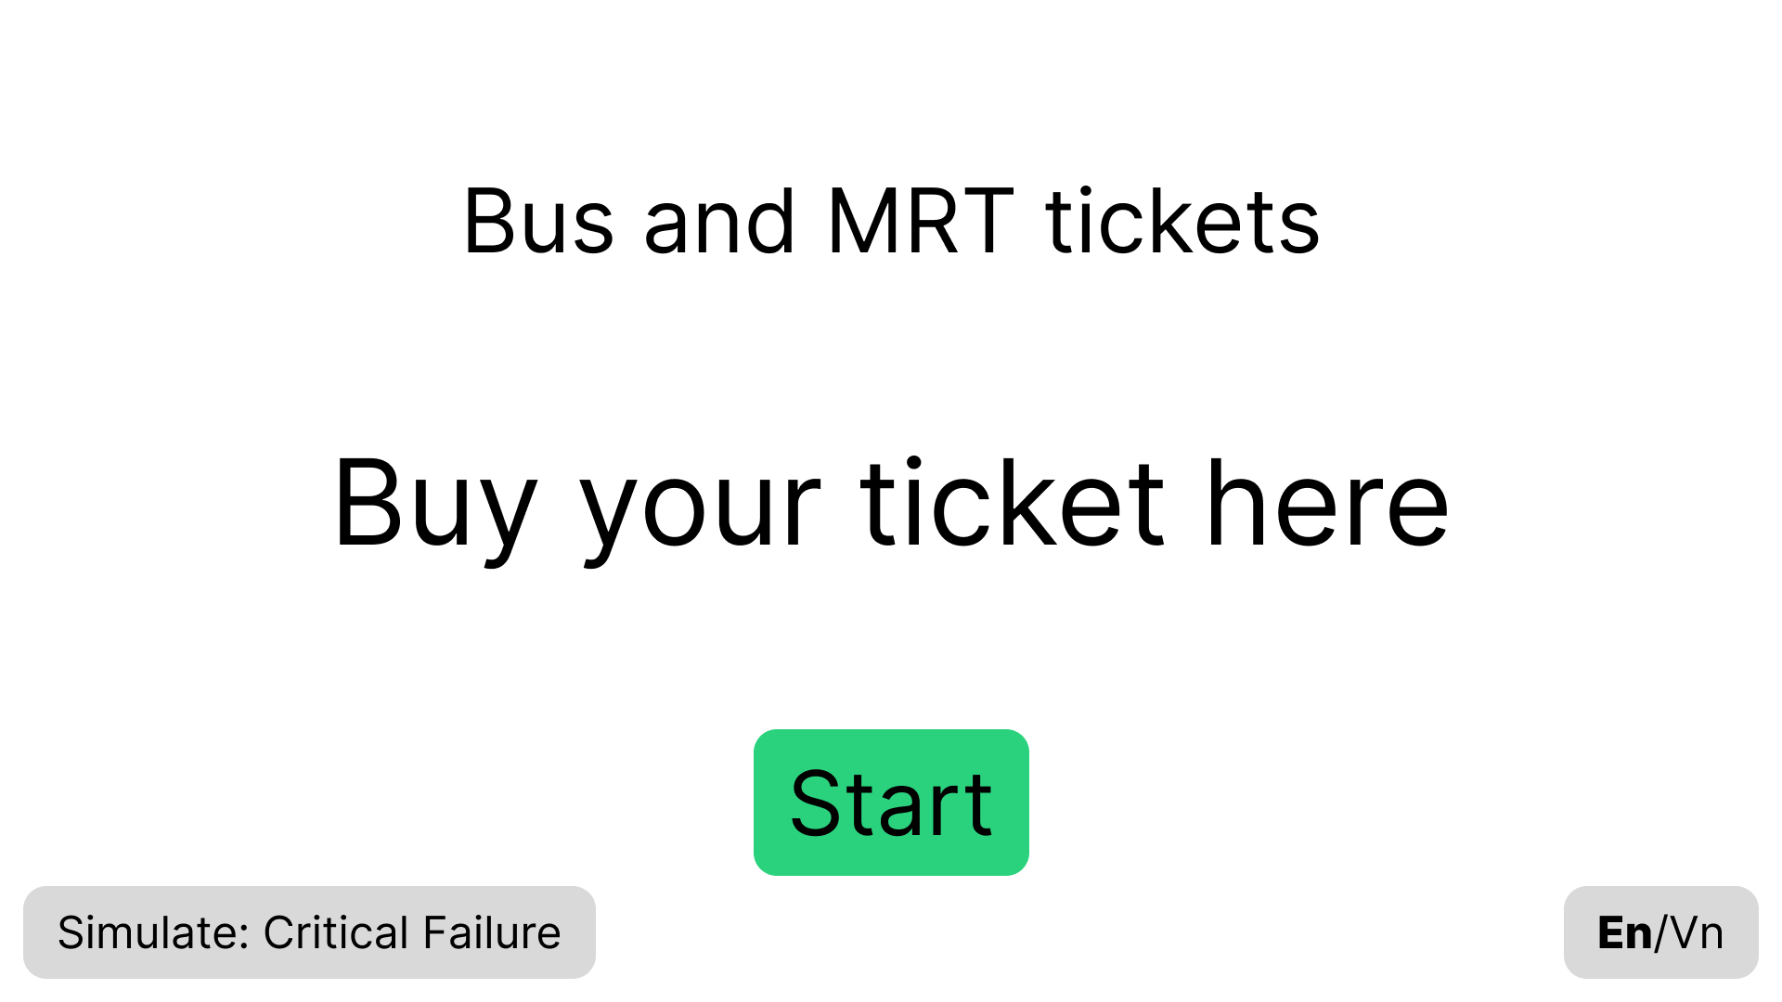
Figure 4.1.1: S01-En

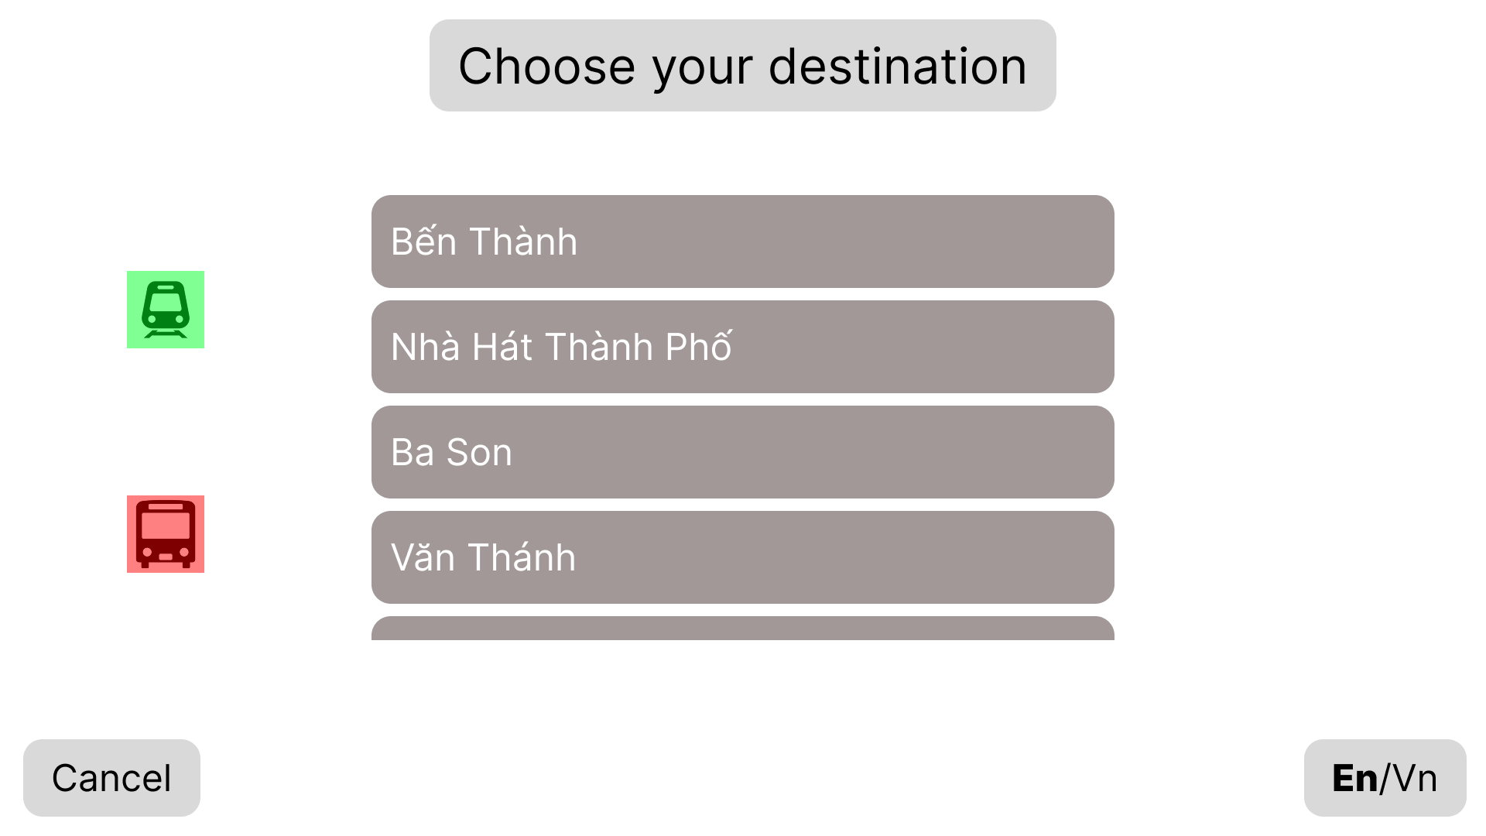
Figure 4.1.2: S02-En-Metro

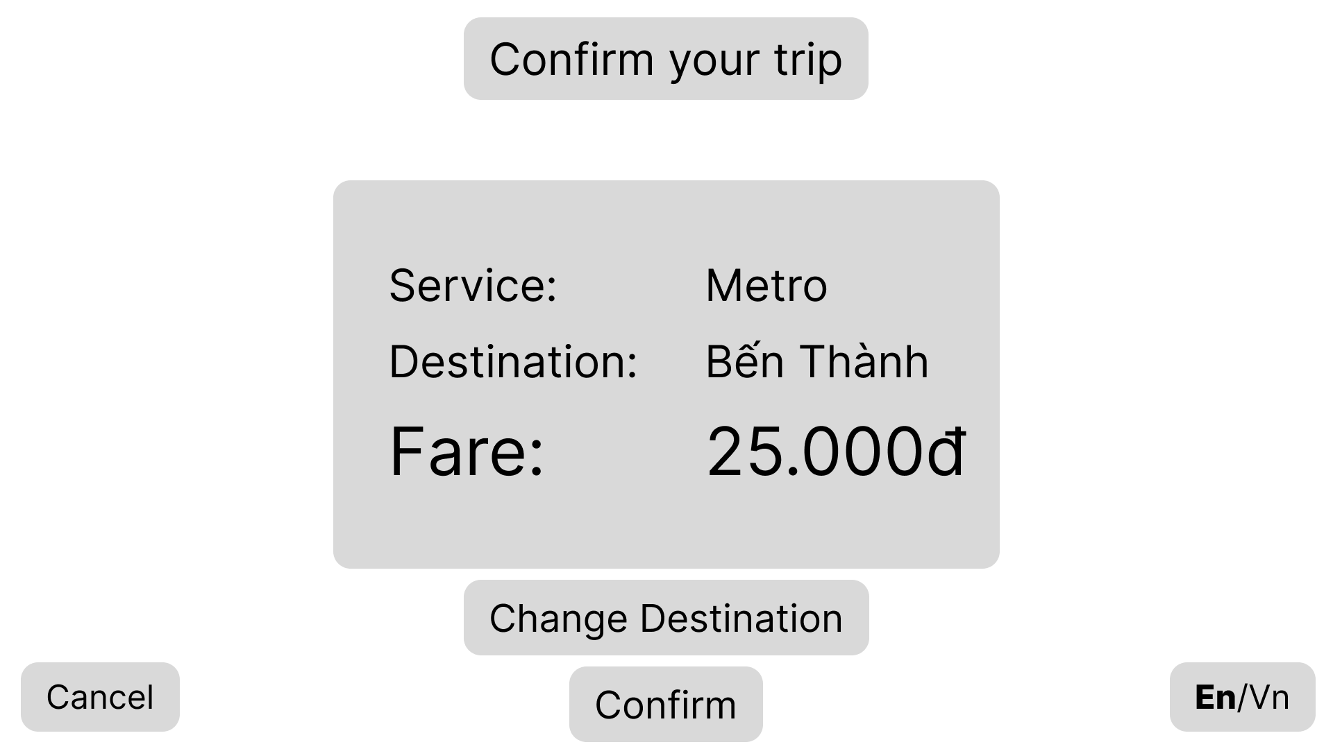
Figure 4.1.3: S03-En-Metro

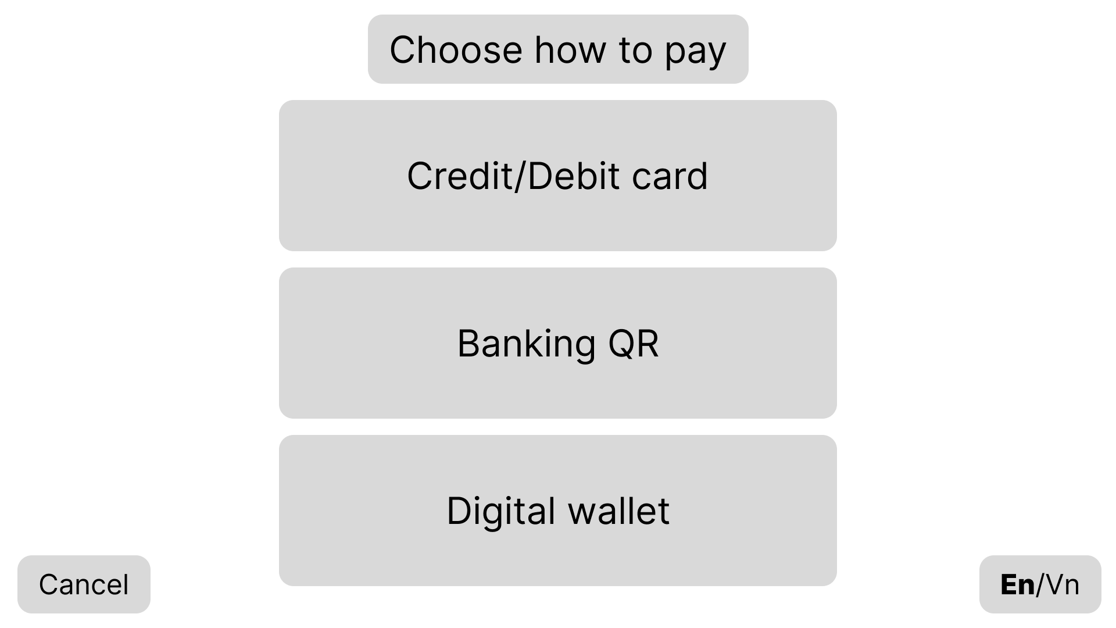
Figure 4.1.4: S04-En

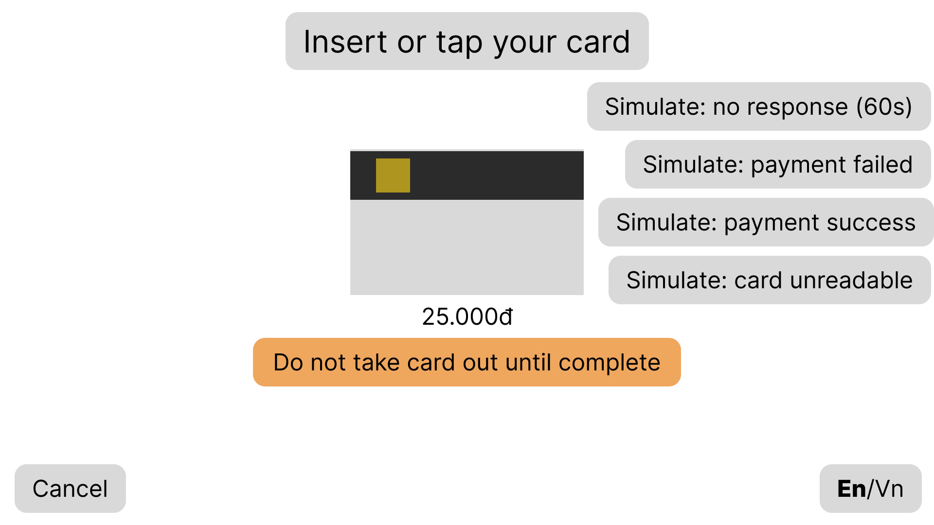
Figure 4.1.5: S05-En

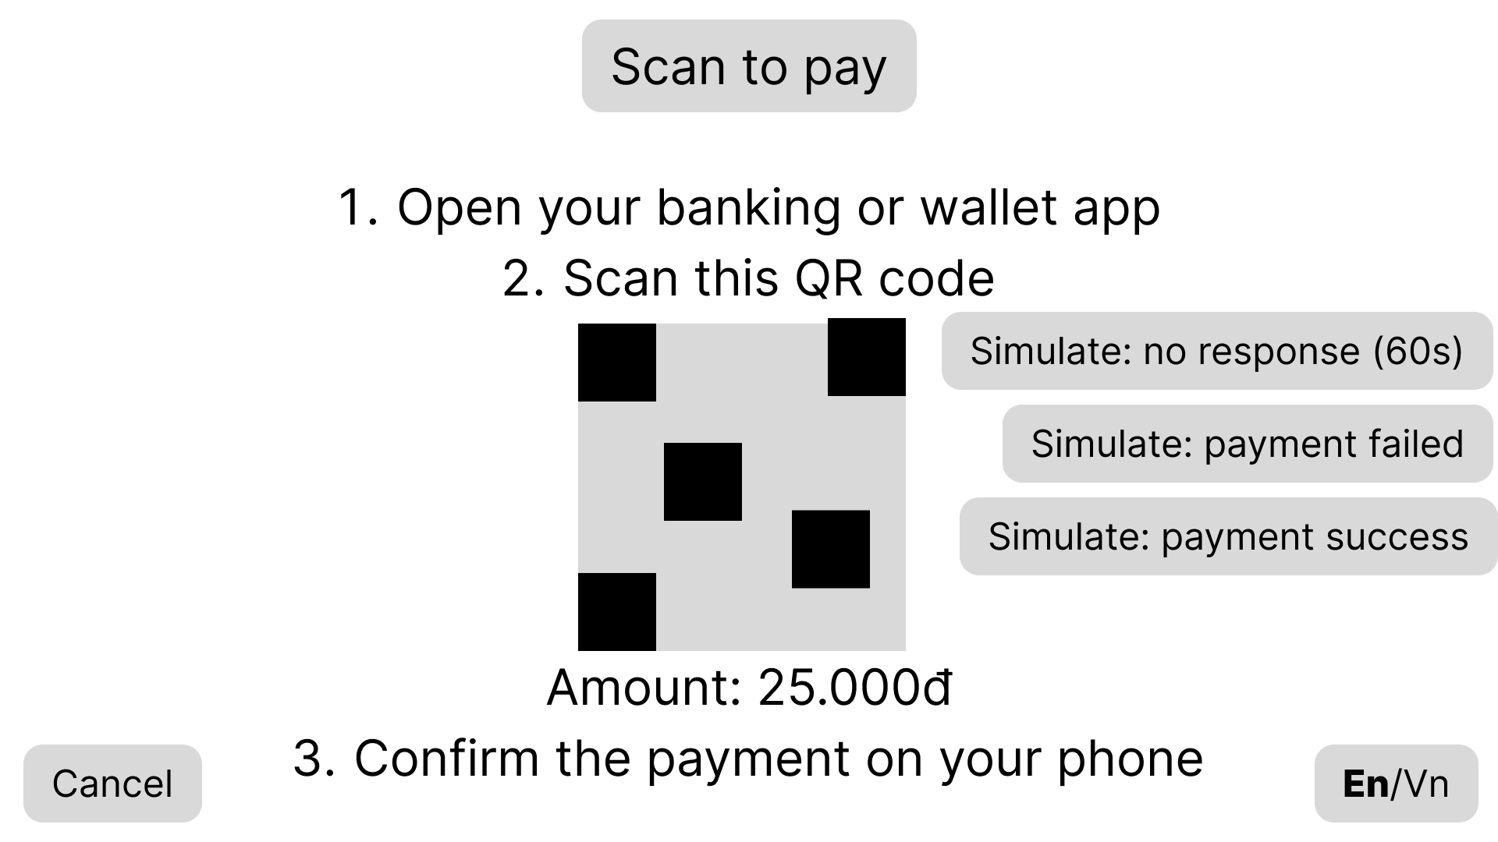
Figure 4.1.6: S06-En

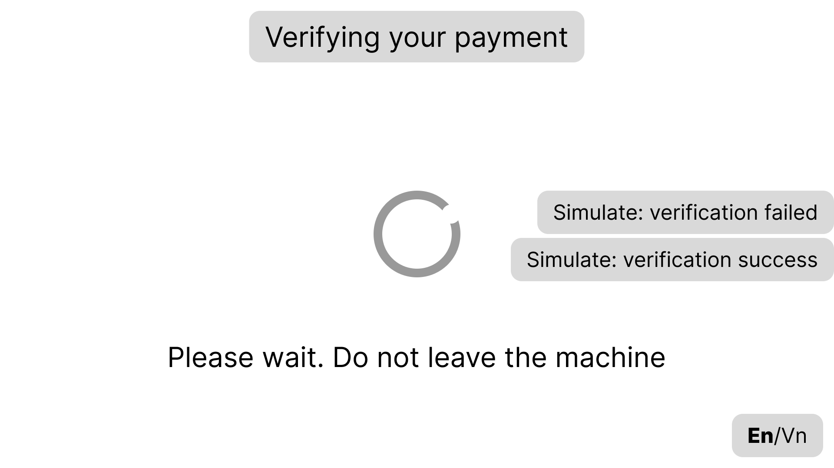
Figure 4.1.7: S07-En-Verify

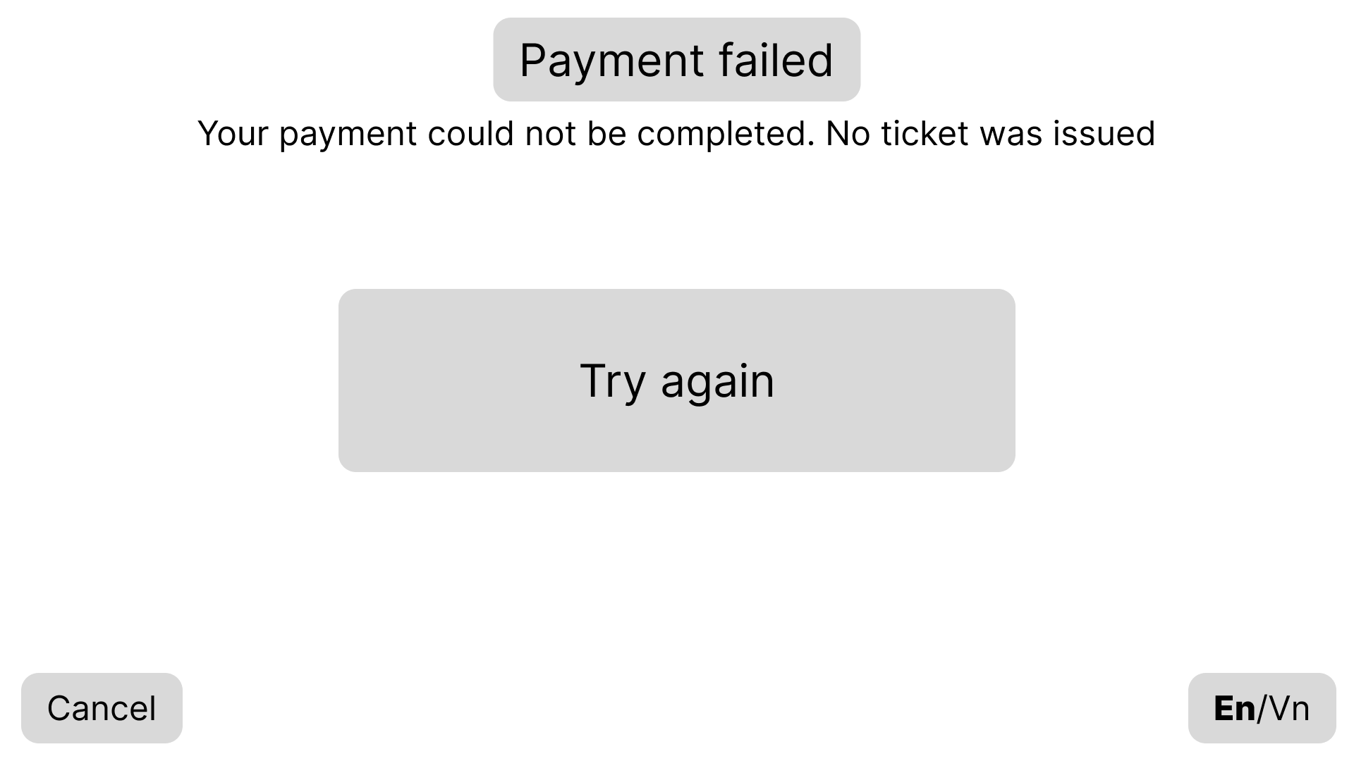
Figure 4.1.8: S08-En

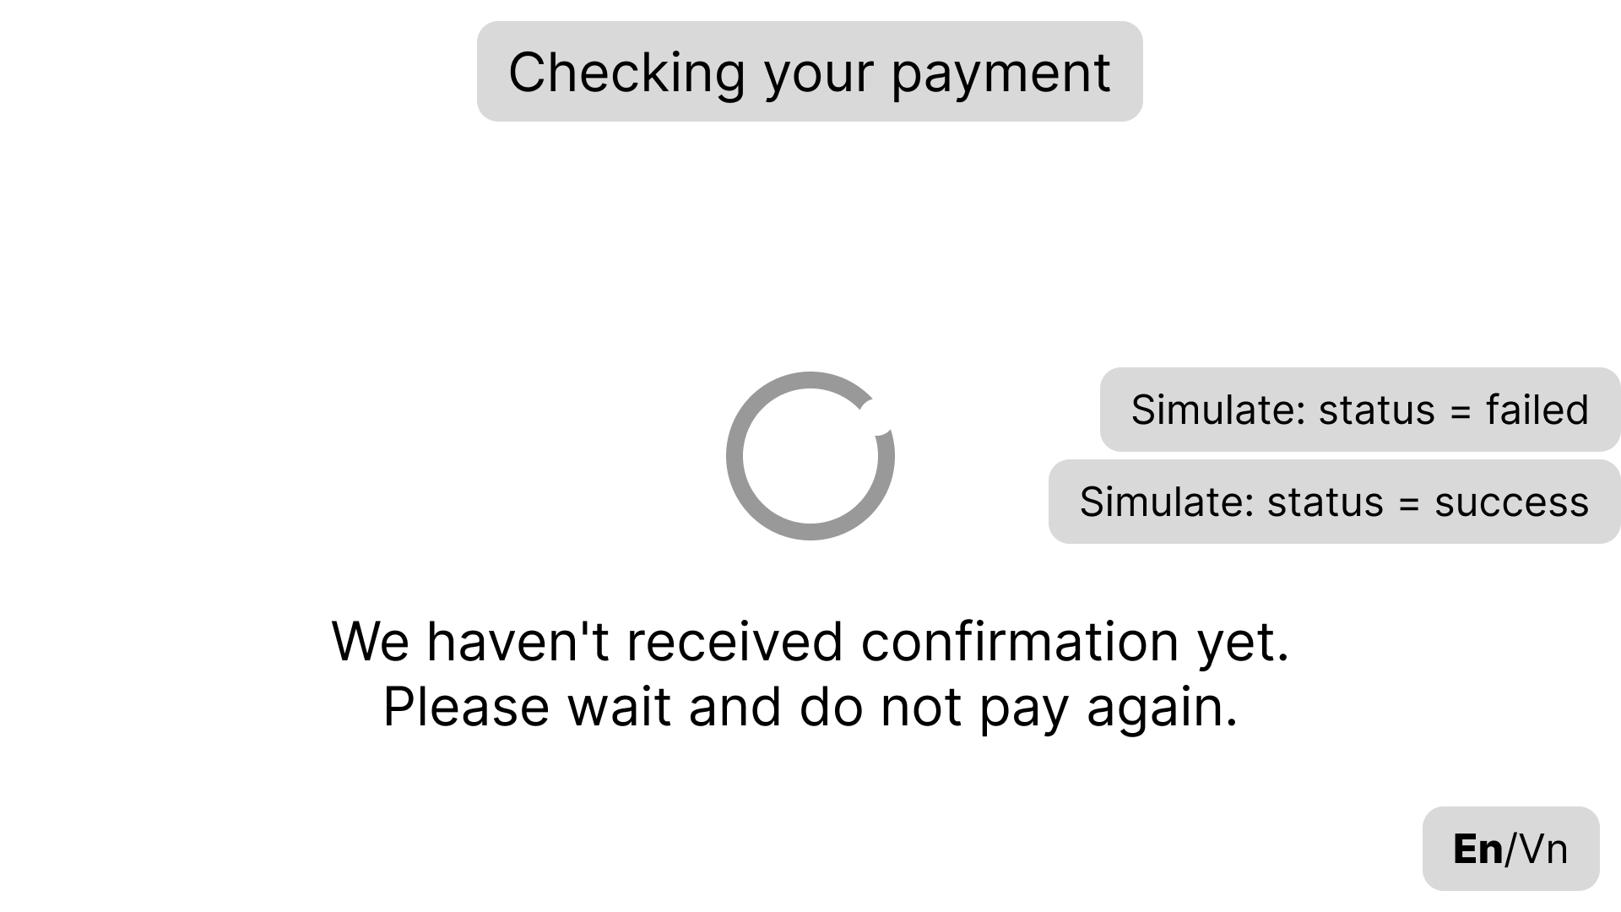
Figure 4.1.9: S09-En

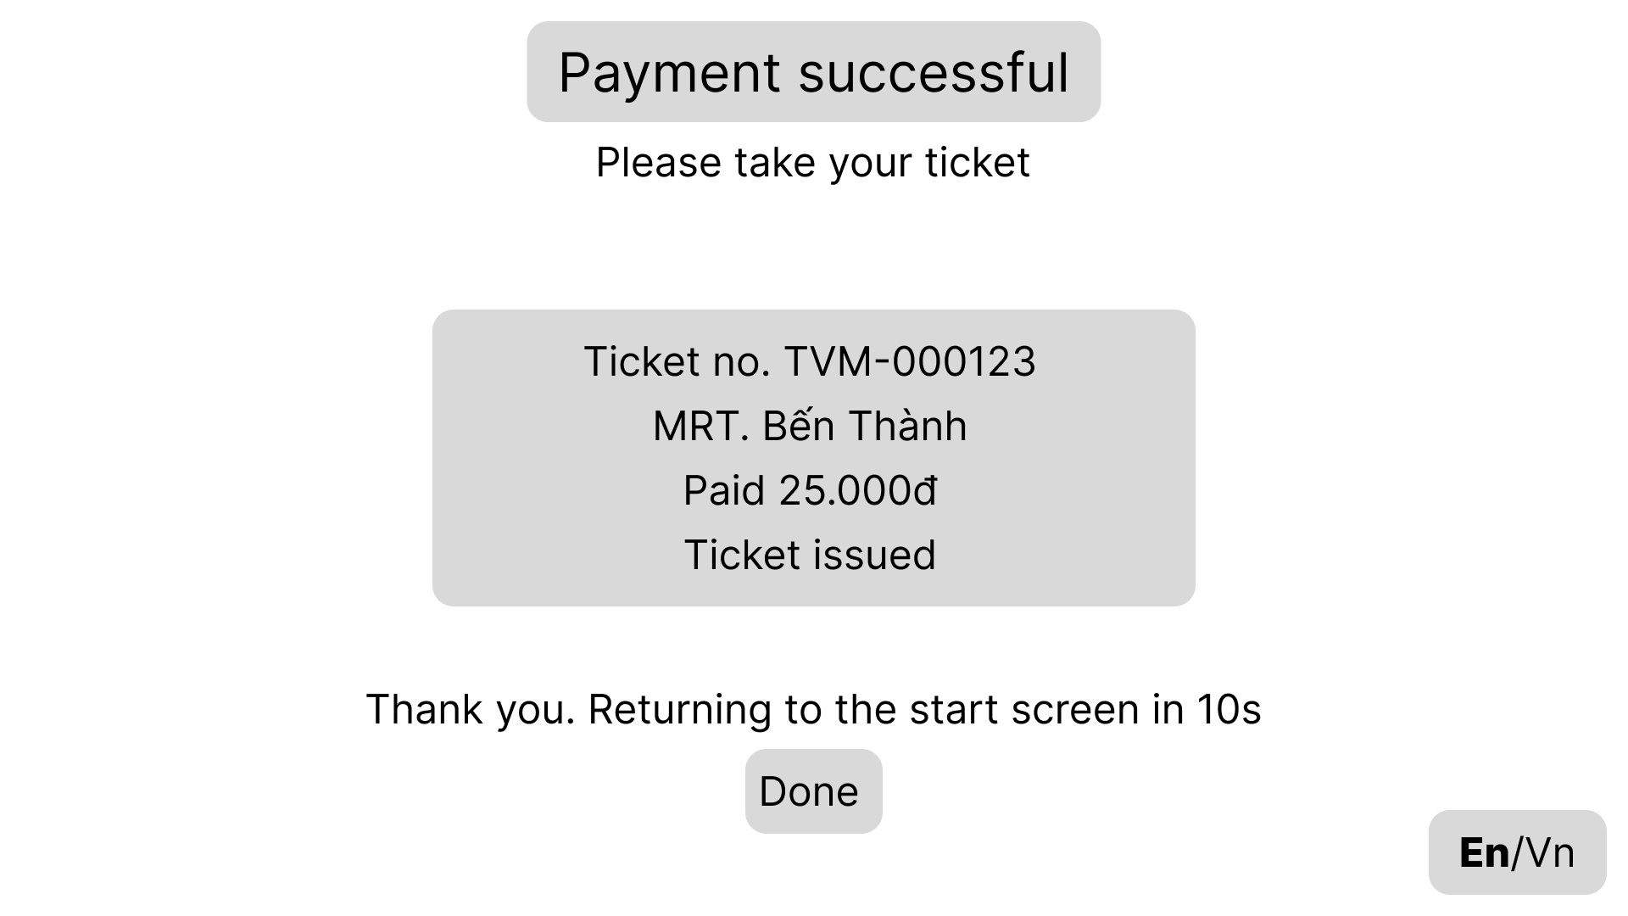
Figure 4.1.10: S10-En

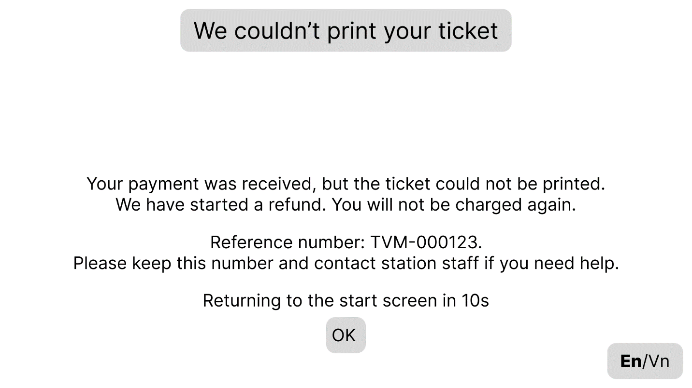
Figure 4.1.11: S11-En

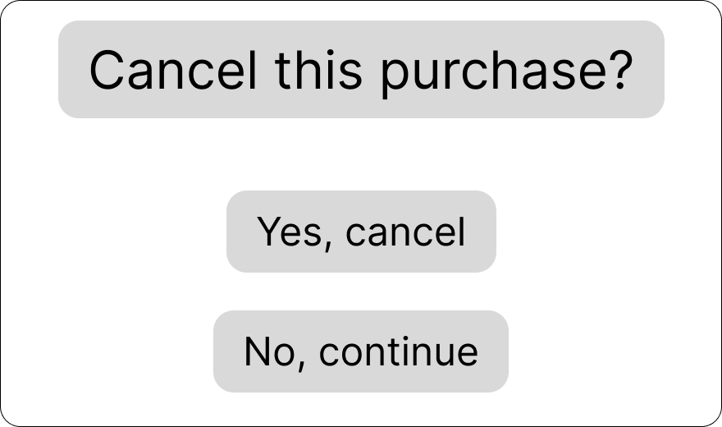
Figure 4.1.12: S12-En-Confirmation

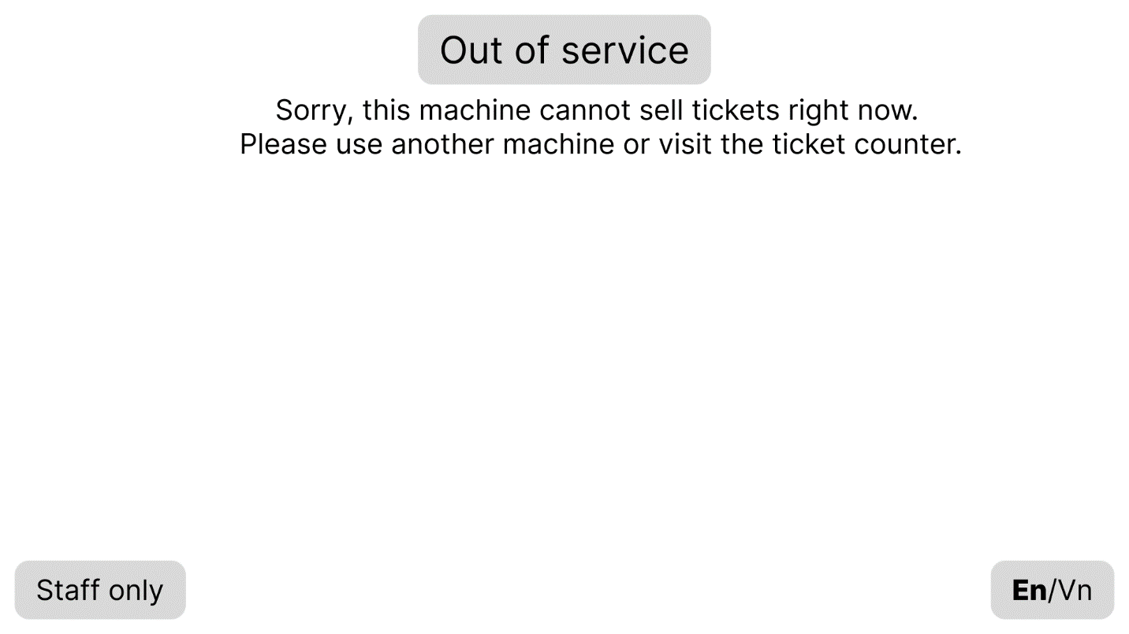
Figure 4.1.13: S13-En

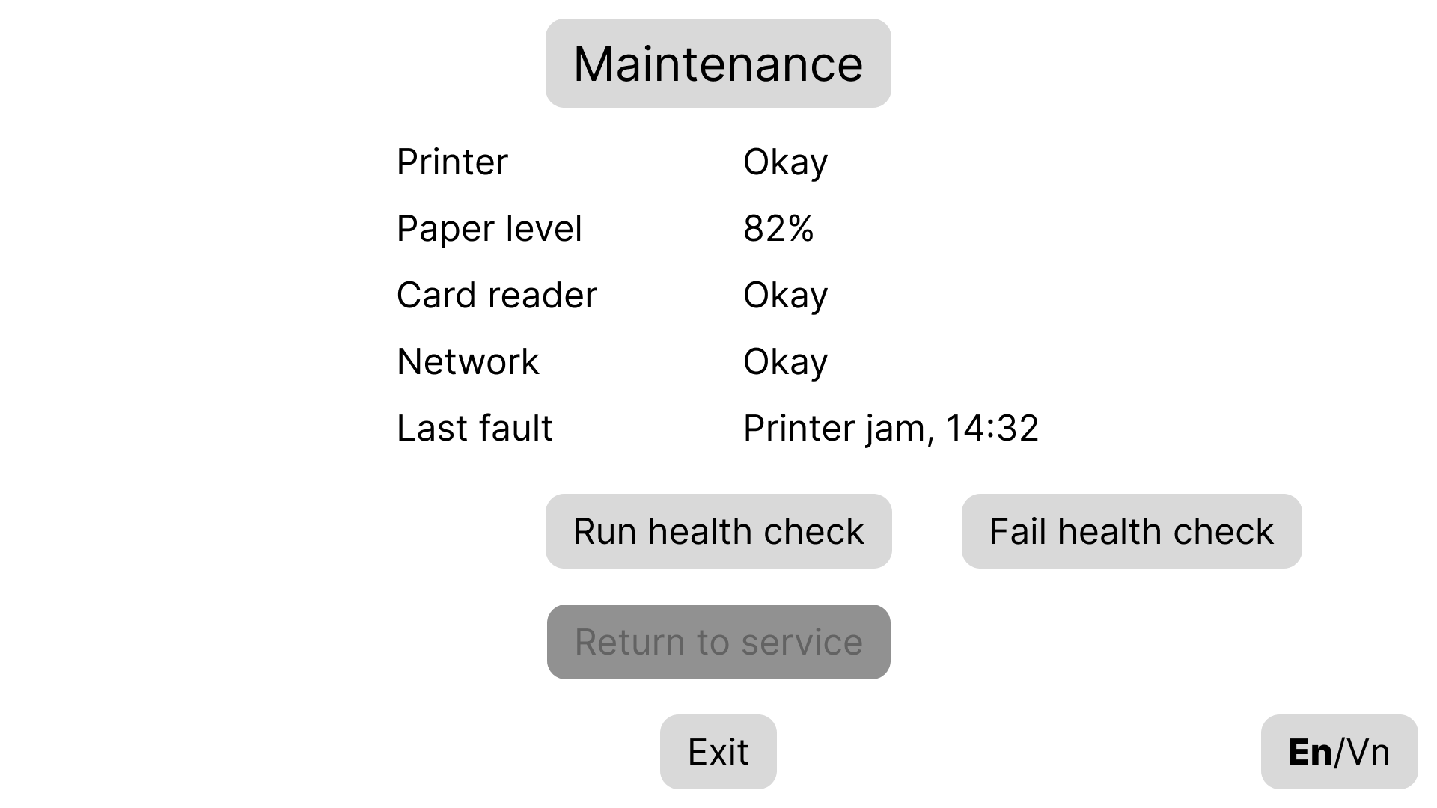
Figure 4.1.14: S14-En

4.2 Architectural Design (10 marks)

4.2.1 Architecture Diagram
Guidance (delete before submitting): A System-in-a-box or MVC architecture diagram. The architecture must be logical, modular and suitable for the hardware. Explain what each part does and why you chose it.
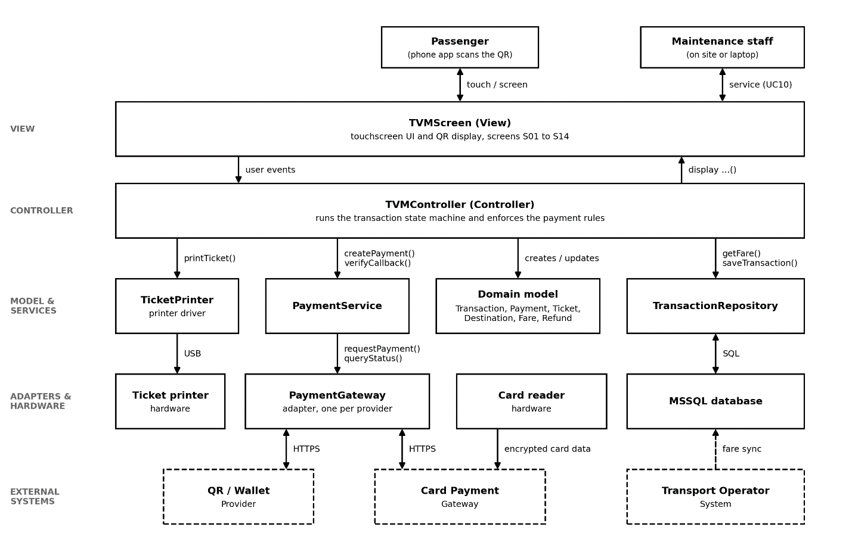
Figure 4.2.1: TVM architecture diagram (layered MVC)
The TVM is built as a layered MVC application, as shown in the Figure 4.2.1 above. The View (TVMScreen) is only the touchscreen interface (screens S01 to S14). It only displays information and passes the passenger’s actions on. The Controller (TVMController) is the only part that decides what happens next. It follows our state chart and enforces the main rules: no ticket until payment is verified, a 60 second limit on waiting for a payment result, and retry only after a confirmed failure. The Model is the set of domain classes from our class diagram (Transaction, Payment, Ticket, Destination, Fare and Refund), supported by PaymentService and TransactionRepository. Everything outside the application sits behind an adapter: PaymentGateway talks to the card and QR/wallet providers, TicketPrinter to the printer, and the repository to the MSSQL database. We chose this structure because it keeps screens, rules and integrations separate. A screen or provider can change without touching the rest, and a printer or gateway failure is handled in one place instead of breaking the whole machine.

4.2.2 Deployment Diagram
Guidance (delete before submitting): How the TVM hardware (touchscreen, card reader, QR display, printer), servers and external APIs (payment gateways) connect. Show nodes, protocols and the network boundary.
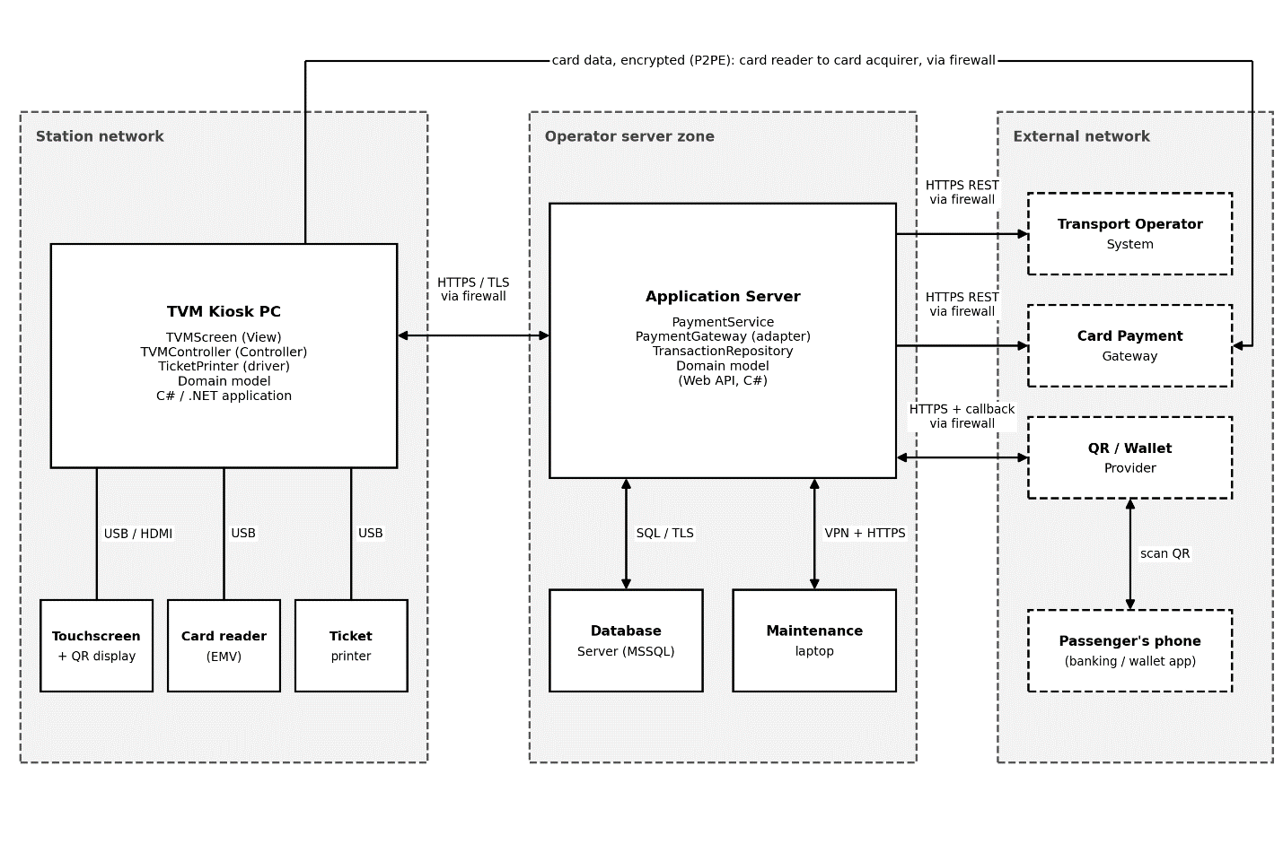
Figure 4.2.2: TVM deployment diagram
Node / component | Description | Connection (protocol, direction)
TVM Kiosk PC (TVM hardware) | Kiosk computer at the station running the TVM application (TVMScreen, TVMController, TicketPrinter, and Domain model). Includes the staff-only maintenance screens (S13, S14) for on-site service (UC10). | USB/HDMI to the peripherals; HTTPS/TLS to the application server, two-way, via firewall; kiosk initiates and polls for payment status
Touchscreen + QR display | Passenger input; shows the menus and the QR code | USB/HDMI to the kiosk PC, two-way
Card reader (EMV) | Reads or taps the card and encrypts the data (P2PE); the application never sees the card number | USB/serial to the kiosk PC; TLS outbound directly to the card acquirer
Ticket printer | Prints the ticket with its barcode; reports errors and paper out | USB from the kiosk PC; print commands out, status back
Application server | Hosts PaymentService, and PaymentGateway (adapter), TransactionRepository, and the Domain model (Web API, C#); receives provider callbacks, verifies the signature, reconciles status, records transactions | Inbound HTTPS from the kiosk and from QR/wallet callbacks; outbound HTTPS REST to gateways and the operator; SQL over TLS to the database; VPN + HTTPS from the maintenance laptop
Database server (MSSQL) | Transactions, payments, tickets, refunds, fares, destinations, logs | SQL over TLS from the application server only, two-way; not reachable from the kiosk or the internet
Payment gateway API: card (Card Payment Gateway) | Card acquirer that authorises card payments | TLS direct from the card reader (authorisation); HTTPS REST outbound from the application server (status query, refund), via firewall
Payment gateway API: QR / wallet | Creates and confirms QR and wallet payments | HTTPS REST outbound from the application server; signed callback inbound to the application server, via firewall
Transport Operator System | Authoritative fares and destinations (DR1, DR2); ticket validation | HTTPS REST outbound from the application server, via firewall
Passenger’s phone | Banking or wallet app that scans the QR shown on the TVM screen | Mobile data, HTTPS to the QR/wallet provider; not connected to the TVM
Maintenance laptop | Staff tool for UC10: fault logs and health checks | VPN + HTTPS to the application server, two-way
Firewalls | Mark the network boundaries between the station, the server zone and the internet | Allow-listed traffic only; only the callback endpoint is exposed inbound

5. Phase 4: Implementation, Tooling & Demo (30 marks)

5.1 Visual Studio Engineering: Model-to-Code (10 marks)

5.1.1 Forward Engineering (Model to Code)
Guidance (delete before submitting): Show how you generated the initial C# code skeletons from your class diagrams in Visual Studio. Include screenshots of the model and of the generated classes.
[ Class diagram in Visual Studio and the generated C# skeleton ]
[Steps taken and what was generated]

5.1.2 Backward Engineering (Code to Model)
Guidance (delete before submitting): List the manual code changes you made and show how they were reflected back into the UML model.
No. | Manual code change | File / class | How it was reflected in the model
1 | [ ] | [ ] | [ ]
2 | [ ] | [ ] | [ ]
…
[ Updated model after reverse engineering ]

5.1.3 Code Map
Guidance (delete before submitting): Generate a Code Map in Visual Studio and explain the relationships and architecture it shows.
[ Visual Studio Code Map ]
[What the code map shows and what you learned]

5.2 GitHub & AI Tooling (10 marks)

5.2.1 Source Control
Guidance (delete before submitting): The repository must show a committed history that proves active collaboration among all members.
Item | Your answer
Repository link | [ ]
Branches (names and purpose) | [ ]
Number of commits and pull requests | [ ]

Member | Commits | Pull requests | Main contributions
[ ] | [ ] | [ ] | [ ]
[ ] | [ ] | [ ] | [ ]
[ ] | [ ] | [ ] | [ ]

5.2.2 AI Assistance: Copilot Prompt Documentation
Guidance (delete before submitting): Document the prompts you used with GitHub Copilot (or a similar AI tool), how it helped (boilerplate or complex logic), and how you validated the AI-generated code. The workbook sheet "AI Prompt Log" is the full log; show the most important ones here.
No. | Member | Prompt | How the AI helped | Used? (kept / changed / rejected) | How we validated it
1 | [ ] | [ ] | [ ] | [ ] | [ ]
2 | [ ] | [ ] | [ ] | [ ] | [ ]
…

5.2.3 Reflection on AI Use
[What worked, what did not, errors found in AI output, and what you would do differently]

5.3 Demo Application (10 marks)
Guidance (delete before submitting): A functional prototype of the main use case using Visual Programming C# and MSSQL, with an input form and an output report (or success screen).
Item | Your answer
Technology and versions | [ ]
Database script location and how to run it | [ ]
How to run the application | [ ]
Video demo link (optional) | [ ]
Input form
[ Screenshot: input form (destination and payment mode) ]
Output report or success screen
[ Screenshot: ticket issued / output report ]
Test scenarios
No. | Scenario | Input | Expected result | Result
1 | [Successful purchase] | [ ] | [ ] | [ ]
2 | [Payment declined] | [ ] | [ ] | [ ]
3 | [ ] | [ ] | [ ] | [ ]
Known limitations
[ ]

6. Checklist for "LabGroup_QT2_Assignment1.pdf"
Guidance (delete before submitting): The submission must address the content of LabGroupAssignment1.pdf (initial context and submission guidelines). List each item of that document, where this report covers it, and tick it.
No. | Item from LabGroupAssignment1.pdf | Where addressed in this report | Done
1 | [ ] | [Section ] | [ ]
2 | [ ] | [Section ] | [ ]
3 | [ ] | [Section ] | [ ]
4 | [ ] | [Section ] | [ ]
5 | [ ] | [Section ] | [ ]
6 | [ ] | [Section ] | [ ]
7 | [ ] | [Section ] | [ ]
8 | [ ] | [Section ] | [ ]

7. Contribution of Each Member
Guidance (delete before submitting): The % contribution of each member must total 100% and match readme.txt.
Member | Student ID | Work products and tasks | % contribution
[ ] | [ ] | [ ] | [ ]
[ ] | [ ] | [ ] | [ ]
[ ] | [ ] | [ ] | [ ]
[ ] | [ ] | [ ] | [ ]
[ ] | [ ] | [ ] | [ ]
Total |  |  | 100%

8. Conclusion and Lessons Learnt
[What the team achieved, limitations, and what each member learnt]

References
1. [Course notes, textbook, tool documentation, links]

Appendix

Appendix A: readme.txt
[Paste the contents of readme.txt: GitHub link, Figma link, database script instructions, % contribution]
Figma link: https://www.figma.com/design/zp3wZjqfM5GrwHQVnmTpJq/524k0022_524k0024_524k0025_524k0038_524k0040?node-id=0-1&p=f&t=qkGJpQBazZOwNH8z-0

Appendix B: Full-size Diagrams
[Full-size use case, activity, sequence, state, class, architecture and deployment diagrams]
Architecture Diagram:

Deployment diagram:

