ACD_BDD2.3_Session_11_Assignment_3

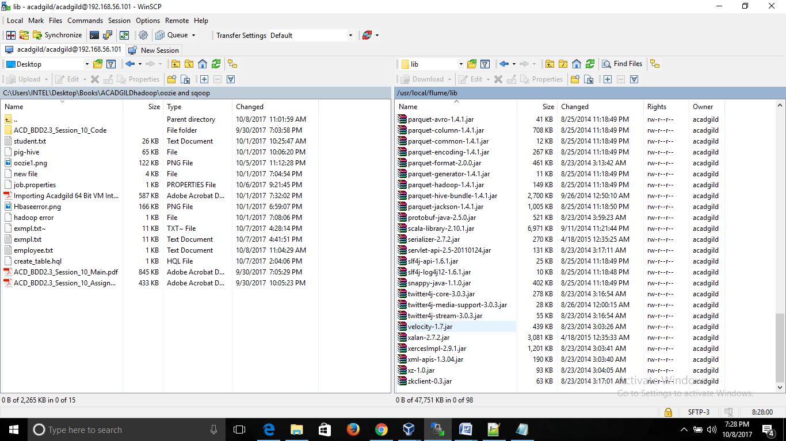

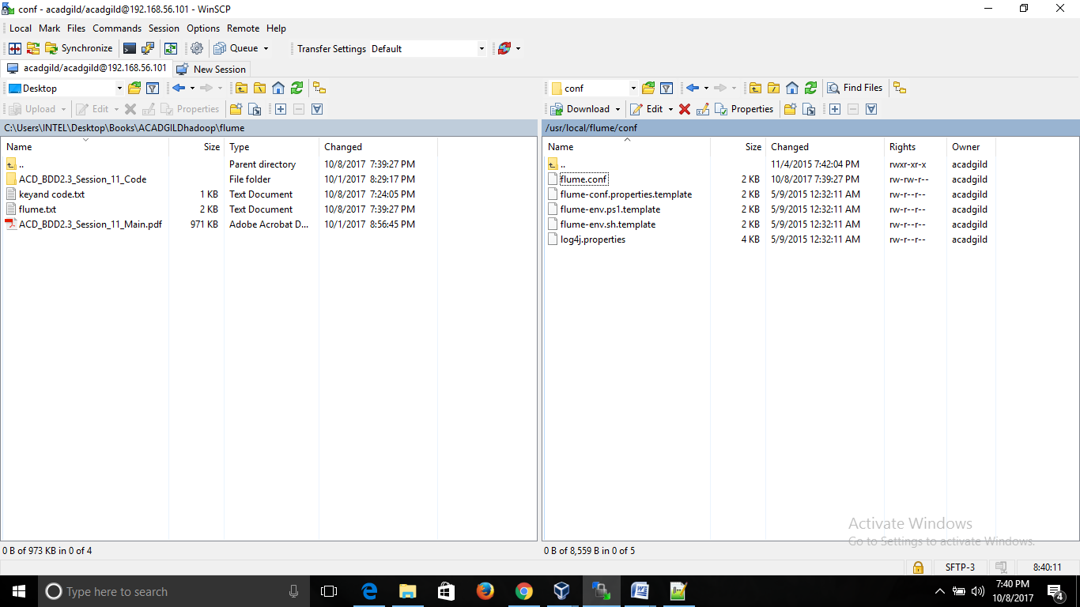

[acadgild@localhost ~]$ jps

3120 SecondaryNameNode

2961 DataNode

15649 Sqoop

2869 NameNode

14373 RunJar

3352 ResourceManager

16570 YarnChild

3451 NodeManager

16380 MRAppMaster

16621 Jps

[acadgild@localhost ~]$

[acadgild@localhost ~]$ hadoop fs -mkdir -p /user/flume/tweets/

[acadgild@localhost ~]$ flume-ng agent -n TwitterAgent -f /usr/local/flume/conf/flume.conf

17/10/08 19:44:38 WARN util.NativeCodeLoader: Unable to load native-hadoop library for your platform... using builtin-java classes where applicable

[acadgild@localhost ~]$

17/10/08 19:53:06 INFO node.Application: Starting Channel MemChannel

17/10/08 19:53:12 INFO instrumentation.MonitoredCounterGroup: Monitored counter group for type: CHANNEL, name: MemChannel: Successfully registered new MBean.

17/10/08 19:53:12 INFO instrumentation.MonitoredCounterGroup: Component type: CHANNEL, name: MemChannel started

17/10/08 19:53:12 INFO node.Application: Starting Sink HDFS

17/10/08 19:53:12 INFO node.Application: Starting Source Twitter

17/10/08 19:53:12 INFO twitter.TwitterSource: Starting twitter source org.apache.flume.source.twitter.TwitterSource{name:Twitter,state:IDLE} ...

17/10/08 19:53:12 INFO twitter.TwitterSource: Twitter source Twitter started.

17/10/08 19:53:12 INFO twitter4j.TwitterStreamImpl: Establishing connection.

17/10/08 19:53:12 INFO instrumentation.MonitoredCounterGroup: Monitored counter group for type: SINK, name: HDFS: Successfully registered new MBean.

17/10/08 19:53:12 INFO instrumentation.MonitoredCounterGroup: Component type: SINK, name: HDFS started

17/10/08 19:53:40 INFO twitter4j.TwitterStreamImpl: Connection established.

17/10/08 19:53:40 INFO twitter4j.TwitterStreamImpl: Receiving status stream.

17/10/08 19:53:54 INFO twitter.TwitterSource: Processed 100 docs

17/10/08 19:53:54 INFO hdfs.HDFSDataStream: Serializer = TEXT, UseRawLocalFileSystem = false

17/10/08 19:54:00 INFO twitter.TwitterSource: Processed 200 docs

17/10/08 19:54:09 INFO twitter.TwitterSource: Processed 300 docs

17/10/08 19:54:18 INFO twitter.TwitterSource: Processed 400 docs

17/10/08 19:54:26 INFO twitter.TwitterSource: Processed 500 docs

17/10/08 19:54:33 INFO hdfs.BucketWriter: Creating hdfs://localhost:9000/user/flume/tweets/FlumeData.1507472634220.tmp

17/10/08 19:54:35 INFO twitter.TwitterSource: Processed 600 docs

17/10/08 19:54:44 WARN hdfs.HDFSEventSink: HDFS IO error

java.io.IOException: Callable timed out after 10000 ms on file: hdfs://localhost:9000/user/flume/tweets/FlumeData.1507472634220.tmp

Did CTRL + C to stop the streaming process

[acadgild@localhost ~]$ hadoop fs -ls /user/flume/tweets

17/10/08 20:00:40 WARN util.NativeCodeLoader: Unable to load native-hadoop library for your platform... using builtin-java classes where applicable

Found 1 items

-rw-r--r-- 1 acadgild supergroup 0 2017-10-08 19:56 /user/flume/tweets/FlumeData.1507472634226.tmp

[acadgild@localhost ~]$