**React-based Assignment:**

List of features:

-The task, based on e-commerce functionalities, doesn't need to think the design pixel perfect but you have to follow the mockup[1,2] section by section.

The task needs to be complete using

- React

- Redux

- Bootstrap

- Standard coding

- Following GPP (Good Programming Practice)

- Next.js (Optional)

And must be all components are functional.

**Note: Do not try to use jQuery!**

Upload the completed project on **Heroku** and send the link and final project files with us!

Best

Mockup #1: Scroll below

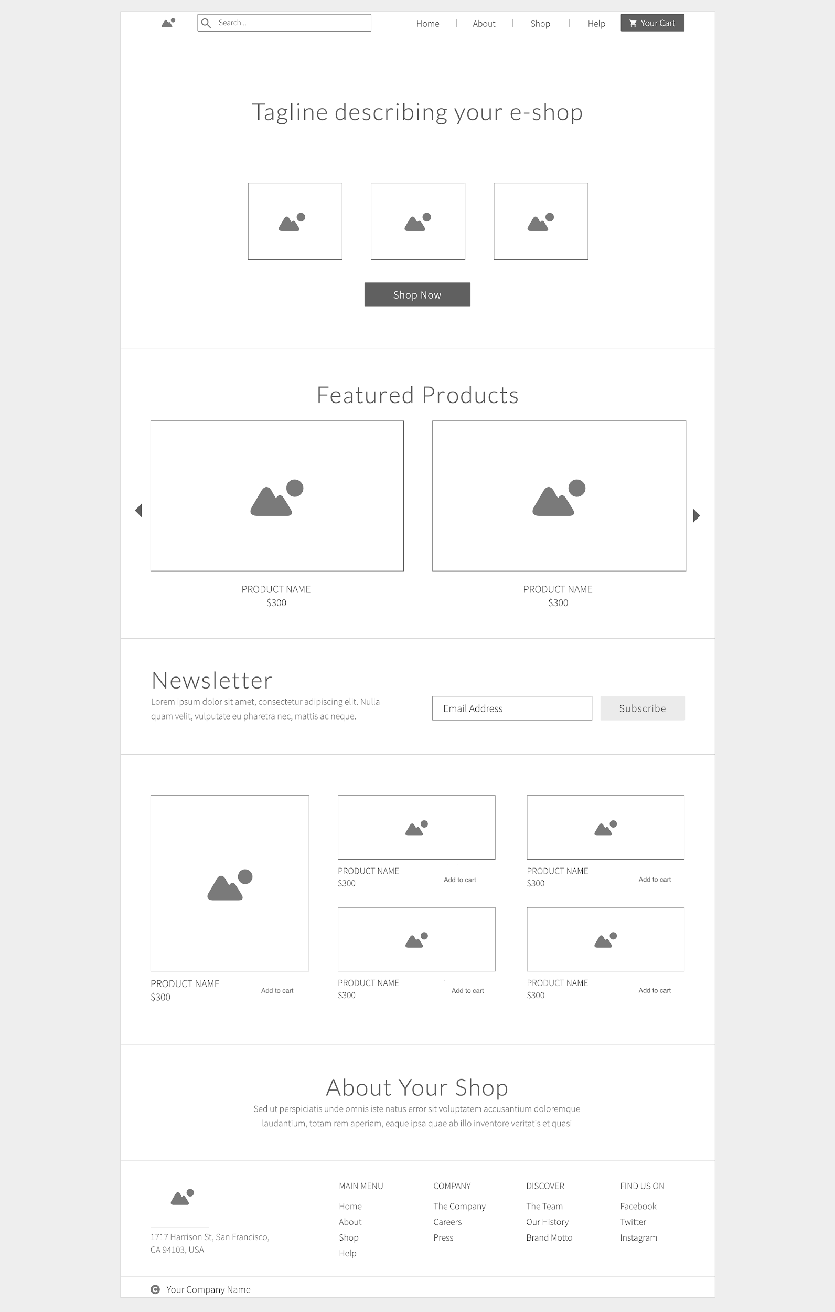

Mockup #2:

