REMARKS:

Like Ernesto, I also worked closely with Willian but on the other part, the Constraint Programming one.

It was a great pleasure for me to interact with Willian,

He is someone very motivated and enthusiastic,

CP Optimizer was something completely new to him and I must say that he learned it very fast and in deep

I really appreciate the breath of the work done in Willian’s PhD, with the exploration of so many very different techniques to solve the problem (MIP, CP, Meta-heuristics)

It is a huge amount of work including the understanding of the industrial problem (and I can tell I have a lot of experience in this domain and I really know how difficult it is to reach a common understanding of the problem), with the mastering of the different techniques (including MIP and CP, which was something new for Willian) and a huge amount of implementation and experiments for the models and for the meta-heuristics … So it is really an impressive piece of work !

Manuscript:

- In general, I find that the manuscript is very well written and very very clear, thanks to many relevant figures (in particular in the section presenting the problem).

- I think it is also a very good idea to have a special section on the abbreviations at the very beginning

QUESTIONS:

- In original problem, would it also make sense to consider have alternative processes (to produce the same product you have to select among two completely different processes, I mean different graph topology …) ? → Planning phase … how would you approach the problem (this is something we see more & more with CP Optimizer and the notion of alternative and optional intervals makes it “easy” to formulate in CP Optimizer) +++

- Objective function: really makespan minimization?

Does it really matter when you finish the last product ?
I would rather imagine that each product has different due dates and different priorities and you would like to minimize some sort of weighted tardiness ...

- General question: from the perspective of the application, if you were to start your PhD again, what would you do in a different way ?

- Fig. 2.1: I don't think the Open Shop can be considered as a generalization of Job Shop or Flow Shop. You cannot represent a Job Shop as a (classical) Open Shop problem as Open shop has not the notion of precedence constraints between operations.

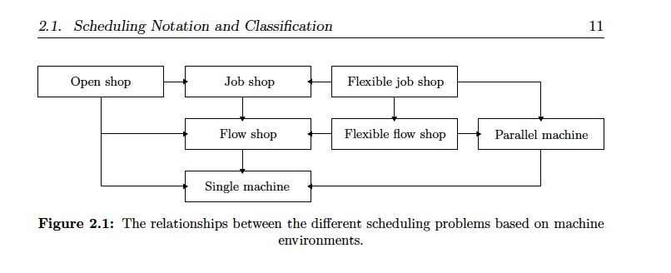

- "The FJS scheduling problem, also known as the JS scheduling problem with duplicate
machines, first introduced by Nuijten and Aarts (1996)". I think the FJS was introduced earlier, see at least:
P. Brandimarte, Routing and scheduling in a flexible job shop by tabu search, Annals of Operations Research 22 (1993)

- Fig 5.13: Perf CPO against Meta-heuristics on large OPS instances (LOPS). The gap between the methods is very large here (more than 10% in makespan).
By curiosity, I'd like to understand better. Is it because CP Optimizer is really worse on a couple of instances? Is it balanced over all instances ?
Is there a problem when exploiting the result of the first step (optimization of the simpler version of the problem?).
I think there is something to dig here.

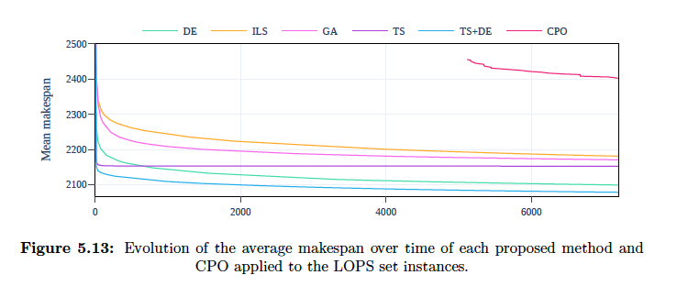

- Did you compare your meta-heuristics also against CP Optimizer on the classical flexible job-shop instances ?
I did not see this comparison in the manuscript. Also, on these instances, did you manage to improve some best known upper-bounds?

- Table A.4: The results for the "edata" instances of Hurink, Jurisch, and Thole seem strange, the makespan do not correspond to the ones reported in other papers.
* Johann Hurink. Tabu search for the job-shop scheduling problem with multi-purpose machines, 1994, OR Spektrum
* Vilim. Failure-Directed Search. Proc. CPAIOR-2015.

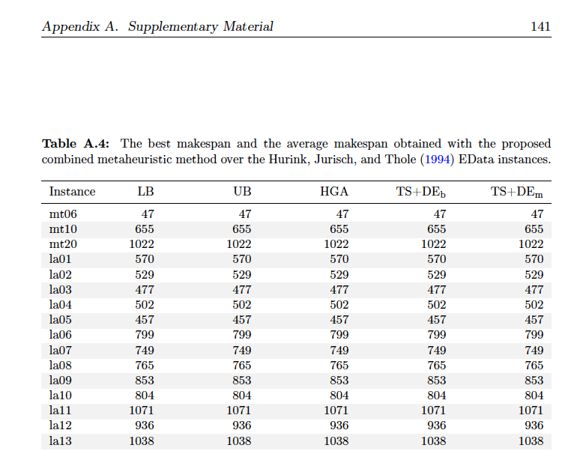

REMARKS:
Manuscript:

- In the Tables (like 4.2) giving the number of variables in the CP Optimizer model, I guess one should read "Interval variables" instead of "Integer variables" as column name

- "While the MILP solver is a general-purpose solver; the CP Optimizer solver was born
as a solver dedicated to scheduling problems, with its own modeling language that
fully explores the structure of the underlying problem."
Just be careful, CP Optimizer is not only dedicated to scheduling. There are also "classical" integer variables and global constraints (like allDifferent)
and it is also used in applications outside of the scheduling scope. For instance for configuration problems,

