**Digital Logic Design**

**Report (CSE20221-LAB NO 4)**

**2 March 2016**

**Submitted By -**

**Group 27**

**Joseph P. Lacher**

**Alex Brizius**

**Michael Burke**

**Terrence Clines**

**Your complete code for Task 3:**

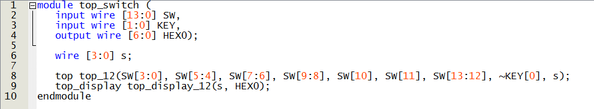

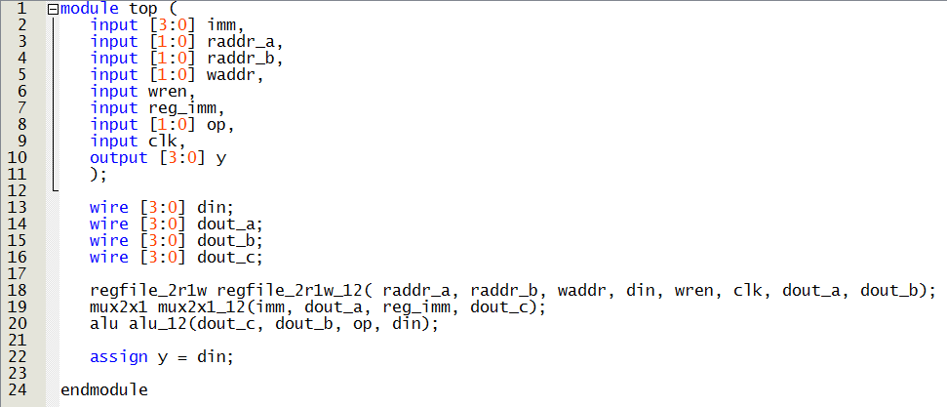

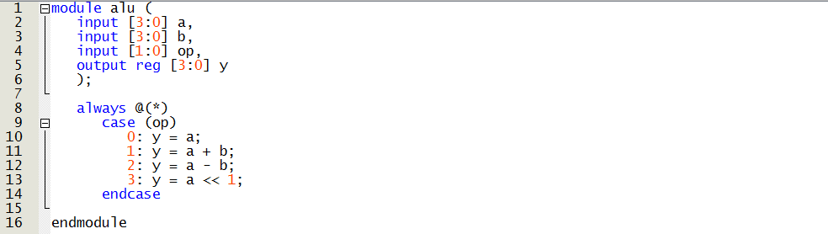

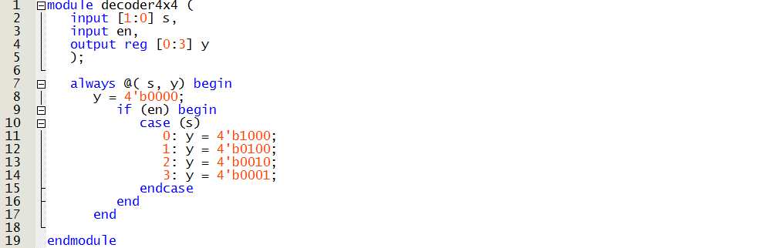

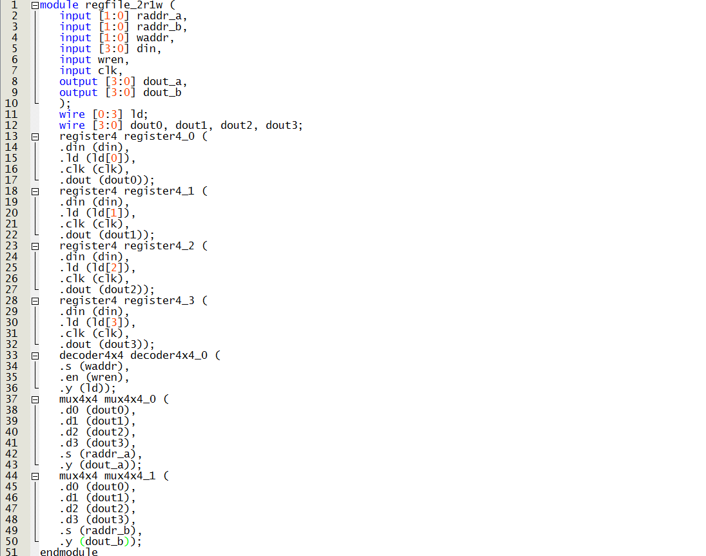

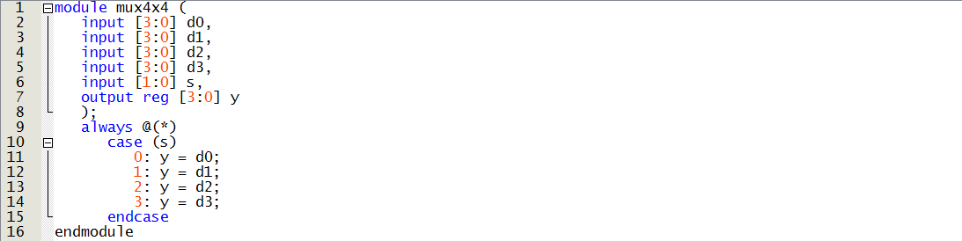

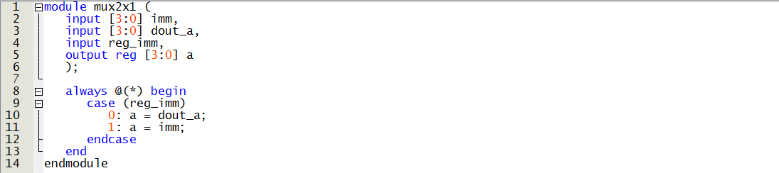

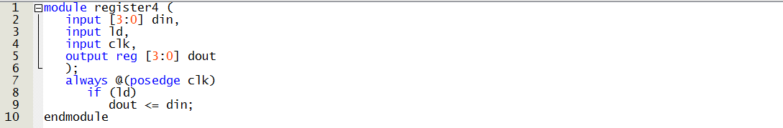

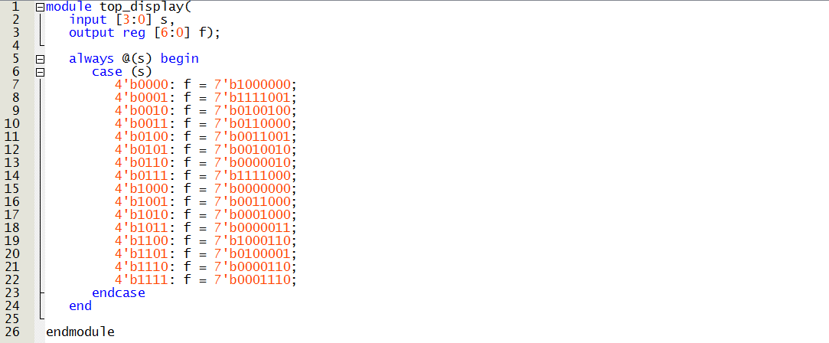

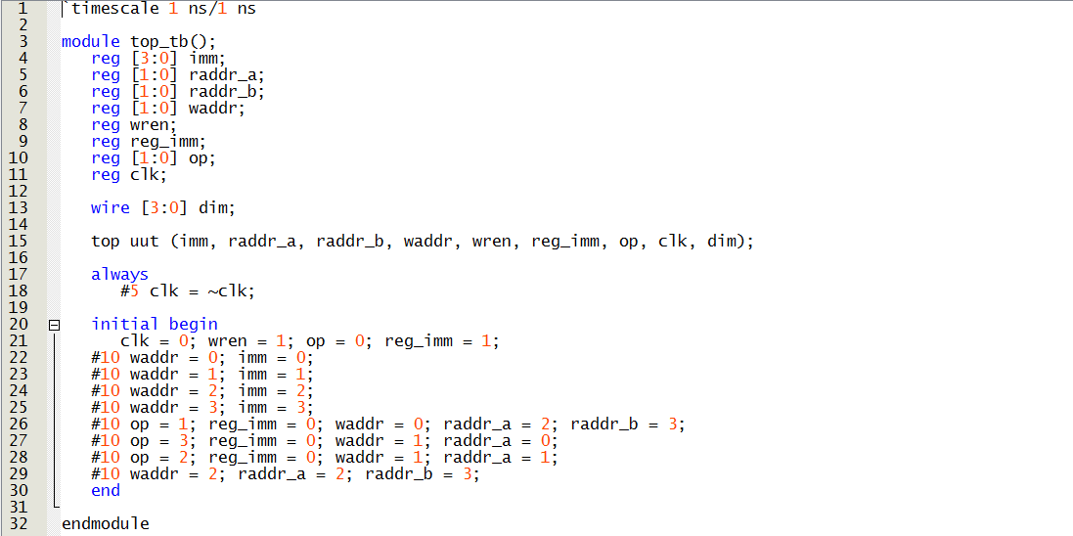

**Screenshot of simulation waveforms for Task 3:**

