**Digital Logic Design**

**Report (CSE20221-LAB NO 2)**

**16 March 2016**

**Submitted By -**

**Group 27**

**Joseph P. Lacher**

**Alex Brizius**

**Michael Burke**

**Your complete code for Task 3:**

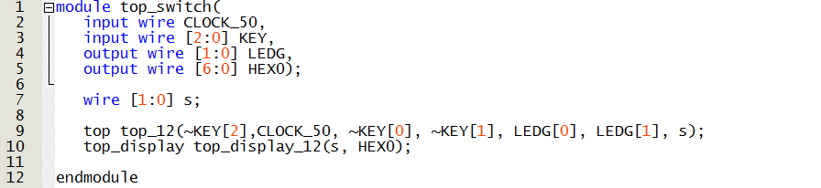

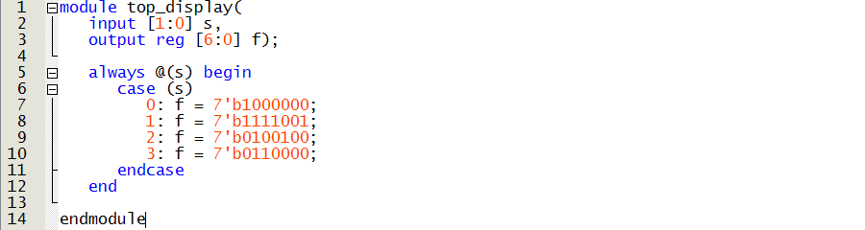

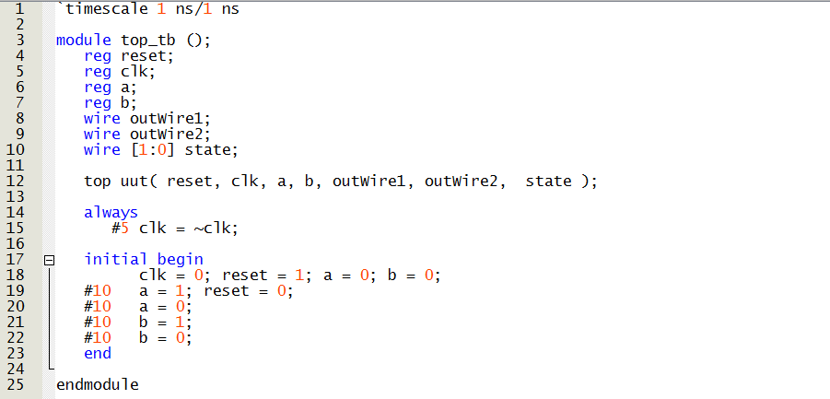

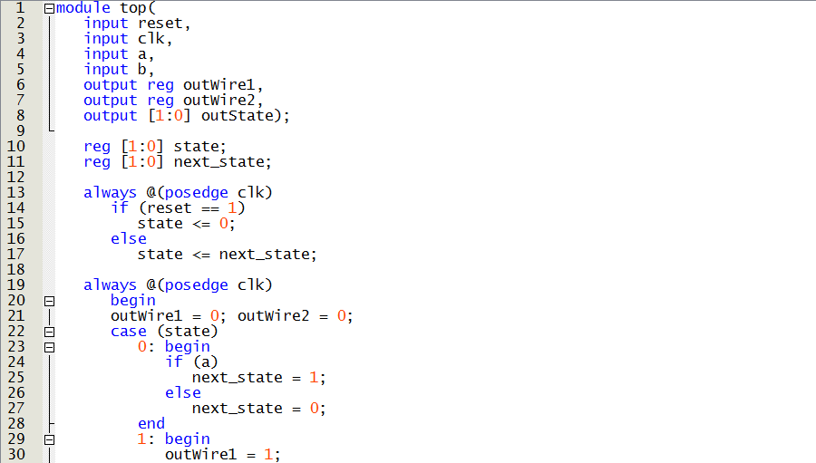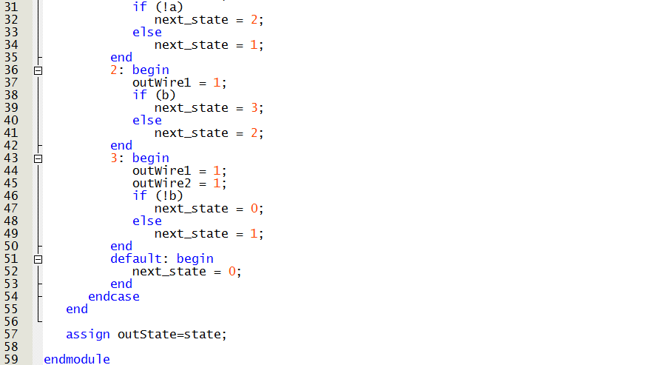

**Screenshot of simulation waveforms for Task 3**

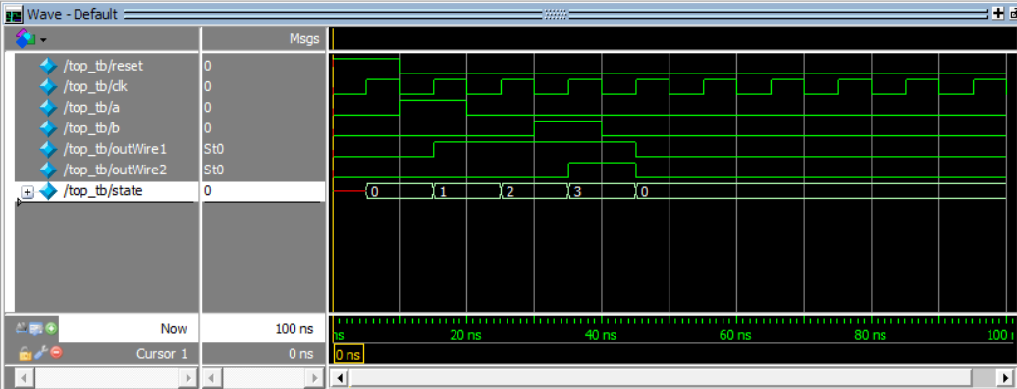

**Screenshot of FSM Diagram from ZyBook Model Software**

