**Digital Logic Design**

**Report (CSE20221-LAB NO 7)**

**31 March 2016**

**Submitted By -**

**Group 27**

**Joseph P. Lacher**

**Alex Brizius**

**Michael Burke**

**Your complete code for Task 3:**

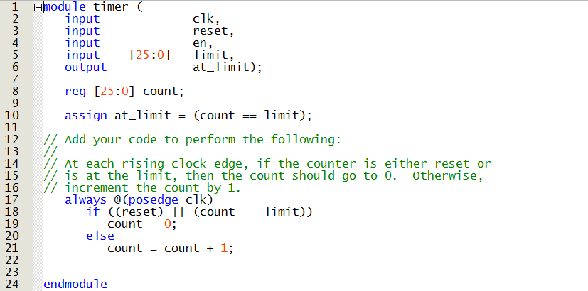

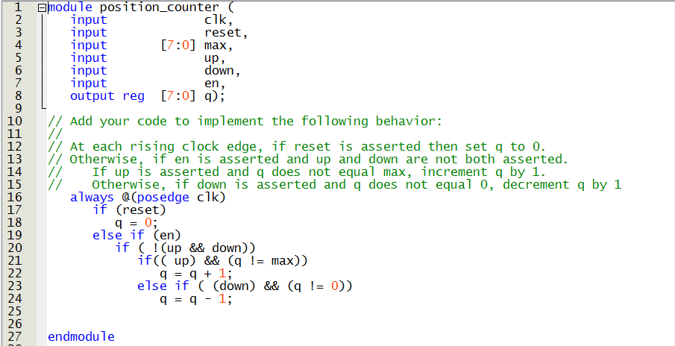

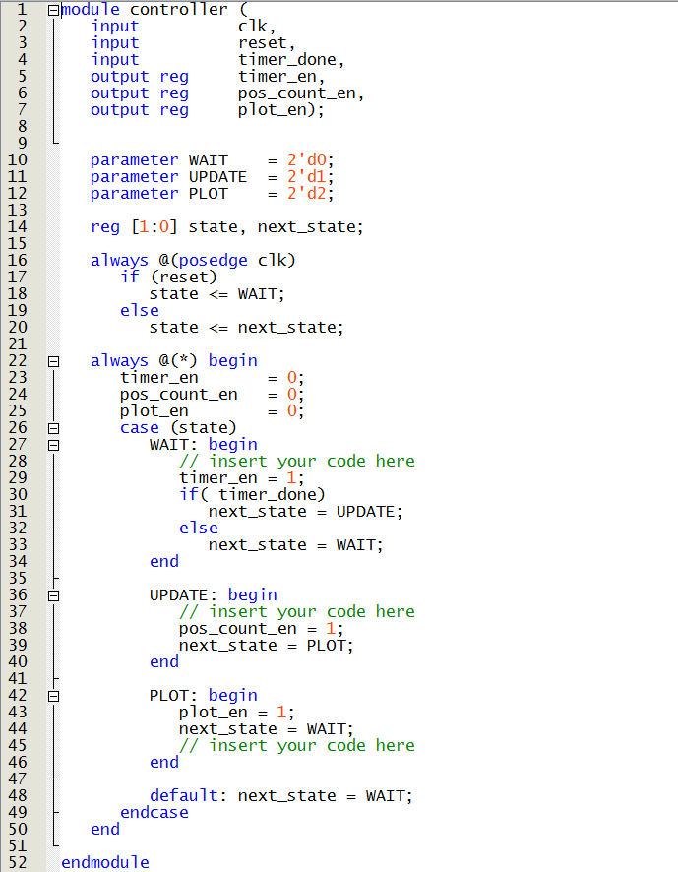

**Screenshot of simulation waveforms for Task 3:**

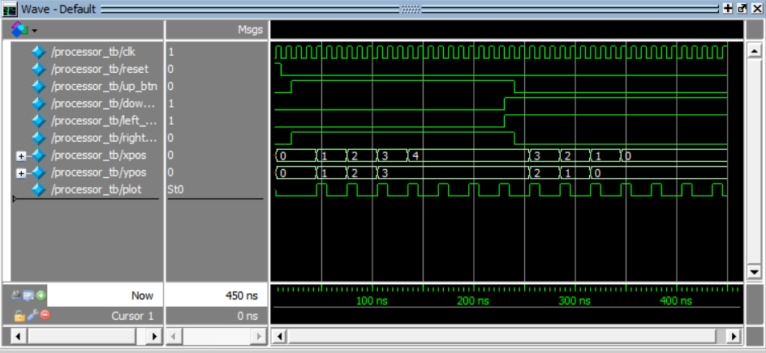

**Photo of Working Program:**

