**Digital Logic Design**

**Report (CSE20221-LAB NO 3)**

**17 February 2016**

**Submitted By -**

**Group27**

**J. Patrick Lacher**

**Alex Brizius**

**Michael Burke**

**Your complete code for Task 3:**

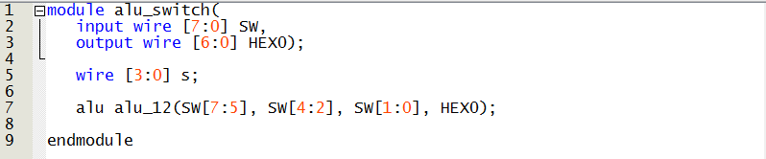

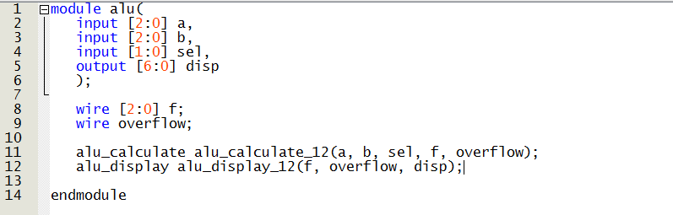

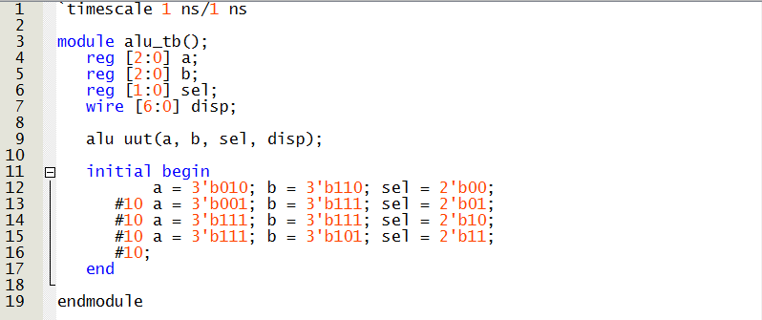

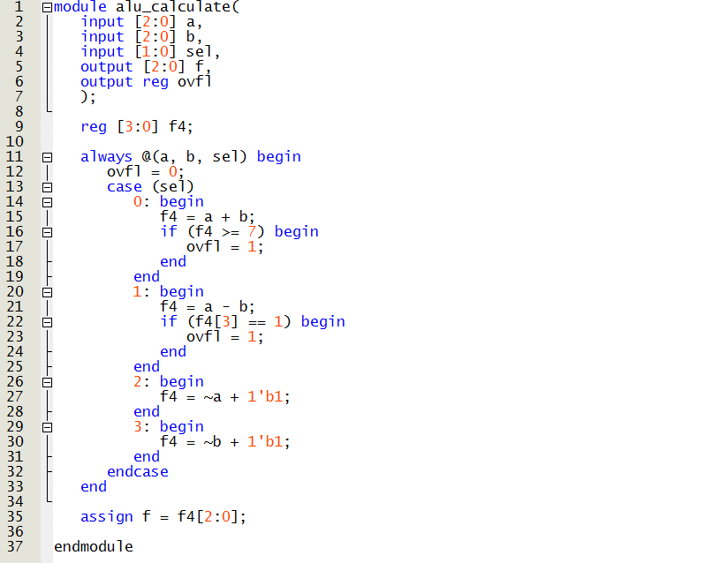

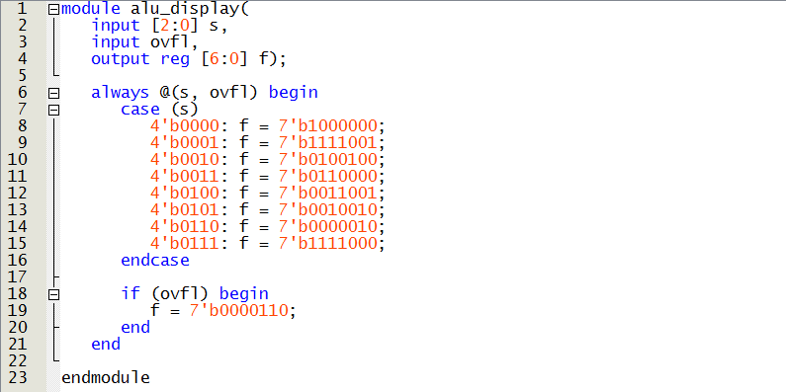

**Screenshot of simulation waveforms for Task 3**

