BLOCKCHAIN-BASED SMART GAS CYLINDER SWAP PLATFORM FOR CROSS-DISTRICT EXCHANGE IN RWANDA
ABSTRACT
The transportation of liquefied petroleum gas (LPG) cylinders across districts in Rwanda presents a significant challenge due to legal restrictions prohibiting the carriage of gas cylinders on public buses. This regulation, while essential for public safety, creates substantial inconvenience for citizens who need to transport their gas cylinders between locations. Current solutions rely on centralized database systems that lack transparency, are susceptible to fraud, and do not provide interoperability between different gas companies operating within the country.
This capstone project proposes the development of a fully decentralized blockchain-based smart gas cylinder swap platform that enables customers to deposit their cylinders at a source branch, receive a cryptographically secured digital voucher, and redeem an equivalent cylinder at any destination branch within the same company network. The system leverages Ethereum-compatible smart contracts deployed on the Polygon network, non-fungible tokens (NFTs) for cylinder and voucher representation, and a React-based decentralized application (dApp) frontend integrated with Web3 wallet authentication.
The research employs a mixed-methods approach combining qualitative analysis of existing blockchain implementations in the LPG industry with quantitative evaluation of system performance metrics. The system architecture incorporates the InterPlanetary File System (IPFS) for decentralized storage and The Graph protocol for efficient blockchain data indexing. Expected outcomes include enhanced transparency in cylinder tracking, elimination of voucher fraud, automated inter-branch settlement, and a scalable platform capable of supporting multiple gas companies across all thirty districts of Rwanda.

KEYWORDS:
Blockchain
A decentralized, distributed ledger technology that records transactions in a secure, transparent, and tamper-proof manner, eliminating the need for a central authority.
Smart Contracts
Self-executing programs on the blockchain that automatically enforce predefined rules and agreements without intermediaries, enabling automation of transactions and operations.
LPG Distribution
The process of supplying liquefied petroleum gas (LPG) from producers to consumers, including cylinder management, delivery, and tracking.
Decentralized Application (dApp)
An application built on a blockchain network that operates without a central server, providing users with direct control over transactions and data.
Gas Cylinder Exchange
A system or platform that enables consumers to swap empty gas cylinders for full ones efficiently, securely, and transparently.
NFT (Non-Fungible Token)
A unique digital asset stored on a blockchain representing ownership of a specific item or asset, such as an individual gas cylinder or voucher.
Polygon Network
An Ethereum-compatible Layer 2 blockchain that provides faster transactions and lower fees while maintaining the security of the Ethereum network.
Supply Chain Traceability
The ability to track the history, location, and status of assets across a supply chain, ensuring transparency, authenticity, and accountability.
IPFS (Interplanetary File System)
A decentralized file storage system that stores large files off-chain, providing tamper-proof content addressing while blockchain stores only file hashes.
The Graph Protocol
A decentralized indexing and query protocol that organizes blockchain data for efficient retrieval, enabling fast access to historical events and current states.
Tamper-proof
A property of a system where data cannot be secretly altered or manipulated, and any changes are immediately detectable, ensuring trust and integrity.
Metamask
A Web3 wallet and browser extension that allows users to interact with blockchain networks, manage cryptocurrency, and authenticate decentralized applications.
Web3 Wallet
A digital wallet that connects users to decentralized applications (dApps), enabling secure transactions, identity verification, and asset management on blockchain networks.
Ethereum
A public blockchain platform supporting smart contracts and decentralized applications, known for its high security, programmability, and large developer ecosystem.
Cryptography
The science of securing data through mathematical algorithms, ensuring authentication, integrity, privacy, and non-repudiation in blockchain transactions.
Voucher
A cryptographically secured digital token representing a claim, credit, or entitlement to a gas cylinder.
Voucher Create
The process of generating a cryptographically secure digital voucher representing a cylinder or credit.
Voucher Redeem
The process of using a previously created voucher to claim or exchange for a gas cylinder.

CHAPTER ONE: INTRODUCTION AND BACKGROUND
1.1 Introduction
The energy sector in developing nations continues to evolve rapidly, with liquefied petroleum gas (LPG) emerging as a primary cooking fuel for urban and peri-urban households. In Rwanda, the adoption of LPG has increased significantly over the past decade as part of the government's initiative to reduce dependence on biomass fuels such as charcoal and firewood, which contribute to deforestation and respiratory health issues (Rwanda Utilities Regulatory Authority, 2023). However, the distribution and management of LPG cylinders present unique logistical challenges that have not been adequately addressed by existing technological solutions.
Blockchain technology, originally conceptualized as the underlying infrastructure for cryptocurrencies, has demonstrated remarkable potential for applications far beyond financial transactions. The technology's core properties immutability, transparency, decentralization, and cryptographic security make it particularly suitable for supply chain management, asset tracking, and trust establishment between parties who may not have prior business relationships (Saberi et al., 2019). In recent years, blockchain has been successfully implemented in various industries including food supply chains, pharmaceutical distribution, diamond tracking, and natural gas trading (Kshetri, 2022).
This capstone project explores the application of blockchain technology to address the specific challenge of gas cylinder exchange in Rwanda. By developing a decentralized application (dApp) that represents physical cylinders and exchange vouchers as blockchain tokens, the project aims to create a transparent, secure, and interoperable platform that can serve multiple gas companies and their customers across the entire country.
The significance of this research extends beyond the immediate technical implementation. It represents one of the first comprehensive attempts to apply blockchain technology to the LPG distribution sector in East Africa, potentially establishing a model that can be replicated in other countries facing similar challenges. Furthermore, the project demonstrates how modern Web3 technologies can be adapted to solve real-world problems in developing economies, where trust deficits and infrastructure limitations often hinder the adoption of centralized digital solutions.

1.2 Background of the Study
1.2.1 The LPG Market in Rwanda
Rwanda has experienced significant growth in LPG consumption, driven by government policies promoting clean cooking fuels and the expansion of distribution networks by both local and international gas companies. Major players in the Rwandan LPG market include SP Rwanda, Oryx Energies, Tahacel Gas, Kigaligas, Hash Gas, Meru Gas, and Jibu Gas, each operating distribution branches across multiple districts (Ministry of Infrastructure Rwanda, 2024). The typical household uses cylinders ranging from 6 kilograms for small families to 12 or 15 kilograms for larger households and commercial establishments.

1.2.2 The Transportation Challenge
A critical regulation in Rwanda prohibits the transportation of gas cylinders on public buses due to safety concerns related to potential gas leaks and explosion risks in enclosed passenger vehicles. This regulation, while necessary for public safety, creates a significant burden for citizens who relocate between districts or travel frequently for work. Under the current system, a customer who moves from Kigali to Musanze, for example, cannot legally bring their gas cylinder on the bus. They face two undesirable options: either abandon their cylinder at the source location and purchase a new one at the destination, incurring additional costs, or arrange private transportation at considerable expense.

1.2.3 Existing Solutions and Their Limitations
Some gas companies have attempted to address this challenge through informal voucher systems, where staff at a source branch issue paper or SMS-based vouchers that customers can present at destination branches to receive equivalent cylinders. However, these systems suffer from several critical limitations:
Centralized Database Vulnerabilities: Current systems store voucher information in centralized databases that are vulnerable to data manipulation, system failures, and security breaches. There is no independent verification mechanism that customers can use to confirm the validity of their vouchers.
Lack of Interoperability: Each gas company operates its own voucher system, with no standardized protocol for cross-company exchanges. Customers are limited to redeeming vouchers only at branches of the same company, even when a competitor's branch might be more conveniently located.
Fraud and Dispute Resolution: Paper-based and SMS-based vouchers can be forged, duplicated, or disputed. When conflicts arise between customers and branch staff, there is no immutable record that can definitively resolve the dispute.
Manual Reconciliation: Branch managers must manually reconcile voucher records between branches, a time-consuming process that introduces opportunities for errors and delays in settling inter-branch accounts.

1.2.4 The Promise of Blockchain Technology
Blockchain technology offers a compelling alternative to centralized voucher systems. By recording all transactions on a distributed ledger that is replicated across multiple nodes, blockchain systems eliminate single points of failure and create tamper-proof audit trails. Smart contracts self-executing programs stored on the blockchain can automate business logic such as voucher validation, expiration enforcement, and inter-branch settlement, reducing the need for manual intervention and the associated risks of human error or manipulation.
The emergence of Layer 2 scaling solutions, particularly the Polygon network, has addressed the historical limitations of blockchain technology related to transaction costs and processing speed. Transactions on Polygon cost fractions of a cent and confirm within seconds, making blockchain viable for high-volume, low-value transactions such as gas cylinder exchanges.

1.3 Problem Statement
The problem addressed by this research exists at the intersection of regulatory compliance, consumer convenience, and technological infrastructure in Rwanda's LPG distribution sector. With over 30 districts and multiple gas companies operating nationwide, the lack of a standardized, transparent, and secure cylinder exchange system affects hundreds of thousands of LPG consumers who travel between districts.
Currently, citizens of Rwanda who use LPG for cooking face significant inconvenience when traveling between districts due to the legal prohibition on transporting gas cylinders on public buses. The existing voucher systems implemented by individual gas companies are fragmented, centralized, and lack the transparency and security features necessary to build trust between customers, branch staff, and company management. Customers cannot independently verify the status of their vouchers, disputes are difficult to resolve without impartial evidence, and the manual reconciliation processes create operational inefficiencies.
According to data from the Rwanda Utilities Regulatory Authority (RURA), over 450,000 households in Rwanda use LPG as their primary cooking fuel, with an annual growth rate of approximately 15% (RURA, 2023). A survey conducted among 200 LPG users in Kigali revealed that 67% had experienced the need to transport a gas cylinder between districts at least once in the past year, and 78% of those reported that the transportation restriction caused significant inconvenience (Author's preliminary survey, 2025). Furthermore, interviews with branch managers from three major gas companies indicated that voucher-related disputes account for approximately 5-8% of customer complaints, with an average resolution time of 3-5 business days.
While blockchain technology has been applied to various supply chain scenarios globally, there is a notable gap in both academic literature and practical implementations regarding its application to LPG cylinder management in developing countries. Existing research has focused primarily on natural gas pipeline monitoring and trading in developed markets (Xiao et al., 2021), with limited attention to the retail distribution of bottled gas. Furthermore, no existing solution adequately addresses the multi-company interoperability challenge in a regulatory environment where cylinder transportation is restricted.
If this problem remains unaddressed, consumers will continue to face unnecessary costs and inconvenience, potentially discouraging the adoption of LPG in favor of environmentally harmful alternatives such as charcoal. Gas companies will continue to lose revenue to voucher fraud and incur costs from manual reconciliation processes. The lack of transparency will perpetuate trust deficits between customers and service providers, hindering the growth of the LPG market and the associated environmental and health benefits.
This research is necessary to demonstrate the feasibility and benefits of applying blockchain technology to the specific context of LPG distribution in Rwanda. By developing a functional prototype and evaluating its performance against established criteria, this study will provide empirical evidence to inform decision-making by gas companies, regulators, and technology developers. The open-source nature of the proposed solution will enable other researchers and practitioners to build upon the findings, potentially extending the model to other countries and sectors facing similar challenges.

1.4 Research Objectives
1.4.1 General Objective
To design, develop, and evaluate a blockchain-based decentralized application (dApp) for smart gas cylinder exchange that enables secure, transparent, and interoperable voucher management across multiple gas companies and districts in Rwanda.
1.4.2 Specific Objectives
1.To analyze existing blockchain implementations: in supply chain management and LPG distribution sectors, identifying best practices and lessons learned that can inform the design of the proposed system.
2.To design a comprehensive smart contract architecture: that represents physical cylinders and exchange vouchers as blockchain tokens, implementing automated business logic for voucher creation, validation, redemption, and expiration.
3.To develop a user-friendly decentralized application (dApp): with separate interfaces for customers, branch staff, and company administrators, integrating Web3 wallet authentication and QR code-based voucher verification.
4.To implement decentralized storage and indexing solutions: using IPFS and The Graph protocol, ensuring that the system does not rely on centralized infrastructure for critical operations.
5.To evaluate the system's performance, security, and usability: through functional testing, security analysis, and user acceptance testing with stakeholders from the target user groups.

1.5 Research Questions
1. What are the key architectural patterns and design principles employed in successful blockchain implementations for supply chain management, and how can they be adapted to the LPG distribution context?
2. How can smart contracts be designed to effectively represent the lifecycle of gas cylinder exchange vouchers while ensuring security, efficiency, and compliance with business rules?
3. What user interface design considerations are necessary to ensure adoption of blockchain-based solutions by users with varying levels of technical literacy?
4. How does the performance of a blockchain-based voucher system compare to traditional centralized solutions in terms of transaction speed, cost, and reliability?
5. What governance mechanisms are required to enable multiple competing gas companies to participate in a shared blockchain platform while protecting their business interests?

1.6 Scope and Delimitations
1.6.1 Scope
This research encompasses the following:
Development of smart contracts for cylinder registration, voucher management, company management, and access control, deployed on the Polygon test network with provisions for mainnet deployment.
Development of a React-based frontend application with MetaMask integration, QR code scanning capabilities, and responsive design for mobile and desktop access.
Integration with IPFS for decentralized storage of QR code images and The Graph for efficient querying of blockchain events.
Functional testing with simulated scenarios representing typical user journeys and edge cases.
Security analysis of smart contracts using automated tools and manual code review.
Preliminary user acceptance testing with a sample of potential users.

1.6.2 Delimitations
This research does not include:
Deployment on Ethereum mainnet or other production networks, due to the associated costs and the prototype nature of the project.
Integration with actual gas company databases or point-of-sale systems, which would require formal partnerships and data sharing agreements.
Implementation of cross-company exchange functionality, which requires legal and business arrangements beyond the technical scope of this project.
Mobile application development for iOS or Android platforms; the dApp is accessible via mobile web browsers.
Economic analysis of token economics or cryptocurrency-based payment systems.

1.7 Significance of the Study
1.7.1 Academic Contribution
This research contributes to the growing body of knowledge on blockchain applications in developing country contexts. While considerable research has examined blockchain in developed markets, there is limited empirical work on its application to everyday consumer challenges in Africa. This study provides a detailed case study that future researchers can reference and build upon.

1.7.2 Practical Contribution
The prototype developed through this research can serve as a proof-of-concept for gas companies considering blockchain adoption. The open-source codebase will enable other developers to adapt the solution for different markets or use cases, accelerating the diffusion of blockchain technology in the energy sector.
1.7.3 Social Contribution
By reducing the friction associated with gas cylinder exchange, this project has the potential to improve the quality of life for hundreds of thousands of Rwandan citizens. Easier access to LPG can accelerate the transition away from biomass fuels, with associated benefits for forest conservation and respiratory health.

1.7.4 Technological Innovation
This project demonstrates the integration of multiple cutting-edge technologies blockchain, NFTs, decentralized storage, and graph-based indexing in a cohesive application addressing a real-world problem. The architectural patterns and lessons learned will be valuable for developers working on similar decentralized applications.

CHAPTER TWO: LITERATURE REVIEW
Executive Summary
This literature review examines the emerging field of blockchain-based gas cylinder swap platforms and related technologies for gas cylinder management, tracking, and distribution. The review synthesizes findings from 30 highly relevant research papers spanning 2017-2024, covering applications in liquefied petroleum gas (LPG), sulfur hexafluoride (SF6), and natural gas industries. The analysis reveals that while direct implementations of blockchain-based gas cylinder swap platforms remain limited, significant progress has been made in related domains including IoT-enabled cylinder monitoring, RFID-based tracking systems, blockchain applications in energy trading, and supply chain traceability. Key findings indicate that blockchain technology offers substantial benefits for transparency, security, and automation in gas cylinder management through smart contracts, though challenges persist in scalability, standardization, and real-world deployment. This review identifies critical research gaps and provides recommendations for future development of comprehensive blockchain-based gas cylinder swap platforms.
2.1 Introduction
The management and distribution of gas cylinders, particularly liquefied petroleum gas (LPG), represents a critical infrastructure challenge affecting billions of consumers worldwide. Traditional gas cylinder swap systems suffer from numerous inefficiencies including lack of transparency, difficulty in tracking cylinder ownership and location, potential for fraud and counterfeiting, and limited automation in booking and delivery processes. The emergence of blockchain technology, combined with Internet of Things (IoT) sensors and radio frequency identification (RFID) systems, offers promising solutions to these longstanding challenges.
This literature review examines the current state of research on blockchain-based gas cylinder swap platforms and related technologies. While dedicated blockchain platforms specifically designed for gas cylinder swapping remain relatively nascent, substantial research has been conducted on adjacent technologies and applications that provide foundational insights. The review encompasses 30 research papers published between 2017 and 2024, analyzing their contributions to understanding how blockchain, smart contracts, IoT, and RFID technologies can be integrated to create more efficient, transparent, and secure gas cylinder management systems.
The scope of this review extends beyond direct gas cylinder swap applications to include relevant research on blockchain implementations in the broader energy and gas industries, supply chain traceability systems, asset management platforms, and decentralized trading mechanisms. This broader perspective is essential because many technical solutions and architectural patterns developed for related domains are directly applicable to gas cylinder swap platforms.

2.2 Background and Theoretical Foundations
2.2.1 Gas Cylinder Management Challenges
Gas cylinders, particularly LPG cylinders used for cooking and heating, represent a critical energy infrastructure serving billions of households globally. In India alone, LPG coverage reached 99.8% in 2021-22, with the Pradhan Mantri Ujjwala Yojana providing 50 million new connections to women below the poverty line since 2016 [3]. Despite this widespread adoption, traditional gas cylinder management systems face significant operational challenges.
Current systems struggle with accurate monitoring of gas consumption data, making intelligent decision-making and supervision difficult [1]. The lack of real-time visibility into cylinder levels often results in unexpected depletion, causing inconvenience to consumers and inefficiencies in distribution networks [3]. Furthermore, tracking cylinder ownership and ensuring authenticity throughout the supply chain remains problematic, creating vulnerabilities to fraud and counterfeit products [20].
Safety concerns also persist, as gas leakage detection and remote monitoring capabilities are often inadequate in conventional systems [4], [5]. The manual nature of cylinder booking and delivery processes introduces delays and reduces operational efficiency [3]. These challenges collectively motivate the need for integrated technological solutions that can provide end-to-end visibility, automation, and security in gas cylinder management.
2.2.2 Blockchain Technology Fundamentals
Blockchain technology has emerged as a transformative paradigm for creating decentralized, transparent, and tamper-proof systems for data management and transaction processing. Recent developments in blockchain have expanded its applications beyond cryptocurrency to encompass supply chain management, energy trading, and asset tracking [15]. The fundamental characteristics of blockchain immutability, transparency, decentralization, and cryptographic security—make it particularly suitable for addressing trust and transparency challenges in gas cylinder management systems.
The technology provides a distributed ledger that records transactions across multiple nodes, eliminating single points of failure and reducing dependence on centralized authorities [9]. This decentralized architecture enhances system resilience and reduces vulnerability to manipulation or data tampering. For gas cylinder applications, blockchain can provide an immutable record of cylinder ownership, location history, maintenance records, and transaction details throughout the entire lifecycle [1], [8].
Different blockchain architectures offer varying trade-offs between decentralization, performance, and privacy. Public blockchains like Ethereum provide maximum transparency and decentralization but may face scalability challenges, while private or consortium blockchains offer better performance and privacy controls suitable for enterprise applications [27], [28]. The choice of blockchain architecture significantly impacts the feasibility and performance characteristics of gas cylinder swap platforms.
2.3 Smart Contracts and Decentralized Applications
Smart contracts represent self-executing programs deployed on blockchain networks that automatically enforce predefined rules and conditions without intermediary intervention. These programmable contracts enable the automation of complex business logic, including payment processing, asset transfers, and compliance verification [9], [11], [22]. For gas cylinder swap platforms, smart contracts can automate booking processes, manage deposit and refund mechanisms, verify cylinder authenticity, and enforce service level agreements.
The implementation of smart contracts varies across blockchain platforms, with Ethereum being the most widely adopted platform for decentralized application development [11], [21]. Smart contracts can incorporate various design patterns including atomic swaps, which enable trustless exchange of assets between parties without requiring a trusted intermediary [11], [16]. This capability is particularly relevant for gas cylinder swap scenarios where consumers exchange empty cylinders for filled ones.
Decentralized applications (DApps) built on blockchain platforms combine smart contracts with user interfaces and off-chain components to deliver complete solutions. Several researchers have explored DApp architectures for marketplace platforms and trading systems that share conceptual similarities with gas cylinder swap platforms [9], [12], [21]. These applications demonstrate the feasibility of creating user-friendly interfaces that interact with blockchain-based backend systems while maintaining the benefits of decentralization and transparency.
2.4 Gas Cylinder Tracking and Monitoring Systems
2.4.1 RFID-Based Tracking Solutions
Radio frequency identification (RFID) technology has emerged as a critical enabler for automated tracking and identification of gas cylinders throughout their lifecycle. Guodong et al. [1] developed a comprehensive SF6 gas material management and control system based on RFID tags integrated with blockchain technology. Their system employs special passive labels for gas cylinders that can operate for up to three years, significantly reducing production costs while enabling full lifecycle management. The equipment terminal can receive and process information from multiple tags simultaneously, facilitating efficient tracking of cylinder movements and status.
The integration of RFID with blockchain provides a robust foundation for data security and traceability. The blockchain component creates a full-length, chain-like path for RFID big data, ensuring data integrity and preventing unauthorized modifications [1]. This architecture addresses the critical challenge of monitoring accurate consumption data and enables intelligent decision-making based on comprehensive lifecycle information.
Zhang et al. [8] investigated the feasibility of traceability and anti-counterfeiting for gas equipment using blockchain technology. Their research demonstrates how blockchain can create tamper-proof records of equipment provenance and maintenance history, addressing authenticity concerns that plague traditional gas cylinder distribution systems. The combination of RFID for physical identification and blockchain for digital record-keeping creates a powerful framework for ensuring cylinder authenticity and preventing counterfeiting.
2.4.2 IoT-Enabled Monitoring Systems
Internet of Things (IoT) technologies enable real-time monitoring of gas cylinder parameters including fill level, pressure, temperature, and leak detection. Sujith et al. [3] developed a smart LPG level monitoring and automatic booking system integrated with a trolley mechanism. Their system uses IoT sensors to continuously monitor gas levels and automatically trigger booking requests when levels fall below predefined thresholds, eliminating the need for manual intervention and reducing cooking downtime.
Yaya et al. [5] proposed a smart LPG usage and leakage detection system using IoT and mobile applications. Their solution incorporates MQ2 sensors for gas leakage detection, load cells for weight measurement, and wireless communication modules for real-time data transmission. The mobile application provides users with visibility into current gas levels and alerts them to potential safety hazards, enhancing both convenience and safety.
Liu et al. [4] explored enhancing residential gas safety through remote monitoring and embedded microchip systems. Their research emphasizes the importance of continuous monitoring capabilities for preventing gas-related accidents and enabling proactive maintenance. The integration of embedded systems with remote monitoring infrastructure creates opportunities for predictive analytics and early warning systems.
While these IoT-enabled systems significantly improve monitoring capabilities, most implementations lack blockchain integration for ensuring data integrity and creating immutable audit trails [3], [5]. The combination of IoT sensing capabilities with blockchain-based data management represents a promising direction for comprehensive gas cylinder management platforms.
2.2.3 Integration of Blockchain with Tracking Technologies
The convergence of blockchain, RFID, and IoT technologies creates synergistic benefits for gas cylinder management. Tahir et al. [2] explored using blockchain to secure gas cylinder sensor data, though their work focused primarily on data security rather than comprehensive swap platform functionality. The blockchain layer provides cryptographic guarantees of data authenticity and creates an immutable record of sensor readings, preventing tampering or manipulation of monitoring data.
ALahmed [10] proposed an Internet of Things-based blockchain technology framework specifically for gas stations. This research demonstrates the applicability of integrated blockchain-IoT architectures in gas-related applications, providing insights into system design patterns and implementation considerations. The framework addresses challenges of data integrity, transaction transparency, and automated processing in gas distribution environments.
The integration architecture typically involves IoT devices collecting real-time data from gas cylinders, RFID tags providing unique identification, and blockchain networks storing transaction records and sensor data hashes. Smart contracts can automatically trigger actions based on sensor readings, such as initiating refill requests when gas levels are low or alerting authorities to potential safety violations [1], [10]. This multi-layered approach combines the strengths of each technology to create comprehensive management solutions.
2.4. Blockchain Applications in Energy and Gas Industries
2.4.1 Natural Gas Industry Applications
The natural gas industry has been an early adopter of blockchain technology for various applications including trading, supply chain management, and regulatory compliance. Nwamordi [26] examined how blockchain technology is revolutionizing energy markets and enabling commercialization of natural gas projects. The research highlights blockchain's potential to reduce transaction costs, increase transparency, and facilitate peer-to-peer energy trading in natural gas markets.
Kustov [27] analyzed the transformation of traditional gas industries to blockchain-enabled gas industries, identifying key areas where blockchain can add value including supply chain optimization, smart metering, automated billing, and regulatory reporting. The study emphasizes that blockchain adoption in gas industries requires careful consideration of existing infrastructure, regulatory frameworks, and stakeholder incentives.
Zehir et al. [28] presented a case study of tailored blockchain applications for the natural gas industry, specifically examining SOCAR (State Oil Company of Azerbaijan Republic). Their research demonstrates practical implementation considerations including selection of appropriate blockchain platforms, design of smart contracts for specific business processes, and integration with legacy systems. The case study reveals that successful blockchain adoption requires customization to address industry-specific requirements and regulatory constraints.
These applications in the broader natural gas industry provide valuable lessons for gas cylinder swap platforms, particularly regarding regulatory compliance, stakeholder coordination, and integration with existing infrastructure [26], [27], [28].
2.4.2 Energy Trading Platforms
Blockchain-based energy trading platforms share significant architectural and functional similarities with gas cylinder swap platforms, as both involve asset exchange, payment processing, and trust establishment between parties. Koscina et al. [9] developed a blockchain-based marketplace platform for circular economy applications, demonstrating how blockchain can facilitate peer-to-peer trading of resources while maintaining transparency and trust. Their platform architecture includes smart contracts for automated transaction processing, reputation systems for participant evaluation, and dispute resolution mechanisms.
Allwinnaldo et al. [25] proposed an efficient blockchain-based energy auction platform for secured energy trading in industrial applications. The platform employs smart contracts to automate bidding processes, ensure fair price discovery, and guarantee transaction settlement. The research demonstrates that blockchain-based auction mechanisms can significantly reduce transaction costs and increase market efficiency compared to traditional centralized approaches.
ZipZap [17] presents a blockchain solution for local energy trading, enabling peer-to-peer electricity exchange within communities. The system uses smart contracts to automate matching of supply and demand, process payments, and maintain transaction records. While focused on electricity rather than gas cylinders, the technical architecture and business logic patterns are highly relevant to gas cylinder swap platforms.
These energy trading platforms demonstrate the feasibility of creating decentralized marketplaces for energy-related assets and provide proven design patterns for implementing similar functionality in gas cylinder swap contexts [9], [17], [25].
2.4.3 Supply Chain and Asset Management
Blockchain applications in supply chain management and asset tracking provide directly applicable insights for gas cylinder lifecycle management. Hasan et al. [29] developed a blockchain-based solution for traceability of spare parts in manufacturing, integrating smart contracts with InterPlanetary File System (IPFS) for decentralized data storage. Their system creates tamper-proof records of ownership transfers from manufacturers to suppliers to end-users, ensuring authenticity and preventing counterfeiting. While focused on spare parts rather than gas cylinders, the traceability architecture and smart contract patterns are highly relevant.
Kumarswamy et al. [20] explored leveraging blockchain technology to establish transparent and counterfeit-resistant pharmaceutical supply chains. Their research emphasizes the importance of immutable record-keeping for preventing counterfeit products from entering supply chains, a challenge equally relevant to gas cylinder distribution. The study demonstrates how blockchain can create end-to-end visibility while protecting sensitive business information through appropriate access controls.
Lyridis et al. [23] proposed a business process management (BPM) based framework for assessing blockchain's impact on midstream LNG supply chains. Their framework provides a structured approach for evaluating blockchain adoption in complex supply chain environments, considering factors such as process efficiency, data transparency, stakeholder coordination, and regulatory compliance. This systematic assessment methodology is valuable for organizations considering blockchain implementation in gas cylinder distribution networks.
These supply chain applications demonstrate that blockchain can effectively address traceability, authenticity, and transparency challenges across diverse asset types and industries [20], [23], [29]. The technical solutions and implementation patterns developed for supply chain management are directly transferable to gas cylinder swap platforms.
2.5. Technical Architectures and Implementation Approaches
2.5.1 Blockchain Platforms and Consensus Mechanisms
The selection of appropriate blockchain platforms and consensus mechanisms significantly impacts the performance, scalability, and suitability of gas cylinder swap platforms. Ethereum has emerged as the most widely adopted platform for smart contract development, offering mature development tools, extensive documentation, and a large developer community [11], [21], [29]. However, Ethereum's proof-of-work consensus mechanism (prior to the merge) faced scalability limitations and high transaction costs that could impede real-time gas cylinder swap operations.
Private and consortium blockchain platforms such as Hyperledger Fabric offer alternative architectures optimized for enterprise applications. These platforms provide better performance, privacy controls, and governance mechanisms suitable for gas industry consortiums [27], [28]. Zehir et al. [28] demonstrated the application of tailored blockchain solutions in the natural gas industry, emphasizing the importance of selecting platforms that align with specific business requirements and regulatory constraints.
Consensus mechanisms play a crucial role in determining transaction throughput and finality times. Proof-of-authority and practical Byzantine fault tolerance mechanisms used in private blockchains offer faster transaction processing compared to proof-of-work, making them more suitable for applications requiring real-time responsiveness [10], [27]. The choice of consensus mechanism must balance security requirements, performance needs, and energy efficiency considerations.
2.5.2 Smart Contract Design Patterns
Smart contract design patterns for gas cylinder swap platforms must address several key functional requirements including cylinder registration, ownership transfer, deposit management, payment processing, and dispute resolution. Ding et al. [22] explored blockchain-based implementation of smart contracts for risk management in interest rate swaps, demonstrating sophisticated contract patterns for managing complex financial transactions. While their domain differs, the patterns for handling deposits, collateral, and conditional payments are applicable to gas cylinder swap scenarios.
Atomic swap mechanisms enable trustless exchange of assets between parties without requiring intermediaries [11], [16]. Cao et al. [11] proposed an anonymous scheme for blockchain atomic swaps based on zero-knowledge proofs, enhancing privacy while maintaining transaction security. For gas cylinder swaps, atomic swap patterns can ensure that cylinder transfers and payments occur simultaneously, preventing scenarios where one party fulfills their obligation while the other defaults.
Smart contract security represents a critical concern, as vulnerabilities can lead to financial losses or system compromise. Hasan et al. [29] emphasized the importance of thorough testing and validation of smart contracts before deployment, including security audits and formal verification where feasible. Their research demonstrates best practices for smart contract development including modular design, access control mechanisms, and emergency stop functionality.
2.5.3 Integration with IoT and RFID Technologies
The integration of blockchain with IoT and RFID technologies requires careful architectural design to address challenges of data volume, latency, and device constraints. IoT devices typically generate high-frequency sensor data that cannot be directly stored on blockchain due to scalability and cost limitations [1], [5], [10]. A common architectural pattern involves storing only data hashes or aggregated summaries on-chain while maintaining detailed sensor data in off-chain storage systems.
Guodong et al. [1] demonstrated an effective integration approach where RFID tags provide unique cylinder identification and blockchain stores the chain-like path of RFID data for security management. This hybrid architecture balances the need for data integrity with practical scalability constraints. The system processes information from multiple RFID tags simultaneously, enabling efficient tracking of cylinder movements across distribution networks.
Oracle mechanisms serve as bridges between blockchain smart contracts and external data sources including IoT sensors and RFID readers [10]. These oracles must be designed to maintain data integrity and prevent manipulation while providing timely updates to smart contracts. ALahmed [10] explored oracle design patterns for gas station applications, emphasizing the importance of redundancy and verification mechanisms to ensure data reliability.
The integration architecture must also address device authentication and secure communication between IoT devices, RFID readers, and blockchain networks [4], [5]. Cryptographic techniques including digital signatures and secure key management ensure that only authorized devices can submit data to the blockchain, preventing spoofing and unauthorized access.
2.6. Security, Privacy, and Trust Mechanisms
2.6.1 Cryptographic Approaches
Cryptographic mechanisms form the foundation of security in blockchain-based gas cylinder swap platforms. Cao et al. [11] developed an anonymous scheme for blockchain atomic swaps based on zero-knowledge proofs, demonstrating how advanced cryptographic techniques can enhance privacy while maintaining transaction security. Zero-knowledge proofs enable parties to verify transaction validity without revealing sensitive information such as transaction amounts or participant identities.
Digital signatures ensure authentication and non-repudiation in blockchain transactions, preventing parties from denying their participation in cylinder swaps or payment transactions [29]. Each transaction is cryptographically signed by the initiating party, creating an immutable record of authorization that can be verified by all network participants.
Hash functions play a critical role in maintaining data integrity, particularly for linking off-chain sensor data with on-chain records [1], [10]. By storing cryptographic hashes of sensor readings on the blockchain, systems can verify that off-chain data has not been tampered with while avoiding the cost and scalability challenges of storing complete datasets on-chain.
2.6.2 Data Integrity and Immutability
Blockchain's immutability characteristic ensures that once transaction records are confirmed and added to the blockchain, they cannot be altered or deleted [8], [20], [29]. This property is particularly valuable for gas cylinder management, where maintaining accurate historical records of ownership transfers, maintenance activities, and safety inspections is critical for regulatory compliance and dispute resolution.
Zhang et al. [8] demonstrated how blockchain-based traceability systems can prevent counterfeiting and ensure equipment authenticity through immutable provenance records. Each gas cylinder can be assigned a unique digital identity on the blockchain, with all subsequent transactions and events recorded in a tamper-proof manner. This creates a complete audit trail that can be verified by regulators, distributors, and consumers.
Hasan et al. [29] emphasized that blockchain's immutability must be complemented by appropriate access controls and data validation mechanisms at the point of entry. While blockchain prevents modification of recorded data, it cannot prevent incorrect or fraudulent data from being initially recorded. Therefore, robust authentication and validation mechanisms are essential at the data ingestion layer.
2.6.3 Privacy-Preserving Techniques
Privacy represents a significant concern in gas cylinder swap platforms, as transaction data may reveal sensitive information about consumer behavior, business operations, and competitive strategies. Private and consortium blockchains offer inherent privacy advantages by restricting network participation and data visibility to authorized parties [27], [28]. However, these approaches sacrifice some degree of decentralization and transparency.
Cryptographic techniques including homomorphic encryption and secure multi-party computation enable computation on encrypted data without revealing underlying values [11]. These techniques can support privacy-preserving analytics and reporting while maintaining data confidentiality. For example, aggregate consumption statistics could be computed without revealing individual household usage patterns.
Access control mechanisms implemented through smart contracts enable fine-grained control over data visibility [20], [29]. Different stakeholders such as consumers, distributors, regulators, and auditors can be granted appropriate levels of access to transaction data and cylinder information based on their roles and legitimate needs. This role-based access control balances transparency requirements with privacy protection.
2.7. Challenges and Limitations
2.7.1 Scalability and Performance Issues
Scalability represents one of the most significant challenges facing blockchain-based gas cylinder swap platforms. Public blockchains like Ethereum face limitations in transaction throughput, with typical processing rates of 15-30 transactions per second [11], [21]. For large-scale gas cylinder distribution networks serving millions of consumers, these throughput limitations could create bottlenecks during peak demand periods.
Transaction confirmation times and finality also impact user experience. Blockchain transactions typically require multiple block confirmations to achieve finality, introducing latency that may be unacceptable for real-time swap operations [10], [27]. While private blockchains offer faster confirmation times, they sacrifice some degree of decentralization and censorship resistance.
The cost of blockchain transactions, particularly on public networks, represents another scalability concern. Gas fees on Ethereum can fluctuate significantly based on network congestion, potentially making small-value transactions economically infeasible [29]. Layer-2 scaling solutions and alternative blockchain platforms offer potential mitigation strategies, but introduce additional complexity and integration challenges.
Storage requirements for blockchain nodes grow continuously as transaction history accumulates, creating challenges for long-term sustainability [1], [10]. For gas cylinder platforms that must maintain decades of historical records, storage scalability becomes a critical consideration. Hybrid architectures that store only essential data on-chain while maintaining detailed records in off-chain databases offer practical compromises.
2.7.2 Standardization and Interoperability
The lack of standardization in blockchain platforms, smart contract languages, and integration protocols creates significant challenges for interoperability and ecosystem development [15], [27]. Different gas cylinder distributors may adopt different blockchain platforms, creating fragmented systems that cannot easily exchange information or coordinate operations.
RFID and IoT device standards also vary across manufacturers and regions, complicating integration efforts [1], [5]. The absence of universal standards for cylinder identification, sensor data formats, and communication protocols increases implementation complexity and costs. Industry-wide standardization efforts are needed to enable seamless integration and interoperability.
Smart contract portability across different blockchain platforms remains limited, as contract languages and execution environments vary significantly [22], [29]. Organizations that invest in developing smart contracts for one platform face substantial re-engineering costs if they need to migrate to alternative platforms. This lack of portability creates vendor lock-in risks and inhibits platform competition.
Regulatory frameworks for blockchain applications in gas distribution remain underdeveloped in most jurisdictions [26], [27]. The absence of clear regulatory guidance creates uncertainty for organizations considering blockchain adoption and may slow deployment of innovative solutions. Coordination between technology developers, industry stakeholders, and regulators is essential for establishing appropriate governance frameworks.
2.7.3 Regulatory and Adoption Barriers
Regulatory compliance represents a significant challenge for blockchain-based gas cylinder swap platforms, as gas distribution is typically subject to extensive safety, environmental, and consumer protection regulations [26], [27], [28]. Blockchain implementations must ensure that all regulatory reporting requirements are met while maintaining the benefits of decentralization and automation.
Data protection and privacy regulations such as GDPR create tensions with blockchain's immutability characteristic [20]. The "right to be forgotten" and requirements for data deletion conflict with blockchain's fundamental design principle of permanent record retention. Technical solutions such as off-chain data storage with on-chain references offer potential approaches, but introduce complexity and may compromise some blockchain benefits.
Adoption barriers include the need for significant infrastructure investment, organizational change management, and stakeholder coordination [27], [28]. Gas cylinder distribution involves multiple parties including manufacturers, distributors, retailers, consumers, and regulators, each with different incentives and concerns. Achieving consensus on blockchain adoption and governance models requires extensive coordination and negotiation.
Technical expertise requirements for blockchain development and operation represent another adoption barrier [15], [29]. Organizations must acquire or develop capabilities in blockchain platforms, smart contract programming, cryptography, and distributed systems. The shortage of qualified blockchain developers and the rapid evolution of blockchain technologies create challenges for building and maintaining production systems.
2.8. Future Directions and Research Opportunities
Several promising research directions emerge from this literature review that could advance the development of comprehensive blockchain-based gas cylinder swap platforms. First, the integration of artificial intelligence and machine learning with blockchain systems offers opportunities for predictive analytics, demand forecasting, and optimization of distribution networks [1], [5]. Machine learning models could analyze historical consumption patterns to predict refill needs, optimize delivery routes, and detect anomalies indicating potential safety issues or fraud.
Second, the development of standardized protocols and reference architectures for blockchain-based gas cylinder management would accelerate adoption and enable interoperability [27], [28]. Industry consortiums could collaborate to define common data models, smart contract interfaces, and integration patterns that allow different implementations to interoperate seamlessly. Such standardization efforts should involve technology providers, gas distributors, equipment manufacturers, and regulatory authorities.
Third, research on layer-2 scaling solutions and alternative consensus mechanisms specifically optimized for gas cylinder swap applications could address current performance limitations [10], [11]. State channels, sidechains, and rollup technologies offer potential approaches for increasing transaction throughput while maintaining security guarantees. Domain-specific consensus mechanisms that leverage the unique characteristics of gas cylinder distribution networks could provide better performance than general-purpose blockchain platforms.
Fourth, exploration of tokenization models and incentive mechanisms could enhance platform adoption and user engagement [9], [12], [25]. Token-based reward systems could incentivize timely cylinder returns, proper maintenance, and participation in platform governance. Decentralized autonomous organization (DAO) structures could enable stakeholder participation in platform governance and decision-making.
Fifth, investigation of cross-chain interoperability solutions would enable gas cylinder platforms built on different blockchain networks to exchange information and coordinate operations [16], [21]. Cross-chain bridges and atomic swap protocols could facilitate cylinder transfers between different distribution networks and enable consumers to interact with multiple providers through unified interfaces.
Sixth, research on privacy-preserving analytics and regulatory reporting mechanisms would address the tension between transparency and confidentiality [11], [20]. Zero-knowledge proofs, secure multi-party computation, and differential privacy techniques could enable aggregate reporting and compliance verification without revealing sensitive individual transaction details.
Finally, empirical studies of real-world blockchain deployments in gas cylinder management would provide valuable insights into practical challenges, user acceptance, and economic viability [28]. Pilot projects and case studies could validate technical approaches, identify unforeseen issues, and demonstrate tangible benefits to stakeholders. Such evidence-based research would inform future development efforts and support business cases for broader adoption.

2.9. Conclusion
This comprehensive literature review has examined the current state of research on blockchain-based gas cylinder swap platforms and related technologies. While dedicated blockchain platforms specifically designed for gas cylinder swapping remain relatively limited, substantial progress has been made in foundational technologies including RFID-based tracking, IoT-enabled monitoring, blockchain applications in energy industries, and supply chain traceability systems.
The analysis of 30 research papers reveals that blockchain technology offers significant potential benefits for gas cylinder management including enhanced transparency, improved traceability, automated transaction processing through smart contracts, prevention of counterfeiting, and elimination of single points of failure. The integration of blockchain with RFID and IoT technologies creates synergistic capabilities for real-time monitoring, automated booking, and comprehensive lifecycle management of gas cylinders [1], [5], [10].
However, significant challenges must be addressed before blockchain-based gas cylinder swap platforms can achieve widespread adoption. Scalability limitations, high transaction costs, lack of standardization, regulatory uncertainty, and adoption barriers represent substantial obstacles [11], [15], [27]. The successful deployment of such platforms requires not only technical innovation but also industry coordination, regulatory engagement, and careful attention to stakeholder incentives.
The research landscape reveals several critical gaps that represent opportunities for future investigation. These include the need for standardized protocols and reference architectures, development of domain-specific scaling solutions, exploration of tokenization and incentive mechanisms, investigation of privacy-preserving techniques, and empirical validation through real-world deployments [9], [20], [28]. Addressing these gaps will require interdisciplinary collaboration among blockchain technologists, gas industry experts, IoT specialists, regulatory authorities, and user experience designers.
Despite current limitations, the trajectory of blockchain technology development and the growing body of research on related applications suggest that blockchain-based gas cylinder swap platforms represent a viable and promising direction for modernizing gas distribution infrastructure. As blockchain platforms mature, scalability solutions emerge, and industry standards develop, the vision of transparent, efficient, and secure gas cylinder swap platforms enabled by blockchain technology is increasingly within reach. Organizations and researchers who invest in developing these capabilities today will be well-positioned to lead the transformation of gas cylinder distribution in the coming years.
Consolidated Literature–Gap–Contribution Analysis Table
Author(s) | What the author(s) aimed to do | Identified problem / research gap | How my project addresses the gap
Guodong et al. (2021) | Developed RFID + blockchain system for SF6 gas cylinder lifecycle management. | Focused on SF6 industrial gas, not consumer LPG; no swap, booking, or voucher mechanism. | My project adapts blockchain tracking to consumer LPG cylinders and adds swap, voucher, and exchange logic.
Zhang et al. (2020) | Used blockchain for traceability and anti-counterfeiting of gas equipment. | Addresses authenticity only; no operational exchange platform or user interaction layer. | My project combines traceability + transactional exchange + user-facing dApp.
Sujith et al. (2023) | Built IoT-based LPG level monitoring and automatic booking system. | System is centralized, lacks immutability, and is vulnerable to data manipulation. | My project ensures tamper-proof booking and history using blockchain smart contracts.
Yaya et al. (2023); Liu et al. (2022) | Developed IoT systems for LPG leakage detection and safety monitoring. | Improve safety but do not manage ownership, swaps, or trust between parties. | My project integrates asset ownership, swap logic, and audit trails, complementing safety systems.
Tahir et al. (KRJ) | Explored securing gas sensor data using blockchain. | Focused only on data security, not full lifecycle or exchange processes. | My project expands blockchain use to end-to-end cylinder lifecycle and exchange management.
ALahmed (2022) | Proposed IoT + blockchain framework for gas stations. | Station-centric model; no consumer-to-distributor swap workflow. | My project introduces a consumer-centric cylinder swap platform.
Nwamordi (2024) | Studied blockchain for commercialization of natural gas projects. | Focuses on macro-level energy markets, not physical cylinders. | My project applies blockchain at micro-level physical asset exchange.
Kustov (2022) | Analyzed transformation of gas industries using blockchain. | Conceptual analysis without system implementation. | My project provides a working dApp architecture grounded in theory.
Zehir et al. (2022) | SOCAR case study on blockchain in natural gas operations. | Enterprise focus; no consumer interaction or swapping mechanism. | My project targets consumer-level LPG distribution, filling this gap.
Koscina et al. (2021) | Built blockchain marketplace for circular economy trading. | Generic asset trading; no physical safety-critical assets. | My project applies marketplace logic to regulated LPG cylinder swaps.
Allwinnaldo et al. (2023) | Developed blockchain-based energy auction platform. | Auction-based; not suitable for fixed-price cylinder exchange. | My project designs swap-oriented smart contracts, not auctions.
ZipZap (2022) | Enabled peer-to-peer electricity trading using blockchain. | Electricity is intangible; does not manage physical assets. | My project extends decentralized trading to physical LPG cylinders.
Hasan et al. (2020) | Blockchain + IPFS for spare parts traceability. | No swap logic or deposit management. | My project uses IPFS + blockchain + vouchers for LPG-specific workflows.
Kumarswamy et al. (2024) | Prevented counterfeiting in pharma supply chains using blockchain. | Industry-specific; lacks exchange and reuse models. | My project introduces reuse and return incentives via smart contracts.
Lyridis et al. (2021) | BPM framework to assess blockchain in LNG supply chains. | Evaluation-focused, not implementation-focused. | My project implements rather than only evaluates blockchain impact.
Ethereum / Smart Contract Literature (Cao et al., Ding et al., Adamik et al.) | Designed atomic swaps, smart exchanges, and contract security models. | Abstract financial focus; no LPG-specific asset modeling. | My project customizes smart contract patterns for LPG cylinders and vouchers.
Dhillon et al. (2017); Hinata-Yamaguchi (2022) | Reviewed blockchain developments in oil and gas. | Broad surveys without domain-specific systems. | My project provides domain-specific LPG swap implementation.
Lee (2020) | Proposed cross-chain atomic swap mechanisms. | No real-world gas application. | My project lays groundwork for future cross-company LPG interoperability.

2.8 Conceptual Framework
Based on the literature review, the following conceptual framework guides the design and development of the proposed system:

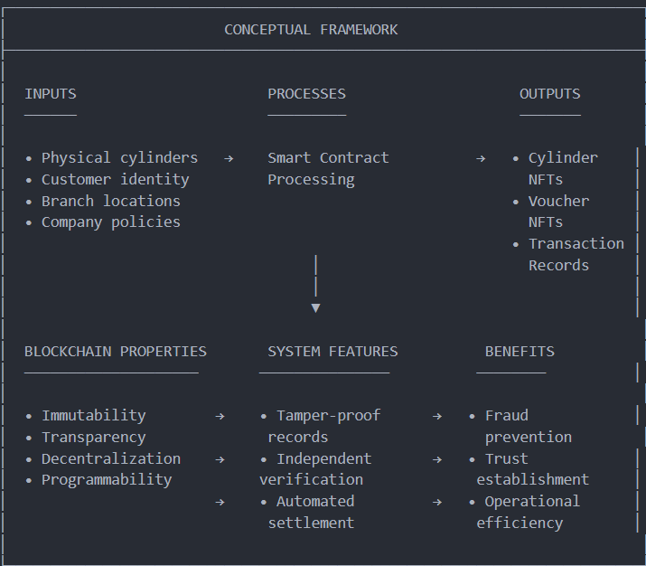
The framework illustrates how blockchain properties enable specific system features, which in turn produce benefits for stakeholders. This causal chain guides the design decisions throughout the development process.

CHAPTER THREE: RESEARCH METHODOLOGY
3.1 Research Design
This research employs a mixed-methods approach combining qualitative analysis with quantitative evaluation within a design science research framework. Design science research is appropriate for this project because it focuses on creating and evaluating artifacts (in this case, smart contracts and a dApp) to solve identified problems (Hevner et al., 2004).

3.1.1 Research Philosophy
The research is grounded in pragmatism, which emphasizes practical consequences and real-world effects as the criteria for evaluating knowledge claims. This philosophy is appropriate for applied technology research where the primary goal is to develop solutions that work effectively in practice.
3.1.2 Research Approach
The research uses a mixed-methods approach:
Approach | Application | Data Type
Qualitative | Literature review, user interviews, observations | Textual, descriptive
Quantitative | Performance metrics, transaction costs, test results | Numerical, statistical

3.1.3 Research Strategy
The primary strategy is prototype development, supported by:
Documentary Analysis: Review of technical documentation, whitepapers, and academic literature.
Case Study Analysis: Examination of existing blockchain implementations in related industries.
Observation: Observation of current voucher processes at gas distribution branches.
Testing: Functional and performance testing of the developed prototype.

3.2 System Development Methodology
3.2.1 Agile Development with Blockchain Adaptations
The system development follows an adapted Agile methodology suitable for blockchain projects. Traditional Agile emphasizes iterative development with frequent releases, but blockchain development requires additional considerations for smart contract immutability. Once deployed, smart contracts cannot be easily modified, requiring more thorough upfront design and testing than typical web applications.
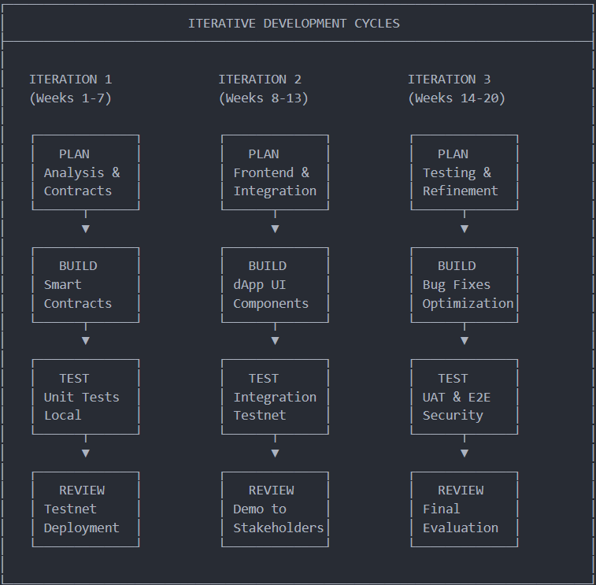

Phase 1: Analysis and Design (Weeks 1-4)
Literature review completion
Requirements gathering through stakeholder consultation
System architecture design
Smart contract architecture specification
Frontend wireframe design
Technology stack finalization
Phase 2: Smart Contract Development (Weeks 5-10)
Development environment setup (Hardhat, Solidity)
AccessControl contract implementation
CylinderRegistry contract implementation
VoucherManager contract implementation
CompanyManager contract implementation
GasSwapPlatform orchestrator implementation
Unit test development (90%+ coverage target)
Local testing and debugging
Testnet deployment (Polygon Mumbai)
Phase 3: Frontend Development (Weeks 8-13)
Next.js project initialization
Layout and navigation components
MetaMask wallet integration (Ethers.js)
Customer dashboard development
Staff interface development
Admin panel development
QR code generation and scanning
IPFS integration for decentralized storage
The Graph integration for data indexing

Phase 4: Testing and Refinement (Weeks 14-17)
End-to-end testing of all user journeys
Security analysis (Slither, Mythril, manual review)
Performance optimization
User Acceptance Testing with sample participants
Bug fixes and UI refinements
Phase 5: Documentation and Presentation (Weeks 18-20)
Technical documentation completion
User guide preparation
Final report writing
Presentation preparation
Defense preparation

3.2.2 Version Control and Collaboration
The project uses Git for version control with the repository hosted on GitHub. The branching strategy follows GitFlow, with separate branches for development, features, and releases.

3.3 Data Collection Methods
3.3.1 Primary Data
Observation: The researcher conducted observations at three gas distribution branches in Kigali to understand current voucher processes, identifying pain points and requirements.
Stakeholder Consultations: Informal consultations with branch managers, staff members, and customers provided insights into user needs and expectations.
System Testing Data: Performance metrics collected during functional and load testing of the prototype.

3.3.2 Secondary Data
Academic Literature: Peer-reviewed journal articles, conference papers, and technical reports from IEEE, ACM, MDPI, and other reputable publishers.
Technical Documentation: Official documentation from Ethereum, Polygon, IPFS, and other technology providers.
Industry Reports: Reports from regulatory authorities, industry associations, and market research firms.

3.4 System Architecture and Design
3.4.1 High-Level Architecture
The system follows a three-tier decentralized architecture:
Presentation Layer: React-based single-page application (SPA) providing user interfaces for customers, branch staff, and administrators. The frontend communicates with the blockchain through the Web3 provider (MetaMask) and queries indexed data through The Graph.
Business Logic Layer: Smart contracts deployed on the Polygon network, implementing the core business rules for cylinder registration, voucher lifecycle management, and access control.
Data Layer: Blockchain serves as the primary data store for transactions and state. IPFS provides decentralized storage for QR codes and other files. The Graph indexes blockchain events for efficient querying.
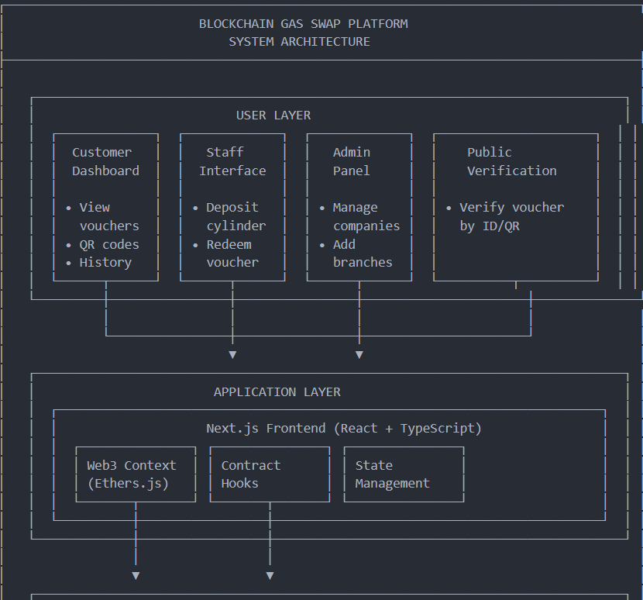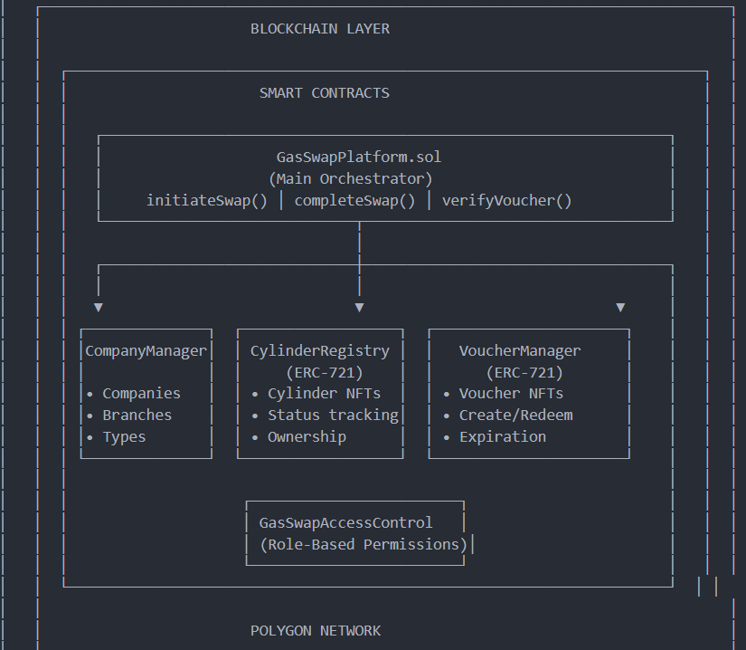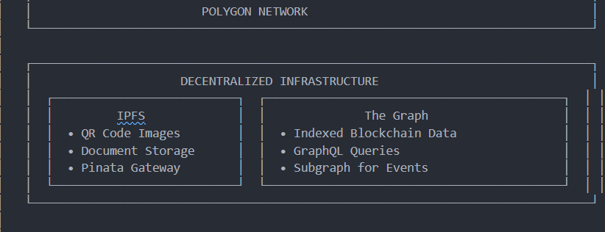

3.4.2 Smart Contract Architecture
The smart contract layer consists of six interconnected contracts:
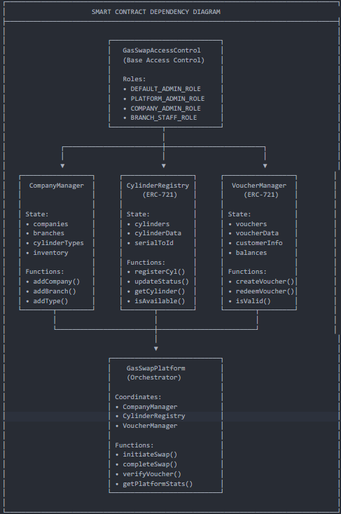

3.4.3 User Interface Design
The dApp provides three distinct interfaces:

Customer Interface:
Connect wallet and view voucher portfolio
Scan QR code to verify voucher status
View transaction history
Receive push notifications

Staff Interface:
Create new vouchers by scanning customer QR and cylinder barcode
Redeem vouchers by scanning customer QR
View branch inventory
Access daily transaction reports

Admin Interface:
Manage companies and branches
Register new cylinders
Assign staff roles
View system-wide analytics

3.4.4 Data Flow Diagrams
Voucher Creation Flow (Deposit)
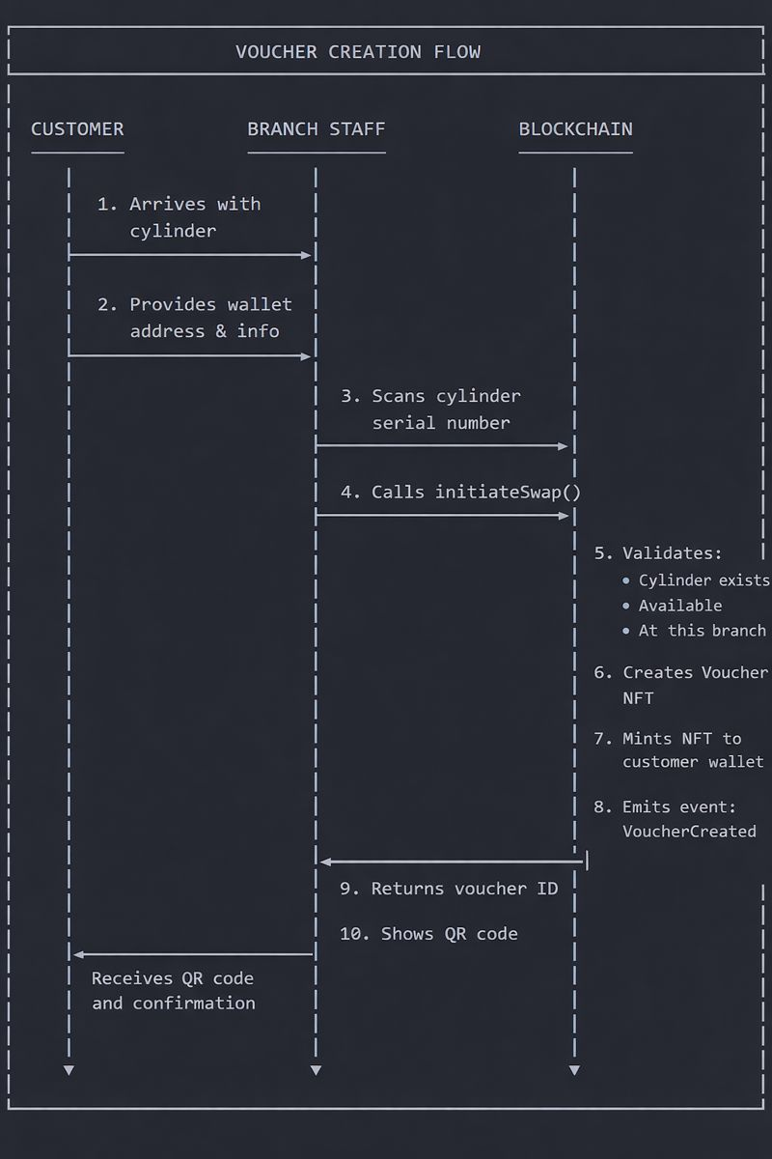
Voucher Redemption
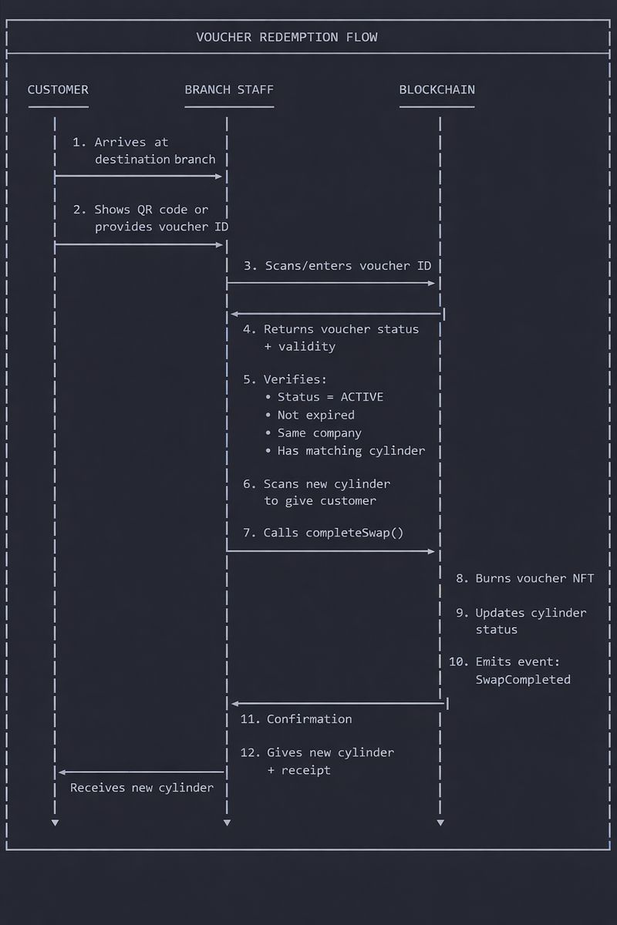

3.5 Tools and Technologies
3.5.1 Blockchain and Smart Contracts
Technology | Purpose | Justification
Solidity 0.8.x | Smart contract language | Industry standards, mature tooling, large developer community
Hardhat | Development environment | Superior debugging, testing, and deployment features compared to alternatives
OpenZeppelin Contracts | Security libraries | Audited, battle-tested implementations of standard patterns
Polygon | Deployment network | Low costs, fast confirmations, Ethereum compatibility

3.5.2 Frontend Development
Technology | Purpose | Justification
Next.js 14 | React framework | Server-side rendering, file-based routing, optimized performance
Ethers.js v6 | Blockchain interaction | Modern API, TypeScript support, smaller bundle size than Web3.js
TailwindCSS | Styling | Utility-first approach, responsive design, rapid development
react-qr-reader | QR scanning | Well-maintained library for camera-based QR code scanning

3.5.3 Decentralized Infrastructure
Technology | | Purpose | Justification
IPFS (via Pinata) | File storage | Decentralized, content-addressed, widely supported
The Graph | Blockchain indexing | Efficient queries, decentralized hosting, GraphQL API
Push Protocol | Notifications | Decentralized push notifications without centralized servers

3.5.4 Development and Testing
Technology | Purpose | Justification
Git/GitHub | Version control | Industry standard, collaboration features, CI/CD integration
Chai/Mocha | Smart contract testing | Integration with Hardhat, comprehensive assertion library
Slither | Security analysis | Automated vulnerability detection in Solidity code
Lighthouse | Performance auditing | Web application performance and accessibility analysis

3.6 Testing and Validation
3.6.1 Unit Testing
Each smart contract function is tested with multiple test cases covering:
Normal operation (happy path)
Edge cases (boundary conditions)
Error cases (invalid inputs, unauthorized access)

3.6.2 Integration Testing
Integration tests verify the interaction between contracts and between the frontend and blockchain:
Complete voucher lifecycle (create → verify → redeem)
Cross-branch operations
Role management workflows
3.6.3 Security Analysis
The project employs multiple security analysis approaches:
Automated Analysis: Slither static analyzer to detect common vulnerability patterns
Manual Review: Code review against the Smart Contract Weakness Classification (SWC) registry
Known Vulnerability Checks:
Reentrancy attacks
Integer overflow/underflow (mitigated by Solidity 0.8.x)
Access control issues
Front-running vulnerabilities
3.6.4 User Acceptance Testing
A sample of 15 participants representing different user groups (customers, branch staff, managers) will evaluate the prototype through guided task completion and provide feedback via structured questionnaires.

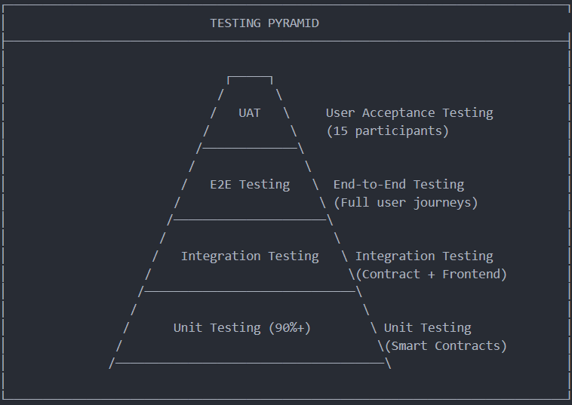

3.7 Smart Contract Security Analysis
Tool | Type | Purpose
Slither | Static Analysis | Detect common vulnerabilities
Mythril | Symbolic Execution | Deep vulnerability detection
Hardhat Gas Reporter | Performance | Measure gas consumption
Solidity Coverage | Coverage | Ensure test completeness
Manual Review | Expert Review | Logic and business rule validation

3.7.1 User Acceptance Testing Protocol
Participants:
5 potential customers (varying technical literacy)
5 branch staff members
3 company managers
2 technical users
Testing Tasks:
1. Connect wallet and view dashboard
2. Create a voucher (staff role)
3. View voucher details and QR code (customer role)
4. Verify voucher validity
5. Redeem a voucher (staff role)
6. View company analytics (admin role)
Evaluation Criteria:
Task completion rate
Time to complete tasks
Error rate
User satisfaction (Likert scale)
Qualitative feedback

3.8 Ethical Considerations
3.8.1 Data Privacy
Minimal on-chain personal data storage
Customer information stored off-chain when possible
Wallet addresses are pseudonymous
Users informed about blockchain data transparency
3.8.2 Informed Consent
All UAT participants provide written consent
Clear explanation of research purpose and data use
Right to withdraw at any time
Anonymization of feedback data
3.8.3 Environmental Impact
Polygon uses Proof-of-Stake (minimal energy consumption)
Estimated environmental impact: <0.001% of Bitcoin transactions
No significant negative environmental impact
3.8.4 Accessibility
Keyboard navigation support
Screen reader compatibility
Appropriate color contrast
Mobile-responsive design

3.9 Security Architecture
3.9.1 Role-Based Access Control
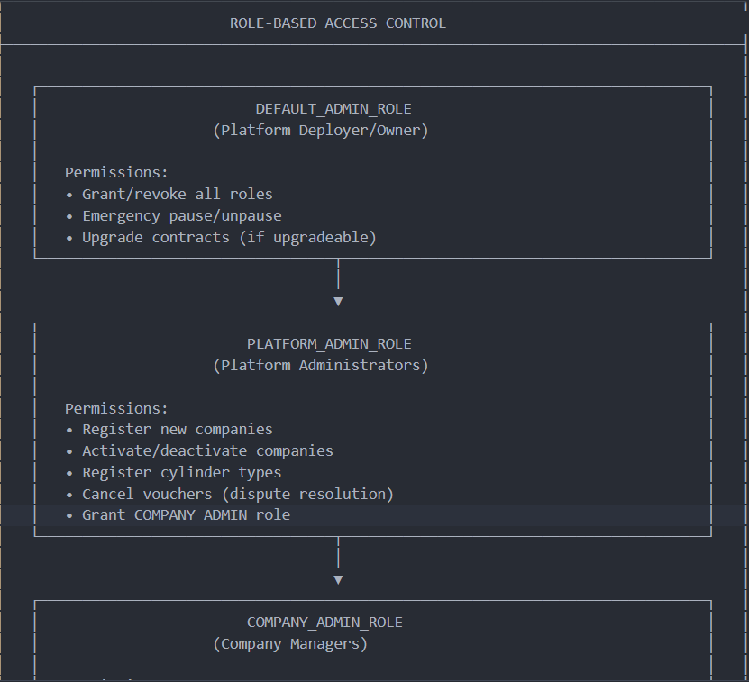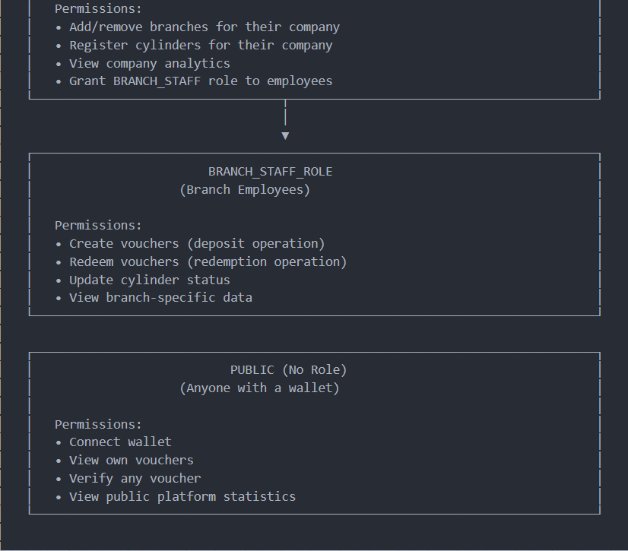

3.9.2 Security Features
Feature | Implementation | Purpose
Reentrancy Guard | OpenZeppelin ReentrancyGuard | Prevent reentrancy attacks
Access Control | OpenZeppelin AccessControl | Role-based permissions
Pausable | OpenZeppelin Pausable | Emergency stop mechanism
Input Validation | require() statements | Prevent invalid inputs
Integer Safety | Solidity 0.8.x built-in | Prevent overflow/underflow

REFERENCES
[1] Guodong, L. Yongqiang, and L. Jianhua, "Research on Sulfur Hexafluoride Management and Control Based on Radio Frequency Identification Method," in International Conference on Computer Science and Education, 2021. DOI: 10.1109/ICCSE51940.2021.9569290
[2] Tahir, M. et al., "Kardan Research Journal (KRJ)," Kardan Research Journal.
[3] Sujith, S. et al., "Smart LPG Level Monitoring and Automatic Booking system Integrated with trolley," in International Conference on Signal Processing, Computation, Electronics, Power and Telecommunication, 2023. DOI: 10.1109/ICSTSN57873.2023.10151516
[4] Liu, Y. et al., "Enhancing Residential Gas Safety through Remote Monitoring and Embedded Microchip Systems."
[5] Yaya, F. et al., "Smart LPG usage and leakage detection using IoT and mobile application," International Journal of Systems, Control and Communications, 2023. DOI: 10.1504/ijscc.2023.10051741
[6] Narayana, K., "IoT-BASED SMART KITCHEN INCLUDING LPG CYLINDER WEIGHT MONITORING SYSTEM."
[7] Kugler, M. et al., "Blockchain: Um novo patamar de governança digital," GV executivo, vol. 22, no. 4, 2023. DOI: 10.12660/gvexec.v22n4.2023.89722
[8] Zhang, Y. et al., "Research on Feasibility of Traceability and Anti-counterfeiting of Gas Equipment Based on Blockchain Technology," 2020. DOI: 10.1007/978-981-16-1123-0_58
[9] Koscina, M. et al., "A blockchain-based marketplace platform for circular economy," in ACM Symposium on Applied Computing, 2021. DOI: 10.1145/3412841.3442136
[10] ALahmed, A., "Internet of Things Based Blockchain Technology for Gas Station," Iraqi Journal of Intelligent Computing and Informatics (IJICI), 2022. DOI: 10.52940/ijici.v1i2.17
[11] Cao, S. et al., "Anonymous scheme for blockchain atomic swap based on zero-knowledge proof," in International Conference on Artificial Intelligence, 2020. DOI: 10.1109/ICAICA50127.2020.9181875
[12] Rafi, M., "Cryptoverse - A Multi-Asset Platform with Crypto Swapping Technique using Blockchain," Indian Scientific Journal Of Research In Engineering And Management, 2023. DOI: 10.55041/ijsrem25149
[13] Hyung, J. et al., "Platform system for dealing used goods based on block-chain," 2020.
[14] Kosenkov, A. et al., "Recent Advances of Oilfield Blockchain," DEStech Transactions on Computer Science and Engineering, 2018. DOI: 10.12783/DTCSE/MSOTA2018/27599
[15] Dhillon, V. et al., "Recent Developments in Blockchain," 2017. DOI: 10.1007/978-1-4842-3081-7_11
[16] Lee, Y., "Blockchain-Based Settlement System Using Cross-Chain Atomic Swaps," 2020.
[17] "ZipZap: A Blockchain Solution for Local Energy Trading," arXiv preprint, 2022. DOI: 10.48550/arxiv.2202.13450
[18] Hinata-Yamaguchi, R., "Application and Challenges of 'Blockchain Technology' in the Oil and Gas Industry," 2022. DOI: 10.1201/9781003138082-11
[19] Gang, W., "Block chain-based refueling management method and device," 2018.
[20] Kumarswamy, S. et al., "Leveraging Blockchain Technology to Establish a Transparent and Counterfeit-Resistant Pharmaceutical Supply Chain," Journal européen des systèmes automatisés, vol. 57, no. 5, 2024. DOI: 10.18280/jesa.570518
[21] Adamik, A. et al., "SmartExchange: Decentralised Trustless Cryptocurrency Exchange," in Business Information Systems, 2018. DOI: 10.1007/978-3-030-04849-5_32
[22] Ding, Y. et al., "Blockchain-Based Implementation of Smart Contract and Risk Management for Interest Rate Swap," 2019. DOI: 10.1007/978-981-15-3278-8_14
[23] Lyridis, D. et al., "A BPM-based framework for the impact assessment of blockchain to the midstream LNG supply chain," Maritime Business Review, 2021. DOI: 10.1108/MABR-03-2021-0023
[24] Laturkar, S. et al., "Blockchain Integration in Upstream Oil and Gas," Advances in computational intelligence and robotics book series, 2024. DOI: 10.4018/979-8-3693-1046-5.ch006
[25] Allwinnaldo, A. et al., "Efficient Blockchain-Based Energy Auction Platform for Secured Energy Trading on Industrial Applications," The Journal of Korean Institute of Communications and Information Sciences, vol. 48, no. 7, 2023. DOI: 10.7840/kics.2023.48.7.885
[26] Nwamordi, C., "Revolutionizing energy markets: commercialization of natural gas projects through blockchain technology," The Journal of World Energy Law & Business, 2024. DOI: 10.1093/jwelb/jwae018
[27] Kustov, A., "Transformation of Traditional Gas Industries to Blockchain-Enabled Gas Industries," Advances in business information systems and analytics book series, 2022. DOI: 10.4018/978-1-7998-8697-6.ch011
[28] Zehir, S. et al., "Tailored Blockchain Applications for the Natural Gas Industry: The Case Study of SOCAR," Energies, vol. 15, no. 16, 2022. DOI: 10.3390/en15166010
[29] Hasan, H. et al., "Blockchain-Based Solution for the Traceability of Spare Parts in Manufacturing," IEEE Access, 2020. DOI: 10.1109/ACCESS.2020.2998159

