UNIVERSITY OF RWANDA

COLLEGE OF SCIENCE AND TECHNOLOGY SCHOOL OF ICT

COMPUTER AND SOFTWARE ENGINEERING DEPARTMENT NYARUGENGE CAMPUS
MODULE CODE/TITLE: WEB DESIGN

SMART FISH FARM MANAGEMENT SYSTEM, Case of Rwasave, Huye, Rwanda

20272638271
Year of study: …………….
Date: ………………….

Project Technical Report- Web Technology TECHNICAL ASSESSMENT 2026

Table of contents
- Automatic table of contents

Table of Figures
- Automatic table of figures

List of Abbreviations
- Selected list of abbreviations if any in your document

Chapter 1. Introduction
- 1.1. Historical background of the case study
- 1.2. Problem statement
- 1.3. Objectives of your project.
- 1.4. Expected Outcomes
- 1.5. Project Rationale (Importance to the community)

Chapter 2. System Analysis and Design
- 2.1. System Analysis
2.1.1 Intended users of the project
2.1.2 Intended system partners

- 2.2. System Design
    - High-Level Architecture
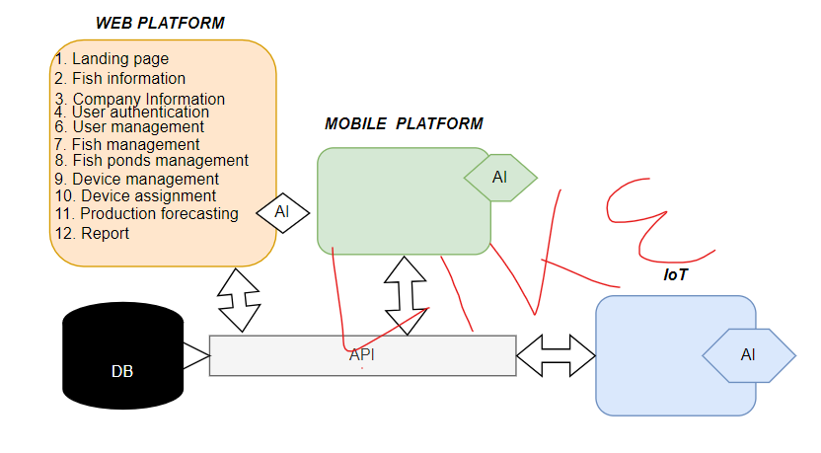
    - UI design (sketch of the UI module) and Flowcharts
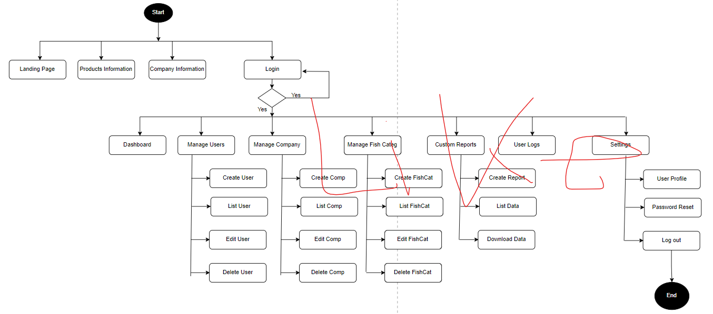
    - Database design with ERD and relationships

Chapter 3. Implementation
- 3.1. Introduction of the section
- 3.2 All screenshots with captions and a one-page discussion per screenshot.
E.g.: 3.2. Login page, User registration page, dashboard page, product page (list, create, update, delete).
- Generally this part is about the screenshots of your apps.

Chapter 4. Conclusion and Recommendation
- Discuss the state of the implemented system (90% of your objectives are achieved? Or 10%)
- What do you recommend?
- To the lecturer about technicalities?
- To school about Time constraints?
- To the partners (owners of the business you are targeting) about the app developed?
- To the user about training?
- To the beneficiaries (customers or students….) about the new technological tool?

Appendix.
- Link to the account and password of the GitHub repository of the deployed project.

