CSCI222 Assignment 2 Test Cases

Team Leader’s Name : Mei Konishi
Team Leader’s Student No. : 5281374

General Instructions

- Prepare the following :

- Open up the exact same version of your deliverables (submitted 1 day earlier via email)

- Open up Excel document ‘Assn2_Checklist.xls ‘

- Perform test cases SEQUENTIALLY with reference to your submitted deliverables, do not skip steps / sequence!

- FOR EACH test case :

  - Fill in the necessary details required by the test case (with reference to its corresponding instructions)

  - Update Assn2_Checklist.xls (select the available choices under column 'C') at the row corresponding to your test case

- Note : Please RESIZE your screen capture, Adjust the Spacing such that each
test case begins on a new page !!

Test Case #1 – Report's overall structure (declaration)

    - Update “Assn2_Checklist.xls”, (i.e. the row with test-case 1a), select ‘Yes’ if all spelling and grammar checks have been done on all documents, ‘No’ if otherwise

    - Update “Assn2_Checklist.xls”, (i.e. the row with test-case 1b), select ‘Yes’ if your team has followed instructions and organized your content according to the format provided in A3_Sample_Report_Format.doc, for all documents, ‘No’ if otherwise

    - Update “Assn2_Checklist.xls”, (i.e. the row with test-case 1c), select ‘Yes’ if your team has followed instructions and made use of MS Word's "insert table of contents" facility in pg 2 of your report, ‘No’ if otherwise

Test Case #2 – Report's usage of communication aids (declaration)

- Update “Assn2_Checklist.xls”, (i.e. the rows with test-case 2a) to 2g). For each row, select:

      - ‘Extensively (all sections / docs)’ : the visual aid (e.g. tables) appears frequently throughout most sections in your report document(s)
      - ‘Moderately (some sections / docs)’ : the visual aid appears moderately in some sections in your report document(s)
      - ‘A little (1 or 2 sections / docs)’ : the visual aid appears sparingly in some sections in your report document(s)
      - ‘None at all’ : the visual aid was not used at all in your report document(s)
      - ‘Not Sure (pls explain)’ : consult your tutor, or explain in the same row, column ‘D’

Test Case #3 – Report's content
organization / professionalism (declaration)

- Update “Assn2_Checklist.xls”, (i.e. the row with test-case 3a) to 3i). For each row, select:

      - ‘Yes’ : if you used the item in your report document(s)
      - ‘No’ : if you did not use the item in your report document(s)
      - ‘Not sure (pls explain)’ : consult your tutor, or explain in the same row, column ‘D’

Test Case #4 – Report Items (declaration)

- Update “Assn2_Checklist.xls”, (i.e. the rows with test-case 4a) to 4as). For each row, select:

      - ‘Yes’ : if you included the item in your report document(s)
      - ‘No’ : if you did not include the item in your report document(s)
      - ‘Not sure (pls explain)’ : consult your tutor, or explain in the same row, column ‘D’

- For any of the report content item in the Excel checklist where you declared “Yes”, please provide the appropriate references by filling up the table below :

Test Case | Report Items | Page Range | Document Name, Caption / Description  (optional)
 | E.g.  Group Meetings | E.g.  Pg 18 – 23,  Pg 38 - 68 | E.g.  Main Report.doc, Appendix C – Group Meetings  Sub Report.doc, Section 3 - Grp Mtg Details
4a | Project overview - Vision | Pg 3 | Main Report, Section 1.1
4b | Project overview - Initial Use Case Model | Pg 3 | Main Report, Section 1.2
4c | Project overview - Project Plan (e.g. Gantt Chart) | Sheet 2 | Gantt chart
4d | Project overview - Roles and Responsibility | Pg 4 | Main Report, Section 2
4e | Risk Analysis and Counter Measures | Pg 5 | Main Report, Section 3
4f | Iteration 1 - Use Cases | Pg 6 | Main Report, Section 4.1
4g | Iteration 2 - Use Cases | Pg 7 | Main Report, Section 4.2
4h | Iteration 3 - Use Cases
4i | Iteration 1 - Activity Diagram | Pg 4-17 | Appendix, appendix A
4j | Iteration 2 - Activity Diagram | Pg 18-33 | Appendix, appendix B
4k | Iteration 3 - Activity Diagram

 | Report Items | Page Range | Document Name, Caption / Description  (optional)
4l | Iteration 1 - Component Diagram | Pg 10 | Main Report, Section 4.5
4m | Iteration 2 - Component Diagram | Pg 11 | Main Report, Section 4.6
4n | Iteration 3 - Component Diagram
4o | Iteration 1 - Class Diagram | Pg 12 | Main Report, Section 4.7
4p | Iteration 2 - Class Diagram | Pg 13 | Main Report, Section 4.8
4q | Iteration 3 - Class Diagram
4r | Iteration 1 - Sequence Diagram | Pg 34-47 | Appendix, appendix C
4s | Iteration 2 - Sequence Diagram | Pg 48-62 | Appendix, appendix D
4t | Iteration 3 - Sequence Diagram
4u | Iteration 1 - Deployment Diagram | Pg 16 | Main Report, Section 4.11
4v | Iteration 2 - Deployment Diagram | Pg 17 | Main Report, Section 4.12
4w | Iteration 1 - Deployment Diagram
4x | Iteration 1 - Other Diagram #1
4y | Iteration 2 - Other Diagram #1
4z | Iteration 3 - Other Diagram #1
4aa | Iteration 1 - Other Diagram #2
4ab | Iteration 2 - Other Diagram #2
4ac | Iteration 3 - Other Diagram #2

 | Report Items | Page Range | Document Name, Caption / Description  (optional)
4ad | Implementing Test Classes and Functions to test program | Pg 19 | User Acceptance Test
4ae | Writing Test Plan | Pg 19 | User Acceptance Test
4af | Construction - Iter1 - Formal Mtg Minutes | Pg 20-22 | Main Report, Section 5 Appendices A
4ag | Construction - Iter2 - Formal Mtg Minutes | Pg 23-25 | Main Report, Section 5 Appendices A
4ah | Construction - Iter3 - Formal Mtg Minutes
4ai | Transition - Iter1 - Formal Mtg Minutes | Pg 26-27 | Main Report, Section 5 Appendices A
4aj | Transition - Iter2 - Formal Mtg Minutes
4ak | Transition - Iter3 - Formal Mtg Minutes
4al | Construction - Iter1 - Diaries of ALL members | Pg 28, 31, 34, 37, 40, 43, 46 | Main Report, Section 5 Appendices B
4am | Construction - Iter2 - Diaries of ALL members | Pg 29, 32, 35, 38, 41, 44, 47 | Main Report, Section 5 Appendices B
4an | Construction - Iter3 - Diaries of ALL members
4ao | Transition - Iter1 - Diaries of ALL members | Pg 30, 33, 36, 39, 42, 45, 48 | Main Report, Section 5 Appendices B
4ap | Transition - Iter2 - Diaries of ALL members
4aq | Transition - Iter3 - Diaries of ALL members
4ar | Evidence of using Version Control Software | Pg 49 - 51 | Main Report, Section 5 Appendices C
4as | SRS (S/w Requirem Specifications) | Pg 1-9 | SRS

- For testcases 4af - 4ak, please summarize the Formal Mtg Minutes info and schedules in the table below:

 | Formal Mtg Minutes Summary | Mtg Date  (dd / mm / yyyy) | Number of
 | Formal Mtg Minutes Summary | Mtg Date  (dd / mm / yyyy) | Members Absent  (Include names of absentees)  E.g. John, Mary | No. of Un-resolved issues / Urgent action items / Uncompleted action items  (fr. prev. mtg)  E.g. 3 | No. of Newly identified action items (in curr. mtg)  E.g. 5
4af | Construction - Iter1 - Formal Mtg Minutes | 20/02/17 |  | 0 | 13
4ag | Construction - Iter2 - Formal Mtg Minutes | 22/01/17 |  | 0 | 11
4ah | Construction - Iter3 - Formal Mtg Minutes
4ai | Transition - Iter1 - Formal Mtg Minutes | 25/02/17 |  | 0 | 5
4aj | Transition - Iter2 - Formal Mtg Minutes
4ak | Transition - Iter3 - Formal Mtg Minutes

- For testcases 4al - 4aq, please summarize the Individual Diaries and info in the table below:

 | Individual Diaries Summary | Team  Member's  Name  E.g. John, Mary | No. of action item(s) allocated to member  E.g. 4 | Amt. of time allocated to complete all tasks (in hrs)  E.g. 24 | Actual time spent to complete all tasks (in hrs)  E.g. 8 | No. of uncompleted tasks by next Formal Mtg  E.g. 1
4al | Construction - Iter1 - Diaries of ALL members | Mei konishi | 2 | 8 | 8 | 0
4al | Construction - Iter1 - Diaries of ALL members | Loh Si Ying | 3 | 8 | 8 | 0
4al | Construction - Iter1 - Diaries of ALL members | Chua Han Ming Adler | 3 | 8 | 8 | 0
4al | Construction - Iter1 - Diaries of ALL members | Ong Wei Hao | 3 | 8 | 8 | 0
4al | Construction - Iter1 - Diaries of ALL members | Nicola Tan Yin Ci | 2 | 8 | 8 | 0
4al | Construction - Iter1 - Diaries of ALL members | Wee Hon Sen Daryl | 2 | 8 | 8 | 0
4al | Construction - Iter1 - Diaries of ALL members | Tao Si Yue | 3 | 8 | 8 | 0
4am | Construction - Iter2 - Diaries of ALL members | Mei konishi | 1 | 30 | 28 | 0
4am | Construction - Iter2 - Diaries of ALL members | Loh Si Ying | 2 | 25 | 18 | 0
4am | Construction - Iter2 - Diaries of ALL members | Chua Han Ming Adler | 2 | 25 | 18 | 0
4am | Construction - Iter2 - Diaries of ALL members | Ong Wei Hao | 2 | 25 | 18 | 0
4am | Construction - Iter2 - Diaries of ALL members | Nicola Tan Yin Ci | 2 | 25 | 18 | 0
4am | Construction - Iter2 - Diaries of ALL members | Wee Hon Sen Daryl | 1 | 30 | 18 | 0
4am | Construction - Iter2 - Diaries of ALL members | Tao Si Yue | 1 | 25 | 28 | 0
4an | Construction - Iter2 - Diaries of ALL members
4ao | Transition - Iter1 - Diaries of ALL members | Mei konishi | 2 | 18 | 14 | 0
4ao | Transition - Iter1 - Diaries of ALL members | Loh Si Ying | 2 | 18 | 14 | 0
4ao | Transition - Iter1 - Diaries of ALL members | Chua Han Ming Adler | 2 | 18 | 14 | 0
4ao | Transition - Iter1 - Diaries of ALL members | Ong Wei Hao | 2 | 18 | 14 | 0
4ao | Transition - Iter1 - Diaries of ALL members | Nicola Tan Yin Ci | 2 | 18 | 14 | 0
4ao | Transition - Iter1 - Diaries of ALL members | Wee Hon Sen Daryl | 2 | 18 | 14 | 0
4ao | Transition - Iter1 - Diaries of ALL members | Tao Si Yue | 2 | 18 | 14 | 0
4ao | Transition - Iter2 - Diaries of ALL members
4ao | Transition - Iter3 - Diaries of ALL members

Test Case #5 – Additional Usage of docs / design diagrams / aids
to express system design (declaration)

- Update “Assn2_Checklist.xls”, (i.e. the rows with test-case 5a) to 5h). For each row, select:

      - ‘Yes’ : if you included the item in your report document(s)
      - ‘No’ : if you did not include the item in your report document(s)
      - ‘Not sure (pls explain)’ : consult your tutor, or explain in the same row, column ‘D’

- For any of the design diagram / devices where you used at least once, please provide the appropriate references FOR ONE EXAMPLE by filling up the table below :

Test Case | Design Diagram / Devices | Page Range | Document Name, Caption / Description  (optional)
Test Case | Design Diagram / Devices | E.g.  Pg 18 – 23, | E.g.  Main Report.doc, Section E
5a | Data Dictionary
5b | Object Diagram(s)
5c | State Diagram(s)
5d | Package Diagram(s)
5e | Communication Diagram(s)
5f | lnteraction Overview Diagram(s)
5g | Deployment Diagram(s) | Pg 17 | Main report section 4.12
5h | Bonus - ER Diagrams

Test Case #6 – Grp A Functionalities

- Update “Assn2_Checklist.xls”, (i.e. the rows with test-case 6a) to 6f). For each row, select:

      - ‘Yes’ : if you captured the (above) system functionality in the document / design diagram
      - ‘No’ : if you did not include/capture it
      - ‘Not sure (pls explain)’ : consult your tutor, or explain in the same row, column ‘D’

- For any of the report content item in the Excel checklist where you declared “Yes”, please provide the appropriate references by filling up the table below :

Test Case | Report Artifacts / Design Diagrams | Page Range | Document Name, Caption / Description  (optional)
Test Case | Report Artifacts / Design Diagrams | E.g.  Pg 18 – 23 | E.g.  Team1_SRS_Report.doc, Section 3  Main_Report, Section 4.8
6a | Captured in SRS?
6b | Designed / Reflected in Use Case(s)? | Pg 7 | Main report Section 4.2
6c | Designed / Reflected in Activity Diagram(s)? | Pg 9 | Appendix B  Main report section 4.4
6d | Designed / Reflected in Class Diagram(s)? | Pg 13 | Main report section 4.8
6e | Designed / Reflected in Sequence Diagram(s)? | Pg 15 | Appendix D  Main report section 4.10
6f | Designed / Reflected in Any Other Diagram(s)?

Test Case #7 – Grp B Functionalities

- Update “Assn2_Checklist.xls”, (i.e. the rows with test-case 7a) to 7f). For each row, select:

      - ‘Yes’ : if you captured the (above) system functionality in the document / design diagram
      - ‘No’ : if you did not include/capture it
      - ‘Not sure (pls explain)’ : consult your tutor, or explain in the same row, column ‘D’

- For any of the report content item in the Excel checklist where you declared “Yes”, please provide the appropriate references by filling up the table below :

Test Case | Report Artifacts / Design Diagrams | Page Range | Document Name, Caption / Description  (optional)
Test Case | Report Artifacts / Design Diagrams | E.g.  Pg 18 – 23 | E.g.  Team1_SRS_Report.doc, Section 3  Main_Report, Section 4.8
7a | Captured in SRS?
7b | Designed / Reflected in Use Case(s)?
7c | Designed / Reflected in Activity Diagram(s)?
7d | Designed / Reflected in Class Diagram(s)?
7e | Designed / Reflected in Sequence Diagram(s)?
7f | Designed / Reflected in Any Other Diagram(s)?

Test Case #8 – Grp C Functionalities

- Update “Assn2_Checklist.xls”, (i.e. the rows with test-case 8a) to 8f). For each row, select:

      - ‘Yes’ : if you captured the (above) system functionality in the document / design diagram
      - ‘No’ : if you did not include/capture it
      - ‘Not sure (pls explain)’ : consult your tutor, or explain in the same row, column ‘D’

- For any of the report content item in the Excel checklist where you declared “Yes”, please provide the appropriate references by filling up the table below :

Test Case | Report Artifacts / Design Diagrams | Page Range | Document Name, Caption / Description  (optional)
Test Case | Report Artifacts / Design Diagrams | E.g.  Pg 18 – 23 | E.g.  Team1_SRS_Report.doc, Section 3  Main_Report, Section 4.8
8a | Captured in SRS?
8b | Designed / Reflected in Use Case(s)? | Pg 7 | Main report Section 4.2
8c | Designed / Reflected in Activity Diagram(s)? | Pg 9 | Appendix B  Main report section 4.4
8d | Designed / Reflected in Class Diagram(s)? | Pg 13 | Main report section 4.8
8e | Designed / Reflected in Sequence Diagram(s)? | Pg 15 | Appendix D  Main report section 4.10
8f | Designed / Reflected in Any Other Diagram(s)?

Test Case #9 – Grp D Functionalities

- Update “Assn2_Checklist.xls”, (i.e. the rows with test-case 9a) to 9f). For each row, select:

      - ‘Yes’ : if you captured the (above) system functionality in the document / design diagram
      - ‘No’ : if you did not include/capture it
      - ‘Not sure (pls explain)’ : consult your tutor, or explain in the same row, column ‘D’

- For any of the report content item in the Excel checklist where you declared “Yes”, please provide the appropriate references by filling up the table below :

Test Case | Report Artifacts / Design Diagrams | Page Range | Document Name, Caption / Description  (optional)
Test Case | Report Artifacts / Design Diagrams | E.g.  Pg 18 – 23 | E.g.  Team1_SRS_Report.doc, Section 3  Main_Report, Section 4.8
9a | Captured in SRS?
9b | Designed / Reflected in Use Case(s)? | Pg 7 | Main report Section 4.2
9c | Designed / Reflected in Activity Diagram(s)? | Pg 9 | Appendix B  Main report section 4.4
9d | Designed / Reflected in Class Diagram(s)? | Pg 13 | Main report section 4.8
9e | Designed / Reflected in Sequence Diagram(s)? | Pg 15 | Appendix D  Main report section 4.10
9f | Designed / Reflected in Any Other Diagram(s)?

Test Case #10 – Grp E Functionalities

- Update “Assn2_Checklist.xls”, (i.e. the rows with test-case 10a) to 10f). For each row, select:

      - ‘Yes’ : if you captured the (above) system functionality in the document / design diagram
      - ‘No’ : if you did not include/capture it
      - ‘Not sure (pls explain)’ : consult your tutor, or explain in the same row, column ‘D’

- For any of the report content item in the Excel checklist where you declared “Yes”, please provide the appropriate references by filling up the table below :

Test Case | Report Artifacts / Design Diagrams | Page Range | Document Name, Caption / Description  (optional)
Test Case | Report Artifacts / Design Diagrams | E.g.  Pg 18 – 23 | E.g.  Team1_SRS_Report.doc, Section 3  Main_Report, Section 4.8
10a | Captured in SRS?
10b | Designed / Reflected in Use Case(s)? | Pg 7 | Main report Section 4.2
10c | Designed / Reflected in Activity Diagram(s)? | Pg 9 | Appendix B  Main report section 4.4
10d | Designed / Reflected in Class Diagram(s)? | Pg 13 | Main report section 4.8
10e | Designed / Reflected in Sequence Diagram(s)? | Pg 15 | Appendix D  Main report section 4.10
10f | Designed / Reflected in Any Other Diagram(s)?

Test Case #11a – Implementation (Daily Summary Report)

- Start your program, reading in the file “SampleData_Eval.txt” (provided by your Tutor specially for this evaluation session)

- Navigate to the generation of “Daily Summary Report” function

- Specify that you wish to generate daily summary report for the following date range:

  - From : 17/03/2016 To : 23/03/2016

- Compare your report’s generated data against the sample information shown below (see under “Expected Outcome”

- Update “Assn2_Checklist.xls”, on the row corresponding to this testcase, select:

      - ‘Yes’ : if the CONTENTS of your report matches that of the expected outcome
      - ‘No’ : if you did not implement, or the CONTENTS do not match
      - ‘Not sure (pls explain)’ : consult your tutor, or explain in the same row, column ‘D’

Expected Outcome:
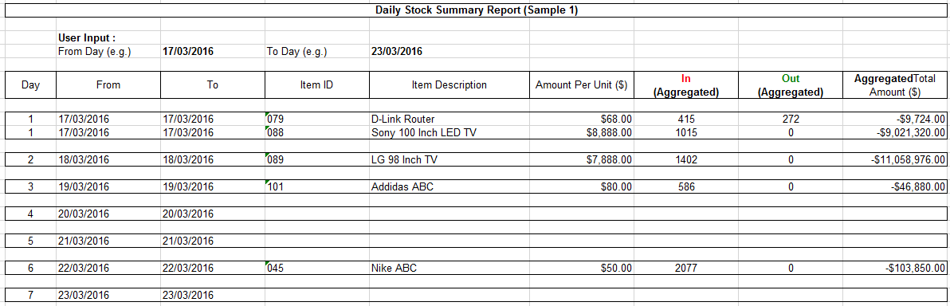

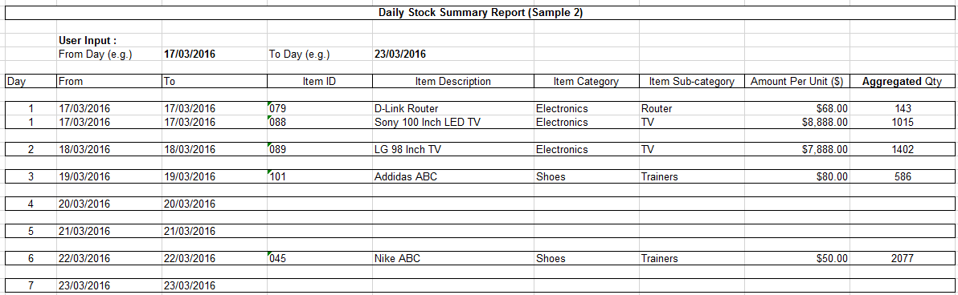

Test Case #11b – Implementation (Weekly Summary Report)

- Start your program, reading in the file “SampleData_Eval.txt” (provided by your Tutor specially for this evaluation session)

- Navigate to the generation of “Weekly Summary Report” function

- Specify that you wish to generate weekly summary report for the following date range:

  - From : 07/03/2016 To : 03/04/2016

- Compare your report’s generated data against the sample information shown below (see under “Expected Outcome”

- Update “Assn2_Checklist.xls”, on the row corresponding to this testcase, select:

      - ‘Yes’ : if the CONTENTS of your report matches that of the expected outcome
      - ‘No’ : if you did not implement, or the CONTENTS do not match
      - ‘Not sure (pls explain)’ : consult your tutor, or explain in the same row, column ‘D’

Expected Outcome:
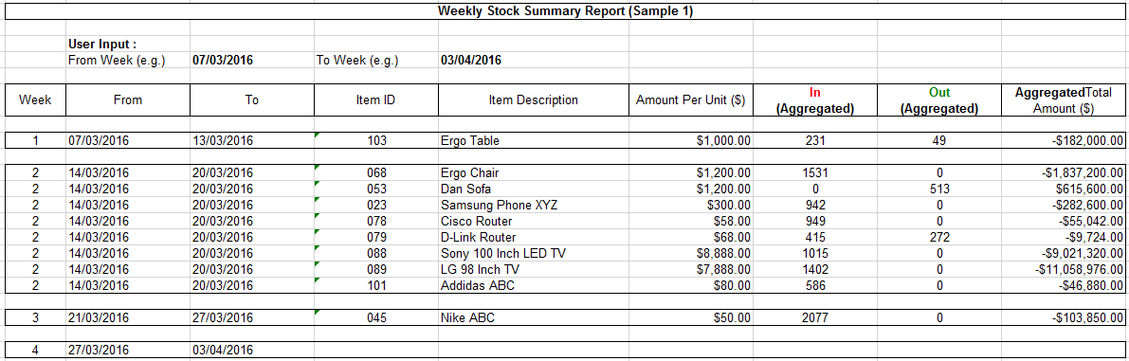

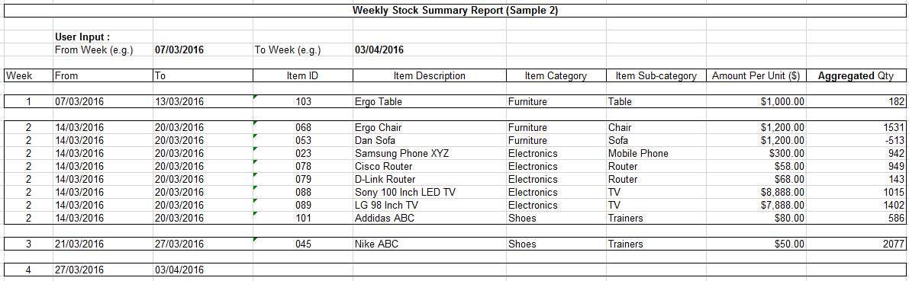

Test Case #11c – Implementation (Monthly Summary Report)

- Start your program, reading in the file “SampleData_Eval.txt” (provided by your Tutor specially for this evaluation session)

- Navigate to the generation of “Monthly Summary Report” function

- Specify that you wish to generate monthly summary report for the following date range:

  - From : 01/03/2016 To : 30/04/2016

- Compare your report’s generated data against the sample information shown below (see under “Expected Outcome”

- Update “Assn2_Checklist.xls”, on the row corresponding to this testcase, select:

      - ‘Yes’ : if the CONTENTS of your report matches that of the expected outcome
      - ‘No’ : if you did not implement, or the CONTENTS do not match
      - ‘Not sure (pls explain)’ : consult your tutor, or explain in the same row, column ‘D’

Expected Outcome:
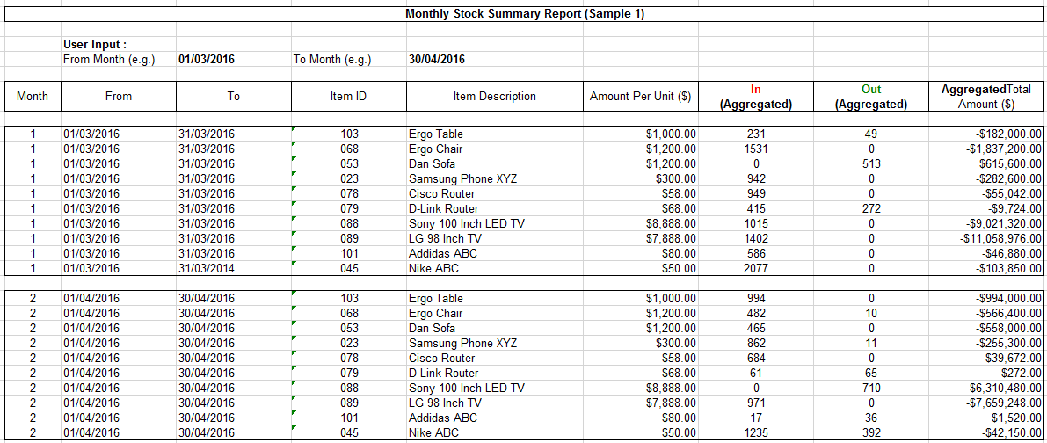

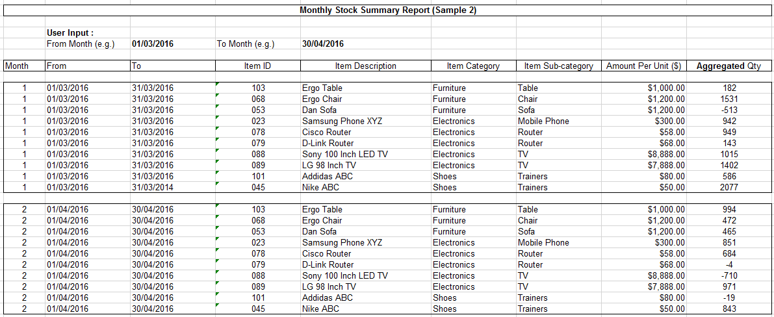

Test Case #11d – Implementation (Yearly Summary Report)

- Start your program, reading in the file “SampleData_Eval.txt” (provided by your Tutor specially for this evaluation session)

- Navigate to the generation of “Yearly Summary Report” function

- Specify that you wish to generate yearly summary report for the following date range:

  - From : 01/01/2014 To : 31/12/2015

- Compare your report’s generated data against the sample information shown below (see under “Expected Outcome”

- Update “Assn2_Checklist.xls”, on the row corresponding to this testcase, select:

      - ‘Yes’ : if the CONTENTS of your report matches that of the expected outcome
      - ‘No’ : if you did not implement, or the CONTENTS do not match
      - ‘Not sure (pls explain)’ : consult your tutor, or explain in the same row, column ‘D’

Expected Outcome:
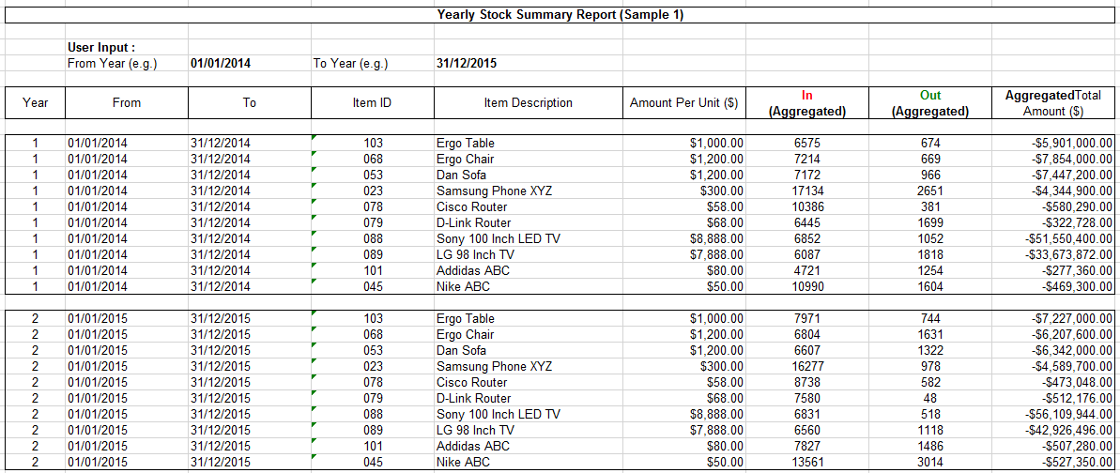

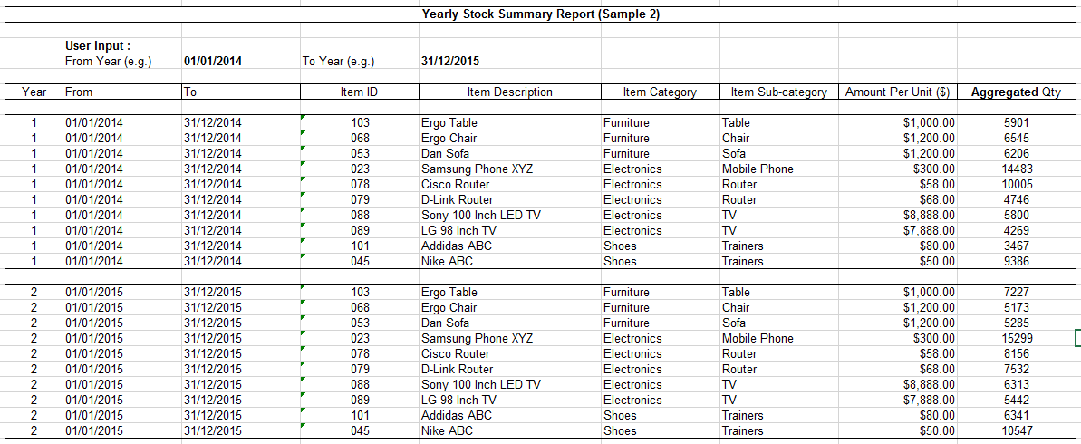

Test Case #11e – Implementation (Set low stock limit)

- Start your program, reading in the file “SampleData_Eval.txt” (provided by your Tutor specially for this evaluation session)

- Navigate to your functionality pertaining to specifying “Low stock limit”

- Paste a screen capture below, of you selecting a particular stock item (e.g. Ergo Table), and entering some suitable values to set the “Low stock limit” threshold

- Update “Assn2_Checklist.xls”, on the row corresponding to this testcase, select:

      - ‘Yes’ : if your screen capture shows the selection of stock item, and specification of its low stock limit
      - ‘No’ : if you did not implement, or the functionality does not work correctly
      - ‘Not sure (pls explain)’ : consult your tutor, or explain in the same row, column ‘D’

< Paste Screen Capture below >

Test Case #11f – Implementation (Low stock quantity report)

- Start your program, reading in the file “SampleData_Eval.txt” (provided by your Tutor specially for this evaluation session)

- Navigate to your functionality generating “Low stock quantity” report, select any particular date range (e.g. from 01/03/2016, to 01/04/2016)

- Paste a screen capture below, of your “Low stock quantity” report, for all stock items whose respective quantities are below the threshold that was (previously set by you), for the indicated date range (e.g. from 01/03/2016, to 01/04/2016)

- Update “Assn2_Checklist.xls”, on the row corresponding to this testcase, select:

      - ‘Yes’ : if your screen capture shows the “Low stock quantity” report for the specific date range
      - ‘No’ : if you did not implement, or the functionality does not work correctly
      - ‘Not sure (pls explain)’ : consult your tutor, or explain in the same row, column ‘D’

< Paste Screen Capture below >

