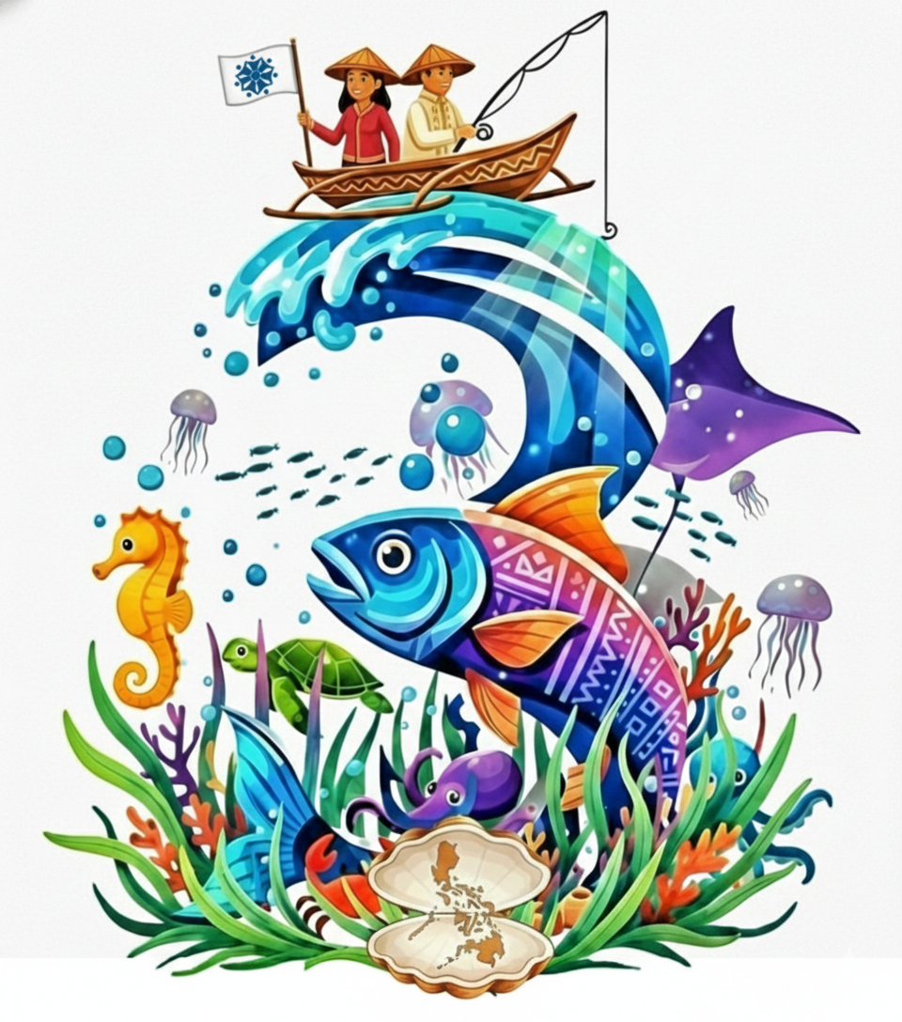
THIRD PHILIPPINE SMALL-SCALE FISHERIES NATIONAL SYMPOSIUM

“From Action to Replication: Scaling Up and Deepening
the Impact of Small-Scale Fisheries”

PSSFNS 3

FISHING FOR SOLUTIONS COMPETITION GUIDELINES

(Graduate and Undergraduate Categories)

Eligibility
The competition is open to graduate and undergraduate students who are 18 years old and above. Each team must be composed of three to five members and must have one faculty mentor.

Abstract Submission
Interested participants must submit an abstract of their proposed idea or solution addressing any gap, issue, or problem related to the theme of the Symposium. Abstracts must be submitted through the abstract submission portal on the Symposium website on or before July 31, 2026 at 23:59 Philippine Standard Time (UTC+8).
The abstract must contain the following information:
- Title, with a maximum of 25 words, written in bold capital letters using 14-point Arial font; scientific names, where applicable, must be italicized
- Name/s of author/s, written in 12-point Arial font
- Institutional affiliation/s, written in 10-point Arial font
- Name of the presenting author, written in bold letters
- Email address of the corresponding and/or presenting author
- Abstract of not more than 300 words, following the prescribed abstract template
- Three to five keywords
The prescribed abstract template must be used. Abstracts must be written in English, the official language of the Symposium. The abstract must be prepared on one page only, using standard A4 paper in portrait orientation. Margins must be set at one inch on all sides. The text must use 12-point Arial font with 1.15 line spacing. Paragraphs must be separated by a blank line and should not be indented.
The abstract must be saved and submitted in MS Word format. The filename should follow this format:
Fishing for Solutions_Surname of Corresponding Author_First Three Words of Abstract Title
Example:
Fishing for Solutions_DelaCruz_Sustainable Gear Innovation
The Fishing for Solutions Competition Committee shall evaluate submitted abstracts based on technical merit and relevance to the Symposium theme. The decision of the said Committee shall be final and non-negotiable.
Authors who submitted abstracts for the Fishing for Solutions Competition will be notified on or before August 15, 2026 whether their abstracts have been accepted.

Registration
Authors and team members of accepted entries must register for the Symposium not later than September 15, 2026. Registration is required for the official inclusion of the entry in the competition.

Submission of Prerecorded Video and Script
Authors of accepted abstracts shall submit a 15-minute prerecorded video and the script of their presentation to the Symposium organizer on or before October 4, 2026. Detailed guidelines on video and script submission shall be provided to the authors of accepted abstracts.

Informed Consent
Consent from all collaborators, participants, and individuals appearing in the video must be secured prior to the submission of entries for the competition.
Submission of an entry to the Fishing for Solutions Competition grants permission to the organizers of the Third Philippine Small-Scale Fisheries National Symposium (PSSFNS 3) to use the abstract, video, images, and other related materials for the Symposium website, official social media platforms, mainstream media releases, symposium e-publications, printed materials, and other venues or platforms deemed necessary by the organizers.

Judging Criteria

Entries shall be evaluated based on the following criteria:

Criteria | Percentage
Clarity of the problem presented | 25%
Clarity and soundness of the proposed solution process | 25%
Workability and feasibility of the proposed solution | 25%
Potential impact of the proposed solution when implemented | 25%

Total

Announcement of Winners

Winners will be announced during the Closing Ceremony on October 23, 2026.

Prizes

Three entries shall be declared as winners:
- First Place: Php 10,000
- Second Place: Php 8,000
- Third Place: Php 5,000
Certificates of Recognition shall be awarded to the three major winners and their faculty mentors. Certificates of Participation shall be given to all competing entries.

Note
For the competition to proceed, a minimum of six qualified submissions must be received.

