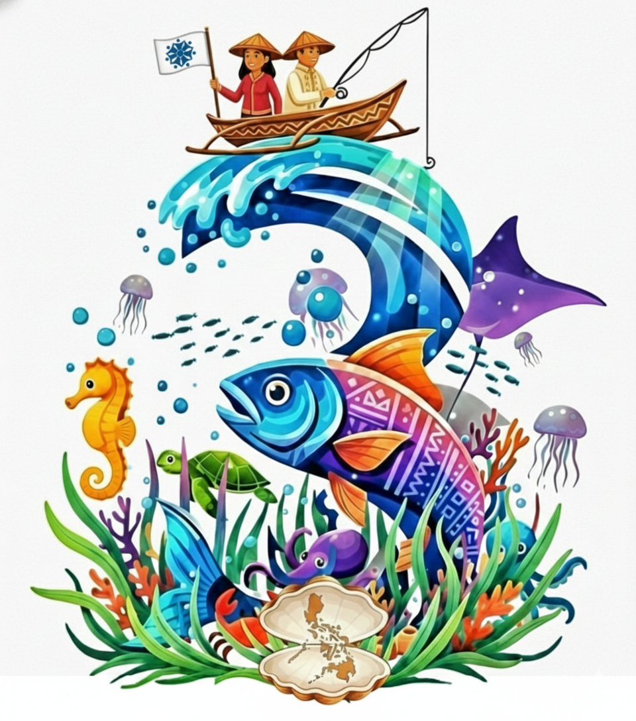
THIRD PHILIPPINE SMALL-SCALE FISHERIES NATIONAL SYMPOSIUM

“From Action to Replication: Scaling Up and Deepening
the Impact of Small-Scale Fisheries”

PSSFNS 3

STUDENT VLOG COMPETITION GUIDELINES

(Graduate and Undergraduate Categories)

Documenting Small Stories with Big Impact

Theme of the Competition
Small-Scale Fisheries as a Way of Life

Sub-Themes
Participants must choose one of the following sub-themes:
- Bright Spots - highlighting the importance, contributions, strengths, and inspiring practices in small-scale fisheries
- Hope Spots - highlighting the challenges, needs, aspirations, and possibilities for improving small-scale fisheries

Eligibility
The competition is open to graduate and undergraduate students who are 18 years old and above. Each entry may be submitted by an individual student or by a team composed of a maximum of three members.

Abstract Submission
Interested participants must submit an abstract of their proposed vlog idea related to the competition theme on or before August 15, 2026 at 23:59 Philippine Standard Time (UTC+8). The prescribed abstract template must be used. Participants must also indicate the selected sub-theme, either Bright Spot or Hope Spot.
The abstract must contain the following information:
- Title of the vlog
- Genre of the vlog, such as personal documentary, challenge or contest, profile or feature, travel, technology, cooking, do-it-yourself, or lifestyle
- Estimated running time, with a minimum of eight minutes and a maximum of 12 minutes
- Name/s of author/s and institutional affiliation/s
- Name of presenting author
- Email address of the corresponding and/or presenting author
- Abstract of not more than 300 words, following the prescribed template
- Three to five keywords
- Selected symposium sub-theme, either Bright Spot or Hope Spot

The abstract may be written in English or Filipino. It must be prepared on one page only, using standard A4 paper in portrait orientation. Margins must be set at one inch on all sides. The abstract must use Arial, 12-point font, with 1.5 line spacing. Paragraphs must be separated by a blank line and should not be indented.
The abstract must be saved and submitted in MS Word format. The filename should follow this format:

SSF Student Vlog_Surname of Corresponding Author_First Three Words of the Vlog Title

Example:
SSF Student Vlog_DelaCruz_Life by the Sea

The Competition Committee shall evaluate submitted abstracts based on creativity and relevance to the competition theme and selected sub-theme. The decision of the Competition Committee shall be final and non-negotiable.
Participants who have submitted abstracts will be notified on or before August 15, 2026 whether their abstracts have been accepted.

Submission of Vlog Entries
Authors of accepted abstracts shall submit their final vlog entries to the symposium organizer on or before October 4, 2026. Detailed submission guidelines will be provided to the authors of accepted abstracts.

Registration
Authors and team members of accepted vlog entries must register for the Symposium not later than September 15, 2026. Registration is required for the inclusion of the vlog abstract in the Symposium Program.

Informed Consent
Consent from all collaborators, participants, and individuals appearing in the vlog must be secured prior to the submission of entries for the competition.
Submission of an entry to the SSF Student Vlog Competition grants permission to the organizers of the Third Philippine Small-Scale Fisheries National Symposium (PSSFNS 3) to use the abstract, video, images, and other related materials for the Symposium website, official social media platforms, mainstream media releases, symposium e-publications, printed materials, and other venues or platforms deemed necessary by the organizers.

Viewing of Entries
All qualified vlog entries will be made available for viewing during the Symposium. The vlogs may be shown on loop on a designated screen at the symposium venue.

Judging Criteria

Entries shall be evaluated in two stages:

Component | Percentage
Abstract | 30%
Vlog Entry | 70%
Total | 100%

Criteria for the Abstract
Criteria | Percentage
Thematic Clarity | 40%
Creativity | 40%
Feasibility | 20%
Total | 100%

Criteria for the Vlog Entry
Criteria | Percentage
Cinematic and Visual Quality | 30%
Audio and Sound Quality | 30%
Storytelling and Content | 40%
Total | 100%

Announcement of Winners
Winners will be announced during the Closing Ceremony on October 23, 2026.

Prizes
Three winning entries shall be declared for the Hope Spot category:
- First Place: Php 10,000
- Second Place: Php 8,000
- Third Place: Php 5,000

Three winning entries shall also be declared for the Bright Spot category:
- First Place: Php 10,000
- Second Place: Php 8,000
- Third Place: Php 5,000

Certificates of Recognition shall be awarded to the major winners and their advisers. Certificates of Participation shall be given to all registered competing entries.

Note
For the competition to proceed, a minimum of six qualified submissions must be received per category.

