Team TRL Project 2 (TP-2)

Phase 2, Elaboration 1

Software Analysis and Design
SEIS 635, Section 07
University of St Thomas
June 17, 2017

Heather Mortensen
Temi Akinsanmi
Yazeed AlQahas

(Fully-dressed) Use case #1. Worker Checks Copies Out to Patron
See Larman, page 67, for details.

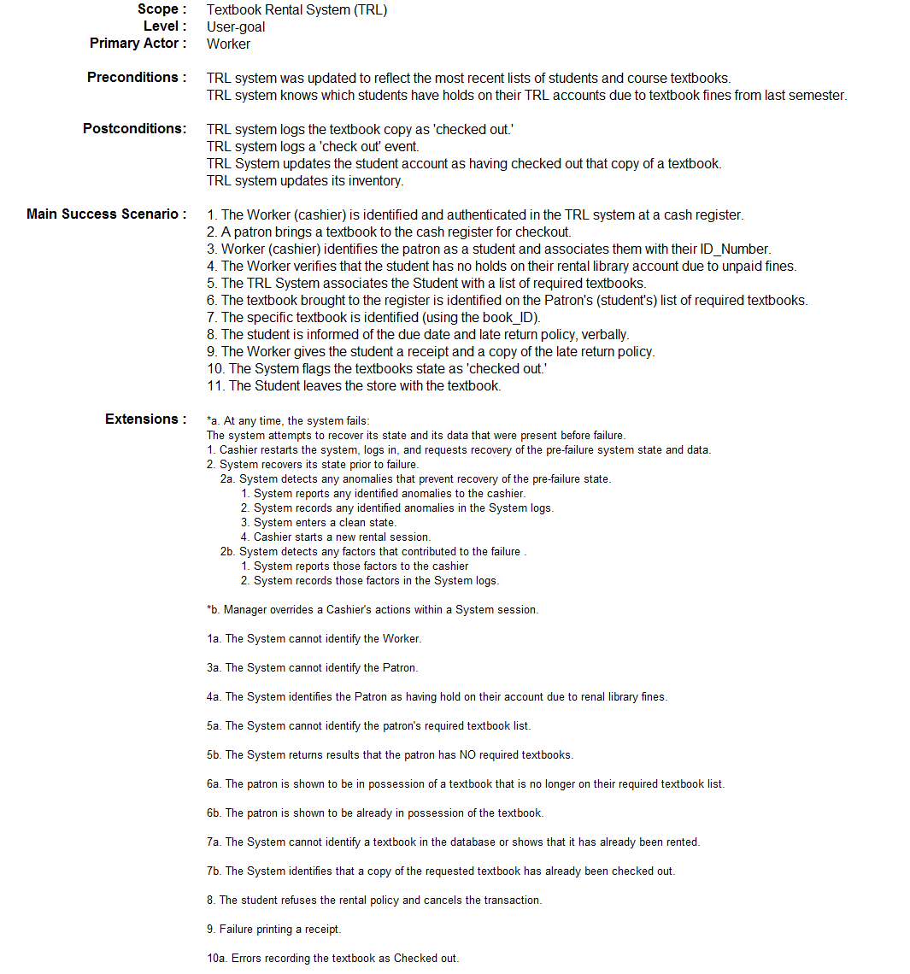

(Fully-dressed) Use case #2. Worker Checks Copies In from Patron (See Larman, p67)

Brief Description of Conceptual Classes for the TRL System

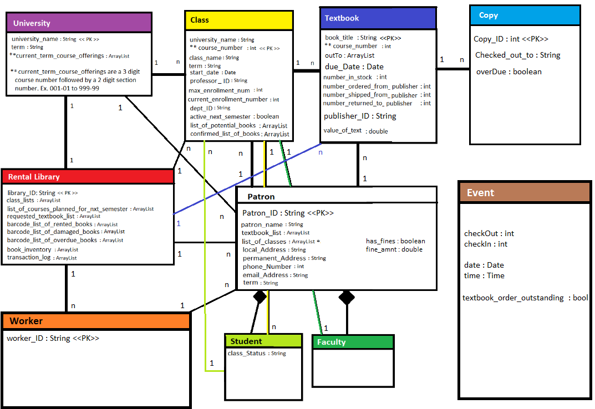
Workers are employed by the Rental Library. They use the TRL System to facilitate the process of Patrons checking in and checking out Textbooks for Classes held at the University. An individual instance of a Textbook is called a Copy. One Rental Library operates within each University. A University offers Classes to Students. A Class is taught by a Faculty professors, who request Textbooks from the Rental Library, for use during a semester Class. Faculty professors also checkout Textbooks to teach a Class. Therefore, Students and Faculty professors are Rental Library Patrons. An Event logs and stores data regarding significant business events for the Rental Library.

Figure 1. Conceptual Classes

Note: In the Domain Class Diagram, we are not supposed to list the attribute AND the arrow relationship (unlike in an ER diagram). It is either/or. We should double check this.

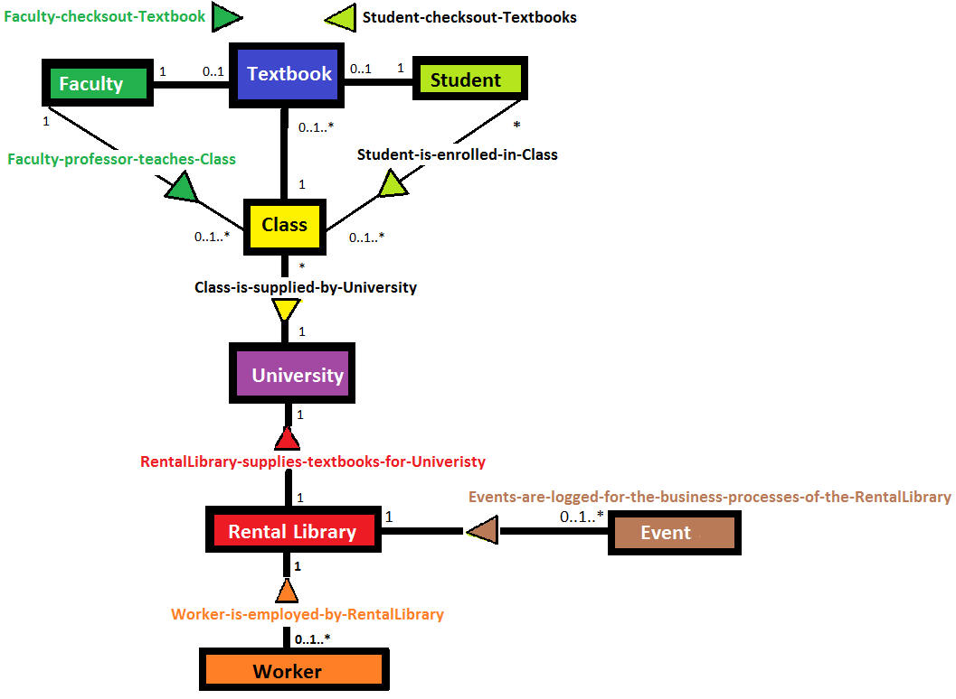
Figure 2. TRL Domain
You should model concepts that relate to "events" in your SuD, such "worker checks out a specific copy to a specific patron". Add a cashier (Worker) class!!! Add a receipt class?
Create and submit to Canvas a single electronic .pdf document named TP_2_Report.pdf

