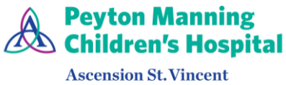 | Pediatric Gastroenterology  (317) 338-9450 | 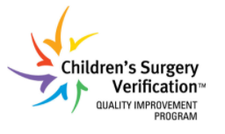
Colonoscopy Bowel Prep | Scan for  mobile-friendly  instructions | 
{{DOCX_HEADING}}

Procedure Location: {{LOCATION_NAME}}  {{LOCATION_ADDRESS}}  {{LOCATION_PHONE_LABEL}}: {{LOCATION_PHONE}}  {{LOCATION_ARRIVAL}} | 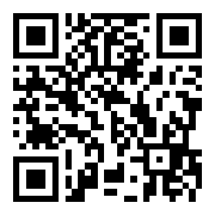  Scan for Google Maps directions
Clear Liquids + Saline Enema Option
✅ Plan Ahead (pick up from the pharmacy)
• Pedialyte® or clear apple juice
• Clear broth (chicken or vegetable)
• Popsicles or plain gelatin (no red or purple colors)
• Saline enema (if prescribed, or if we instruct you separately to give the enema)
• Protective ointment (A&D, Desitin®, or Vaseline®) for the diaper area
📅 Day Before the Procedure
Allowed and Avoided
AVOID: | OK TO DRINK:
All solid foods | Formula or milk (until 12:00 PM)
Formula or milk after 12:00 PM | Breast milk (until 8:00 PM)
Breast milk after 8:00 PM | Pedialyte®
Anything red or purple (looks like blood) | Clear apple juice (no pulp)
 | Water
 | Clear broth (chicken or vegetable, strained)
 | Popsicles or plain gelatin (no red/purple)

Saline enema: If your doctor prescribed a saline enema, give it in the evening at the prescribed dose (10 mL per kg of body weight). If a saline enema was not prescribed for home, the doctor will give one right before the procedure — no action needed at home.
Apply protective ointment to the diaper area.
⏰ Fasting Rules — Day of Procedure
What | When to Stop
Formula or milk (1 year and older) | 12:00 PM the day before
Breast milk | 8:00 PM the day before
Clear liquids (Pedialyte, water, clear juice) | 2 hours before procedure time
After the clear liquid cutoff, no food or drink. This keeps your child safe during anesthesia.
⚠️ When to Call the Doctor
• Your child won't drink, or has dehydration signs: no tears, dry mouth, or no wet diapers for 6+ hours
• Vomiting that prevents your child from keeping liquids down
• Fever, bloody stools, or severe belly pain
• You are unsure whether the prep is working
• You have questions about your child's medications
💡 Tips for Success
• Offer clear liquids frequently in small amounts — a syringe, sippy cup, or bottle may help.
• Popsicles and gelatin help keep your child hydrated. Avoid red and purple — they can look like blood.
• Expect frequent watery stools — this means the prep is working.
• Keep the diaper area well protected with ointment to prevent irritation.
Helpful Resources  🎥 Watch: How to prepare for your child's colonoscopy  Learn more about pediatric colonoscopy (GIKids.org) | 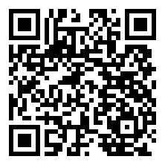  Scan to watch prep video
Questions?  Message us via the patient portal (preferred contact method)  For urgent issues, call (317) 338-9450 | 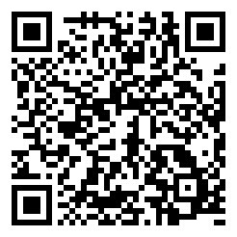  Scan for the patient portal

