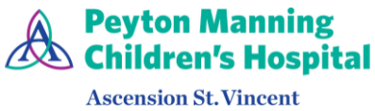 | Pediatric Gastroenterology  (317) 338-9450 | 
Colonoscopy Bowel Prep | Scan for  mobile-friendly  instructions | 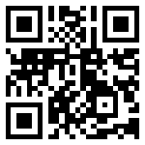
{{DOCX_HEADING}}

Procedure Location: {{LOCATION_NAME}}  {{LOCATION_ADDRESS}}  {{LOCATION_PHONE_LABEL}}: {{LOCATION_PHONE}}  {{LOCATION_ARRIVAL}} | 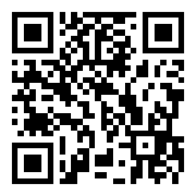  Scan for Google Maps directions
MiraLAX Prep Option
✅ Plan Ahead (pick up from the pharmacy)
• MiraLAX® (polyethylene glycol 3350) — only a small amount needed, see dose table below
• Pedialyte® or clear apple juice (for mixing the MiraLAX)
• Protective ointment (A&D, Desitin®, or Vaseline®) for the diaper area
⚖️ MiraLAX Dose by Weight
Your Child's Weight | MiraLAX Dose | How to Give
Under 5 kg (under 11 lb) | ¼ capful (about 4 g) | Mix into 2–4 oz of Pedialyte or clear apple juice
5–9 kg (11–20 lb) | ½ capful (about 8.5 g) | Mix into 4–6 oz of Pedialyte or clear apple juice
10–15 kg (22–33 lb) | ¾ capful (about 13 g) | Mix into 6–8 oz of Pedialyte or clear apple juice
Give the dose listed above once daily on each prep day as described below. If your child has trouble drinking it all at once, offer it in small sips over 1–2 hours.
📅 3 Days and 2 Days Before the Procedure
• Continue your child's normal diet
• Give one MiraLAX dose per day, mixed into juice or Pedialyte (see dose table above)

📅 Day Before the Procedure
Low-Residue Foods — until 6:00 PM
AVOID: | OK TO EAT:
Baby cereal with whole grains, oats, or added fiber | Plain white rice or white rice cereal
Raw or dried fruits and vegetables | Plain pasta (no chunky sauce)
Beans, peas, lentils | White bread or crackers
Nuts, seeds, popcorn | Strained baby foods (no skins/seeds/chunks)
Chunky table foods, meats with gristle | Plain yogurt (no fruit pieces or granola)
 | Scrambled eggs

Liquids — with these specific cutoffs
AVOID: | OK TO DRINK:
Solid foods after 6:00 PM | Formula (until 10:00 PM)
Formula after 10:00 PM | Breast milk (until 2:00 AM day of procedure)
Breast milk after 2:00 AM (day of procedure) | Pedialyte®
Anything red or purple (looks like blood) | Clear apple juice (no pulp)
 | Water
 | Clear broth (chicken or vegetable, strained)
 | Popsicles or plain gelatin (no red/purple)

Apply protective ointment to the diaper area.
⏰ Fasting Rules — Day of Procedure
These times are counted backward from your child's scheduled procedure time:
What | When to Stop
All solid and low-residue foods | 6:00 PM the day before
Formula | 10:00 PM the day before
Breast milk | 2:00 AM the day of procedure
Clear liquids (Pedialyte, water, clear juice) | 2 hours before procedure time
After the clear liquid cutoff, no food or drink. This keeps your child safe during anesthesia.
⚠️ When to Call the Doctor
• Your child won't drink, or has dehydration signs: no tears, dry mouth, or no wet diapers for 6+ hours
• Vomiting that prevents your child from keeping liquids down
• Fever, bloody stools, or severe belly pain
• You are unsure whether the prep is working
• You have questions about your child's medications
💡 Tips for Success
• Offer clear liquids frequently in small amounts — a syringe, sippy cup, or bottle may help.
• Popsicles and gelatin help keep your child hydrated. Avoid red and purple — they can look like blood.
• Expect frequent watery stools — this means the prep is working.
• Keep the diaper area well protected with ointment to prevent irritation.
Helpful Resources  🎥 Watch: How to prepare for your child's colonoscopy  Learn more about pediatric colonoscopy (GIKids.org) | 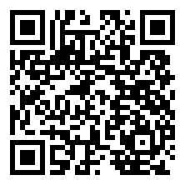  Scan to watch prep video
Questions?  Message us via the patient portal (preferred contact method)  For urgent issues, call (317) 338-9450 | 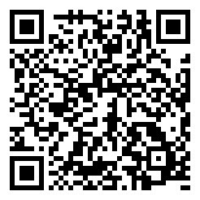  Scan for the patient portal

