 | Pediatric Gastroenterology  (317) 338-9450 | 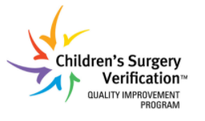
Colonoscopy Bowel Prep | Scan for  mobile-friendly  instructions | 
{{DOCX_HEADING}}
Procedure Location: {{LOCATION_NAME}}  {{LOCATION_ADDRESS}}  {{LOCATION_PHONE_LABEL}}: {{LOCATION_PHONE}}  {{LOCATION_ARRIVAL}} | 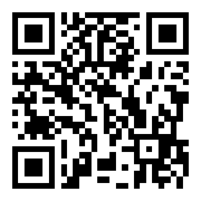  Scan for Google Maps directions
✅ Plan Ahead (buy 2 days before)
Buy these items at least 2 days before the procedure:
- {{DOCX_DULCOLAX_LONG}}
- {{DOCX_MIRALAX_SHOPPING}}
- Protective ointment (Desitin or Vaseline) for anal area comfort
About Medications:
- Tell your doctor about all medicines your child takes
- Stop ibuprofen, Motrin, Advil, Aleve and other anti-inflammatory medicines 2 days before
- Stop iron or anti-diarrhea medicines (Imodium, Kaopectate) 7 days before
- Give routine morning medicines with a small sip of water unless told otherwise
📅 3 Days Before — Low-Residue Diet
AVOID: | OK TO EAT:
- Whole grains, nuts, seeds  - Raw fruits and vegetables  - Corn, beans, popcorn | - White rice, pasta, potatoes (no skin)  - Bananas, melons, cooked veggies  - Eggs, chicken, fish  - Yogurt, pudding
📅 1 Day Before — Low-Residue Through Lunch
After 2:00 PM — Clear Liquids Only
AVOID: | OK TO EAT/DRINK:
- Any solid food  - Dairy (milk, yogurt, ice cream)  - Juices with pulp  - Anything red or purple | - Water, apple juice, white grape juice  - Lemonade, clear soda, clear broth  - Popsicles, plain Jell-O, tea/coffee without milk

💊 Prep Medicine (afternoon/evening):
- At bedtime, 2 nights before procedure — Give Dulcolax tablets ({{DOCX_DULCOLAX_BEDTIME_LONG}}) with a sip of water
- {{DOCX_DULCOLAX_DAYOF_TIME}} — Give Dulcolax tablets ({{DOCX_DULCOLAX_DAYOF_LONG}}) with a sip of water
- {{DOCX_MIRALAX_TIME}} — Start MiraLAX solution ({{DOCX_MIRALAX_5PM}} — shake well, refrigerate beforehand)
- Have your child drink {{DOCX_DRINK_CUP}} every 30 minutes until finished
- Expect diarrhea — this is normal and means the prep is working
- Keep giving clear liquids throughout the day

📅 Day of Procedure
- Nothing to eat or drink 8 hours before the procedure
- Up to 2 hours before, your child may have {{DOCX_DRINK_CUP}} of clear liquid
- Bring comfort items for your child (toy, blanket, tablet, etc.)
⚠️ If the prep is not followed exactly, the colonoscopy may be delayed or canceled

⚠️ Was your child prescribed a pre-cleanout for constipation?
If your doctor told you to start a pre-cleanout, here is what to do: Give your child MiraLAX daily — {{DOCX_PRECLEANOUT}} — for 3–5 days before starting the regular prep instructions above.
If you are not sure whether your child needs a pre-cleanout, send us a message through the patient portal or call the office.

Helpful Resources  🎥 Watch: How to prepare for your child's colonoscopy  Learn more about pediatric colonoscopy (GIKids.org) | 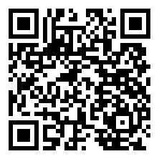  Scan to watch prep video

Questions?  Message us via the patient portal (preferred contact method)  For urgent issues, call (317) 338-9450 | 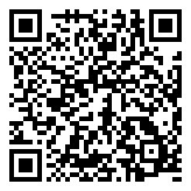  Scan for the patient portal
🍎 Low-Residue Diet — Sample Meals
These are meal ideas for the low-residue diet (also called "white" diet). Continue this diet for the 3 days before the procedure, through lunch the day before. After 2:00 PM the day before, switch to clear liquids only — no dairy.
Breakfast (morning)
• Scrambled eggs
• White toast with butter
• Banana
• Yogurt (no seeds or berries)
• Apple juice
Lunch (~noon)
• Plain chicken sandwich on white bread (no veggies)
• Mac and cheese
• White rice with chicken
• Plain pasta
• Applesauce
• Vanilla pudding
After lunch (~2:00 PM onward)
• Clear liquids only (see page 2 for allowed drinks)
• No more dairy — milk, yogurt, ice cream, etc.

