**DHCP Server (Dynamic Host Configuration Protocol)**

DHCP is used to allocate the following automatically…

1. IP
2. Mask
3. Router Address (gateway)
4. DNS Address
5. Domain name

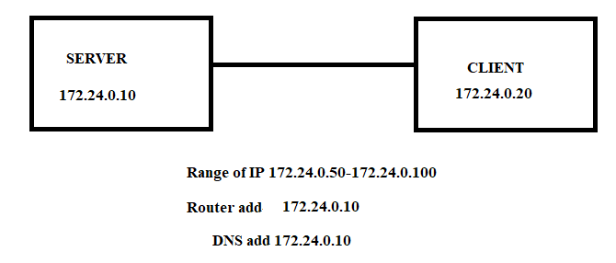

**To install the DHCP in Linux:**

Install the package dhcpd

Now go to /usr/share/doc/dhcp-4.1.1/dhcpd.conf.sample and copy it to and rename

/etc/dhcp/dhcpd.conf

And edit the file at # A slightly different configuration for an internal subnet.

subnet 172.24.0.0 netmask 255.255.0.0 {

range 172.24.0.50 172.24.0.100;

option domain-name-servers 172.24.0.10;

To check the syntax of the dhcpd file

|dhcpd -f

And turn on the service by |service dhcpd start

To make the settings permanent |chkconfig dhcpd on

To configure DHCP type |system-config-network and select DHCP

check route type |using route -n

to give specific clients special privilege i.e. whatso ever it may it should be assigned with the IP irrespectively of the IP Pool exhaustion

change in the file dhcpd.conf and edit at host server1 {

and replace the MAC address with the specified machine MAC

fixed-address 172.24.0.70