**Cloud Applications**

* IAAS (Infrastructure as a service cloud)
* PAAS (Platform as a service cloud)
* SAAS (Storage as a service cloud)
* SAAS (Software as a service cloud)

**Remote Management Protocols**

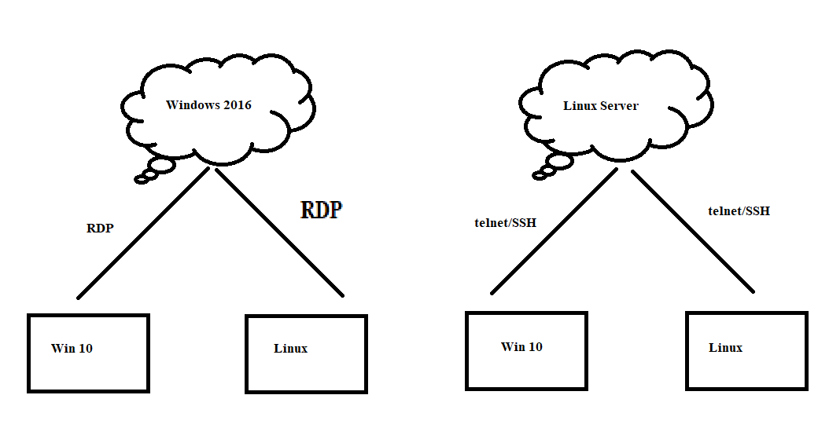

RDP- Remote Desktop Protocol

Telnet- Telecommunication Protocol

SSH- Secure Shell

**Installing windows server 2016**

* while installing windows server 2016 select option datacenter evaluation (desktop mode) or else it will get installed in command line mode.
* Turn of the firewall and give it the IP
* Go to server management software in start
* Click on add roles and features
* Select server from server pool
* Select remote desktop services
* In roles and services 🡪 select remote desktop licensing and remote desktop session host.

Now in client windows machine, open remote desktop client and insert IP and password respectively.

To access a Linux server remotely using windows you need “putty software”.

**Accessing Linux remotely…**

|yum install telnet*

|chkconfig telnet on

telnet cannot be used to login through root user.

Accessing remote machine using SSH and root

|ssh root@<dest IP> ,and insert password

Download WinSCP(drag and drop for linux) and install it on Host OS where the communication has to be done with virtual machine (in virtual machine select Dynamic IP option) connect with external OS and enjoy.

Connecting pendrive with VM…

|fdisk -l

Connect it and select the device to be connected, then mount /dev/sdb/ /media