**XEN Hypervisor**

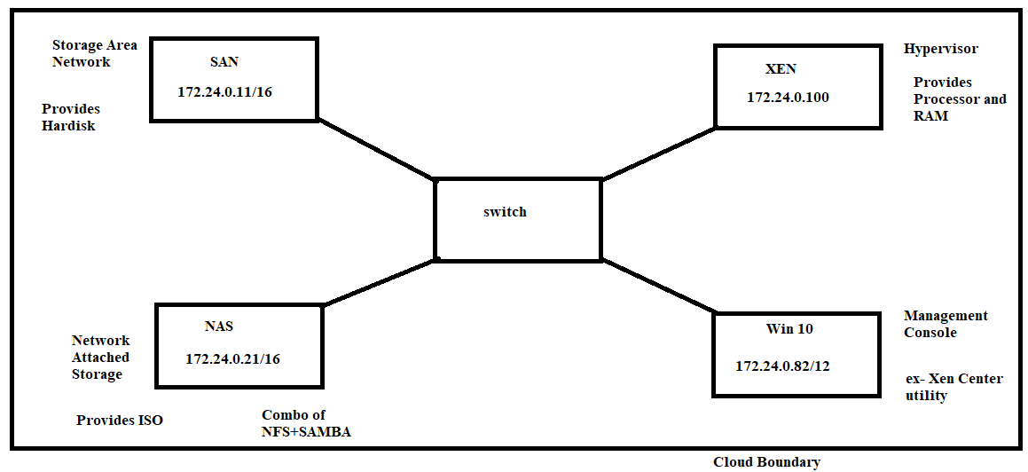

IAAS Cloud Implementation

Virtualize Intel VT-x/ET or AMD-V/RVI to be selected in allotting processor to

Copy the path and paste it to explorer and paste find .vmx file of of the machine and edit it to vcpu.hotadd=False rather than true

To permanenety mount nfs do entry in /etc/fstab at last

/dev/sdb1 /iso ext4 defaults 0 0