To convert the ui into CUI one will need to tweak the file in root>etc>inittab

Just type ‘3’ in defaults

TO see the list of user into the linux

Just go through the file etc>passwd

|  |  |  |  |  |  |  |
| --- | --- | --- | --- | --- | --- | --- |
| Username say ‘vikalp’ | Placeholder  Password undisclosed ‘x’ | Uid generally first user id starts with 500 and then iterates | Gid group id | comment | Home directory | Shell default BASH |

Root user always had uid 0i

Since the passwd file was availed to general user therefore the details of passwords were moved to etc>Shadow file

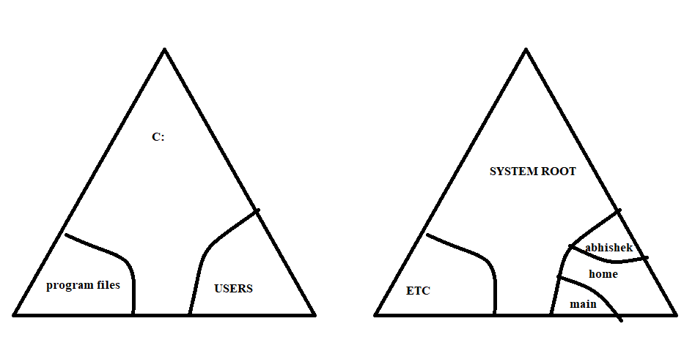

* .rmdir <empty directory name>
* .rm -r <dir name which is not empty>
* .rm -rf <dir name which has multiple files and needs to be forcefully delete>
* To copy the directory with all the hidden files

Cp -r cu/. <new file name>

* To copy the directory with excluding the hidden files

Cp -r cu/* <new file name>

[alias c=cal] now c will replace the cal command in terminal

[alias- commands actually fetches all the alias which are currently active in the system]

-i flag stands for interactive mode, which actually asks the user the confirmation whether to delete the file or not

In root -i is default along with rm command which actually asks the confirmation.

ls -a is used to see the hidden files

temporary alias

the alias which is declared by the alias keyword on terminal is temporary it gets deleted as soon as you log off the system

permanent alias

* The user specific alias which is declared by tweaking the users home directory hidden file i.e. .bashrc and .bash_profile
* The alias which is declared under the root etc file bashrc and profile is alias for all the users and that too permanent

………………………

[who] it tells total number of users

[wc] tells the word count

| symbol is also called redirection symbol

Chaining of commands

[who |wc -l >f3] this writes the no of users of the system to the file f3