## Introductory Econometrics: Chapter 1

## Author: J M Woolridge

## R Code Compilation by RJ Neel

# End of Chapter 1 exercises (Page 39)

### Computer Exercises

**C1: Use the data in WAGE1 for this exercise**

## Computer Exercise C1  
library(wooldridge) #load the Woolridge Package  
wage1  
?wage1 #Description of the dataset

## starting httpd help server ... done

head(wage1) #First 6 rows. Easy to view  
ncol(wage1) # No of rows  
nrow(wage1) #No. of columns

**(i) Find the average education level in the sample. What are the lowest and highest years of education?**

*Solution*

summary(wage1$educ)

## Min. 1st Qu. Median Mean 3rd Qu. Max.   
## 0.00 12.00 12.00 12.56 14.00 18.00

#Alternatively  
mean(wage1$educ) #avg education level

## [1] 12.56274

min(wage1$educ) #min education leve

## [1] 0

max(wage1$educ) #max

## [1] 18

**(ii) Find the average hourly wage in the sample. Does it seem high or low?**

*Solution*

mean(wage1$wage) #Gives you the average hourly wage

## [1] 5.896103

summary(wage1$wage) #Wage appears to be low

## Min. 1st Qu. Median Mean 3rd Qu. Max.   
## 0.530 3.330 4.650 5.896 6.880 24.980

hist(wage1$wage) #Clearly skewed towards right

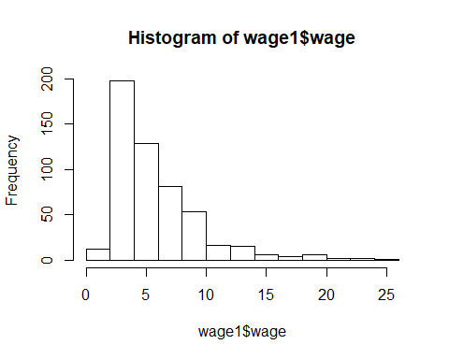

**(iii) The wage data are reported in 1976 dollars. Using the Internet or a printed source, find the Consumer Price Index (CPI) for the years 1976 and 2013.**

*Solution* Using Table B-60 in the 2004 Economic Report of the President, the CPI was 56.9 in 1976 and 233 in 2013.

**(iv) Use the CPI values from part (iii) to find the average hourly wage in 2013 dollars. Now does the average hourly wage seem reasonable?**

*Solution* To convert 1976 dollars into 2013 dollars, we use the ratio of the CPIs, which is 233/56.9 ≈ 4.09. Therefore, the average hourly wage in 2013 dollars is roughly 4.09($\5.90) ≈ $\24.13, which is a reasonable figure.

**(v) How many women are in the sample? How many men?**

*Solution*

head(wage1)

## wage educ exper tenure nonwhite female married numdep smsa northcen south  
## 1 3.10 11 2 0 0 1 0 2 1 0 0  
## 2 3.24 12 22 2 0 1 1 3 1 0 0  
## 3 3.00 11 2 0 0 0 0 2 0 0 0  
## 4 6.00 8 44 28 0 0 1 0 1 0 0  
## 5 5.30 12 7 2 0 0 1 1 0 0 0  
## 6 8.75 16 9 8 0 0 1 0 1 0 0  
## west construc ndurman trcommpu trade services profserv profocc clerocc  
## 1 1 0 0 0 0 0 0 0 0  
## 2 1 0 0 0 0 1 0 0 0  
## 3 1 0 0 0 1 0 0 0 0  
## 4 1 0 0 0 0 0 0 0 1  
## 5 1 0 0 0 0 0 0 0 0  
## 6 1 0 0 0 0 0 1 1 0  
## servocc lwage expersq tenursq  
## 1 0 1.131402 4 0  
## 2 1 1.175573 484 4  
## 3 0 1.098612 4 0  
## 4 0 1.791759 1936 784  
## 5 0 1.667707 49 4  
## 6 0 2.169054 81 64

#Notice the female column is a binary variable implying 1 for female and 0 for male requring us to proceed with 'dplyr'  
library(dplyr)

##   
## Attaching package: 'dplyr'

## The following objects are masked from 'package:stats':  
##   
## filter, lag

## The following objects are masked from 'package:base':  
##   
## intersect, setdiff, setequal, union

w=nrow(wage1 %>% group_by(female) %>% filter(female=='1'))  
w

## [1] 252

m=nrow(wage1)-w  
m

## [1] 274

End of Computer Exercise 1

**C2: Use the data in BWGHT to answer this question**

1. How many women are in the sample, and how many report smoking during pregnancy?

*Solution*

#Note: This data set contains all women  
nrow(bwght) #No of women smoking

## [1] 1388

1. What is the average number of cigarettes smoked per day? Is the average a good measure of the “typical” woman in this case? Explain.

*Solution*

mean(bwght$cigs)

## [1] 2.087176

summary(bwght$cigs)

## Min. 1st Qu. Median Mean 3rd Qu. Max.   
## 0.000 0.000 0.000 2.087 0.000 50.000

hist(bwght$cigs)

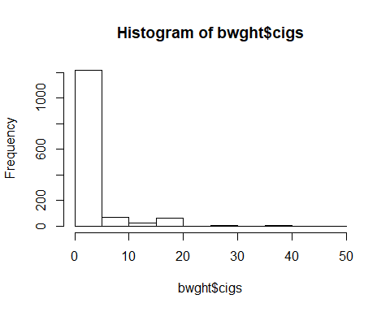

#Based on the histogram and range it appears to be a good measure.

1. Among women who smoked during pregnancy, what is the average number of cigarettes smoked per day? How does this compare with your answer from part (ii), and why?

avg_all=mean(bwght$cigs)  
avg_all

## [1] 2.087176

library(dplyr)  
nrow(bwght %>% group_by(cigs) %>% filter(cigs=='0'))

## [1] 1176

s=(bwght %>% group_by(cigs) %>% filter(cigs>'0'))  
avg_s=mean(s$cigs)  
avg_s

## [1] 13.66509

hist(s$cigs, xlab='Pregnant Women Smokers')

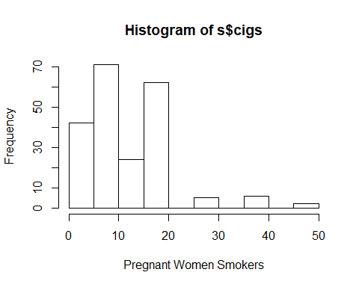

#It markedly differs from the privious average by about 11 units.

**C3 The data in MEAP01 are for the state of Michigan in the year 2001. Use these data to answer the following questions.**

head(meap01)

## dcode bcode math4 read4 lunch enroll expend exppp lenroll lexpend  
## 1 1010 4937 83.3 77.8 40.60 468 2747475 5870.673 6.148468 14.82619  
## 2 2070 597 90.3 82.3 27.10 679 1505772 2217.632 6.520621 14.22482  
## 3 2080 4860 61.9 71.4 41.75 400 2121871 5304.678 5.991465 14.56781  
## 4 3010 790 85.7 60.0 12.75 251 1211034 4824.836 5.525453 14.00698  
## 5 3010 1403 77.3 59.1 17.08 439 1913501 4358.772 6.084499 14.46445  
## 6 3010 4056 85.2 67.0 23.17 561 2637483 4701.396 6.329721 14.78534  
## lexppp  
## 1 8.677725  
## 2 7.704195  
## 3 8.576344  
## 4 8.481532  
## 5 8.379946  
## 6 8.455615

**(i) Find the largest and smallest values of math4. Does the range make sense? Explain.**

*Solution*

head(meap01)

## dcode bcode math4 read4 lunch enroll expend exppp lenroll lexpend  
## 1 1010 4937 83.3 77.8 40.60 468 2747475 5870.673 6.148468 14.82619  
## 2 2070 597 90.3 82.3 27.10 679 1505772 2217.632 6.520621 14.22482  
## 3 2080 4860 61.9 71.4 41.75 400 2121871 5304.678 5.991465 14.56781  
## 4 3010 790 85.7 60.0 12.75 251 1211034 4824.836 5.525453 14.00698  
## 5 3010 1403 77.3 59.1 17.08 439 1913501 4358.772 6.084499 14.46445  
## 6 3010 4056 85.2 67.0 23.17 561 2637483 4701.396 6.329721 14.78534  
## lexppp  
## 1 8.677725  
## 2 7.704195  
## 3 8.576344  
## 4 8.481532  
## 5 8.379946  
## 6 8.455615

summary(meap01$math4) # It makes sense as percentage is between 0 and 100

## Min. 1st Qu. Median Mean 3rd Qu. Max.   
## 0.00 61.60 76.40 71.91 87.00 100.00

**(ii) How many schools have a perfect pass rate on the math test? What percentage is this of the total sample?**

*Solution*

library(dplyr)  
passrate100=nrow(meap01 %>% group_by(math4) %>% filter(math4=='100'))  
passrate100

## [1] 38

samplesize=nrow(meap01)  
samplesize

## [1] 1823

percent_passrate=round((passrate100/samplesize)*100,2)  
percent_passrate

## [1] 2.08

**(iii) How many schools have math pass rates of exactly 50%?**

*Solution*

library(dplyr)  
  
nrow(meap01 %>% group_by(math4) %>% filter(math4=='50'))

## [1] 17

**(iv) Compare the average pass rates for the math and reading scores. Which test is harder to pass?**

*Solution*

pass_m=mean(meap01$math4)  
pass_m

## [1] 71.909

pass_r=mean(meap01$read4)  
pass_r

## [1] 60.06188

#Cleary Reading is much more difficult to pass

**(v) Find the correlation between math4 and read4. What do you conclude?**

*Solution*

cor(meap01$math4,meap01$read4)

## [1] 0.8427281

library(ggplot2)  
ggplot(data=meap01,aes(x=meap01$math4,y=meap01$read4))+geom_point(col='salmon')+ggtitle("Scatterplot: Maths vs Reading")+xlab("Math Score")+ylab("Reading Score")

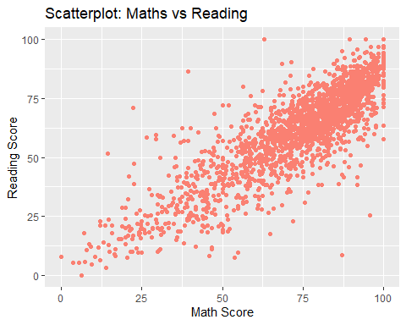

#It is strongly positive

**(vi) The variable exppp is expenditure per pupil. Find the average of exppp along with its standard deviation. Would you say there is wide variation in per pupil spending?**

mean(meap01$exppp)

## [1] 5194.865

sd(meap01$exppp)

## [1] 1091.89

summary(meap01$exppp)

## Min. 1st Qu. Median Mean 3rd Qu. Max.   
## 1207 4502 5078 5195 5767 11958

library(ggplot2)  
ggplot(data=meap01,aes(x=meap01$exppp))+geom_histogram(col='dark grey',fill='white')+ggtitle("Histogram: Expenditure per Pupil")+xlab("Expenditure")+ylab("Frequency")

## `stat_bin()` using `bins = 30`. Pick better value with `binwidth`.

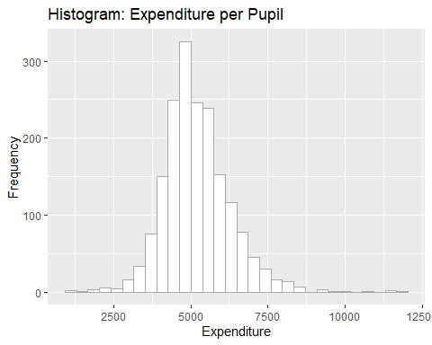

#Considering Min=1207 and Max=11958, It is significantly wide

**(vii) Suppose School A spends $6,000 per student and School B spends $5,500 per student. By what percentage does School A’s spending exceed School B’s? Compare this to 100 · [log(6,000) – log(5,500)], which is the approximation percentage difference based on the difference in the natural logs. (See Section A.4 in Appendix A.)**

*Solution*

round((log(6000)-log(5500))*100,2) # Gives the Percentage

## [1] 8.7

round(((6000-5500)/ 5500)*100,2)

## [1] 9.09

**C4: The data in JTRAIN2 come from a job training experiment conducted for low-income men during 1976–1977; see Lalonde (1986).**

head(jtrain2)

## train age educ black hisp married nodegree mosinex re74 re75 re78 unem74  
## 1 1 37 11 1 0 1 1 13 0 0 9.93005 1  
## 2 1 22 9 0 1 0 1 13 0 0 3.59589 1  
## 3 1 30 12 1 0 0 0 13 0 0 24.90950 1  
## 4 1 27 11 1 0 0 1 13 0 0 7.50615 1  
## 5 1 33 8 1 0 0 1 13 0 0 0.28979 1  
## 6 1 22 9 1 0 0 1 13 0 0 4.05649 1  
## unem75 unem78 lre74 lre75 lre78 agesq mostrn  
## 1 1 0 0 0 2.295566 1369 13  
## 2 1 0 0 0 1.279792 484 13  
## 3 1 0 0 0 3.215249 900 13  
## 4 1 0 0 0 2.015723 729 13  
## 5 1 0 0 0 -1.238599 1089 13  
## 6 1 0 0 0 1.400318 484 13

?jtrain2

**(i) Use the indicator variable train to determine the fraction of men receiving job training.**

*Solution*

tr=nrow(jtrain2 %>% group_by(train) %>% filter(train=='1'))  
tr

## [1] 185

total=nrow(jtrain2)  
total

## [1] 445

percent_trained=round((tr/total)*100,2)  
percent_trained

## [1] 41.57

**(ii) The variable re78 is earnings from 1978, measured in thousands of 1982 dollars. Find the averages of re78 for the sample of men receiving job training and the sample not receiving job training. Is the difference economically large?**

*Solution*

train78=jtrain2 %>% select(re78,train) %>% group_by(re78) %>% filter(train=='1')  
train78

## # A tibble: 185 x 2  
## # Groups: re78 [141]  
## re78 train  
## <dbl> <int>  
## 1 9.93 1  
## 2 3.60 1  
## 3 24.9 1  
## 4 7.51 1  
## 5 0.290 1  
## 6 4.06 1  
## 7 0 1  
## 8 8.47 1  
## 9 2.16 1  
## 10 12.4 1  
## # ... with 175 more rows

mean(train78$re78)

## [1] 6.349145

untrain78=jtrain2 %>% select(re78,train) %>% group_by(re78) %>% filter(train=='0')  
untrain78

## # A tibble: 260 x 2  
## # Groups: re78 [169]  
## re78 train  
## <dbl> <int>  
## 1 0 0  
## 2 12.4 0  
## 3 0 0  
## 4 10.7 0  
## 5 11.8 0  
## 6 9.23 0  
## 7 10.6 0  
## 8 6.04 0  
## 9 3.88 0  
## 10 0 0  
## # ... with 250 more rows

mean(untrain78$re78)

## [1] 4.554802

library(sm)

## Package 'sm', version 2.2-5.6: type help(sm) for summary information

ab=c(train78$re78,untrain78$re78)  
hist(train78$re78)

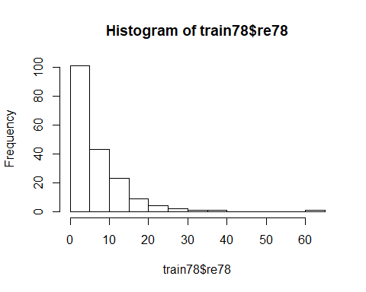

hist(untrain78$re78)

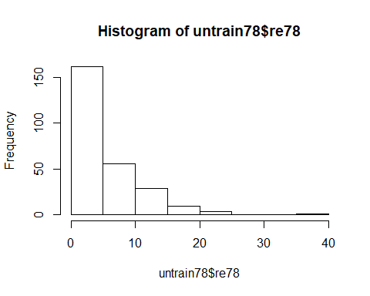

g=rep(1:2, rep(100,2))  
sm.density.compare(ab,g, xlab="Earnings, 1978",model="equal") # plot densities

## Warning in cbind(X, group): number of rows of result is not a multiple of vector  
## length (arg 2)

##   
## Test of equal densities: p-value = 0.95

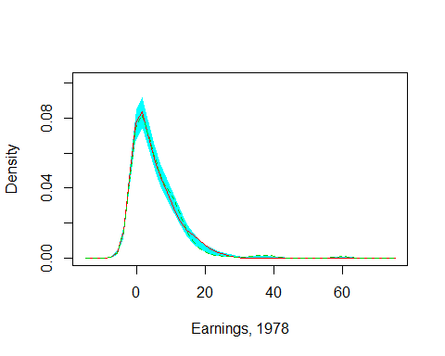

#Mean for Trained worker is 6.35 and Untrained is 4.55. Significant Difference

**(iii) The variable unem78 is an indicator of whether a man is unemployed or not in 1978. What fraction of the men who received job training are unemployed? What about for men who did not receive job training? Comment on the difference.**

*Solution*

train_uemp=jtrain2 %>% select(unem78,train) %>% group_by(train) %>% filter(train=='1' & unem78=='1')  
tu=nrow(train_uemp)  
tu

## [1] 45

tot_train=nrow(jtrain2 %>% select(unem78,train) %>% group_by(train) %>% filter(train=='1'))  
tot_train

## [1] 185

round((tu/tot_train)*100,2) #Percentage Unemployed with Training

## [1] 24.32

untrain_unemp=jtrain2 %>% select(unem78,train) %>% group_by(train) %>% filter(train=='0' & unem78=='1')  
utue=nrow(untrain_unemp)  
utue

## [1] 92

tot_untrain=nrow(jtrain2 %>% select(unem78,train) %>% group_by(train) %>% filter(train=='0'))  
  
round((utue/tot_untrain)*100,2) #Percentage Unemployed without Training

## [1] 35.38

#Unemployment figure among untrained individuals is much larger than trained

**(iv) From parts (ii) and (iii), does it appear that the job training program was effective? What would make our conclusions more convincing?**

*Solution* The differences in earnings and unemployment rates suggest the training program had strong, positive effects. Our conclusions about economic significance would be stronger if we could also establish statistical significance

*End of C4*

**C5 The data in FERTIL2 were collected on women living in the Republic of Botswana in 1988. The variable children refers to the number of living children. The variable electric is a binary indicator equal to one if the woman’s home has electricity, and zero if not.**

head(fertil2)

## mnthborn yearborn age electric radio tv bicycle educ ceb agefbrth children  
## 1 5 64 24 1 1 1 1 12 0 NA 0  
## 2 1 56 32 1 1 1 1 13 3 25 3  
## 3 7 58 30 1 0 0 0 5 1 27 1  
## 4 11 45 42 1 0 1 0 4 3 17 2  
## 5 5 45 43 1 1 1 1 11 2 24 2  
## 6 8 52 36 1 0 0 0 7 1 26 1  
## knowmeth usemeth monthfm yearfm agefm idlnchld heduc agesq urban urb_educ  
## 1 1 0 NA NA NA 2 NA 576 1 12  
## 2 1 1 11 80 24 3 12 1024 1 13  
## 3 1 0 6 83 24 5 7 900 1 5  
## 4 1 0 1 61 15 3 11 1764 1 4  
## 5 1 1 3 66 20 2 14 1849 1 11  
## 6 1 1 11 76 24 4 9 1296 1 7  
## spirit protest catholic frsthalf educ0 evermarr  
## 1 0 0 0 1 0 0  
## 2 0 0 0 1 0 1  
## 3 1 0 0 0 0 1  
## 4 0 0 0 0 0 1  
## 5 0 1 0 1 0 1  
## 6 0 0 0 0 0 1

?fertil2

**(i) Find the smallest and largest values of children in the sample. What is the average of children?**

*Solution*

summary(fertil2$children)

## Min. 1st Qu. Median Mean 3rd Qu. Max.   
## 0.000 0.000 2.000 2.268 4.000 13.000

**(ii) What percentage of women have electricity in the home?**

*Solution*

library(dplyr)  
tot_women=nrow(fertil2)  
tot_women

## [1] 4361

elec_women=nrow(fertil2 %>% filter(electric=="1"))  
elec_women

## [1] 611

perc_with_elect=round((elec_women/tot_women)*100,2)  
perc_with_elect

## [1] 14.01

**(iii) Compute the average of children for those without electricity and do the same for those with electricity. Comment on what you find.**

*Solution*

library(dplyr)  
elect_child=fertil2 %>% select(children,electric) %>% filter(electric==1)  
  
avg_chil_with_elec=mean(elect_child$children)   
  
avg_chil_with_elec #Average Children in Electricy households

## [1] 1.898527

non_elect_child=fertil2 %>% select(children,electric) %>% filter(electric==0)  
  
avg_chil_with_no_elec=mean(non_elect_child$children)   
  
avg_chil_with_no_elec #Average Children in Non Electricy households

## [1] 2.327729

#Clearly the electricity households have fewer children

1. From part (iii), can you infer that having electricity “causes” women to have fewer children? Explain.

*Solution* Not directly byt may be influency of electricity devices like TV and radio are more likely to promote fewer children and more liberal thoughts.

**C6 Use the data in COUNTYMURDERS to answer this question. Use only the year 1996. The variable murders is the number of murders reported in the county. The variable execs is the number of executions that took place of people sentenced to death in the given county. Most states in the United States have the death penalty, but several do not.**

head(countymurders)

## arrests countyid density popul perc1019 perc2029 percblack percmale  
## 1 2 1001 54.05 32216 20.63 15.28 22.33 40.25  
## 2 3 1001 53.66 31984 20.19 15.55 22.07 40.36  
## 3 2 1001 53.75 32036 19.66 15.73 21.80 40.42  
## 4 7 1001 53.78 32056 19.10 15.88 21.53 40.47  
## 5 3 1001 53.91 32128 18.54 15.92 21.26 40.51  
## 6 1 1001 54.11 32248 18.06 15.87 20.96 40.45  
## rpcincmaint rpcpersinc rpcunemins year murders murdrate arrestrate statefips  
## 1 167.67 8780.80 29.16 1980 2 0.6208096 0.6208095 1  
## 2 167.99 8232.80 43.92 1981 1 0.3126563 0.9379690 1  
## 3 166.63 8327.61 71.41 1982 3 0.9364465 0.6242977 1  
## 4 176.53 8545.55 72.22 1983 7 2.1836790 2.1836790 1  
## 5 166.25 8965.16 40.36 1984 2 0.6225100 0.9337650 1  
## 6 153.12 9254.02 44.54 1985 2 0.6201935 0.3100968 1  
## countyfips execs lpopul execrate  
## 1 1 0 10.38022 0  
## 2 1 0 10.37299 0  
## 3 1 0 10.37462 0  
## 4 1 0 10.37524 0  
## 5 1 0 10.37748 0  
## 6 1 0 10.38121 0

?countymurders  
#This is a Panel dataset

**(i) How many counties are there in the data set? Of these, how many have zero murders? What percentage of counties have zero executions? (Remember, use only the 1996 data.)**

*Solution*

library(dplyr)  
county96=countymurders %>% select(countyid,year,murdrate,execs) %>% filter(year=="1996")  
nrow(county96)

## [1] 2197

county96_0murd=countymurders %>% select(countyid,year,murdrate,execs) %>% filter(year=="1996" & murdrate=="0")  
nrow(county96_0murd) #Counties with Zero murders

## [1] 1051

county96_0exec=countymurders %>% select(countyid,year,murdrate,execs) %>% filter(year=="1996" & execs=="0")  
nrow(county96_0exec) #Counties with Zero executions

## [1] 2166

perc_county_0exe=round(nrow(county96_0exec)/nrow(county96),2)*100  
perc_county_0exe #Percentage of Counties with zero exexutions

## [1] 99

**(ii) What is the largest number of murders? What is the largest number of executions? Why is the average number of executions so small?**

*Solution*

library(dplyr)  
county96 %>% filter(murdrate==max(county96$murdrate))

## countyid year murdrate execs  
## 1 48033 1996 12.39157 0

max(county96$murdrate) #Maximum Murder rate

## [1] 12.39157

max(county96$execs) #Maximum Executions

## [1] 3

mean(county96$execs) #The mean of execution is so small because many counties do not practice death penalty and many have no executions

## [1] 0.01593081

**(iii) Compute the correlation coefficient between murders and execs and describe what you find.**

*Solution*

cor(county96$murdrate,county96$execs)

## [1] 0.08567281

library(ggplot2)  
ggplot(data=county96,aes(x=murdrate,y=execs))+geom_point(col='red')+ggtitle("Scatterplot: Murder rates vs Executions")+xlab("Murders")+ylab("Executions")

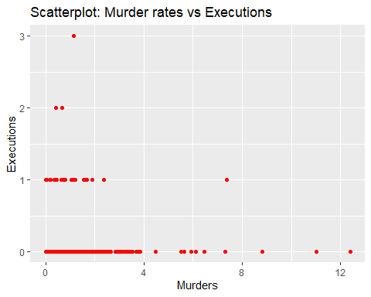

**(iv) You should have computed a positive correlation in part (iii). Do you think that more executions cause more murders to occur? What might explain the positive correlation?**

*Solution* It is a very weak positive correlation. We would expect the two to have negative relationship. Here the data is influenced by the fact that many states have outlawed death penalty

*End of C6*

**C7 The data set in ALCOHOL contains information on a sample of men in the United States. Two key variables are self-reported employment status and alcohol abuse (along with many other variables). The variables employ and abuse are both binary, or indicator, variables: they take on only the values zero and one.**

head(alcohol)

## abuse status unemrate age educ married famsize white exhealth vghealth  
## 1 1 1 4.0 50 4 1 1 1 0 0  
## 2 0 3 4.0 37 12 1 5 1 0 0  
## 3 0 3 4.0 53 9 1 3 1 1 0  
## 4 0 3 3.3 59 11 1 1 1 1 0  
## 5 0 3 3.3 43 10 1 1 1 1 0  
## 6 0 3 3.3 38 10 1 1 1 1 0  
## goodhealth fairhealth northeast midwest south centcity outercity qrt1 qrt2  
## 1 0 0 0 1 0 0 0 1 0  
## 2 1 0 0 1 0 0 0 1 0  
## 3 0 0 0 1 0 0 0 1 0  
## 4 0 0 1 0 0 1 0 1 0  
## 5 0 0 1 0 0 1 0 1 0  
## 6 0 0 1 0 0 1 0 1 0  
## qrt3 beertax cigtax ethanol mothalc fathalc livealc inwf employ agesq  
## 1 0 0.334 38 2.03946 0 0 0 0 0 2500  
## 2 0 0.334 38 2.03946 0 0 0 1 1 1369  
## 3 0 0.334 38 2.03946 0 0 0 1 1 2809  
## 4 0 0.240 26 2.44998 0 0 0 1 1 3481  
## 5 0 0.240 26 2.44998 0 1 1 1 1 1849  
## 6 0 0.240 26 2.44998 0 0 0 1 1 1444  
## beertaxsq cigtaxsq ethanolsq educsq  
## 1 0.111556 1444 4.159397 16  
## 2 0.111556 1444 4.159397 144  
## 3 0.111556 1444 4.159397 81  
## 4 0.057600 676 6.002402 121  
## 5 0.057600 676 6.002402 100  
## 6 0.057600 676 6.002402 100

?alcohol  
#Cross sectional data set

**(i) What is percentage of the men in the sample report abusing alcohol? What is the employment rate?**

**Solution**

ab=nrow(alcohol %>% filter(abuse=="1"))  
tot=nrow(alcohol)  
  
p_ab=(round((ab/tot)*100,2))  
p_ab #Percentage of men reporting alcohol abuse

## [1] 9.92

employed=nrow(alcohol %>% filter(status=="3"))  
employed

## [1] 8822

employment_rate=(round((employed/tot)*100,2))  
employment_rate #Employment rate in the sample

## [1] 89.82

**(ii) Consider the group of men who abuse alcohol. What is the employment rate?**

**Solution**

ab_tot=nrow(alcohol %>% filter(abuse=="1"))  
ab_tot

## [1] 974

ab_employed=nrow(alcohol %>% filter(abuse=='1' & status=="3"))  
ab_employed

## [1] 850

ab_employment_rate=(round((ab_employed/ab_tot)*100,2))  
ab_employment_rate #Employment rate among alcohol abuses in the sample

## [1] 87.27

**(iii) What is the employment rate for the group of men who do not abuse alcohol?**

no_ab_tot=nrow(alcohol %>% filter(abuse=="0"))  
no_ab_tot

## [1] 8848

no_ab_employed=nrow(alcohol %>% filter(abuse=='0' & status=="3"))  
no_ab_employed

## [1] 7972

no_ab_employment_rate=(round((no_ab_employed/no_ab_tot)*100,2))  
no_ab_employment_rate #Employment rate among alcohol abuses in the sample

## [1] 90.1

1. Discuss the difference in your answers to parts (ii) and (iii). Does this allow you to conclude that alcohol abuse causes unemployment?

*Solution* There is hardly a difference of around 3%. Not much significant to make any conclusion with reasonabale certainty.