Web Platform for Digital Deployment of Virtual Servers

# Motivation and rationale

## Abstract

In 2016 there are currently three billion people that have access to the internet. The website google.com handles between two and three billion search queries per day (InternetLiveStats 2016). Handling so many requests on daily basis requires full usage of the available hardware. Part of Google's ability to scale and be performant is due to the emergence of cloud infrastructure. The topic of the paper is tightly connected with one of the building blocks of cloud computing, which is virtualisation.

The term virtualisation is defined as the ability of one piece of hardware to run multiple operating systems (Techopedia Inc. 2014). In this paper, a virtual machine, or an instance, is an operating system that runs on top of a “physical” operating system. The “physical” operating system is often referred to as the “host” system. Creating a platform that uses such technology enables an organisation to quickly set up any environment (operating system) that can be used in a variety of cases. Virtualisation can help solve the following problems.

## Problem

These days, it is a common place for a company to buy a high performing computer per employee which requires physical access to perform repairs and maintenance. Physical systems are also more difficult to manage due to their non-central distribution. Another downside is hardware utilisation, a case where one machine uses maximum resources but another one is idle. Virtualisation technology is integrated into modern Intel processor chips allows a server to run numerous operating systems concurrently. This helps with performance, as a virtual machine can be configured on the fly to use flexible amount of resources or even grab flexible resources from a shared pool. This technology also allows for easy server migration, a physical machine cannot be moved within couple of minutes to a different continent. Physical infrastructure is also prone to hardware-related bugs, as a distributed software solution might not have been tested on all possible computing nodes that run it.

## Approach

The project aims to utilise open-source virtualisation technology and make the process of managing and creating virtual machines automated through a web interface. A system manager should be able to open a website, fill in a web form with enough information about the desired operating system, click a button and create it. The manager should also be able to obtain and generate credentials for that machine, as well as mark common packages for installation on it. The solution should also show performance statistics and allow for network port management. These features, alongside the benefits of virtualisation should create a strong and secure infrastructure for many applications, from virtual office workstation, to server testing and deployment.

# Aim

Give developers a platform for easy deployment, management and monitoring of virtual servers

# Objectives

1. **Deploy a virtual machine of the user's choice through shell scripts**  
   The main feature of the solution is the deployment of the virtual machine instances. The following will be achieved by using Oracle's virtualisation documentation for Virtualbox and the shell scripting language and the automation tool chef.
2. **Configure firewall settings**  
   Will be achieved through the virtualisation technology's API. Will add extra security layer to the guest operating system.
3. **Allow console access and set up authentication credentials (SSH keys) for the instances**

The main usage of the application is to obtain a shell access to the virtual machine

1. **Monitor disk/CPU usage of the virtual instances**
2. **Allow the user to install software from a predefined list**
3. **Create a website that will manage and create the machines on the behalf of the user**

# Background

**Paper:** Menasc´e, D. A. (2005). VIRTUALIZATION: CONCEPTS, APPLICATIONS, AND PERFORMANCE MODELING  
**Description:** The document provides brief description of virtualisation, explains performance modelling and gives a diagram overview of how it works.  
**Relevance:** Gives background and context for the work that I will be doing. Gives a good overview of what virtualisation is and how it can benefit the solution.

**Resource:** Chef Software, Inc. (2014). bash guide  
**Description:** Description of syntax, actions properties and examples of how to use version control for deployment. It also contains examples and a quick start guide.  
**Relevance:** Chef is an automation platform that will help the platform with deployment. The website's guides are a quick way to learn the basics of managing the platform.

**Paper:** Oracle Corporation (2016) Building a Demo Environment using Oracle VM VirtualBox  
**Description:** The paper gives context and intuition about Virtualbox terminology and ideas, provides getting started checklist and it shows step by step guide that cover the basics of virtual machine deployment.  
**Relevance:**This white paper will be the essential source of information for achieving the aim of my dissertation. It also lays the building blocks that need to be automated and configured.

**Paper:** IEEE (2011). Understanding Cloud Computing Vulnerabilities  
**Description:**IEEE document that provides an overview of cloud computing vulnerabilities. The paper discusses Web Applications, managing access and identity and authentication.  
**Relevance:**The solution will include managing ports, installing applications and giving authentication tokens, it is important to be mindful of potential security threat vectors and any security issues that might require attention.

**Paper**: CA Technologies (2005). Creating REST APIs to Enable Our Connected World

**Description**: The document describes the importance of RESTFUL APIs and describe what “REST” is. It also details how to integrate rest with other services.

**Relevance: An important aspect of the work will be how a user interacts with the system, which will be directly associated with the web API. Such an interface will bridge the gap between the user filling a form and the deployment scripts providing the required operating system.**

# Diagrammatic work plan

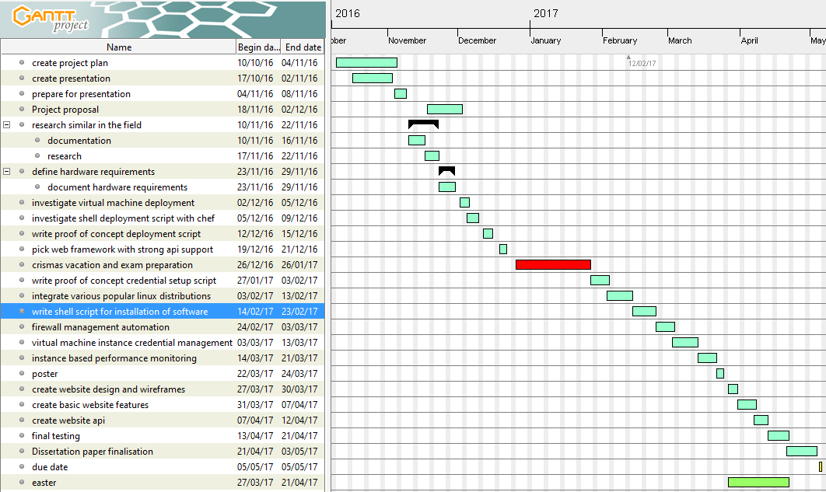

# Explanation of work plan

## Work done so far

As of now, I have defined the key features of my solution and have also become familiar with concepts and terminology. I have also found background research papers, vendor documentations, guides and relevant technologies. As part of my contingency plan, I also investigated alternative solutions that can be used in case of a failure or integration difficulties.

## Future work

As part of my research, I need to pick the web framework that will manage user interactions. I would also need to learn the technical aspects of the different tools that are necessary for full integration. Proof of concept work will be the next step, as it will yield information about the core functionality. The work involves the Virtualbox software and the shell scripting language. Once I have a script that will install and prepare an operating system, I would know the basic deployment workflow. The second semester will mark the beginning of main implementation, testing and documentation part of the work. The reason for leaving major part of the work to the second semester is the module distribution of my course, this will be the time mostly dedicated to the dissertation. Following work will be dedicated to setting up login credentials on the virtual machine instance. For improved security, all virtual machines will have no open ports until one is configured for access. Such script will be created and it should allow an arbitrary port to be opened. Next step will be choosing the software that will be monitoring the virtual machine instance and will be reporting to the web interface. This work would require a reporting interface for sending different data points to the management website API that will be created later. With these building blocks already implemented, I can move on to create the poster and start with website design and wireframes. The website will be the user facing management tool that will interface with the already implemented scripts (installation, port management, performance monitoring, etc.). The work of creating the website and its API will be done during Easter holiday. During the second part of that period, I will also be doing the final testing. After the second term break, the dissertation paper will be concluded.

# References

1. InternetLiveStats (2016). Google Search Statistics. Retrieved November 26, 2016 from <http://www.internetlivestats.com/google-search-statistics/>
2. Techopedia Inc. (2014). Definition of Virtualization. Retrieved November 26, 2016 from <https://www.techopedia.com/definition/719/virtualization>